

depressed

**Figure S.1.** Distribution of total EPDS scores in the cohort, with a line indicating the cutoff for the depressed group.

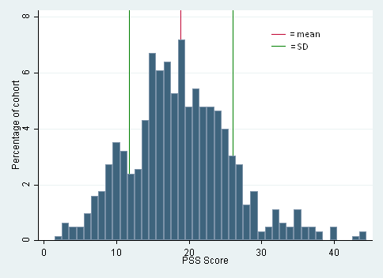

**Figure S.2.** Distribution of perceived stress scores in the cohort.