Table S.1. Twin correlations and standardized ACE Estimates on Residual Composites
 | MZ Twin (n = 902 pairs) | DZ Twin  (n = 480 pairs) | a² | c² | e²
Residual EXT and Peer Affiliationª
EXT at age 20 adjusting for EXT at age 17 | .39  (.32, .45) | .23  (.14, .32) | .35  (.14, .45) | .05  (.00, .23) | .60  (.55, .67)
EXT at age 24 adjusting for EXT at ages 17 and 20 | .22  (.14, .29) | .02  (-.08, .12) | .20  (.08, .27) | .00  (.00, .09) | .80  (.73, .87)
EXT at age 29 adjusting for EXT at ages 17, 20 and 24 | .16  (.09, .24) | .15  (.05, .25) | .04  (.00, .24) | .13  (.00, .22) | .83  (.76, .90)
Antisocial peer affiliation at age 20 adjusting for antisocial peer affiliation at age 17 | .36  (.28, .43) | .30  (.19, .40) | .13  (.00, .40) | .24  (.00, .40) | .63  (.56, .71)
Antisocial peer affiliation at age 24 adjusting for antisocial peer affiliation at age 17 and 20 | .22  (.12, .31) | .22  (.10, .34) | .00  (.00, .28) | .22  (.00, .29) | .78  (.70, .86)
Antisocial peer affiliation at age 29 adjusting for antisocial peer affiliation at age 17, 20, and 24 | .22  (.12, .31) | .07  (-.07, .20) | .22  (.00, .31) | .00  (.00, .22) | .78  (.69, .88)
NOTE: EXT = externalizing problems. This table shows intra-twin correlations for monozygotic (MZ) and dizygotic (DZ) twins as well as standardized estimates of additive genetic (a²), shared environmental (c²), and nonshared environmental (e²) influences from univariate decompositions. Ninety-five percent confidence intervals are provided in parentheses. Coefficients are significant if confidence the confidence interval does not cross zero (non-significant coefficients are shown in grey and in italics for clarity of presentation). All composites (including raw) were adjusted for age, sex, age*sex, and age² by regressing these covariates out prior to analysis. ªThese composites were adjusted for age, sex, age*sex, and age² in addition to EXT and peer affiliation from previous assessments (see notes in parentheses for details).
Table S.2. Phenotypic, genetic, and environmental correlations between residual antisocial peer affiliation and externalizing problem composites from ages 17 to 29.
 | r | rA | rC | rE
Cross-sectional correlations in young adulthood, adjusted ª
Antisocial Peers at age 20 and EXT at age 20  (after adjusting for antisocial peers and EXT at age 17) | .34  (.28, .39) | .45  (.45, 1.0) | 1.0  (.11, 1.0) | .15  (.07, .24)
Antisocial Peers at age 24 and EXT at age 24  (after adjusting for antisocial peers and EXT at ages 17 and 20) | .25  (.20, .30) | 1.0  (-1.0, 1.0) | 1.0  (-1.0, 1.0) | .14  (.06, .22)
Antisocial Peers at age 29 and EXT at age 29  (after adjusting for antisocial peers and EXT at ages 17, 20 and 24) | .15  (.09, .21) | .13  (-1.0, 1.0) | 1.0  (-1.0, 1.0) | .14  (.04, .23)
Longitudinal correlations of adolescent peer affiliation predicting young adult EXT, adjusted ^{b}
Antisocial Peers at age 17 and EXT at age 20  (after adjusting for EXT at age 17) | .24  (.18, .31) | .37  (-.09, .90) | .86  (-1.0, 1.0) | -.01  (-.09, .08)
Antisocial Peers at age 17 and EXT at age 24  (after adjusting for EXT at age 17) | .04  (-.02, .09) | .55  (-.02, 1.0) | -1.0  (-1.0, 1.0) | -.05  (-.14, .04)
Antisocial Peers at age 17 and EXT at age 29  (after adjusting for EXT at age 17) | -.02  (-.08, .04) | .12  (-1.0, 1.0) | 1.0  (-1.0, 1.0) | -.17  (-.17, -.08)
NOTE: EXT = externalizing problems. This table shows phenotypic correlations (r) as well as additive genetic (rA), shared environmental (rC), and nonshared environmental (rE) correlations from bivariate, full ACE cholesky decompositions. All composites were adjusted for age, sex, age*sex, and age² by regressing these covariates out prior to analysis. ªIn addition to age, sex, age*sex, and age², previous EXT and peer affiliation was regressed out of these composites prior to analysis, thus these correlations refer to residual genetic and environmental influences on the covariance between EXT and peer affiliation unique to that time point. ^{b}In addition to age, sex, age*sex, and age², EXT at age 17 was regressed out of EXT at age 20, 24, and 29 prior to analysis; thus these EXT composites refer to the residual EXT variance specific to that time point. Significant coefficient are those with a confidence interval that doesn’t cross zero (those that are not significant are denoted in gray and it italics for clarity of presentation).
Table S.3. Fit statistics for gene-environment interplay models of antisocial peer affiliation and EXT at ages 17, 20, 24, and 29: Results for residual composites
 | -2LnL | df | Δχ² | Δdf | p | AIC |  | Adjusted BIC | DIC
Cross-sectional Associations in Adulthood, adjusting for Adolescent Peer Affiliation and EXT:
Antisocial Peer Affiliation at Age 20 and EXT at Age 20 (adjusting for antisocial peer affiliation and EXT at age 17)ª
1. Full ACE moderation | 7782.26 | 2955 |  |  |  | 1872.26 |  | -1184.57 | -3260.71
2. No ACE moderation | 7821.33 | 2961 | 39.07 | 6 | <.001 | 1899.33 |  | -1175.34 | -3155.49
3. Best fitting model: Unique E and common C moderation only; c21 and c22 parameters dropped | 7790.09 | 2961 | 7.83 | 6 | 0.25 | 1868.09 |  | -1190.96 | -3171.11
Antisocial Peer Affiliation at Age 24 and EXT at Age 24 (adjusting for antisocial peer affiliation and EXT at ages 17 and 20)ª
4. Full ACE moderation | 7069.07 | 2547 |  |  |  | 1975.07 | -652.85 |  | -2455.6
5. No ACE moderation | 7116.96 | 2553 | 47.89 | 6 | <.001 | 2010.96 | -638.77 |  | -2345.53
6. Best fitting model: Unique E and Common A moderation only; c22, a21, and a22 parameters dropped | 7076.59 | 2554 | 7.52 | 7 | 0.38 | 1968.59 | -660.6 |  | -2368.02
Antisocial Peer Affiliation at Age 29 and EXT at Age 29
(adjusting for antisocial peer affiliation and EXT at ages 17, 20, and 29)ª
7. Full ACE moderation | 6472.51 | 2359 |  |  |  | 1754.51 |  | -552.52 | -2129.29
8. No ACE moderation | 6483.49 | 2365 | 10.98 | 6 | 0.09 | 1753.49 |  | -556.68 | -2137.45
9. Best fitting model: No ACE moderation; c11, c21, c22, and a21 parameters dropped | 6484.14 | 2369 | 11.63 | 10 | 0.31 | 1746.14 |  | -562.22 | -2146.22
Longitudinal Associations: Adolescent Peer Affiliation and Adult EXT, adjusting for adolescent EXT:
Antisocial Peer Affiliation at Age 17 and EXT at Age 20 (adjusting for EXT at age 17)^{b}
10. Full ACE moderation | 8303.07 | 3275 |  |  |  | 1753.07 |  | -1687.8 | -3878.48
11. No ACE moderation | 8431.15 | 3281 | 128.08 | 6 | <.001 | 1869.15 |  | -1634.46 | -3829.15
12. Best fitting model: Unique CE moderation only, a21, a22, c22, e21 parameters dropped | 8318.8 | 3283 | 15.73 | 8 | 0.05 | 1752.8 |  | -1694.2 | -3890.3
Antisocial Peer Affiliation at Age 17 and EXT at Age 24 (adjusting for EXT at age 17)^{b}
13. Full ACE moderation | 8544.02 | 3191 |  |  |  | 2162.02 |  | -1417.55 | -3552.04
14. No ACE moderation | 8554.48 | 3197 | 10.46 | 6 | 0.11 | 2160.48 |  | -1423.02 | -3561.52
15. Best fitting model: Unique E moderation only; a21, c21, c22, and e21 parameters dropped | 8548.55 | 3200 | 4.53 | 9 | 0.87 | 2148.55 |  | -1431.33 | -3571.84
Antisocial Peer Affiliation at Age 17 and EXT at Age 29 (adjusting for EXT at age 17)^{b}
16. Full ACE moderation | 8275.99 | 3132 |  |  |  | 2011.99 |  | -1446.37 | -3541.39
17. No ACE moderation | 8311.34 | 3138 | 35.35 | 6 | <.001 | 2035.34 |  | -1439.39 | -3538.43
18. Best fitting model: Unique E moderation only, a21, c22, e21, and c21 parameters dropped | 8279.23 | 3141 | 3.24 | 9 | 0.95 | 1997.23 |  | -1460.8 | -3561.84
NOTE: -2LnL = -2 x Loglikelihood, df = degrees of freedom, Δχ² = chi-square change, Δdf = degree of freedom change, AIC = Akaike Information Criterion, BIC = Bayesian Information Criterion, DIC = Deviance Information Criterion, A = additive genetic effects, C = shared environmental effects, E = nonshared environmental effects, EXT = externalizing problems. The baseline model of comparison used in chi-square difference tests is the full ACE moderation model, which allows for ACE moderation on all common and unique parameters. The change in χ² is the difference between the -2 x log likelihood (-2LnL) in the baseline model (full ACE moderation) compared to the other modes tested. In all best-fitting models, all parameters were significantly different from zero. ªIn addition to age, sex, age*sex, and age², previous EXT and peer affiliation was regressed out of these composites prior to analysis, thus these correlations refer to residual genetic and environmental influences on the covariance between EXT and peer affiliation unique to that time point. ^{b}In addition to age, sex, age*sex, and age², EXT at age 17 was regressed out of EXT at age 20, 24, and 29 prior to analysis; thus these EXT composites refer to the residual EXT variance specific to that time point.

Cross-sectional Relationships | Longitudinal Relationships
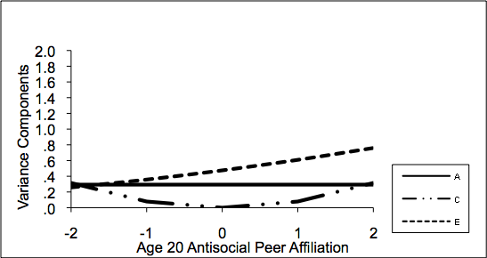  (A) Antisocial peer affiliation at age 20 moderating genetic and environmental influences on EXT at age 20  (after adjusting for antisocial peer affiliation and EXT at age 17) | 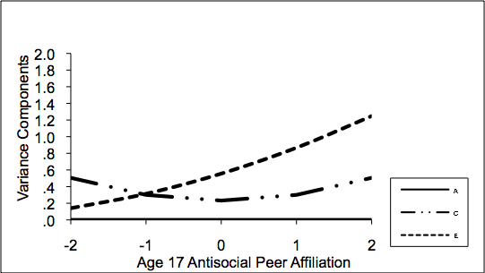  (D) Antisocial peer affiliation at age 17 moderating genetic and environmental influences on EXT at age 20  (after adjusting for EXT at age 17)
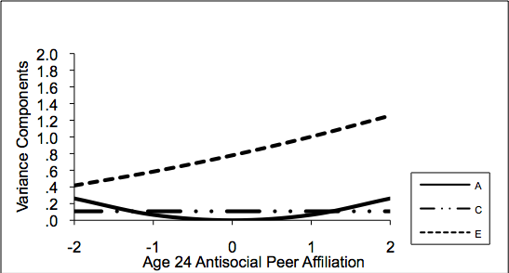  (B) Antisocial peer affiliation at age 24 moderating genetic and environmental influences on EXT at age 24  (after adjusting for antisocial peer affiliation and EXT at ages 17 and 20) | 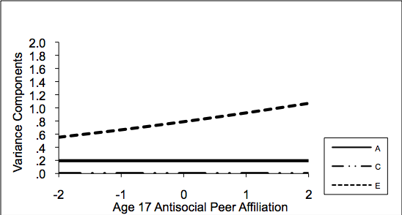  (E) Antisocial peer affiliation at age 17 moderating genetic and environmental influences on EXT at age 24  (after adjusting for EXT at age 17)
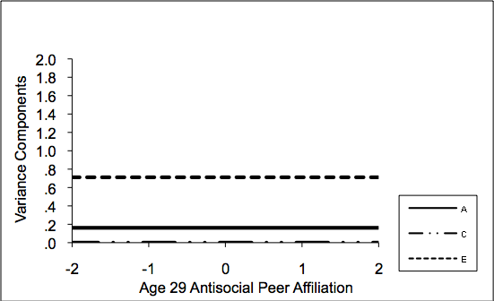  (C) Antisocial peer affiliation at age 29 moderating genetic and environmental influences on EXT at age 29  (after adjusting for antisocial peer affiliation and EXT at ages 17, 20, and 24) | 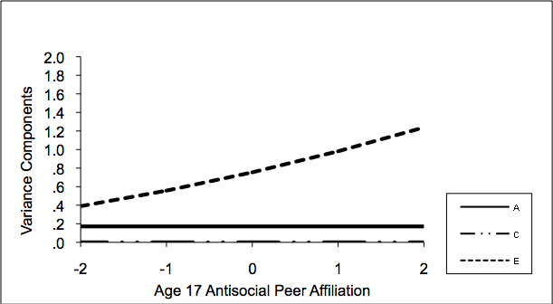  (F) Antisocial peer affiliation at age 17 moderating genetic and environmental influences on EXT at age 29  (after adjusting for EXT at age 17)
Figure S.1. Cross-sectional results on adjusted phenotypes: Cross-Sectional and longitudinal associations. Changes in the unstandardized ACE variance components of externalizing problems (EXT) are given as a function of antisocial peer affiliation for the best-fitting models (see eTable 3). A = additive genetic influence, C = shared environmental influences, E = nonshared environmental influence. The Y-axis represents the unstandardized variance component score (shown for A, C, and E). The X-axis represents the value of antisocial peer affiliation (shown in 0, +/- 1, and +/- 2 standard deviation units. All composites were adjusted for age, sex, age*sex, and age² by regressing these covariates out prior to analysis. Panel A shows results for the cross-sectional associations at age 20; EXT at age 17 was regressed out of EXT at age 20 and peer affiliation at age 17 was regressed out of peer affiliation at age 20 prior to analysis. Panel B shows cross-sectional associations at age 24; EXT at age 17 and 20 was regressed out of EXT at age 24 and peer affiliation at age 17 and 20 was regressed out of peer affiliation at age 24 prior to analysis. Panel C shows results for the cross-sectional association at age 29; EXT at age 17, 20, and 24 was regressed out of EXT at age 29 and peer affiliation at age 17, 20, and 24 was regressed out of peer affiliation at age 29 prior to analysis. Panel D plots interaction results for the prospective association between adolescent peer affiliation (age 17) and early emerging adult EXT (age 20); EXT at age 17 was regressed out of EXT at age 20 prior to this analysis. Panel E plots interaction results for the prospective association between adolescent peer affiliation (age 17) and late emerging adult EXT (age 24); EXT at age 17 was regressed out of EXT at age 24 prior to this analysis. Panel F plots interaction results for the prospective association between adolescent peer affiliation (age 17) and late young adult EXT (age 29); EXT at age 17 was regressed out of EXT at age 29 prior to this analysis.

