Supplementary Materials
Figure S.1. Individual trajectories for 22q11DS individuals who have prodromal/overt psychosis at baseline. S210 and S187 converted to schizophrenia. S004 remained prodromal but was maintained on medications and was functioning well at Time 4. S091 was symptom free at the time of the most recent evaluation but was taking an antipsychotic medication (risperidone) at that time. S057 was not experiencing any prodromal symptoms at the most recent assessment, and was not on antipsychotic medication.
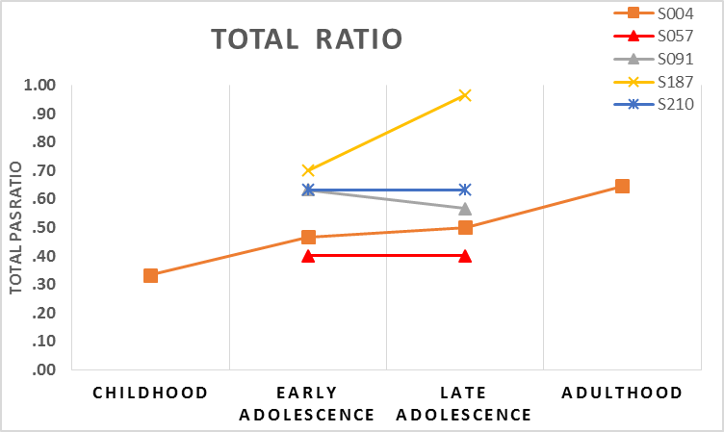
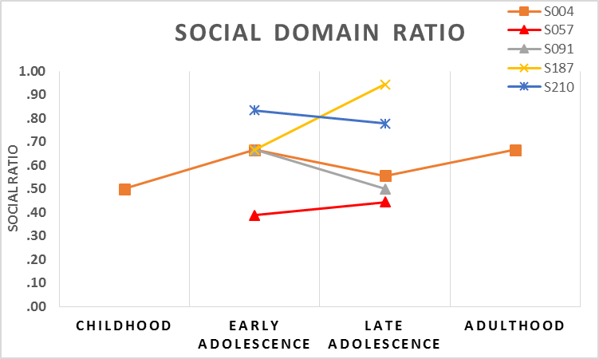
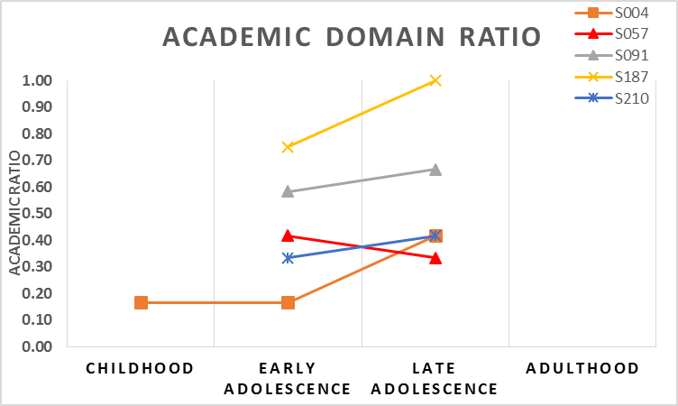

Supplementary Methods
PAS Scores and subsequent overt psychosis in 22q11DS
Mirroring the analyses conducted on the PAS scores and subsequent (prodromal) psychosis (including participants with both significant prodromal symptoms and overt psychosis), we conducted univariate logistic regressions with independent variable PAS ratio (social, academic, or total at each developmental level) and the dependent variable Overt Psychosis. Stepwise, multivariate logistic regression (with independent variables the PAS total, social, and academic domain ratios across childhood, early or late adolescence), and dependent variable Overt Psychosis was conducted in order to assess which variable may be the best predictor of overt psychosis. The association between PAS developmental trajectory (chronically poor, good, vs. deteriorating trajectory) and Overt Psychosis was evaluated with a Pearson chi-square test.

Supplementary Results
PAS Scores and subsequent overt psychosis in 22q11DS
PAS Scores. Childhood total and childhood academic domain scores were significant predictors of overt psychosis (supplementary Table S.1). Stepwise, multivariate logistic regression (with independent variables the PAS scores across the childhood, early and late adolescence periods, and dependent variable Overt Psychosis outcome) did not show significance for any of the independent variables (p > .05).
PAS Trajectories. The three PAS groups (chronically poor, good, vs. deteriorating) did not differ significantly in the rate of subsequent overt psychosis (Supplementary Table S.2). The number of participants in the overt psychosis group was too low to conduct ROC analyses, paralleling the ROC analysis conducted for the (prodromal) psychosis participants versus 22q11DS individuals without (prodromal) psychosis.

Table S.1. Univariate Logistic Regressions of PAS Scores Predictive of Overt Psychosis
Domain Ratio | Developmental Period | B | SE | Wald | p
Total | Childhood | 7.664 | 3.581 | 4.582 | 0.032
 | Early Adolescence | 3.300 | 3.152 | 1.096 | 0.295
 | Late Adolescence | -1.334 | 4.505 | 0.088 | 0.767
Social | Childhood | 5.904 | 3.042 | 3.768 | 0.052
 | Early Adolescence | 2.330 | 2.467 | 0.892 | 0.345
 | Late Adolescence | -4.059 | 4.080 | 0.990 | 0.320
Academic | Childhood | 7.198 | 3.479 | 4.282 | 0.039
 | Early Adolescence | 2.309 | 2.822 | 0.670 | 0.413
 | Late Adolescence | 4.021 | 3.407 | 1.393 | 0.238
Table S.2. Overt psychosis in the PAS trajectory groups
 |  | Prodromal/Overt Psychosis
 |  | No | Yes | Total
Chronically poor PAS |  | 29 | 4 | 33
Deteriorating PAS |  | 6 | 0 | 6
Good PAS |  | 31 | 0 | 31
Total |  | 66 | 4 | 70
Note: Pearson χ² = 4.757, df = 2, p = .093.
Table S.3. Correlations between childhood and early adolescence PAS scores within each group of participants
 | PAS Scores
 | Total | Social | Academic
22q11DS | 0.670** | 0.628** | 0.575**
Controls | 0.725** | 0.733** | 0.627**
Siblings | 0.713** | 0.630** | 0.688**
**p < .01.

References
Addington, A. M. & Rapoport, J. L. (2009). The genetics of childhood-onset schizophrenia:
When madness strikes the prepubescent. Current Psychiatry Reports, 11, 156-161.
American Psychiatric Association (2013). Diagnostic and statistical manual of mental disorders
(5th ed.). Arlington, VA: Author.
Aneja, A., Fremont, W. P., Antshel, K. M., Faraone, S. V., AbdulSabur, N., Higgins, A.
M.,…Kates, W. R. (2007). Manic symptoms and behavioral dysregulation in youth with
velocardiofacial syndrome (22q11.2 deletion syndrome). Journal of Child and Adolescent
Psychopharmacology, 17, 105-114.
Antshel, K. M., Fremont, W., Roizen, N. J., Shprintzen, R., Higgins, A. M., Dhamoon, A., &
Kates, W. R. (2006). ADHD, major depressive disorder, and simple phobias are prevalent
psychiatric conditions in youth with velocardiofacial syndrome. Journal of the American
Academy of Child & Adolescent Psychiatry, 45, 596-603.
Antshel, K. M., Shprintzen, R., Fremont, W., Higgins, A. M., Faraone, S. V., & Kates, W. R.
(2010). Cognitive and psychiatric predictors to psychosis in velocardiofacial syndrome:
A 3-year follow-up study. Journal of the American Academy of Child & Adolescent
Psychiatry, 49, 333-344.
Armando, M., Girardi, P., Vicari, S., Menghini, D., Digilio, M. C., Pontillo, M.,…Amminger, G.
P. (2012). Adolescents at ultra-high risk for psychosis with and without 22q11 deletion
syndrome: A comparison of prodromal psychotic symptoms and general functioning.
Schizophrenia Research, 139, 151-156.
Baker, K., Baldeweg, T., Sivagnanasundaram, S., Scambler, P., & Skuse, D. (2005). COMT
Val108/158 Met modifies mismatch negativity and cognitive function in 22q11 deletion
syndrome. Biological Psychiatry, 58, 23-31.
Baker, K. D. & Skuse, D. H. (2005). Adolescents and young adults with 22q11 deletion
syndrome: Psychopathology in an at-risk group. British Journal of Psychiatry, 186, 115-
120.
Barnett, J. H., Heron, J., Ring, S. M., Golding, J., Goldman, D., Xu, K., & Jones, P. B. (2007) .
Gender-specific effects of the catechol-O-methyltransferase [Val.sup.108/158]Met
polymorphism on cognitive function in children. American Journal of Psychiatry, 164,
142-149.
Bassett, A. S. & Chow, E. W. (1999). 22q11 Deletion Syndrome: A genetic subtype of
schizophrenia. Biolical Psychiatry, 46, 882-891.
Bassett, A. S., Chow, E. W. C., AbdelMalik, P., Gheorghiu, M., Husted, J., & Weksberg, R.
(2003) . The schizophrenia phenotype in 22q11 deletion syndrome. American Journal of
Psychiatry, 160, 1580-1586.
Bassett, A. S. & Chow, E. W. (2008). Schizophrenia and 22q11.2 deletion syndrome. Current
Psychiatry Reports, 10, 148-157.
Bleuler, E. (1911). Dementia praecox oder Gruppe der Schizophrenien [Dementia Praecox or
The Group of Schizophrenias]. Leipzig: Franz Deuticke.
Bleuler, M. & Bleuler, R. (1986). Dementia praecox oder die Gruppe der Schizophrenien: Eugen
Bleuler. British Journal of Psychiatry: The Journal of Mental Science, 149, 661-662.
Botto, L. D., May, K., Fernhoff, P. M., Correa, A., Coleman, K., Rasmussen, S. A.,…Campbell,
R. M. (2003). A population-based study of the 22q11.2 deletion: Phenotype, incidence,
and contribution to major birth defects in the population. Pediatrics, 112, 101-107.
Cannon-Spoor, H. E., Potkin, S. G., & Wyatt, R. J. (1982). Measurement of premorbid
adjustment in chronic schizophrenia. Schizophrenia Bulletin, 8, 470-484.

Coman, I.L., Gnirke, M.H., Middleton, F.A., Antshel, K.M., Fremont, W., Higgins, A.M.,…Kates, W.R. (2010) The effects of gender and catechol O-methyltransferase (COMT) Val108/158Met polymorphism on emotion regulation in velo-cardio-facial syndrome (22q11.2 deletion syndrome): An fMRI study. Neuroimage 53, 1043-1050.
Drew, L. J., Crabtree, G. W., Markz, S., Stark, K. L., Chaverneff, F., Xu, B.,…Karayiorgou, M.
(2011). The 22q11.2 microdeletion: Fifteen years of insights into the genetic and neural complexity of psychiatric disorders. International Journal of Developmental
Neuroscience, 29, 259-281.
Egan, M. F., Goldberg, T. E., Kolachana, B. S., Callicott, J. H., Mazzanti, C. M., Straub, R.
E.,…Weinberger, D. R. (2001). Effect of COMT Val108/158 Met genotype on frontal
lobe function and risk for schizophrenia. Proceedings of the National Academy of
Sciences of the United States of America, 98, 6917–6922.
Eggers, C., Bunk, D., Volberg, G. & Ropcke, B. (1999). The ESSEN study of childhood-onset
schizophrenia: Selected results. European Child & Adolescent Psychiatry, 8, Suppl. 1,
I21-8.
Feinstein, C., Eliez, S., Blasey, C., & Reiss, A. L. (2002). Psychiatric disorders and behavioral
problems in children with velocardiofacial syndrome: Usefulness as phenotypic
indicators of schizophrenia risk. Biological Psychiatry, 51, 312-318.
Furniss, F., Biswas, A. B., Gumber, R., & Singh, N. (2011). Cognitive phenotype of
velocardiofacial syndrome: A review. Research in Developmental Disabilities, 32, 2206-
2213.
Goldman-Rakic, P. S., Muly III, E. C., & Williams, G. V. (2000). D(1) receptors in prefrontal
cells and circuits. Brain Research Reviews, 31, 295–301.
Gothelf, D., Eliez, S., Thompson, T., Hinard, C., Penniman, L., Feinstein, C.,…Reiss, A. L.
(2005) . COMT genotype predicts longitudinal cognitive decline and psychosis in
22q11.2 deletion syndrome. Nature Neuroscience, 8, 1500-1502.

Gothelf, D., Feinstein, C., Thompson, T., Gu, E., Penniman, L., Van Stone, E.,…Reiss, A. L.
(2007) . Risk factors for the emergence of psychotic disorders in adolescents with
22q11.2 deletion syndrome. American Journal of Psychiatry, 164, 663-669.
Gothelf, D., Hoeft, F., Ueno, T., Sugiura, L., Lee, A. D., Thompson, P., & Reiss, A. L. (2011).
Developmental changes in multivariate neuroanatomical patterns that predict risk for
psychosis in 22q11.2 deletion syndrome. Journal of Psychiatric Research, 45, 322-331.
Gothelf, D., Schneider, M., Green, T., Debbane, M., Frisch, A., Glaser, B.,…Eliez, S. (2013) .
Risk factors and the evolution of psychosis in 22q11.2 deletion syndrome: A longitudinal
2-site study. Journal of the American Academy of Child & Adolescent Psychiatry, 52,
1192-1203.e3.
Goulding, S. M., Holtzman, C. W., Trotman, H. D., Ryan, A. T., MacDonald, A. N., Shapiro, D.
I.,…Walker, E.F. (2013). The prodrome and clinical risk for psychotic disorders. Child
Adolescent Psychiatric Clinics of North America, 22, 557-567.
Grati, F.R.. Malvestiti, B., Maggi, F., Simoni, G., Molina Gomes, D., Herve, B.,…Queipo, G.
(2015). Prevalence of recurrent pathogenic microdeletions and microduplications in over
9500 pregnancies. Prenatal Diagnosis, 35, 801-809.
Green, T., Gothelf, D., Glaser, B., Debanne, M., Frisch, A., Kotler, M.,…Eliez, S. (2009).
Psychiatric disorders and intellectual functioning throughout development in
velocardiofacial (22q11.2 deletion) syndrome. Journal of the American Academy of Child
& Adolescent Psychiatry, 48, 1060-1068.
Haas, G. L. & Sweeney, J. A. (1992). Premorbid and onset features of first-episode
schizophrenia. Schizophrenia Bulletin, 18, 373-386.
Hafner, H. & an der Heiden, W. (1997). Epidemiology of schizophrenia. Canadian Journal of
Psychiatry, 42, 139-151.
Hafner, H., Riecher-Rossler, A., Hambrecht, M., Maurer, K., Meissner, S., Schmidtke, A.,…van
der Heiden, W. (1992).IRAOS: An instrument for the assessment of onset and early
course of schizophrenia. Schizophrenia Research, 6, 209-223.
Hanley, J. A. & McNeil, B. J. (1982). The meaning and use of the area under a receiver
operating characteristic (ROC) curve. Radiology, 143, 29-36.
Jiang, H., Xie, T., Ramsden, D. B., & Ho, S. L. (2003). Human catechol-O-methyltransferase
down-regulation by estradiol. Neuropharmacology, 45, 1011-1018.
Joa, I., Johannessen, J. O., Langeveld, J., Friis, S., Melle, I., Opjordsmoen, S.,…Larsen, T. K.
(2009). Baseline profiles of adolescent vs. adult-onset first-episode psychosis in an early
detection program. Acta Psychiatrica Scandinavica, 119, 494-500.
Jolin, E. M., Weller, R. A., & Weller, E. B. (2009). Psychosis in children with velocardiofacial
syndrome (22q11.2 deletion syndrome). Current Psychiatry Reports, 11, 99-105.
Jones, P. B. (2013). Adult mental health disorders and their age at onset. British Journal of
Psychiatry Supplement, 54, s5-10.
Kates, W. R., Antshel, K. M., Faraone, S. V., Fremont, W. P., Higgins, A. M., Shprintzen, R.
J.,…McCarthy, C. (2011). Neuroanatomic predictors to prodromal psychosis in
velocardiofacial syndrome (22q11.2 deletion syndrome): A longitudinal study. Biological
Psychiatry, 69, 945-952.
Kaufman, J., Birmaher, B., Brent, D., Rao, U., & Ryan, N. (1996). Kiddie Schedule for Affective
Disorders and Schizophrenia – Present and Lifetime Version (K-SADS-PL). Accessed from http://www.psychiatry.pitt.edu/node/8233.
Lachman, H. M., Veit, S., Faedda, G., Papolos, D. F., Morrow, B., Goldberg, R.,…Parsia, S. S.
(1996). Association of codon 108/158 catechol-O-methyltransferase gene polymorphism
with the psychiatric manifestations of velo-cardio-facial syndrome. American Journal of
Medical Genetics, 67, 468-472.
Lambe, E. K., Krimer, L. S., & Goldman-Rakic, P. S. (2000). Differential postnatal development
of catecholamine and serotonin inputs to identified neurons in prefrontal cortex of rhesus monkey. Journal of Neuroscience, 20, 8780-8787.
Levine, S. Z. & Rabinowitz, J. (2010). Trajectories and antecedents of treatment response over
time in early-episode psychosis. Schizophrenia Bulletin, 36, 624-632.
Miller, T. J., McGlashan, T. H., Rosen, J. L., Cadenhead, K., Ventura, J., McFarlane,
W.,…Woods, S. W. (2003). Prodromal assessment with the structured interview for
prodromal syndromes and the scale of prodromal symptoms: Predictive validity,
interrater reliability, and training to reliability. Schizophrenia Bulletin, 29, 703-715.
Miller, T. J., McGlashan, T. H., Rosen, J. L., Somjee, L., Markovich, P. J., Stein, K., & Woods,
S. W. (2002). Prospective diagnosis of the initial prodrome for schizophrenia based on
the Structured Interview for Prodromal Syndromes: Preliminary evidence of interrater
reliability and predictive validity. American Journal of Psychiatry, 159, 863-865.
Monks, S., Niarchou, M., Davies, A. R., Walters, J. T. R., Williams, N., Owen, M. J.,…Murphy,
K. C. (2014). Further evidence for high rates of schizophrenia in 22q11.2 deletion
syndrome. Schizophrenia Research, 153, 231-236.
Murphy, K. C. (2002). Schizophrenia and velo-cardio-facial syndrome. Lancet, 359, 426-430.
Nicolson, R. & Rapoport, J. L. (1999). Childhood-onset schizophrenia: Rare but worth studying.
Biological Psychiatry, 46, 1418-1428.
Nieman, D. H., Dragt, S., Soen, F., Van Tricht, M. J., Velthorst, E., Becker, H. E.,…Weiser, M.
(2014). Psychosis prediction: Stratification of risk estimation with information-
processing and premorbid functioning variables. Schizophrenia Bulletin, 40, 1482-1490 .

Rabinowitz, J., Harvey, P. D., Eerdekens, M., & Davidson, M. (2006). Premorbid functioning
and treatment response in recent-onset schizophrenia. British Journal of Psychiatry, 189,
31-35.
Raux, G., Bumsel, E., Legallic, S., Bou, J., Drouin-Garraud, V., Lemarchand, M.,…Afenjar, A.
(2007). Involvement of hyperprolinemia in cognitive and psychiatric features of the
22q11 deletion syndrome. Human Molecular Genetics, 16, 83-91.
Russell, A. T. (1994). The clinical presentation of childhood-onset schizophrenia. Schizophrenia
Bulletin, 20, 631-646.
Saha, S., Chant, D., Welham, J. & McGrath, J. (2005). A systematic review of the prevalence of
schizophrenia. PLoS Med., 2, e141.
Schneider, M., Debanne, M., Bassett, A. S., Chow, E. W. C., Fung, W. L. A., van den Bree, M.
B. M.,…Eliez, S. (2014). Psychiatric disorders from childhood to adulthood in 22q11.2
deletion syndrome: Results from the international consortium on brain and behavior in
22q11.2 deletion syndrome. American Journal of Psychiatry, 171, 627-640.
Shprintzen, R. J. & Golding-Kushner, K. J. (2008). Title of Chapter. In Velo-Cardio-Facial
Syndrome, Volume I . San Diego, CA: Plural Publishing Inc..
Sporn, A., Addington, A., Reiss, A. L., Dean, M., Gogtay, N., Potocnik, U.,…Rapoport, J. L.
(2004). 22q11 deletion syndrome in childhood onset schizophrenia: An update.
Molecular Psychiatry, 9, 225-226.
Strous, R. D., Alvir, J. M. J., Robinson, D., Gal, G., Sheitman, B., Chakos, M., & Lieberman, J.
A. (2004). Premorbid functioning in schizophrenia: Relation to baseline symptoms,
treatment response, and medication side effects. Schizophrenia Bulletin, 30, 265-278.

Takahashi, S. (2013). Heterogeneity of schizophrenia: Genetic and symptomatic factors.
American Journal of Medical Genetics Part B: Neuropsychiatric Genetics, 162, 648-652.
Tandon, R., Gaebel, W., Barch, D. M., Bustillo, J., Gur, R. E., Heckers, S.,…Carpenter, W.
(2013). Definition and description of schizophrenia in the DSM-5. Schizophrenia
Research, 150, 3-10.
Tarbox, S. I., Brown, L. H., & Haas, G. L. (2012). Diagnostic specificity of poor premorbid
adjustment: Comparison of schizophrenia, schizoaffective disorder, and mood disorder
with psychotic features. Schizophrenia Research, 141, 91-97.
Tarbox, S. I., McGlashan, T. H., Woods, S. W., Addington, J., Cadenhead, K. S., Tsuang, M. T.,
…Heinssen, R. (2013). Premorbid functional development and conversion to psychosis in
clinical high-risk youths. Development and Psychopathology, 25, 1171-1186.
Tunbridge, E. M., Harrison, P. J., Weickert, C. S., Klienman, J. E., Herman, M. M., Chen,
J.,…Weinberger, D. R. (2007). Catechol-o-methyltransferase enzyme activity and
protein expression in human prefrontal cortex across the postnatal lifespan. Cerebral
Cortex, 17, 1206-1212.
Tunbridge, E. M., Harrison, P. J., & Weinberger, D. R. (2006). Catechol-o-methyltransferase,
cognition, and psychosis: Val158Met and beyond. Biological Psychiatry, 60, 141-151.
van Os, J. & Kapur, S. (2009). Schizophrenia. Lancet, 374, 635-645.
Walker, E. F., Trotman, H. D., Goulding, S. M., Holtzman, C. W., Ryan, A. T., McDonald,
A.,…Brasfield, J. L. (2013). Developmental mechanisms in the prodrome to psychosis.
Development and Psychopathology, 25, 1585-1600.
Wechsler, D. (1991). Wechsler Intelligence Scale for Children, Third Edition. San Antonio, TX:
The Psychological Corporation.

Wechsler, D. (1997). Wechsler Adult Intelligence Scale, Third Edition. San Antonio, TX: The
Psychological Corporation.
Xie, T., Ho, S. L., & Ramsden, D. (1999). Characterization and implications of estrogenic down-
regulation of human catechol-O-methyltransferase gene transcription. Molecular
Pharmacololgy, 56, 31-38.
Yuen, T., Chow, E. W., Silversides, C. K., & Bassett, A. S. (2013). Premorbid adjustment and
schizophrenia in individuals with 22q11.2 deletion syndrome. Schizophrenia Research,
151, 221-225.

.

.
.

