Supplementary Material
Table S.1. Rotated factor matrix (varimax) for youths’ report measures of parenting
 | f1 | f2 | f3
Conflict With Parents
CP1  CP2  CP3  CP4  CP5  CP6  CP7  CP8 | -.120  -.069  -.379  -.306  -.130  -.108  -.106  -.064 | .680  .626  .447  .476  .662  .646  .596  .615 | -.053  -.014  -.062  -.019  -.042  -.038  -.081  -.076
Parental Knowledge/Youth Disclosure
PK1  PK2  PK3  PK4  PK5  PK6  PK7  PK8  PK9  YD1  YD2  YD3  YD4  YD5 | .595  .519  .576  .562  .560  .586  .635  .500  .601  .566  .604  .555  .535  .607 | -.248  -.118  .016  -.108  -.005  -.020  -.239  -.324  -.186  -.211  -.315  -.034  -.071  -.101 | .091  .095  .101  -.003  .078  .092  .145  .087  .035  .074  .097  .127  .187  .141
Warmth Parenting
PW1  PW2  PW3  PW4  PW5  PW6  PW7 | .099  .121  .181  .083  .141  .058  .099 | -.099  -.092  -.072  -.019  .018  -.101  -.072 | .682  .605  .531  .656  .723  .577  .732
Note: CP, Conflict with parents; PK, parental knowledge; YD, youth disclosure; PW, parental warmth.
Table S.2. Rotated factor matrix (varimax) for mothers’ report measures of parenting
 | f1 | f2 | f3
Conflict With Parents
CP1  CP2  CP3 | -.129  -.158  -.354 | -.001  .035  -.001 | .764  .728  .466
Parental Knowledge/Youth Disclosure
PK1  PK2  PK3  PK4  PK5  PK6  PK7  PK8  PK9  YD1  YD2  YD3  YD4  YD5 | .587  .443  .512  .550  .519  .438  .576  .502  .535  .621  .654  .589  .598  .609 | .021  .085  .166  .042  .111  .195  .027  -.038  .065  .045  .024  .136  .104  .168 | -.034  -.137  -.185  -.109  -.225  -.151  -.116  -.067  -.111  .020  -.020  -.074  .022  -.138
Parental Warmth
PW1  PW2  PW3  PW4  PW5  PW6  PW7 | .035  .040  .077  .050  .094  .039  .087 | .534  .367  .411  .538  .586  .317  .577 | -.001  .030  .021  .018  .024  -.083  -.020
Note: CP, Conflict with parents; PK, parental knowledge; YD, youth disclosure; PW, parental warmth.

Table S.3. Zero-order correlations between all predictors
 | 1 | 2 | 3 | 4 | 5 | 6
1. YPI
Parenting youth report
2. Conflict with parents | .29***
3. Knowledge/disclosure | -.38*** | -.39***
4. Parental warmth | -.22*** | -.17*** | .29***
Parenting mother report
5. Conflict with parents | .21*** | .43*** | -.22*** | -.16***
6. Knowledge/disclosure | -.26*** | -.25*** | .48*** | .25*** | -.36***
7. Parental warmth | -.02 | .02 | .01 | .18*** | -.07 | .19***
Note: YPI, Youth Psychopathy Inventory.
***p < .001.

Figure S.1. Interaction between psychopathy score and level of conflict with parents for youths’ and mothers’ reports.
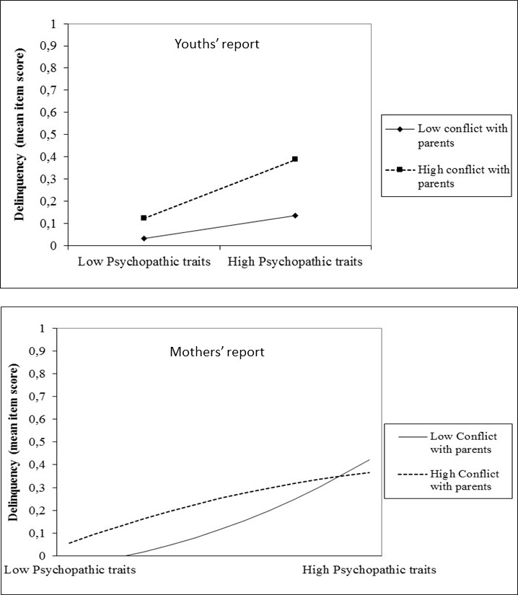

Figure S.2. Interaction between psychopathy score and level of knowledge/disclosure for youths’ and mothers’ reports.
