Supplemental Material
Table S.1. Studies included in the meta-analysis and the variables that could be calculated for overall face-emotion recognition and individuals emotions for each study
 |  |  | ALL |  | ANG |  | DIS |  | FEA |  | HAP |  | SAD |  | SUR
Study | n | Mean Age (SD) | PA | Zr | PA | Zr | PA | Zr | PA | Zr | PA | Zr | PA | Zr | PA | Zr
Akechi et al., 2009 | 28 | 12.00 (1.95) | x |  | x |  |  |  | x
Akechi et al., 2010 | 28 | 13.00 (2.20) | x | x | x | x |  |  | x | x
Ashwin, Chapman, Colle, & Baron-Cohen, 2006 | 26 | 28.42 (7.10) |  | x |  | x |  | x |  | x |  |  |  | x |  | x
Ashwin et al., 2006 | 52 | 31.15 (10.85) |  | x |  | x |  | x |  | x |  | x |  | x |  | x
Bal et al., 2010 | 53 | 10.88 (2.68) | x | x | x | x | x | x | x | x | x | x | x | x | x | x
Balconi, Amenta, & Ferrari, 2012 | 30 | 12.70 (3.30) | x
Baron-Cohen, Spitz, & Cross, 1993 | 30 | 8.50 (1.90) | x | x |  |  |  |  |  |  | x | x | x | x | x | x
Baron-Cohen, Wheelwright, & Jolliffe, 1997 | 32 | 29.30 (9.41) | x | x
Boraston, Blakemore, Chilvers, & Skuse, 2007 | 20 | 35.49 (14.56) |  | x |  | x |  | x |  | x |  | x |  | x |  | x
Braverman, Fein, Lucci, & Waterhouse, 1989 | 30 | 8.04 (1.92) | x | x
Buitelaar, van der Wees, Swaab-Barneveld, & van der Gaag, 1999 | 40 | 11.50 (2.55) | x | x
Castelli, 2005 | 40 | 10.75 (2.35) | x | x | x | x | x | x | x | x | x | x | x | x | x | x
Celani, Battacchi, & Arcidiacono, 1999 | 20 | 9.42 (2.70) | x | x
Clark, Winkielman, & McIntosh, 2008 | 25 | 23.48 (6.34) | x | x
Corden, Chilvers, & Skuse, 2008 | 35 | 32.41 (12.35) | x | x | x | x | x | x | x | x | x | x | x | x | x | x
Critchley et al., 2000 | 18 | 32.00 (7.00) | x
Davies, Bishop, Manstead, & Tantam, 1994 | 20 | 14.82 (1.99) | x | x
Dziobek, Bahnemann, Convit, & Heekeren, 2010 | 56 | 43.50 (13.0) | x | x
Dziobek, Fleck, Rogers, Wolf, & Convit, 2006 | 34 | 40.80 (11.45) | x | x
Gepner, Deruelle, & Grynfeltt, 2001 | 26 | 4.59 (1.03) | x | x
Grossman, Klin, Carter, & Volkmar, 2000 | 26 | 11.65 (2.58) | x | x | x | x |  |  | x | x | x | x | x | x | x | x
Howard et al., 2000 | 20 | N/A |  | x
Hubl et al., 2003 | 20 | 26.50 (7.35) | x | x |  |  |  |  |  |  | x | x
Humphreys, Minshew, Leonard, & Behrmann, 2007 | 38 | 25.89 (9.47) | x |  | x |  | x |  | x |  | x |  | x |  | x
Jones et al., 2011 | 156 | 15.50 (5.71) | x |  | x |  | x |  | x |  | x |  | x |  | x
Lindner & Rosen, 2006 | 30 | 10.20 (3.01) | x | x
O’Connor, 2007 | 36 | 26.05 (7.15) | x | x | x | x |  |  |  |  | x | x | x | x
O’Connor, Hamm, & Kirk, 2005 | 30 | 24.70 (8.75) |  | x |  | x |  |  |  | x |  | x |  | x
Ogai et al., 2003 | 14 | 22.57 (5.45) | x |  |  |  | x | x | x | x | x | x
Ozonoff, Pennington, & Rogers, 1990 | 28 | 4.70 (1.16) | x | x
Pelphrey et al., 2002 | 10 | 26.70 | x | x | x | x | x | x | x | x | x | x | x | x | x | x
Philip et al., 2010 | 46 | 32.45 (11.00) | x | x | x | x | x | x | x | x | x | x | x | x | x | x
Piggot et al., 2004 | 24 | 13.64 (2.83) | x | x
Rosset et al., 2008 | 40 | 9.55 (3.25) | x
Rump, Giovannelli, Minshew, & Strauss, 2009 | 37 | 6.21 (0.80) | x | x |  | x |  |  |  | x |  | x |  | x
Rutherford & Towns, 2008 | 22 | 25.75 (7.48) | x | x
Tantam, Monaghan, Nicholson, & Stirling, 1989 | 20 | 12.17 (3.12) | x | x
Tracy, Robins, Schriber, & Solomon, 2011 | 60 | 12.25 (14.30) | x
Wallace et al., 2011 | 73 | 15.98 (2.45) | x | x | x | x | x | x | x | x | x | x | x | x | x | x
Wallace, Coleman, & Bailey, 2008 | 52 | 31.50 (9.00) | x |  | x | x | x | x | x | x | x | x | x | x | x | x
Wang, Dapretto, Hariri, Sigman, & Bookheimer, 2004 | 24 | 12.00 (3.65) | x | x
Wicker et al., 2008 | 26 | 25.06 (10.46) | x | x
Wright et al., 2008 | 70 | 11.44 (2.06) | x | x | x | x | x | x | x | x | x | x | x | x | x | x
Note: ALL, Overall/multiple expressions; ANG, anger; DIS, disgust; FEA, fear; HAP, happiness; SAD, sadness; SUR, surprise; PA, weighted, corrected percentage correct difference; Zr, weighted, normalized r.

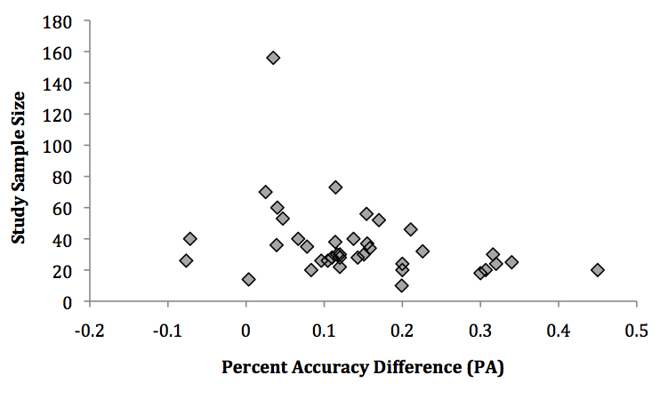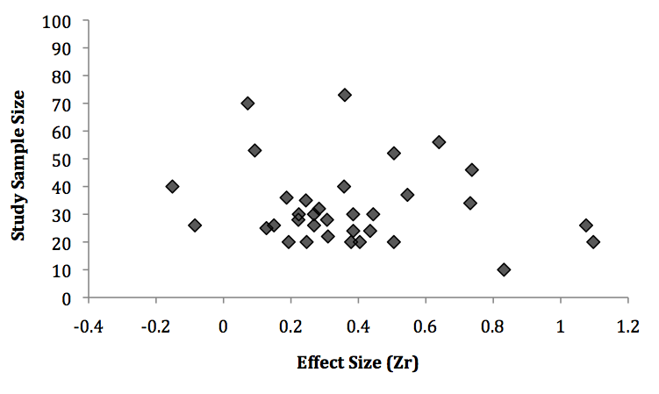
Figure S.1. Funnel plots of the percentage accuracy difference (PA) and effect size (Zr) for overal face-emotion recognition.

