Supplementary materials to:
Victims, Bullies, and their Defenders:
A Longitudinal Study of the Co-evolution of Positive and Negative Networks

Contents
S1: Graphical representation of the bullying and defending networks 2
School A 2
School B 3
School C 4
S2: Stochastic Actor-Based Models with RSiena 5
S3: Model Specification: Uniplex parameters 7
S4: Parameters in the Network Models 10
S5: Table: Uniplex RSiena analyses for bullying 12
S6: Table: Uniplex RSiena analyses for defending 13
S7: Table: Complete results of the multiplex RSiena analyses for bullying and defending 14
S8: Results: Bullying and defending parameters in the uniplex and multiplex models 18
S9: Goodness of Fit (GoF) statistics: Introduction and explanation 21
Table S4.1: M-A-N Triads in Triad Census 22
S10: Goodness of Fit statistics for the uniplex models for bullying 25
S11: Goodness of Fit statistics for the uniplex models for defending 27
S12: Goodness of Fit statistics for the multiplex models for bullying and defending 29
School A 29
School B 31
School C 33

S1: Graphical representation of the bullying and defending networks

School A
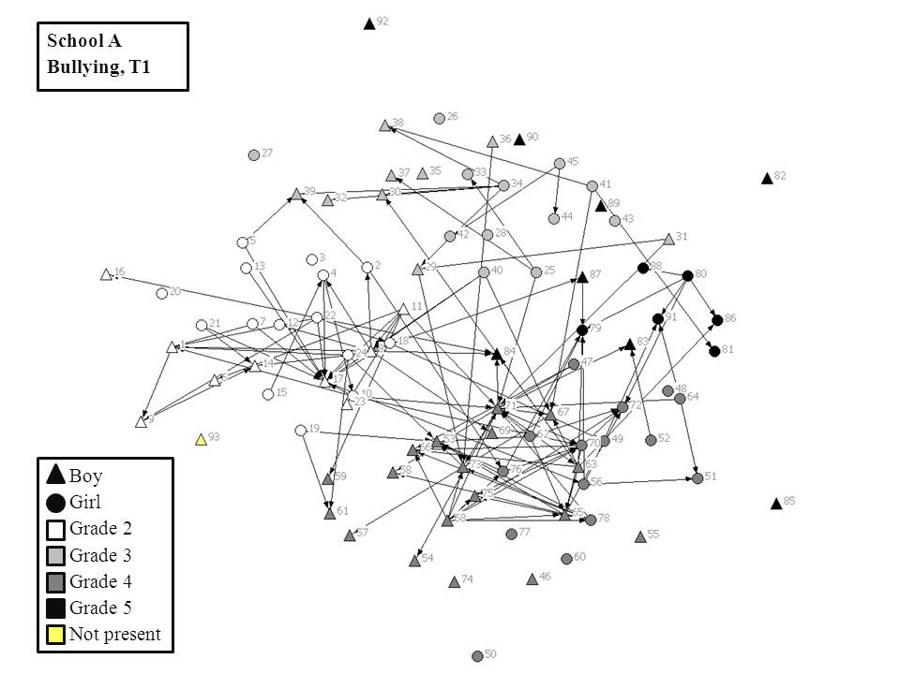 | 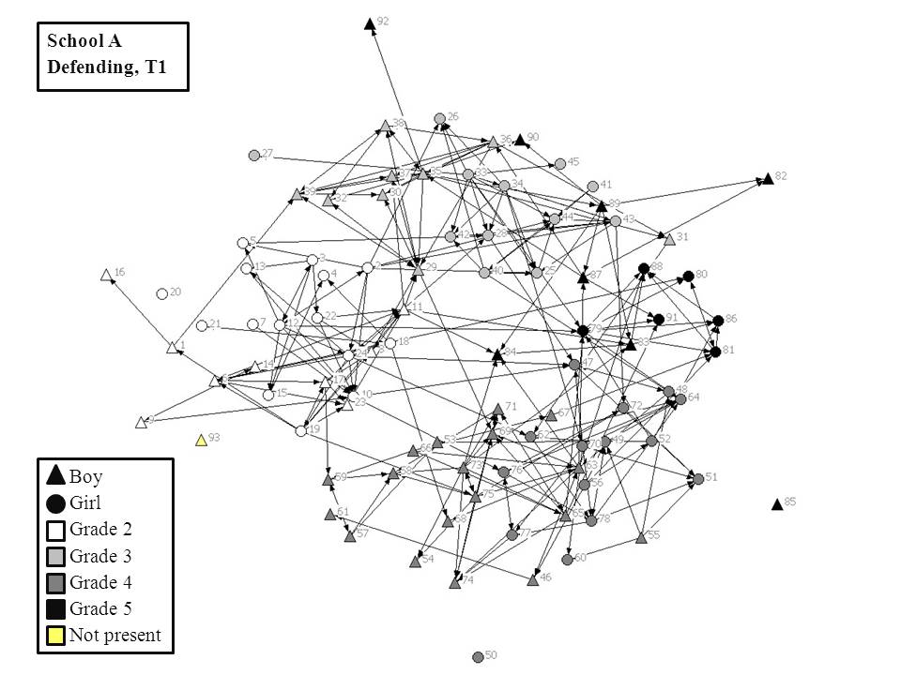
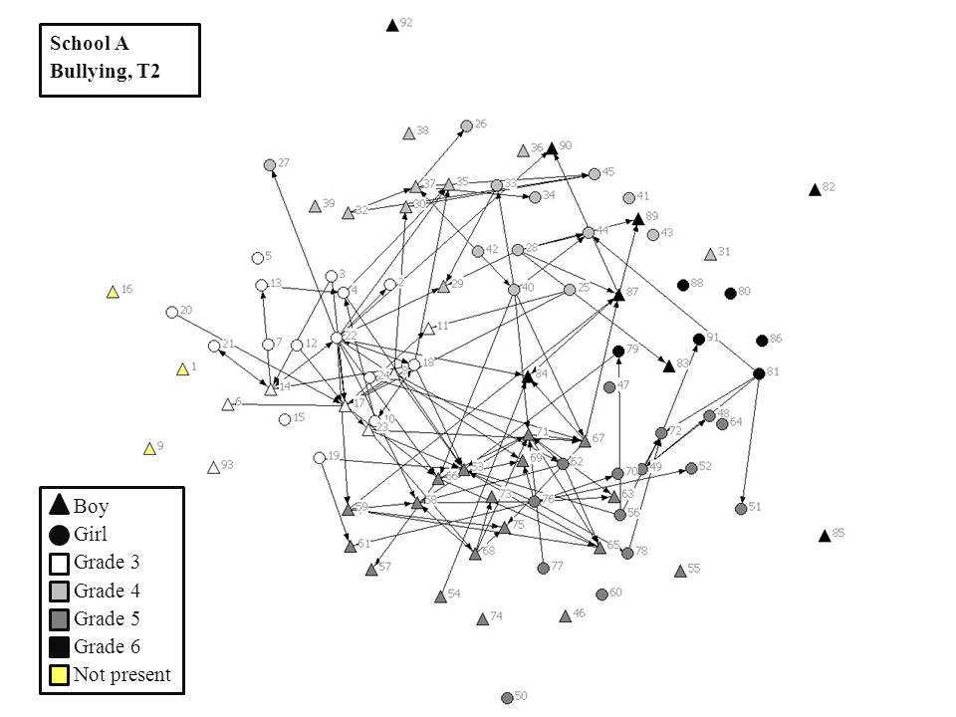 | 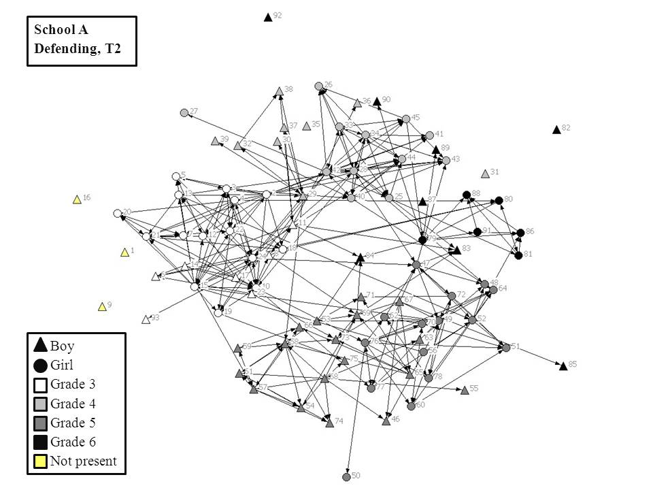
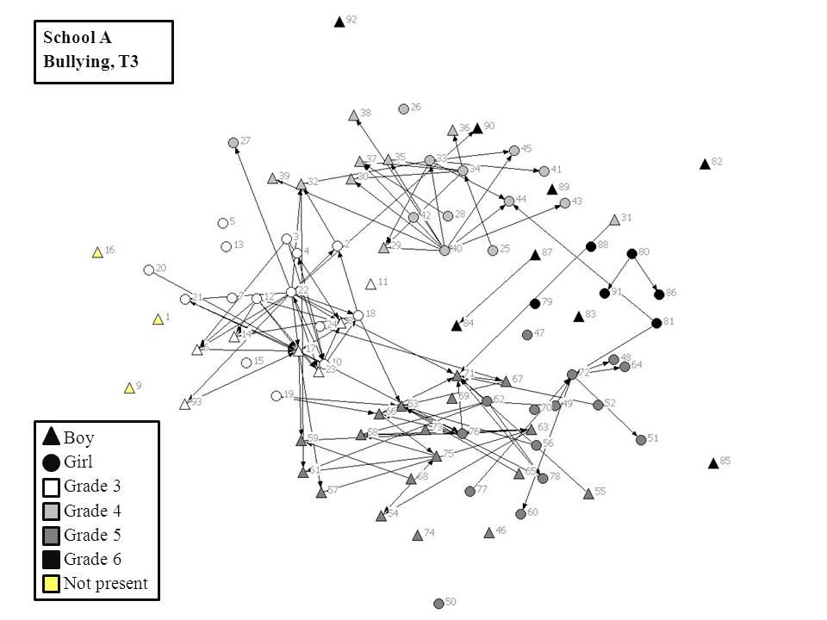 | 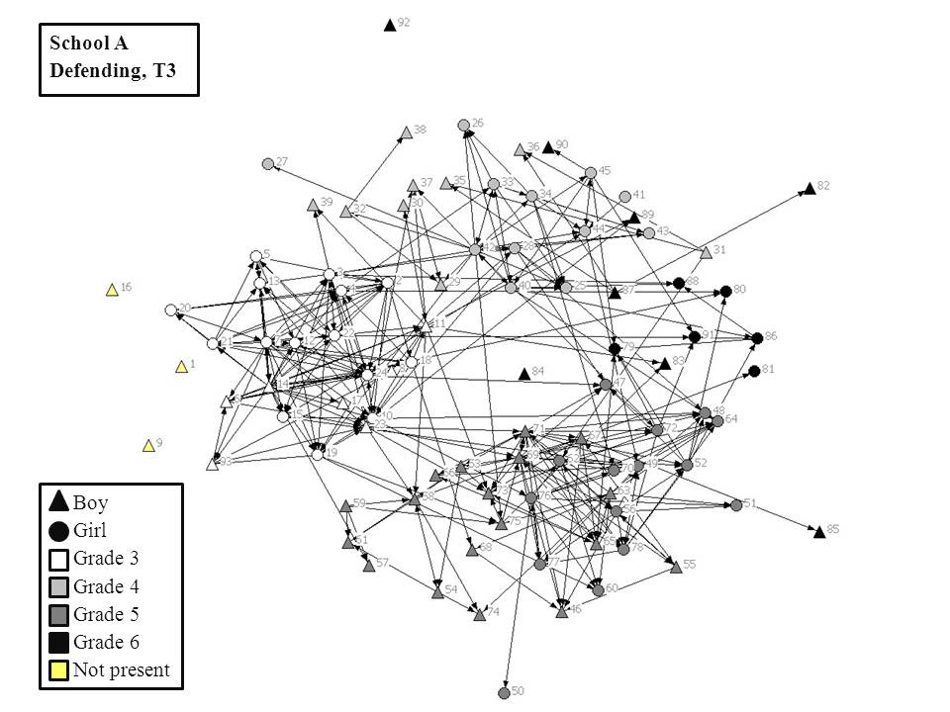

School B
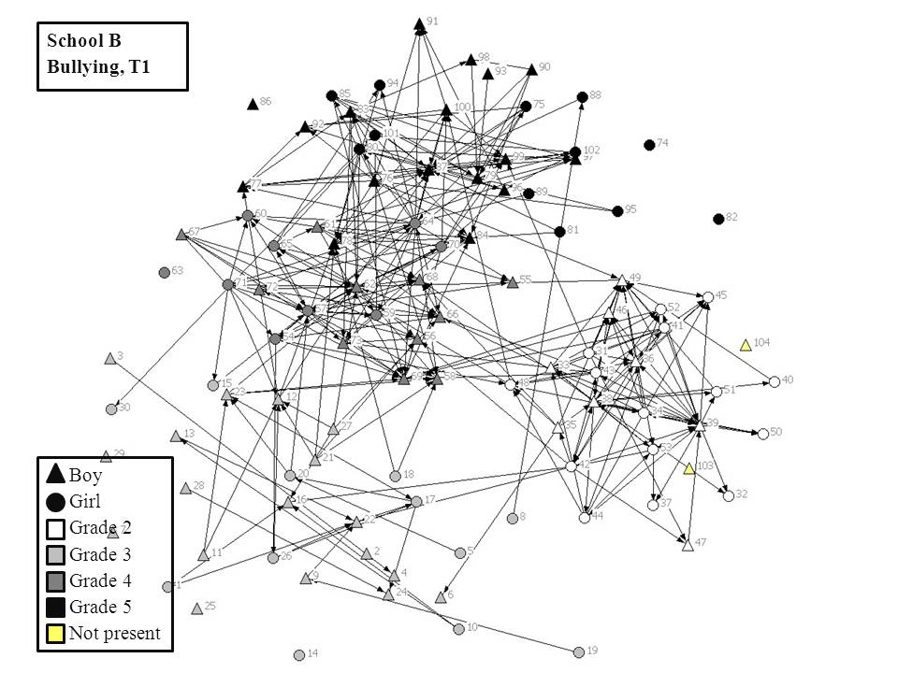 | 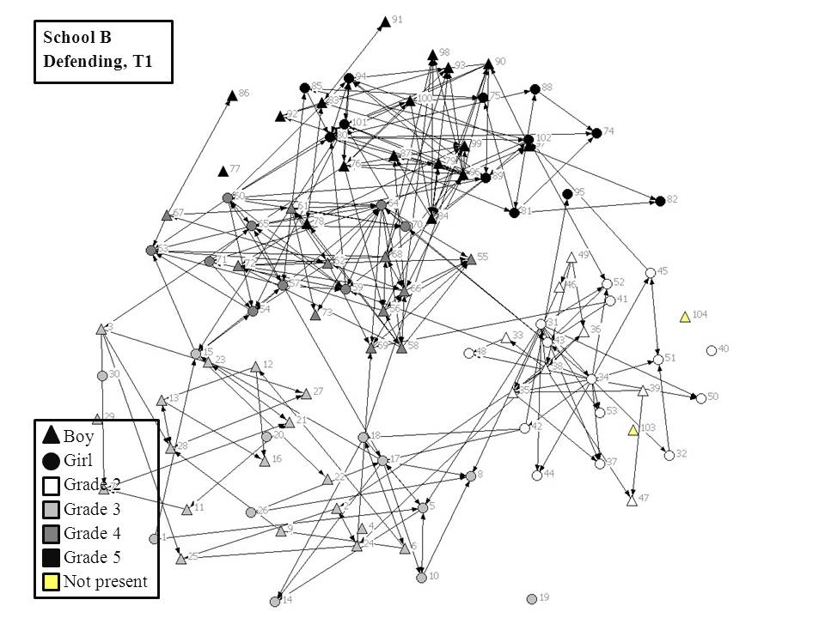
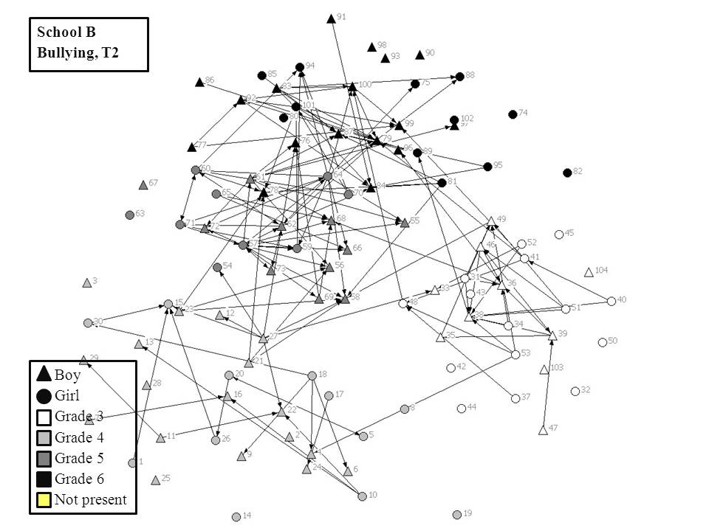 | 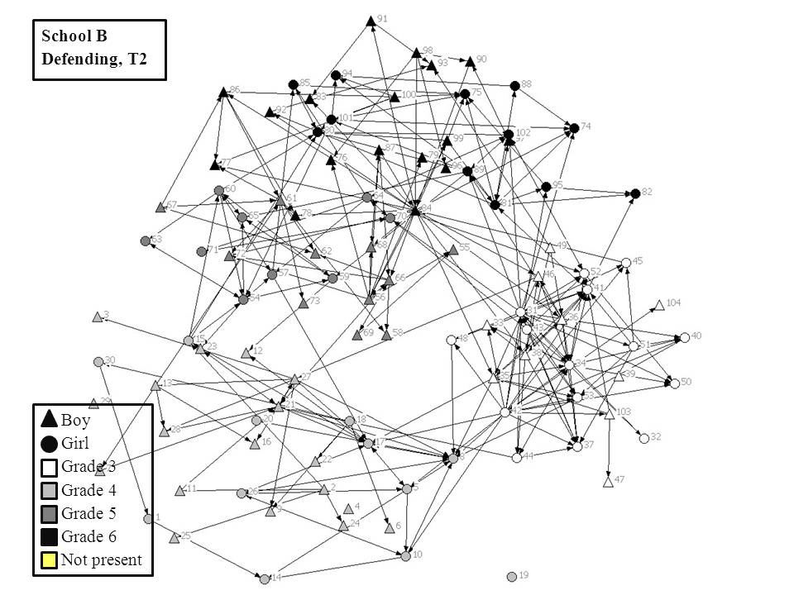
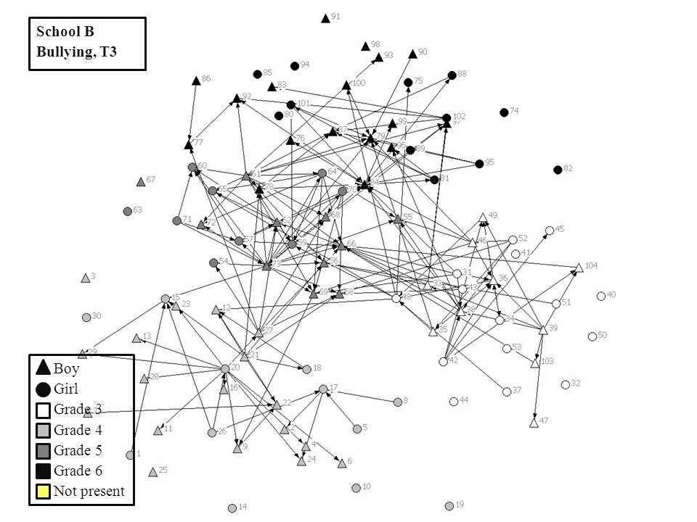 | 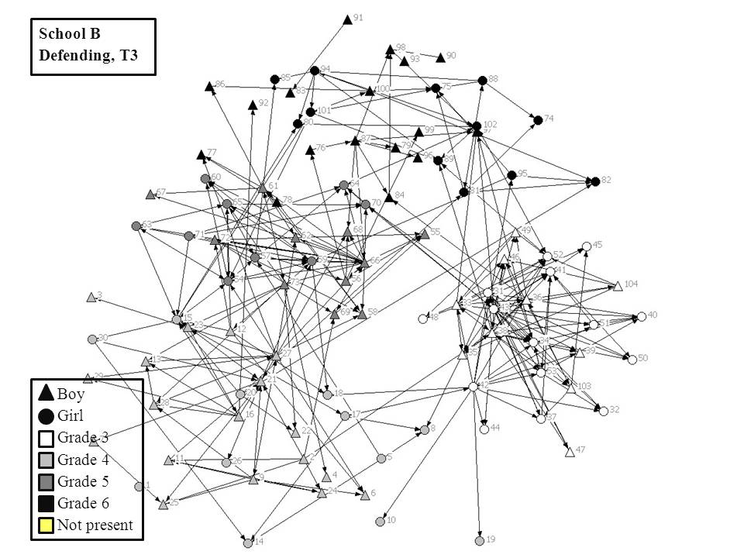

School C
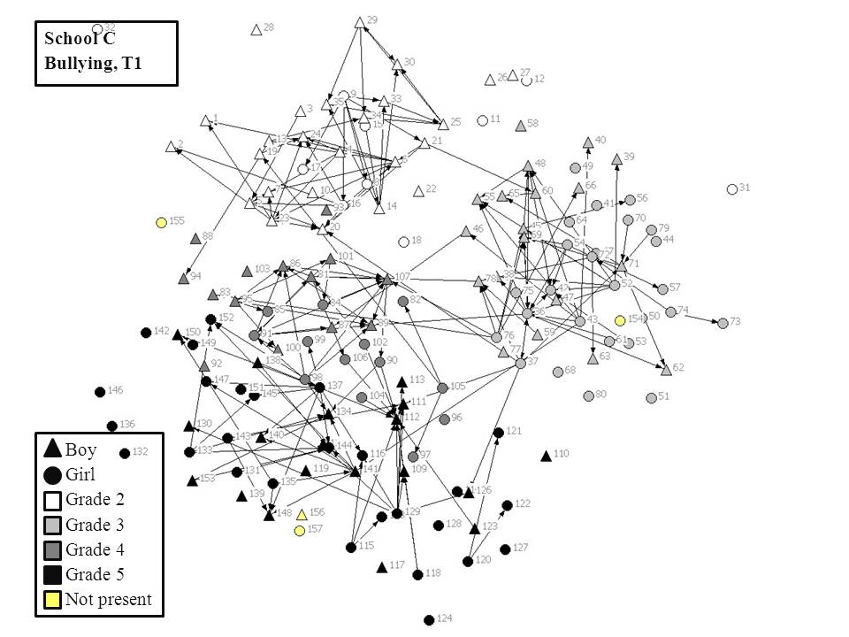 | 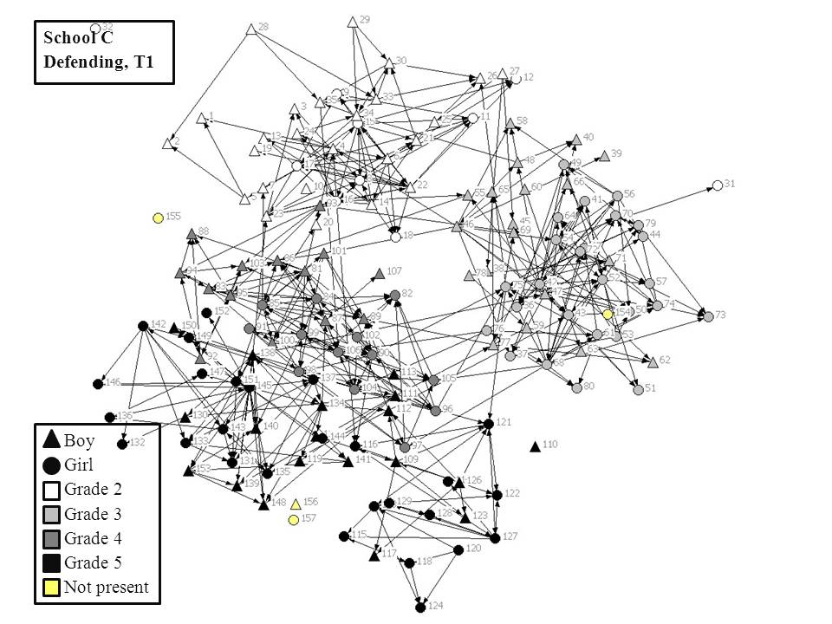
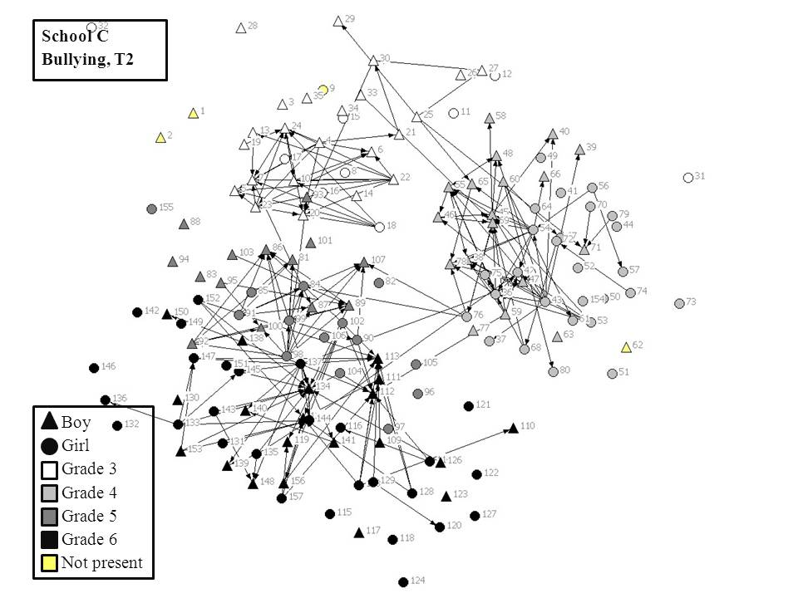 | 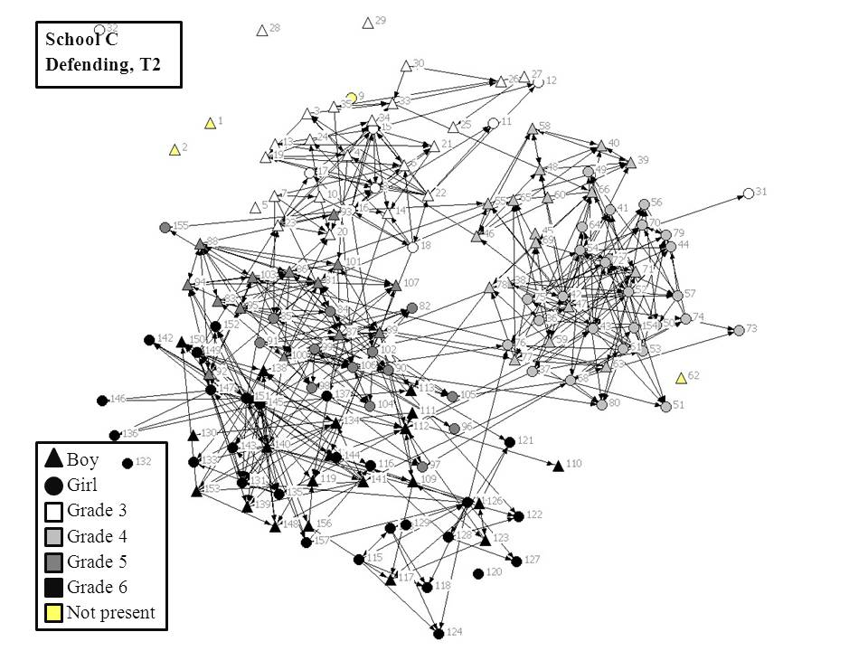
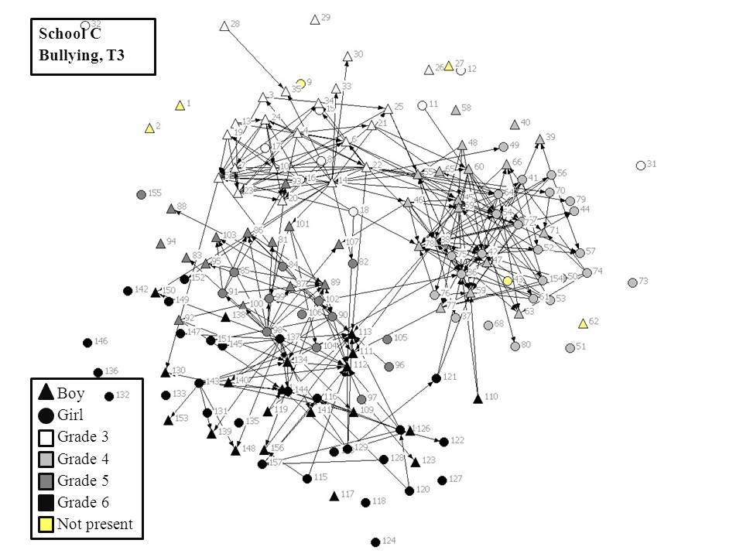 | 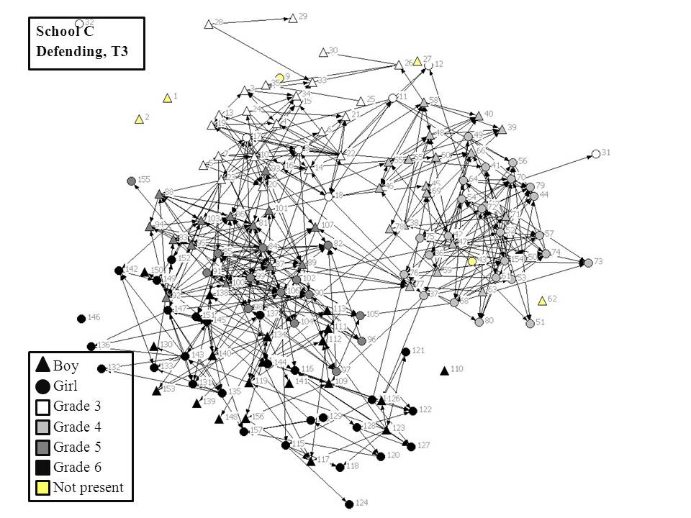

S2: Stochastic Actor-Based Models with RSiena
Interdependent network dynamics for bullying and defending were modeled using stochastic actor-based models (Snijders et al., 2010) by means of the RSiena package (Simulation Investigation for Empirical Network Analysis, version 1.1-251; Ripley, Snijders, & Preciado, 2013). The networks change, unobserved, between the observation moments. The change between the observed time points is modeled. No assumptions have to be made about the determinants of the network structure at the first time point. The model “works” by assuming that at stochastically determined moments, one actor (here: a child) in the model has the opportunity to change one relation (a so-called “micro-step”). An actor does not have to make a change. The sequences of micro-steps result in the observed change from wave to wave. The frequency with which actors have the opportunity to make changes is modeled using the rate function. The advantage of using a model composed of a sequence of many small changes is that instead of specifying the transformation of a network state into a later observed different network, only the probability distribution for the creation and determination of a single relation needs to be specified.
The evaluation of changes by actors is determined using the objective function. The model is actor-based, reflecting the agency of the actors. The objective function is a function of the personal network, as perceived by the focal actors. It expresses how likely it is that the actors will change the network in a particular way. Generally, each actor prefers to move in a direction of higher values for the objective function. The effects in the model (see Model Specification, S3) are incorporated in the objective function. Higher values of (effects in) the objective function can be interpreted as preferences for the creation or maintenance of specific relations.
Students who were not present at a time point (because they had left the school or entered the school in a following wave) were given structural zeros for their relations, specifying that all incoming and outgoing ties were fixed to zero and not allowed to change in the simulations. The parameters in the models can be tested by referring the t-ratio (estimate divided by the standard error) to a standard normal distribution. In all cases, good convergence was obtained, with all t-ratios for convergence less than 0.1 in absolute value, as advised in the RSiena manual (Ripley et al., 2013).

S3: Model Specification: Uniplex parameters
A number of researchers have investigated bullying networks in elementary schools. Recently, Huitsing et al. (2012) examined the structures of bullying networks. Bullying networks are generally expected to have a centralized structure, in which some central bullies target many peers (but usually do not report being victimized themselves), and where some central victims are targeted by many bullies. Another characteristic of bullying networks is that a large number of children are uninvolved (isolates), which means that they are neither victims nor bullies. For bully-victim dyads, one may expect reciprocal bullying (in which two children bully each other) to be relatively unusual because of the power imbalance (bullies exerting power over victims). Nevertheless, in empirical studies on bully-victim dyads researchers have found evidence of reciprocal bullying (Sijtsema et al., 2009; Tolsma, van Deurzen, Stark, & Veenstra, 2013; Veenstra et al., 2007).
Cross-sectional analyses of victim-defender dyads have shown a strong effect for reciprocal defending, meaning that children defended their defenders (Sainio et al., 2011). This is in line with the findings of other research on positive networks; friendships and defending are both relations with a positive interpretation, but they are not completely equivalent: friends may defend each other, whereas defending can take place between children who are not necessarily friends. It is likely that the network dynamics for defending will be in line with the known properties of positive networks (see Veenstra & Steglich, 2012): not only a high degree of reciprocity, but also transitive closure, suggesting that children defend within subgroups of defenders
Parameters
Several effects were included in the model and used to estimate the co-structuration of bullying and defending ties. Effects can be distinguished as structural effects that model how the changes in each network depend on itself and covariate effects that model how changes in each network depend on the attributes of actors. The effects are also explained in S4 of the supplementary materials, including a reference to the RSiena effect names.
For both bullying and defending networks, two basic effects were estimated. The outdegree effect represents the basic tendency to have relations at all, and is related to the density of the network, which is the proportion of existing relations relative to the total number of possible relations. Because most networks are sparse, with a density (far) below 0.5, a negative parameter for the outdegree effect is usually observed. The reciprocity effect was included to model the tendency to prefer reciprocation of a tie.
Two degree-related effects were included for bullying and defending. The indegree-popularity effect implies that, when positive, high indegrees (nominations received) reinforce themselves. This will lead to a relatively high dispersion of the indegrees. The outdegree-activity effect implies that, when positive, nodes with higher outdegrees (nominations given) will have an extra propensity to form ties with others. Experience has shown that these degree-related effects can be better measured using the square roots of the degrees instead of the raw degrees (Snijders et al., 2010), because there may be diminishing returns on increasingly high degrees. The square root leads to decreased variability, especially at high values, which is compensated for larger parameter values. In addition, a substantial number of children were isolates or one-sided isolates (referring to so-called sinks or sources – see also Tables 1a, 1b, and 1c of the paper), meaning that actors had either zero in-ties or zero out-ties, or both. It appears that zero indegrees were satisfactorily estimated using the other effects in the model, but this was not the case for the outdegrees. Therefore, the parameter for zero outdegrees was included, to represent the tendency to be an isolate with respect to outgoing ties. In addition, initial analyses showed that children with defenders were somewhat unlikely to mention only one defender. To account for the tendency to nominate more than one defender, the effect for low outdegrees (1 or 2) was included. To obtain well-converged models for bullying in school C, we added the parameter estimate to model zero or one outdegree.
The network closure (or tendency toward transitivity) of the defending network was modeled in line with earlier investigations into friendship dynamics (Snijders et al., 2010; Veenstra & Steglich, 2012). Two effects were included to model transitivity directly, by investigating whether “intermediaries” (h) would add proportionally to the tendency to form transitive closure (i → h →j; i → j). The first effect (transitivity: 1 intermediary) measured whether at least one intermediary h existed, and extra intermediaries would not further contribute to the tendency to form the tie i → j. The second effect (transitivity: >1 intermediary) modeled that the tie i → j became increasingly likely the more indirect connections (two-paths) i → h →j there were. These two-paths (i → h →j but not i → j) were also added to the model to obtain a reversed transitive measure. Finally, we modelled 3-cycles (i → h → j → i) to investigate whether defending relations were intrinsically non-hierarchical. The other transitivity parameters were in line with hierarchical ordering, because this allows the involved actors to be distinguished and ordered according to the number of relations they received and sent. Because bullying networks usually have a more centralized structure, these closure effects were not included for the bullying networks.

S4: Parameters in the Network Models

Effect | RSiena  effect name | Explanation | Graphical representation
Uniplex Network Effects
Rate function | ~ | The frequency with which actors have the opportunity to make one change
Outdegree | density | Basic tendency to have ties
Reciprocity | recip | Tendency toward reciprocation |  | →
Indegree-popularity | inPopSqrt | Reinforcing or maintaining process: Actors with high indegrees will receive more nominations, leading to a dispersed distribution of the indegrees. |  | →
Outdegree-activity | outActSqrt | Reinforcing or maintaining process: Actors with high outdegrees will give more nominations, leading to a dispersed distribution of the outdegrees. |  | →
Transitivity  (1 intermediary) | transTies | Transitive closure (i → h →j; i → j) when at least one intermediary h exists. Extra intermediaries will not further contribute to the tendency to form the tie i → j |  | →
Transitivity  (>1 intermediary) | transTrip | Transitive closure (i → h →j; i → j): More intermediaries h add proportionally to the tendency to form tie i → j.
3-Cycles | cycle3 | Tendency toward generalized exchange in a non-hierarchial setting |  | →
Two-paths | nbrDist2 | Tendency for actors to keep others at a distance (converse of transitive closure) |  | →
Zero outdegrees | outTrunc (1) | Tendency to be an isolate with respect to outgoing ties
Zero or one outdegree | outTrunc (2) | Tendency to nominate, but not more than one actor
Low outdegrees (1 or 2) | outTrunc (3) | Tendency to nominate, but not more than two actors

(Table continues on next page)

Table S4 (continued)
Effect | RSiena  effect name | Explanation | Graphical representation
Multiplex Dyadic Network Effects
W → X | crprod | Effect of a tie in network W on a tie in network X (for same dyad i → j) |  | →
Multiplex Degree-related Network Effects
Indegree W → Indegree X | inPopIntn | Effect of indegree in network W on indegree in network X |  | →
Outdegree W → Outdegree X | outActIntn | Effect of outdegree in network W on outdegree in network X |  | →
Outdegree W → Indegree X | inPopIntn | Effect of outdegree in network W on indegree in network X |  | →
Multiplex triadic Network Effects
Agreement in W → X | from | Agreement of actors with respect to their W choices. The contribution of the tie X is proportional to the number of joint W choices. |  | →
W leading to agreement along X | to | Actors have the tendency to make the same outgoing X choices as those with whom they have a W tie. |  | →
Closure of shared incoming ties | sharedIn | Shared incoming W ties contribute to the tie X. |  | →
W leading to incoming ties for X | cl.XWX | Tendency toward closure of mixed X → W two-paths through a tie X. |  | →
Actor covariate effects
Sender effect | egoX | Actors with higher values on X have a higher outdegree
Receiver effect | altX | Actors with higher values on X have a higher indegree
Similarity effect | simX | Ties occur more often between actors with similar values on X
Note. Network “W” refers to the independent network; network “X” refers to the dependent network.

S5: Table: Uniplex RSiena analyses for bullying

Parameter | Statistic |  |  | Parameters  School A  (N = 93) |  | Parameters  School B  (N = 104) |  | Parameters  School C  (N = 157) |  | Fisher’s test  (df = 6)
 |  |  |  | Est. | Std. Err. | Est. | Std. Err. | Est. | Std. Err. | Left-sided χ² | Right-sided χ²
Bullying: Network effects
Rate function (period 1) |  |  |  | 15.00 | (2.55) | 14.31 | (1.58) | 10.94 | (1.29)
Rate function (period 2) |  |  |  | 11.31 | (1.90) | 12.98 | (1.71) | 13.21 | (1.59)
Outdegree |  |  |  | -3.79 | (0.36)** | -4.50 | (0.29)** | -5.72 | (0.32)** | 685 ** | 0
Outdegree: Time dummy |  |  |  |  |  | 0.41 | (0.10)**
Reciprocity |  | → |  | 0.98 | (0.25)** | 0.60 | (0.19)** | 0.57 | (0.21)** | 0 | 46**
Indegree-popularity |  | → |  | 0.44 | (0.09)** | 0.57 | (0.07)** | 0.71 | (0.07)** | 0 | 217**
Outdegree-activity |  | → |  | 0.20 | (0.08)* | 0.23 | (0.05)** | 0.44 | (0.07)** | 0 | 76**
Zero outdegrees |  |  |  | 2.71 | (0.39)** | 2.60 | (0.31)** | 4.28 | (0.47)** | 0 | 220**
Zero or one outdegree |  |  |  |  |  |  |  | -1.22 | (0.35)**
Bullying: Covariates
Boy: Receiver |  |  |  | 0.66 | (0.14)** | 0.40 | (0.10)** | 0.37 | (0.09)** | 0 | 75**
Boy: Sender |  |  |  | -0.44 | (0.12)** | -0.15 | (0.09) | 0.05 | (0.07) | 24** | 2.8
Boy: Similarity |  |  |  | 0.38 | (0.13)** | 0.27 | (0.10)** | -0.07 | (0.08) | 3 | 24**
Grade: Receiver |  |  |  | 0.20 | (0.15) | 0.61 | (0.14)** | 0.38 | (0.11)** | 0.2 | 45**
Grade: Sender |  |  |  | -0.12 | (0.15) | -0.74 | (0.15)** | -0.40 | (0.11)** | 51** | 0.4
Grade: Similarity |  |  |  | 4.22 | (0.59)** | 4.61 | (0.55)** | 6.01 | (0.44)** | 0 | 324**
Age: Receiver |  |  |  | 0.10 | (0.11) | 0.06 | (0.08) | 0.05 | (0.07) | 1.5 | 9
Age: Sender |  |  |  | -0.30 | (0.11)** | 0.08 | (0.08) | -0.09 | (0.07) | 17** | 4
Age: Similarity |  |  |  | -0.65 | (0.63) | -0.10 | (0.46) | -0.48 | (0.46) | 9 | 1.7
.

S6: Table: Uniplex RSiena analyses for defending
Defending: Network effects
Rate function (period 1) |  |  |  | 21.06 | (2.81) | 14.61 | (1.44) | 20.73 | (1.58)
Rate function (period 2) |  |  |  | 20.18 | (2.52) | 18.23 | (1.97) | 20.23 | (1.76)
Outdegree (density) |  |  |  | -2.97 | (0.33)** | -3.45 | (0.30)** | -2.40 | (0.24)** | 331** | 0
Reciprocity |  | → |  | 1.05 | (0.15)** | 1.01 | (0.15)** | 1.54 | (0.13)** | 0 | 251**
Transitivity (1 intermediary) |  | → |  | 0.41 | (0.12)** | 0.61 | (0.13)** | 0.53 | (0.08)** | 0 | 94**
Transitivity (>1 intermediary) |  |  |  | 0.26 | (0.05)** | 0.08 | (0.07) | 0.37 | (0.04)** | 0 | 127**
Transitivity * reciprocity |  |  |  |  |  |  |  | -0.48 | (0.09)**
3-cycles |  | → |  | -0.54 | (0.10)** | -0.51 | (0.13)** | -0.15 | (0.07)* | 66** | 0
Two-paths |  | → |  | -0.09 | (0.02)** | -0.09 | (0.02)** | -0.17 | (0.02)** | 129** | 0
Indegree-popularity |  | → |  | -0.18 | (0.09)* | -0.02 | (0.08) | -0.10 | (0.06) | 15* | 1.2
Outdegree-activity |  | → |  | 0.20 | (0.06)** | 0.29 | (0.06)** | -0.02 | (0.04) | 2 | 49**
Zero outdegrees |  |  |  | 4.62 | (0.65)** | 3.27 | (0.39)** | 4.27 | (0.39)** | 0 | 256**
Low outdegrees (1 or 2) |  |  |  | -1.42 | (0.30)** | -0.83 | (0.20)** | -0.78 | (0.20)** | 68** | 0
Defending: Covariates
Boy: Receiver |  |  |  | -0.30 | (0.09)** | -0.33 | (0.09)** | 0.06 | (0.06) | 36** | 4
Boy: Sender |  |  |  | 0.24 | (0.08)** | 0.23 | (0.08)** | 0.00 | (0.06) | 1.3 | 25
Boy: Similarity |  |  |  | 0.72 | (0.09)** | 0.75 | (0.08)** | 0.56 | (0.06)** | 0 | 269**
Grade: Receiver |  |  |  | 0.38 | (0.10)** | 0.14 | (0.07) | 0.13 | (0.07)* | 0 | 32**
Grade: Sender |  |  |  | -0.43 | (0.10)** | -0.07 | (0.08) | -0.19 | (0.07)** | 40** | 0.4
Grade: Similarity |  |  |  | 3.86 | (0.39)** | 2.59 | (0.30)** | 2.67 | (0.26)** | 0 | 297**
Age: Receiver |  |  |  | -0.11 | (0.08) | -0.03 | (0.06) | 0.02 | (0.05) | 8 | 3
Age: Sender |  |  |  | 0.03 | (0.07) | -0.11 | (0.06) | 0.01 | (0.05) | 8.7 | 4
Age: Similarity |  |  |  | -0.94 | (0.40)* | 0.37 | (0.36) | -0.35 | (0.30) | 13.7* | 4

S7: Table: Complete results of the multiplex RSiena analyses for bullying and defending

Parameter | Statistic |  |  | Parameters  School A  (N = 93) |  | Parameters  School B  (N = 104) |  | Parameters  School C  (N = 157) |  | Fisher’s test  (df = 6)
 |  |  |  | Est. | Std. Err. | Est. | Std. Err. | Est. | Std. Err. | Left-sided χ² | Right-sided χ²
Bullying: Network effects
Rate function (period 1) |  |  |  | 15.75 | (2.98) | 14.37 | (1.89) | 10.13 | (1.33)
Rate function (period 2) |  |  |  | 10.40 | (2.06) | 12.54 | (1.78) | 14.68 | (1.93)
Outdegree |  |  |  | -2.99 | (0.48)** | -3.79 | (0.41)** | -4.58 | (0.41)** | 267 ** | 0
Outdegree: Time dummy |  |  |  |  |  | 0.49 | (0.13)**
Reciprocity |  | → |  | 1.05 | (0.29)** | 0.66 | (0.24)** | 0.54 | (0.24)* | 0 | 38**
Indegree-popularity |  | → |  | 0.24 | (0.19) | 0.42 | (0.12)** | 0.52 | (0.10)** | 0.2 | 54**
Outdegree-activity |  | → |  | -0.06 | (0.14) | -0.04 | (0.10) | 0.14 | (0.11) | 5 | 6
Zero outdegrees |  |  |  | 2.83 | (0.48)** | 2.64 | (0.44)** | 4.55 | (0.46)** | 0 | 186**
Zero or one outdegree |  |  |  |  |  |  |  | -1.08 | (0.40)**
Bullying: Covariates
Boy: Receiver |  |  |  | 0.59 | (0.23)** | 0.35 | (0.15)* | 0.25 | (0.09)** | 0 | 31**
Boy: Sender |  |  |  | -0.48 | (0.17)** | -0.22 | (0.12) | 0.07 | (0.09) | 19** | 3.3
Boy: Similarity |  |  |  | 0.33 | (0.15)* | 0.34 | (0.12)** | -0.07 | (0.08) | 3 | 21**
Grade: Receiver |  |  |  | 0.09 | (0.17) | 0.59 | (0.18)** | 0.36 | (0.12)** | 0 | 30**
Grade: Sender |  |  |  | -0.02 | (0.17) | -0.71 | (0.18)** | -0.35 | (0.13)** | 33** | 1
Grade: Similarity |  |  |  | 3.30 | (0.71)** | 4.01 | (0.68)** | 4.57 | (0.50)** | 0 | 156**
Age: Receiver |  |  |  | 0.23 | (0.14) | 0.13 | (0.10) | 0.06 | (0.08) | 1 | 14*
Age: Sender |  |  |  | -0.39 | (0.14)** | 0.05 | (0.10) | -0.11 | (0.08) | 17** | 2.5
Age: Similarity |  |  |  | -0.45 | (0.69) | -0.06 | (0.53) | -0.44 | (0.54) | 7 | 2.3

(Table continues on next page)
Table S7 (continued)
Defending: Network effects
Rate function (period 1) |  |  |  | 20.10 | (2.81) | 13.83 | (1.80) | 21.73 | (2.11)
Rate function (period 2) |  |  |  | 19.41 | (2.70) | 18.55 | (2.58) | 19.61 | (1.72)
Outdegree (density) |  |  |  | -2.41 | (0.52)** | -3.72 | (0.34)** | -2.79 | (0.25)** | 279** | 0
Reciprocity |  | → |  | 1.05 | (0.16)** | 0.94 | (0.18)** | 1.50 | (0.13)** | 0 | 215**
Transitivity (1 intermediary) |  | → |  | 0.40 | (0.12)** | 0.60 | (0.15)** | 0.60 | (0.09)** | 0 | 84**
Transitivity (>1 intermediary) |  |  |  | 0.27 | (0.06)** | 0.05 | (0.08) | 0.32 | (0.04)** | 0 | 91**
Transitivity * reciprocity |  |  |  |  |  |  |  | -0.49 | (0.09)**
3-cycles |  | → |  | -0.55 | (0.10)** | -0.53 | (0.14)** | -0.16 | (0.07)* | 63** | 0
Two-paths |  | → |  | -0.11 | (0.03)** | -0.09 | (0.02)** | -0.16 | (0.02)** | 111** | 0
Indegree-popularity |  | → |  | -0.30 | (0.14)* | 0.01 | (0.09) | -0.09 | (0.06) | 14.6* | 1.7
Outdegree-activity |  | → |  | 0.15 | (0.07)* | 0.33 | (0.06)** | 0.05 | (0.05) | 0 | 47**
Zero outdegrees |  |  |  | 4.65 | (0.64)** | 3.26 | (0.44)** | 4.24 | (0.43)** | 0 | 223**
Low outdegrees (1 or 2) |  |  |  | -1.43 | (0.31)** | -0.86 | (0.22)** | -0.90 | (0.20)** | 72** | 0
Defending: Covariates
Boy: Receiver |  |  |  | -0.45 | (0.18)* | -0.36 | (0.10)** | 0.03 | (0.07) | 27** | 2.3
Boy: Sender |  |  |  | 0.07 | (0.14) | 0.22 | (0.09)* | -0.01 | (0.07) | 2.3 | 13.5*
Boy: Similarity |  |  |  | 0.72 | (0.09)** | 0.77 | (0.09)** | 0.56 | (0.06)** | 0 | 240**
Grade: Receiver |  |  |  | 0.40 | (0.12)** | 0.14 | (0.08) | 0.11 | (0.07) | 0 | 28**
Grade: Sender |  |  |  | -0.38 | (0.12)** | -0.05 | (0.08) | -0.20 | (0.07)** | 30** | 0.5
Grade: Similarity |  |  |  | 3.69 | (0.41)** | 2.55 | (0.32)** | 2.47 | (0.27)** | 0 | 243**
Age: Receiver |  |  |  | -0.16 | (0.10) | -0.03 | (0.07) | 0.05 | (0.05) | 8.2 | 4
Age: Sender |  |  |  | -0.01 | (0.10) | -0.13 | (0.06)* | 0.01 | (0.05) | 10 | 3
Age: Similarity |  |  |  | -0.73 | (0.40) | 0.39 | (0.39) | -0.19 | (0.31) | 9.8 | 4.4
(Table continues on next page)
Table S7 (continued)

Dyadic multiplex effects
Defending → Bullying |  | → |  | 0.29 | (0.38) | -0.57 | (0.55) | -0.11 | (0.37) | 6.2 | 4.2
Bullying → Defending |  | → |  | 0.09 | (0.52) | -1.26 | (0.84) | -0.16 | (0.34) | 8.8 | 2.6
Degree-related multiplex effects
Indegree defending → Indegree bullying |  | → |  | -0.03 | (0.27) | -0.20 | (0.21) | -0.54 | (0.14)** | 24** | 1.6
Outdegree defending → Indegree bullying |  | → |  | -0.08 | (0.17) | -0.18 | (0.13) | -0.06 | (0.12) | 9.6 | 1.7
Outdegree defending → Outdegree bullying |  | → |  | -0.01 | (0.09) | 0.09 | (0.08) | -0.08 | (0.06) | 6.3 | 5.5
Indegree bullying → Indegree defending |  | → |  | 0.15 | (0.21) | 0.02 | (0.10) | -0.08 | (0.07) | 5.6 | 4.8
Outdegree bullying → Indegree defending |  | → |  | 0.22 | (0.15) | -0.04 | (0.08) | -0.08 | (0.07) | 6.8 | 6.3
Outdegree bullying → Outdegree defending |  | → |  | 0.12 | (0.08) | -0.10 | (0.07) | 0.00 | (0.05) | 7.1 | 6.7

(Table continues on next page)

Table S7 (continued)

Mixed triadic multiplex effects
Defending others → being victimized |  | → |  | 0.40 | (0.23) | 0.25 | (0.23) | 0.55 | (0.14)** | 0 | 30**
Being victimized → defending same victims |  | → |  | -0.35 | (0.32) | 0.28 | (0.10)** | 0.17 | (0.08)* | 4.1 | 20**
Being a bully → defending same bullies |  | → |  | 0.02 | (0.25) | 0.21 | (0.14) | 0.43 | (0.10)** | 1.4 | 29**
Defending a bully → Bullying bully’s victim |  | → |  | 0.38 | (0.13)** | 0.52 | (0.11)** | 0.41 | (0.07)** | 0 | 80**

Note. * p < .05. ** p < .01. Dotted lines indicate bully-victim relations; solid lines indicate defending relations in the graphical representations of the (multiplex) parameters.

S8: Results: Bullying and defending parameters in the uniplex and multiplex models
Before estimating combined models for bullying and defending, we estimated uniplex models to examine these relations on their own (see supplementary materials S5 and S6). The parameter estimates of the effects in the uniplex models were highly comparable with the parameter estimates in the multiplex model. Therefore, we discuss only the multiplex estimations that are given in supplementary material S7.
Bullying Dynamics
The first part of the table in S7 gives the estimates for the bullying network. The outdegree was estimated negatively. As a consequence of the relatively high bullying rate at T1 for school B, it was necessary to include a time dummy for the outdegree to have well-converged rate parameters. In line with earlier findings, the development of bullying relations showed a tendency towards reciprocation of bullying.
RSiena allows investigation of whether effects operate at different strengths for the creation or maintenance of relations. A creation effect would mean that children respond to bullying by bullying (thus, striking back at the bully); a maintenance effect would mean that reciprocal relations endure. Testing for differences in the creation or maintenance of reciprocal bullying relations only revealed significant differences for school B. There was a positive creation effect (b = 3.44, SE = 0.61, p < .01) and a very strong negative maintenance effect (b = 19.9, SE = 2.95, p < .01). The latter effect, however, should be interpreted in the light of the significant drop in bullying ties from T1 to T2.
The indegree-popularity for bullying was estimated positively, which means that children who were nominated as bullies also received several nominations for bullying over time. Thus, at the actor level, bullying was quite stable. The parameter for the outdegree-activity suggests that the number of outgoing bullying ties (being victimized) was not predictive over time for giving several nominations for bullying. The effect for zero outdegrees showed that many children had and kept zero out-ties.
Defending Dynamics
The network dynamics for defending (see the second part of Table S7) were in line with the known properties of positive networks: there was a high degree of reciprocity, as seen in the significant reciprocity parameter, and there was evidence for transitive closure, as seen in the significant effects for transitivity (positive) and two-paths (negative). This suggests that children defend within subgroups of defenders.
With regard to the transitivity effects, it was found that one intermediary h had the largest effect on transitive closure (i → h →j; i → j), but extra intermediaries also contributed to the tie i → j. The negative effect for 3-cycles shows that there was a tendency for the defending networks to be hierarchically ordered. In order to obtain acceptable GoF statistics for the triad census, it was necessary to include an interaction of transitivity with reciprocity in school C. When this effect was not included in the model, the number of reciprocal relations in transitive triads was not well estimated.
Being defended was stable over time: children who were defended were likely to keep several defenders over time (outdegree-activity), whereas being nominated as a defender was unrelated to being nominated as defender over time (non-significant indegree-popularity). The effect for zero outdegrees showed that many children had and kept zero out-ties, and a similar effect for low outdegrees showed that children were unlikely to nominate a small number of defenders.
Gender and Grade
A receiver effect for bullying was found for boys, suggesting that boys were more likely to become bullies. Moreover, a sender effect suggests that girls were somewhat more likely to be victimized. A similarity effect was also found for gender.
Defending was strongly gender-segregated (similarity effect). Boys nominated somewhat more defenders than girls (the significant sender effect for boy in school B), but girls were more likely to be nominated as defenders (negative receiver effect for boy).
A strong effect for grade similarity for bullying was found (children in the same grade were more likely to be nominated as bullies than children from other grades); and children in higher grades were more likely to be nominated as bullies (receiver effect for grade), whereas children in lower grades were more likely to be victimized (negative sender effect for grade). Comparable effects were found for defending.

S9: Goodness of Fit (GoF) statistics: Introduction and explanation
The Goodness of Fit Statistics (GoF) were calculated using SienaGOF for four network indices: 1) the distribution of the nominations received (indegrees), 2) the distribution of the nominations given (outdegrees), 3) the geodesic distances in the networks, and 4) the triad census, all for bullying and defending.
A graphical representation of the GoF for the network indices is given in a plot. The plots show through the red line the observed values for each network, summed over all waves except the first. For example, for the indegree distribution, the sum over waves 2 and 3 of the numbers of actors with indegree 0 for bullying is 82 in school A (see the first figure in S10). The rest of the plot refers to the simulated network. The so-called violin plots combine box plots with smoothed density plots (using a kernel density estimate). The dotted band is a pointwise 90% relative frequency region calculated for the simulated data. The data should be within the band; this is confirmed by a p-value larger than .05.
Next to the indegree and outdegree distributions, the distribution of the geodesic distance in the network is given. The geodesic distance is the shortest path between two actors in a network. If actors are not connected (neither directly nor indirectly through others), the distance between them is infinite (or undefined). It is for this reason that the geodesic distances are much larger in the bullying network than in the defending network: the bullying network is sparser with fewer network closure patterns, leading to many unconnected actors.
The triad census is a set of the different kinds of triads – relations between three actors. Wasserman and Faust (1994, p. 564-568) state that there are sixteen isomorphism classes for the sixty-four different triads that may exist. The possible triads can be labeled according to the following scheme:
- The number of mutual dyads (M) in the triad;
- The number of asymmetric (A) dyads in the triad;
- The number of null (N) dyads (or empty dyads) in the triad;
- A character to distinguish further among the types: T is for Transitivity; C is for Cyclic; U is for Up; and D is for Down.
This labeling scheme is also called the M-A-N scheme. The following table provides the 16 different M-A-N triads, corresponding to the triads in the triad census of the GoF plots.

Table S4.1: M-A-N Triads in Triad Census

Number of ties in the triad
0 | 003
1 | 012
2 | 102 | 021D | 012U | 012C
3 | 111D | 111U | 030T | 030C
4 | 201 | 120D | 120U | 120C
5 | 210
6 | 300

Results of the Goodness of Fit Statistics
The goodness of fit of the models can be considered acceptable for almost all of the inspected network indices (see S10-S12). The observed data (red line) fall mostly within the simulated data distribution, as can be seen in the figures and is confirmed by (most) p-values larger than .05.
In order to obtain well-fitting models, i.e., models that represent important network characteristics sufficiently well, some extra parameters had to be included. For example, for all schools, the outdegree distribution of the defending network was initially not fitted well, requiring additional parameters for the zero and one or two outdegrees. Moreover, for some schools we had to include specific parameters in the model in order to obtain an acceptable fit (e.g., zero or one outdegree for the bullying networks of school C, and a time dummy for the outdegree for the bullying networks of school B).
Using the current parameterization in the models, the GoF statistics were satisfactory for the distributions of the indegrees and outdegrees of both the bullying and the defending networks, as well as for the geodesic distances in these networks. For the bullying networks, the triad census was represented adequately by the model, but this was not the case for the triad census in the defending networks. It appeared that the transitive triads (030T, see Table S4.1) were somewhat underestimated, implying that more transitive triads were observed in the data than predicted using the estimated models, despite the inclusion of several parameters to capture the transitive structure in the networks.
It was unexpected that the parameters that are often used to model positive networks did not provide well-fitting models for defending, given that defending networks were expected to have a network structure comparable to that of friendship networks. We can think of several substantive and methodological explanations for this finding. First, defending networks may be more different from friendship networks than we assumed, as almost all children have friends but a substantial number of children do not need defenders. Second, the GoF statistics have only recently become available in RSiena, and were, therefore, not used regularly before. Previous studies on positive networks may have had similar yet undetected problems, and may have needed to include extra parameters to obtain well-fitting models. Third, in this study of three schools, the findings may have occurred by chance and are not necessarily generalizable to other samples or studies. Further research is necessary to confirm the validity of these explanations.

S10: Goodness of Fit statistics for the uniplex models for bullying
 | School A | School B | School C
Indegrees | 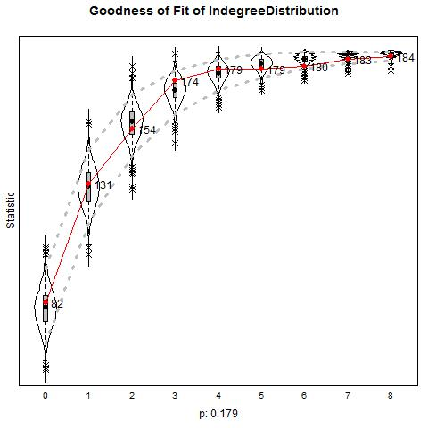 | 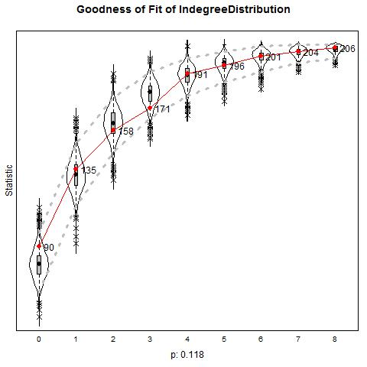 | 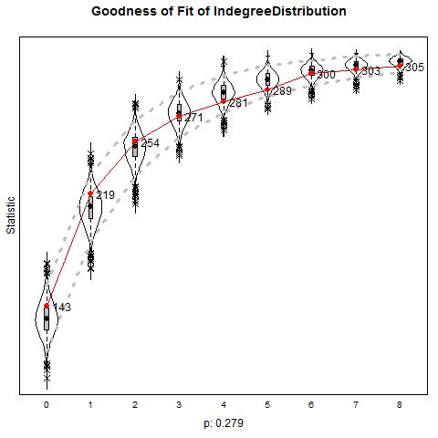
Outdegrees | 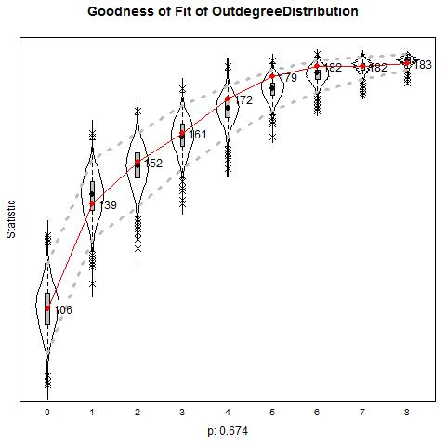 | 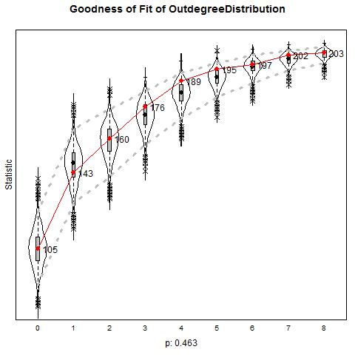 | 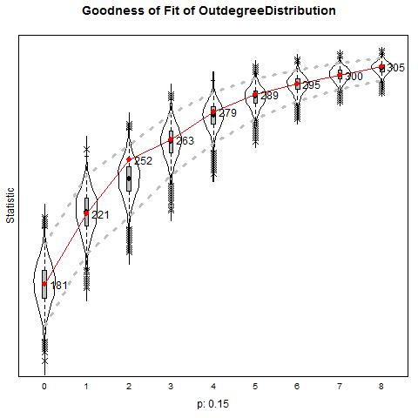

 | School A | School B | School C
Geodesic distance | 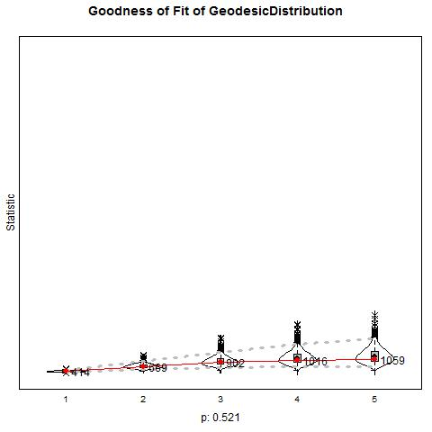 | 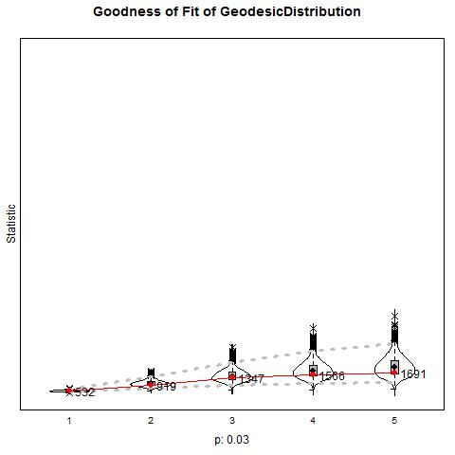 | 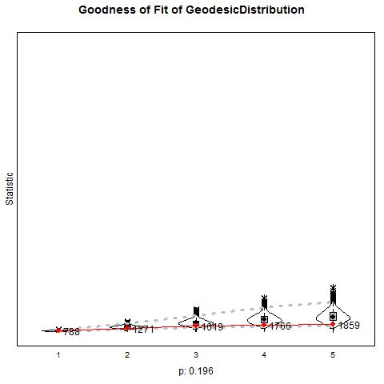
Triad census | 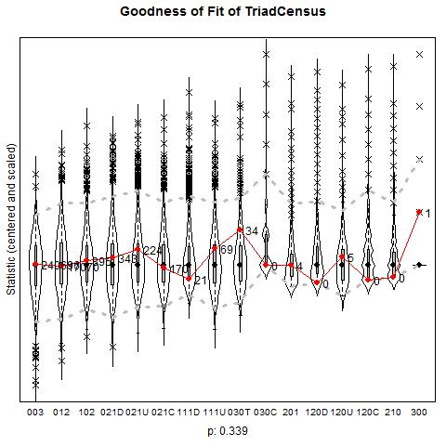 | 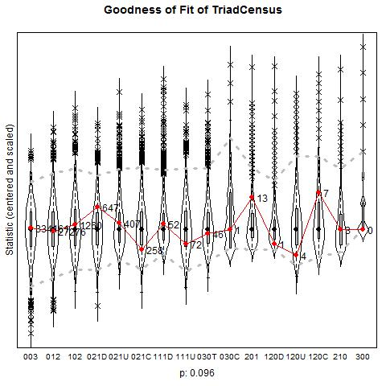 | 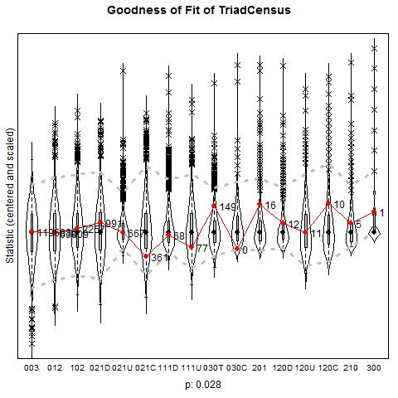

S11: Goodness of Fit statistics for the uniplex models for defending

 | School A | School B | School C
Indegrees | 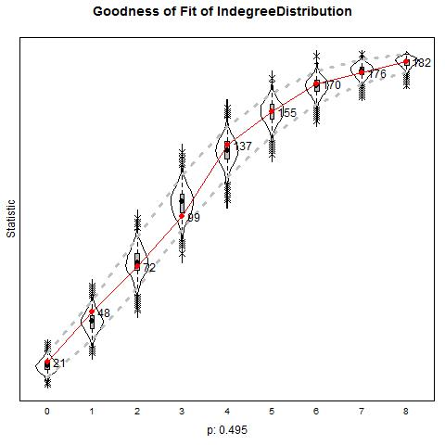 | 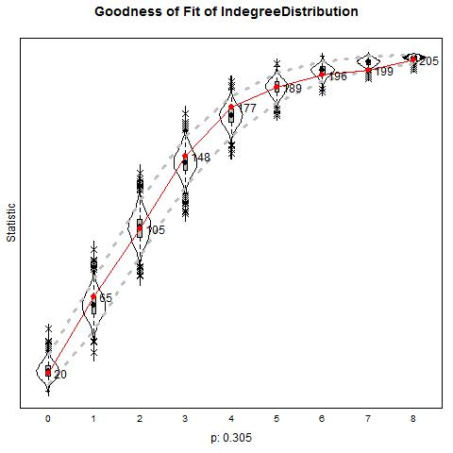 | 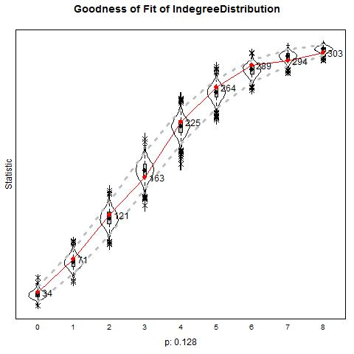
Outdegrees | 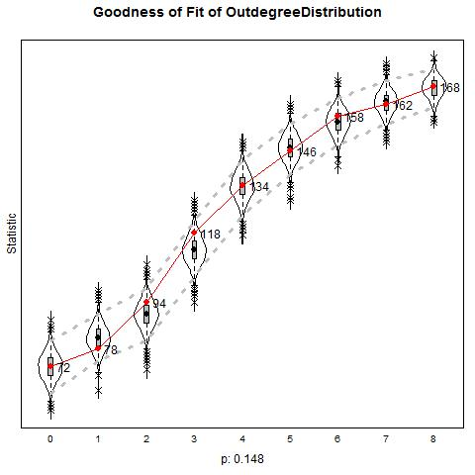 | 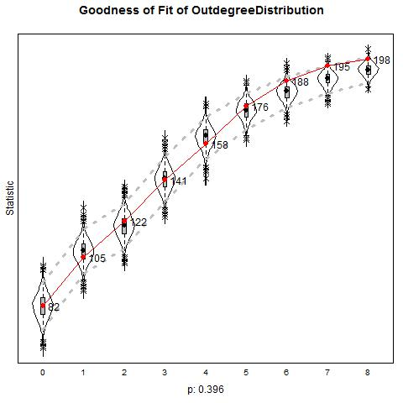 | 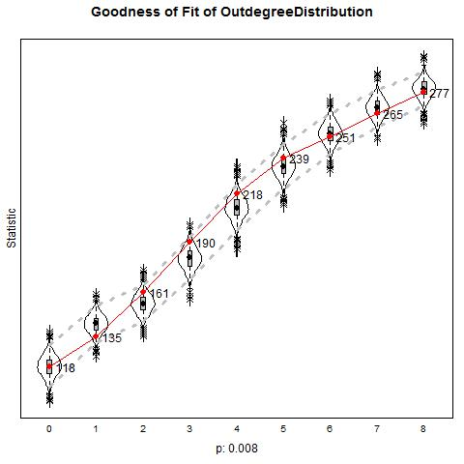

 | School A | School B | School C
Geodesic distance | 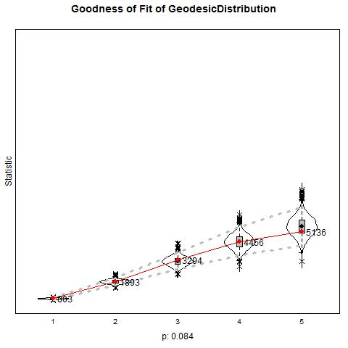 | 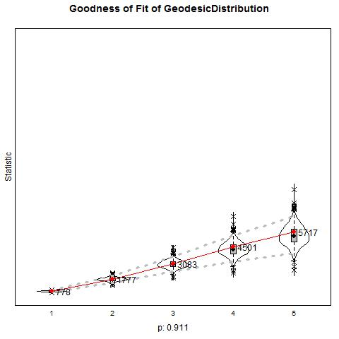 | 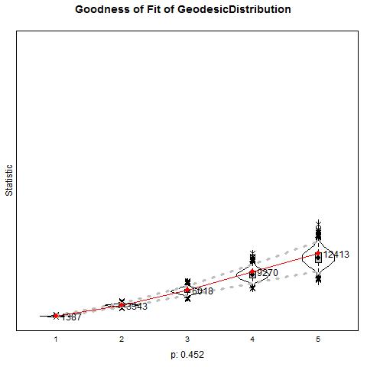
Triad census | 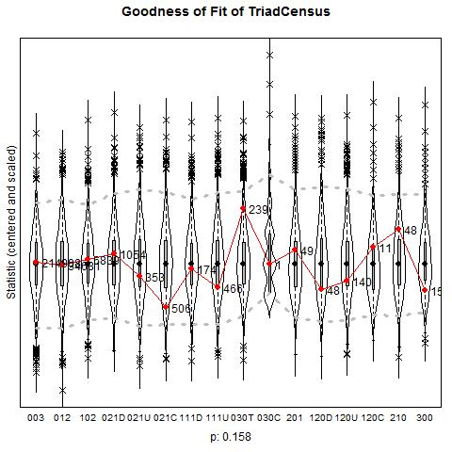 | 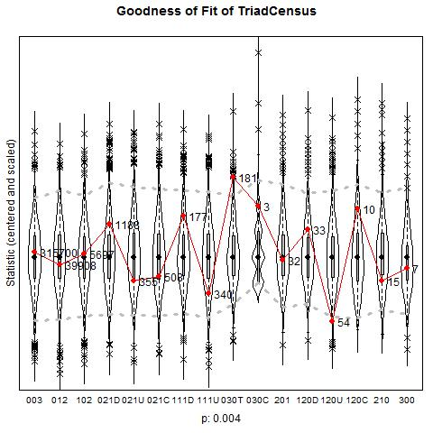 | 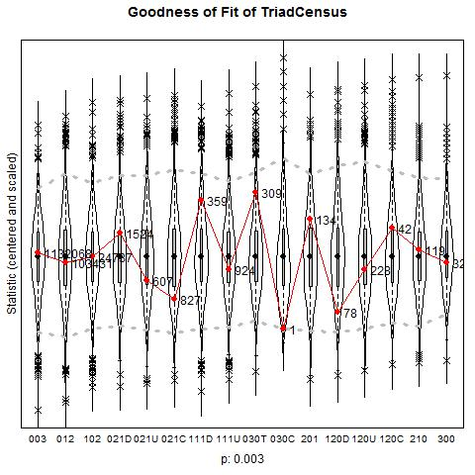

S12: Goodness of Fit statistics for the multiplex models for bullying and defending
 | School A
 | Bullying | Defending
Indegrees | 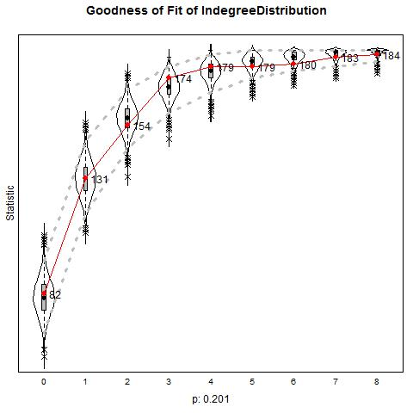 | 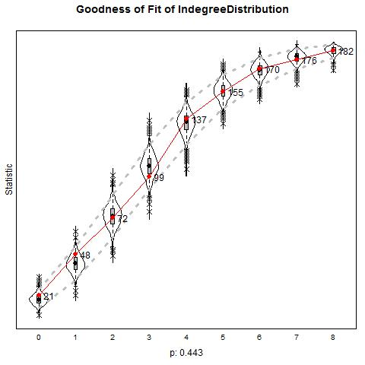
Outdegrees | 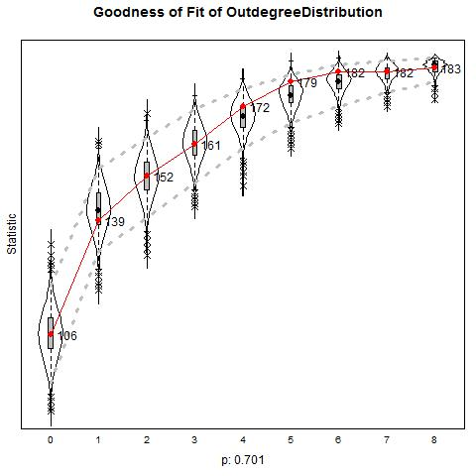 | 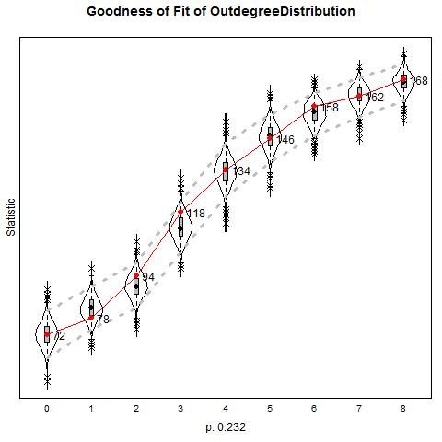
Geodesic distance | 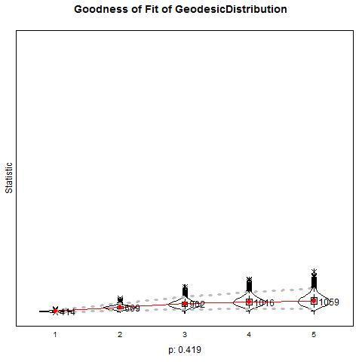 | 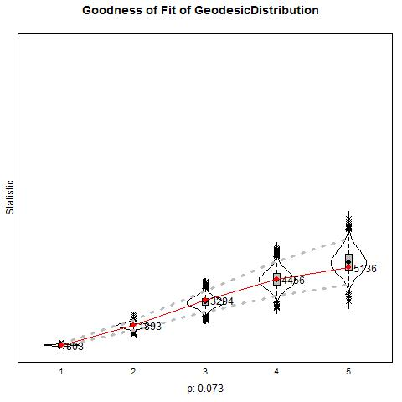
Triad census (bullying) | 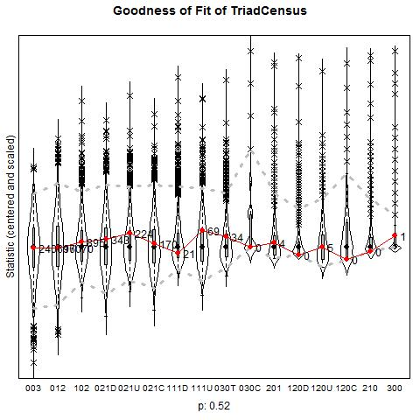
Triad census (defending) | 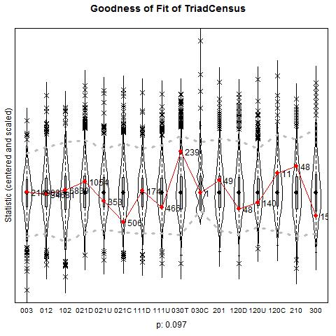

 | School B
 | Bullying | Defending
Indegrees | 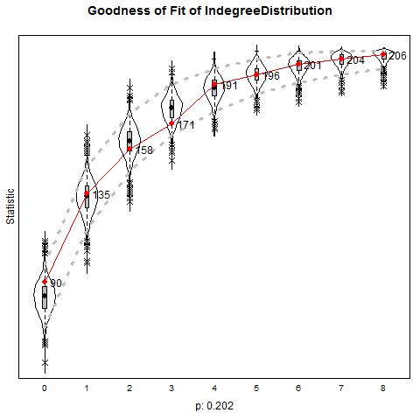 | 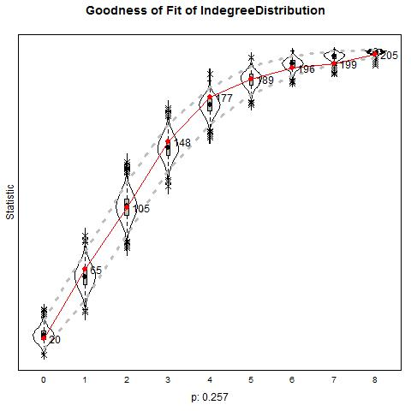
Outdegrees | 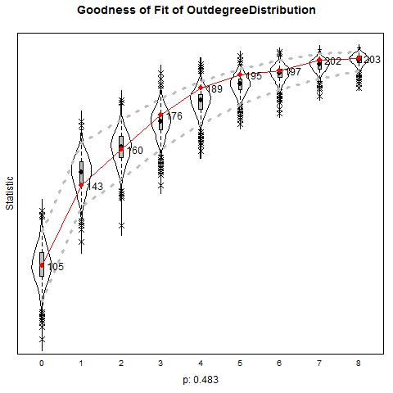 | 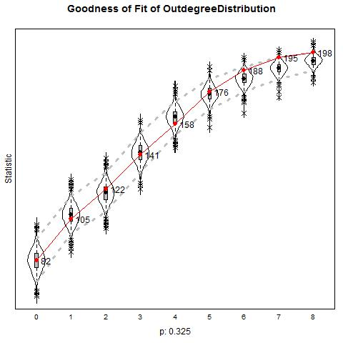
Geodesic distance | 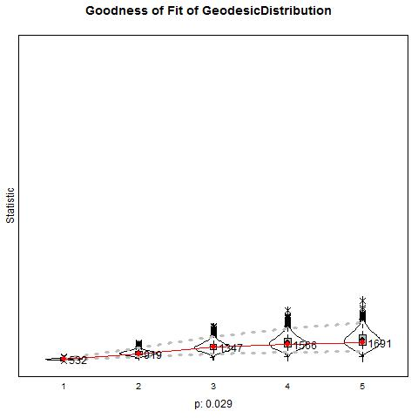 | 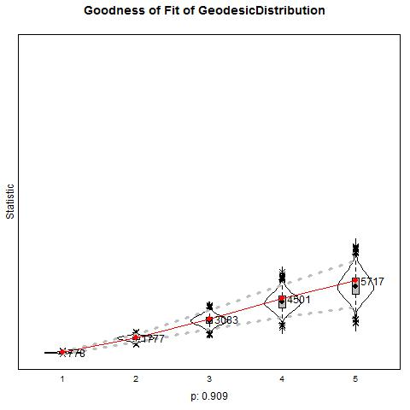
Triad census (bullying) | 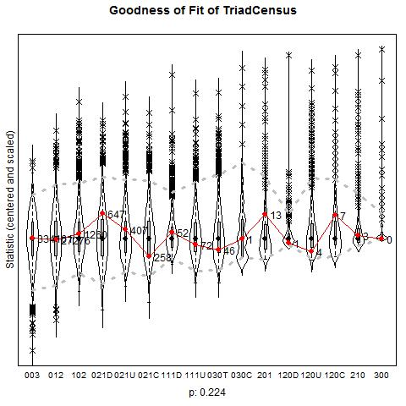
Triad census (defending) | 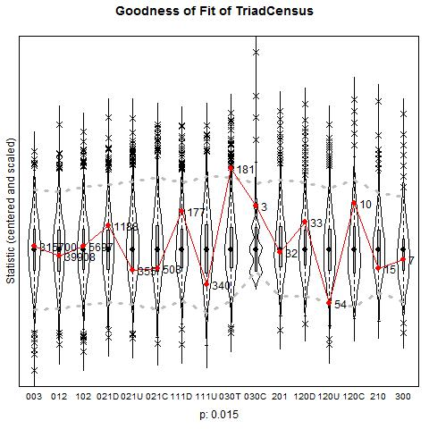

 | School C
 | Bullying | Defending
Indegrees | 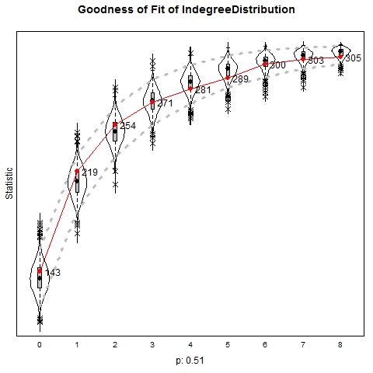 | 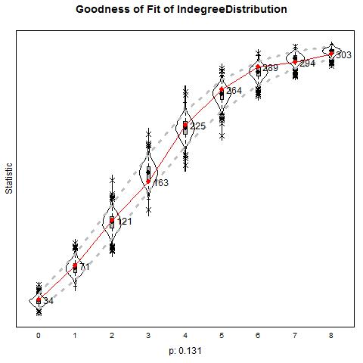
Outdegrees | 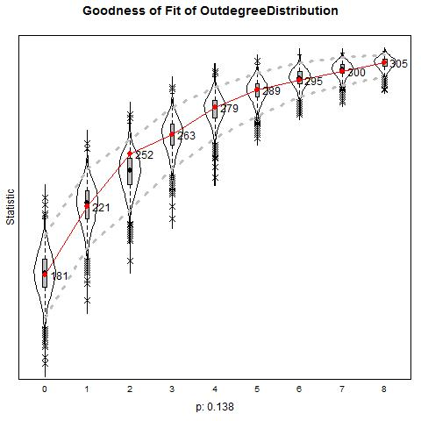 | 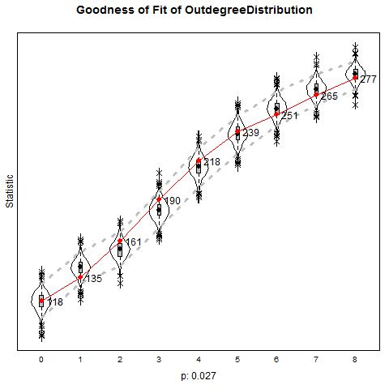
Geodesic distance | 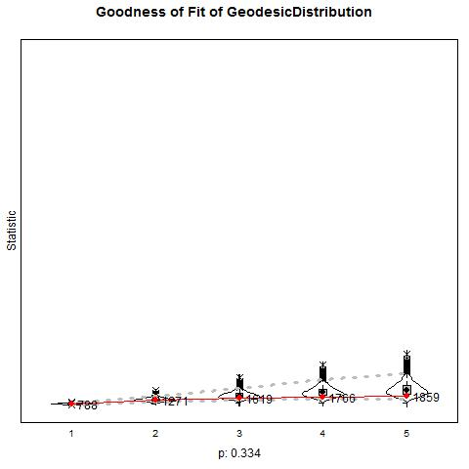 | 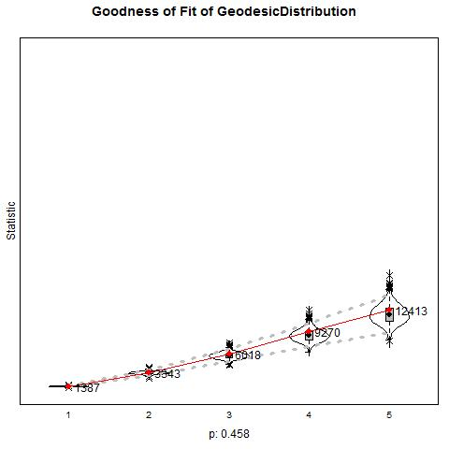
Triad census (bullying) | 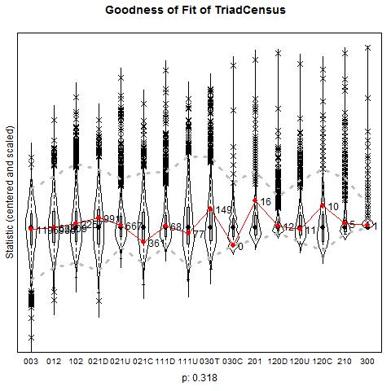
Triad census (defending) | 