Appendix 1
Studies of agreement variation in English often single out sentences in which there immediately precedes be as a key context for variation (e.g., Crawford, 2005; Eisikovits, 1991; Meechan & Foley, 1994; Tagliamonte, 1998). In sociolinguistic and variationist work, these sentences are often, but not always, referred to as existentials. From a strict syntactic-semantic perspective, however, these sentences include both existential uses of there (e.g., There’s a cat in the backyard!) and locative ones (There’s the book I’ve been looking for!, e.g., Breivik, 1981:1). Both structures canonically include there, have VS structure and a non-pronoun subject, and both permit variation (Sparks, 1984).
In the current paper we broke subject-verb order, presence of there (or where or here), and subject-type out individually to determine whether children might initially generalize agreement variation along one or more of these dimensions in non-adult-like ways. This led us to include many locative and adverbial uses of there, where, and here in our dataset that would not have been included in previous work. However, for the purposes of comparison to prior studies, our VS non-pronoun there sentences overlap almost perfectly with the sentences that other papers have labeled as existentials. The exceptions are mostly existential questions (e.g., are there more lions?).
Here, to maximize comparability with previous work, we describe variation in sentences in which a tensed form of be immediately followed there, where, or here, or in which it immediately preceded there. These were identified programmatically in R and hand checked. Of the VS, non-pronoun there, where, and here sentences, only three neither had be immediately after there, where, or here, nor were existential questions. These were three instances of the construction what are the NPs doing here. Figure A1 shows the proportion agreement for each of the sentence types and existential questions. 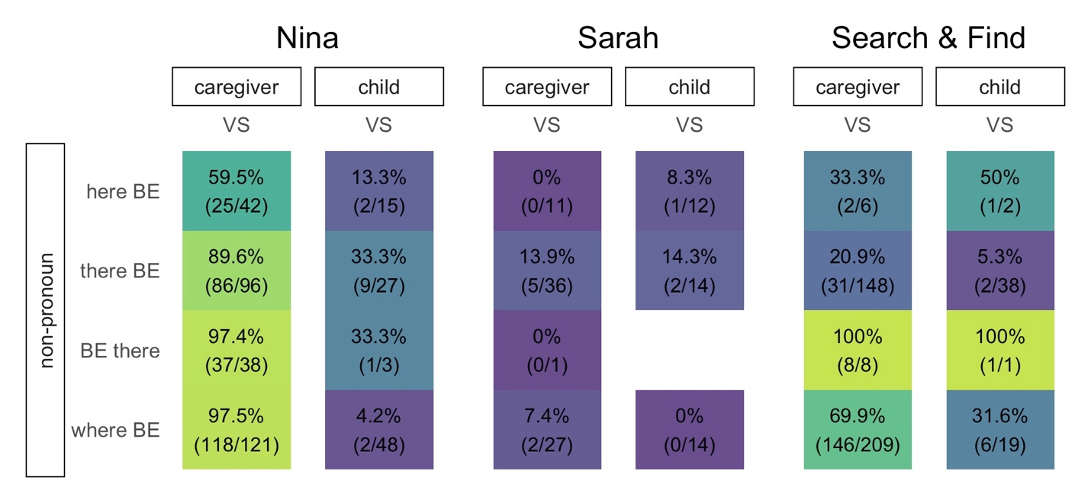
Figure A1. Percentage plural verb-forms in VS sentences with non-pronoun, plural subjects split on the horizontal axis by corpus and speaker, and on the vertical axis by construction. Number of plural verb tokens and total tokens (i.e., plural + singular verb forms) are shown below percentages (plural/total). The darker the cell, the lower the rate of plural agreement. Blank cells indicate combinations of factors that did not occur.

Comparing token numbers and proportion plural agreement with the data in Figure 1 and Figure 6 in the main text shows that this data is identical to the VS non-pronoun there, where, and here data in those figures, with the exception of the three here sentences mentioned above and the division of the there data based on whether the verb precedes there in a question or follows it in a statement. This confirms that despite including a wider range of sentences overall, our coding system is identifying essentially the same sentences examined in previous work. It also provides a more detailed breakdown of there sentences, though the relatively low token numbers for existential questions for most speakers makes them difficult to compare confidently.

