Appendix 1. Acoustic correlates of coda fricative noise by gender. Means, standard deviation and statistical significance. It should be noted that the spectral peak does not differentiate the two allophones in men.

Coda fricative noise [s.t, h.t]
Men
 | [s.t] | [h.t] | Wilcoxon
n | 410 | 48
CFT | 0.07 ± 0.03 | 0.04 ± 0.01 | 5113.5 Sig. < 0.001
CoG | 4900 ± 1512 | 1288 ± 713 | 641 Sig. < 0.001
Peak | 5092 ± 2296 | 5402 ± 3070 | 9012.5 Sig. < 0.334
ZCR | 55 ± 32 | 28 ± 19 | 4614.5 Sig. < 0.001
Women
 | [s.t] | [h.t]
n | 409 | 27
CFT | 0.07 ± 0.02 | 0.05 ± 0.02 | 2696.5 Sig. < 0.001
CoG | 6401 ± 1640 | 1044 ± 748 | 31 Sig. < 0.001
Peak | 7177 ± 2557 | 4102 ± 2078 | 1798.5 Sig. < 0.001
ZCR | 67 ± 39 | 22 ± 11 | 1398 Sig. < 0.001

Appendix 2. Acoustic correlates of onset fricative noise in /-s.t/ variants by gender. Means, standard deviation and statistical significance.

Onset fricative noise [t, t^{h}, ts]
Men
 | [s.t] | [h.t] | [t^{h}] | [ts] | ∅ | Fisher-Pitman
n | 410 | 48 | 572 | 473 | 183
VOT | 0.02 ± 0.01 | 0.03 ± 0.01 | 0.04 ± 0.01 | 0.05 ± 0.01 | 0.02 ± 0.01 | 712.21 (4) Sig. < 0.001
CoG | 3918 ± 1526 | 3758 ± 1378 | 3881 ± 1219 | 4621 ± 1386 | 3261 ± 1095 | 148.92 (4) Sig. < 0.001
Peak | 4805 ± 2281 | 4755 ± 2238 | 4652 ± 2195 | 5051 ± 2389 | 3892 ± 1575 | 36.05 (4) Sig. < 0.001
ZCR | 43 ± 28 | 51 ± 25 | 45 ± 22 | 59 ± 25 | 32 ± 18 | 170.01 (4)  Sig. < 0.001
Women
 | [s.t] | [h.t] | [t^{h}] | [ts] | ∅ | Fisher-Pitman
n | 409 | 27 | 1267 | 898 | 188
VOT | 0.02 ± 0.01 | 0.02 ± 0.01 | 0.04 ± 0.01 | 0.05 ± 0.01 | 0.02 ± 0.01 | 803.29 (4) Sig. < 0.001
CoG | 4342 ± 1599 | 3782 ± 1308 | 4094 ± 1317 | 5483 ± 1473 | 3655 ± 1195 | 282.95 (4) Sig. < 0.001
Peak | 4970 ± 2567 | 4275 ± 2461 | 4486 ± 2287 | 5952 ± 2595 | 4029 ± 1995 | 119.48 (4) Sig. < 0.001
ZCR | 46 ± 29 | 41 ± 18 | 47 ± 26 | 70 ± 28 | 37 ± 21 | 255.24 (4)  Sig. < 0.001

Appendix 3. Screenshot of some of the questions the participants found in the perception test

Figure A3.1. 'Sentence 1. Click on the icon and select the word you heard. Select one of the following options: Casto/Cacho/Cato'.
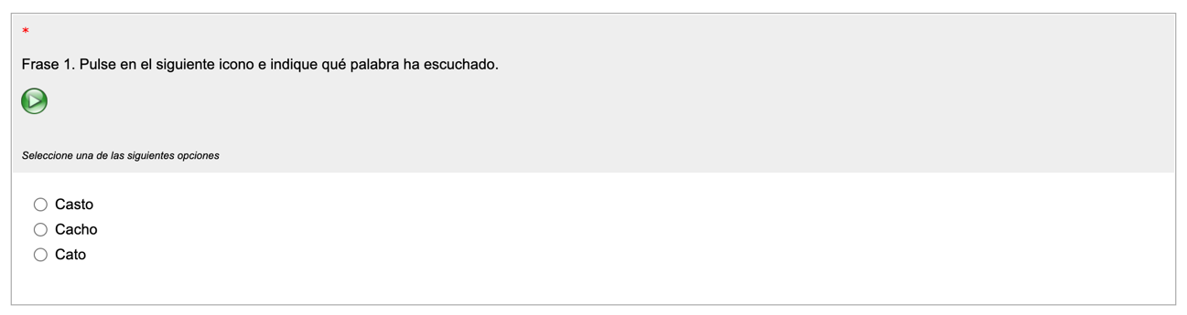

Figure A3.2. 'Sentence 2. Click on the icon and select the word you heard. Select one of the following options: Pasta/Pacha/Pata'.
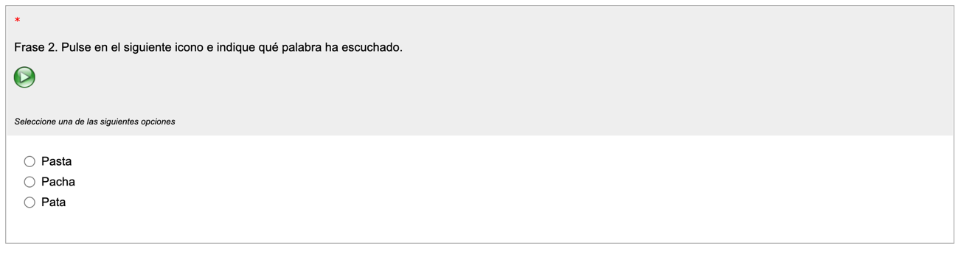
Figure A3.3. 'Sentence 8. Click on the icon and select the word you heard. Select one of the following options: Masta/Macha/Mata.
