Appendices
Appendix 1
Summary statistics for English, French and German listeners across pitch and /s/ manipulations for all levels:
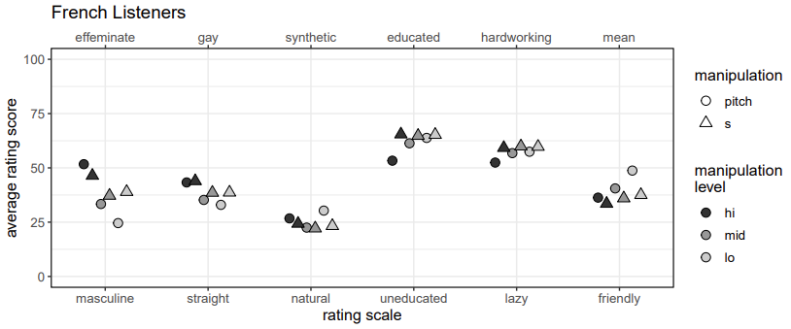
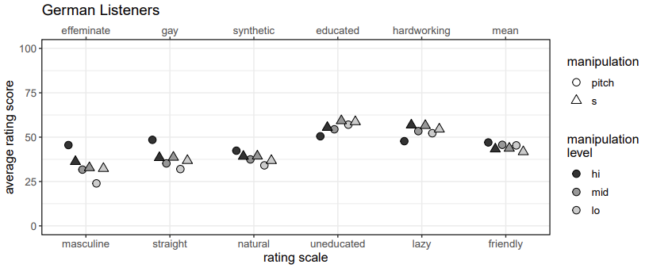

Appendix 2
The higher Gay rating for fronter [s] across all stimulus languages was a general tendency across English listeners, as illustrated in Figure A2. There is not a subset of participants who are highly sensitive to the [s] manipulations across stimuli. Rather, there is a very general trend for participants to rate fronter [s] as more Gay, as indicated by the distribution of individuals’ data above 0. The faint lines in Figure A2 link together data from each individual, which also illustrates that there is no tendency for one or a group of listeners to always appear at either extreme of the ratings distribution for each stimulus language. This degree of agreement between listeners' Gayness rating differences can be quantified by calculating the correlation matrix of these differences. Table A2 plots the Kendall's Tau estimate for the cross-correlation of each of the stimulus languages.
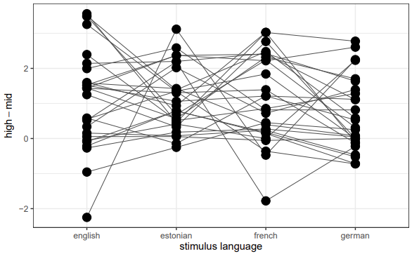
Figure A2. Parallel coordinates plot for English listeners' Gay rating differences for high versus mid /s/ across stimulus languages.

Table A2. Correlation matrix (Kendal’s τ) for English listener’s Gay rating differences ratings between stimulus languages
 | English | Estonian | French
Estonian | 0.16 | - | -
French | 0.45 | 0.01 | -
German | 0.14 | 0.14 | 0.26

Appendix 3
As with our English listeners’ results, our French listeners’ results are due to a general tendency across our participants, as illustrated in Figure A3. Listeners’ data are mostly distributed around 0, indicating little or no sensitivity to the [s] manipulation on their Gay rating, and as the faint lines connecting data points indicate, there aren’t any listeners consistently at either extremes of the rating scale. Table A3 plots the Kendall's Tau estimate for the cross-correlation of each of the stimulus languages for French listeners.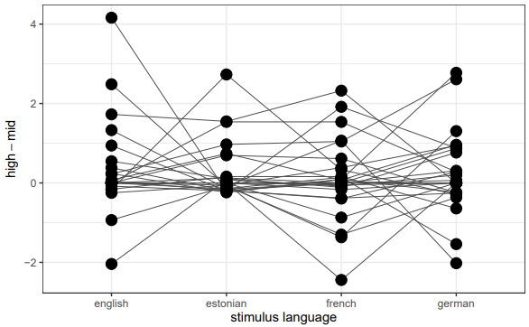
Figure A3. Parallel coordinates plot for French listeners' Gay rating differences for high versus mid /s/ across stimulus languages.

Table A3. Correlation matrix (Kendal’s τ) for French listeners’ Gay rating differences between stimulus languages
 | English | Estonian | French
Estonian | -0.16 | - | -
French | 0.18 | 0.2 | -
German | 0.01 | 0.02 | -0.01

