<Z>appendix A
<B>Means and their standard errors for F1, F2, and F3 per C-E-G group

<T1>C-E-G label | Tokens | Mean F2 | Mean F1 | Mean F3 | SE F2 | SE F1 | SE F3
<Tab>DIF | 155 | 3.679 | 6.881 | 3.202 | .105 | .107 | .064
PWF | 133 | 4.372 | 7.091 | 2.719 | .094 | .108 | .057
PIF | 120 | 3.425 | 7.504 | 4.079 | .105 | .082 | .094
JCF | 198 | 3.750 | 7.521 | 3.771 | .063 | .080 | .076
CBF | 118 | 4.082 | 7.757 | 3.675 | .121 | .143 | .084
JWF | 125 | 4.830 | 7.771 | 2.941 | .074 | .078 | .083
JWM | 137 | 4.696 | 7.780 | 3.084 | .100 | .095 | .061
DWF | 190 | 4.815 | 7.823 | 3.008 | .058 | .061 | .046
JCM | 129 | 4.498 | 7.825 | 3.328 | .087 | .092 | .068
JBF | 122 | 3.554 | 7.856 | 4.302 | .068 | .120 | .099
JBM | 52 | 3.682 | 7.911 | 4.229 | .156 | .179 | .147
JIF | 189 | 4.226 | 7.981 | 3.754 | .060 | .074 | .072
CWF | 150 | 4.541 | 8.086 | 3.545 | .071 | .064 | .071
DBF | 72 | 4.150 | 8.094 | 3.944 | .115 | .156 | .193
JIM | 168 | 4.192 | 8.104 | 3.912 | .073 | .063 | .072
PCF | 81 | 4.776 | 8.188 | 3.413 | .111 | .115 | .129
CBM | 128 | 4.389 | 8.190 | 3.801 | .106 | .132 | .095
DIM | 79 | 4.326 | 8.258 | 3.932 | .104 | .085 | .097
DBM | 213 | 4.458 | 8.264 | 3.806 | .060 | .050 | .069
DWM | 120 | 5.453 | 8.293 | 2.841 | .112 | .113 | .067
KCF | 98 | 4.989 | 8.335 | 3.346 | .099 | .082 | .095
CIF | 162 | 5.092 | 8.499 | 3.408 | .095 | .102 | .081
CIM | 139 | 5.187 | 8.513 | 3.325 | .089 | .084 | .076
DCF | 140 | 5.281 | 8.559 | 3.278 | .084 | .079 | .069
PBF | 136 | 4.184 | 8.594 | 4.410 | .080 | .107 | .102
CCM | 160 | 5.358 | 8.653 | 3.296 | .082 | .089 | .086
PBM | 179 | 4.171 | 8.682 | 4.510 | .068 | .073 | .079
KBM | 120 | 4.017 | 8.691 | 4.674 | .074 | .074 | .096
CCF | 73 | 5.873 | 8.705 | 2.831 | .109 | .099 | .082
PCM | 142 | 5.197 | 8.708 | 3.511 | .084 | .074 | .069
CWM | 152 | 5.096 | 8.725 | 3.629 | .072 | .043 | .076
PIM | 134 | 5.165 | 8.738 | 3.572 | .067 | .065 | .075
KWM | 115 | 5.206 | 8.787 | 3.581 | .088 | .082 | .073
KIF | 170 | 5.373 | 8.844 | 3.471 | .068 | .061 | .084
PWM | 181 | 5.662 | 8.862 | 3.200 | .064 | .037 | .059
KCM | 219 | 5.072 | 9.001 | 3.929 | .076 | .051 | .078
KWF | 107 | 5.911 | 9.033 | 3.121 | .119 | .133 | .068
DCM | 154 | 5.659 | 9.079 | 3.420 | .060 | .049 | .076
KIM | 153 | 5.762 | 9.094 | 3.332 | .073 | .066 | .069
KBF | 140 | 3.472 | 9.253 | 5.780 | .063 | .068 | .062
<ST>All tokens | 5553

<Z>appendix B
<B>Similarity matrix of C-E-G bivariate means (F1 ordering)
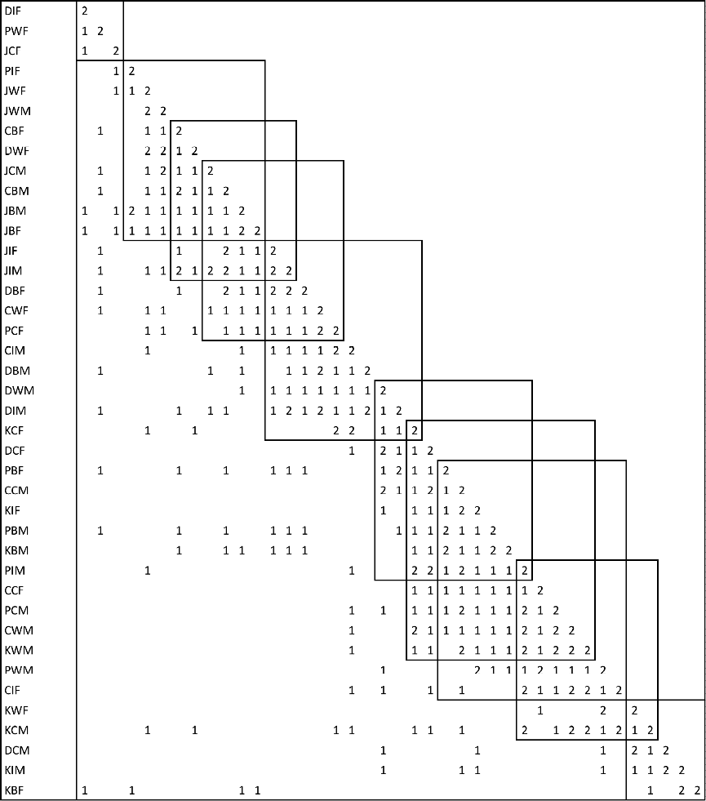
Note: Off-diagonal entries count univariate confidence intervals that include zero difference.

