Supplemental Material
Appendix 1. Summary of the status of aquatic ecosystem representation in the existing ASPAs, Based on details available in their management plans.

For each ASPA, the primary value(s) for protection as reported in, or inferred from, the ASPA Management Plan is noted, then whether the ‘Description of Values to be Protected” includes a reference to aquatic systems, and finally whether the boundaries of the ASPA captures inland aquatic features even if they are not identified as values for protection. Management Plans are diverse documents and some interpretation is required, hence our attributions are not definitive.

Notes on “Primary Values”:
Birds (26) – groups all birds and primarily represents breeding areas
Seals (4) – groups all species, though Weddell and fur seals are specified in some management plans
Ecosystems (6) – includes unspecified and broad categories of ecosystem values, often relating to protected islands or isolated peninsulas
Vegetation (21)– many ASPAs specifically refer to terrestrial vegetation, including as mosses, lichens and fellfield communities. This typically includes not only the macroscopic vegetation that attracts designation, but also the fauna, flora and microbiota associated with these.
Terrestrial ecosystems (8) – representative terrestrial ecosystem values that are more than Vegetation
Aquatic ecosystems (2) – representative inland waters (green shading in table below)
Marine (7) – ASPA that is fully marine
Historic (7) – primary function is to protect heritage sites
Geothermal (3), fossil (3), glaciology (3) and geology (3) are self-explanatory
“Vegetation” includes associated flora, fauna communities.

Number | Name | Primary Value | Aquatic systems additionally identified as a value? | Aquatic systems present within the ASPA?
101 | Taylor Rookery, Mac.Robertson Land | Birds | No | Yes
102 | Rookery Islands, Holme Bay, Mac.Robertson Land | Birds | No | No
103 | Ardery Island and Odbert Island, Budd Coast, Wilkes Land, East Antarctica | Birds | No | Yes
104 | Sabrina Island, Balleny Islands | Ecosystems | No | No
105 | Beaufort Island, McMurdo Sound, Ross Sea | Ecosystems | Yes
106 | Cape Hallett, Northern Victoria Land, Ross Sea | Birds, vegetation | No | No
107 | Emperor Island, Dion Islands, Marguerite Bay, Antarctic Peninsula | Birds | No | No
108 | Green Island, Berthelot Islands, Antarctic Peninsula | Vegetation | No | No
109 | Moe Island, South Orkney Islands | Ecosystems | No | No
110 | Lynch Island, South Orkney Islands | Vegetation | No | No
111 | Southern Powell Island and adjacent islands, South Orkney Islands | Birds, seals, vegetation | No | Yes
112 | Coppermine Peninsula, Robert Island, South Shetland Islands | Birds, vegetation | Yes
113 | Litchfield Island, Arthur Harbor, Anvers Island, Palmer Archipelago | Birds, vegetation | No | No
114 | Northern Coronation Island, South Orkney Islands | De-designated ASPA
115 | Lagotellerie Island, Marguerite Bay, Graham Land | Vegetation, birds, fossils | No | Yes
116 | New College Valley, Caughley Beach, Cape Bird, Ross Island | Vegetation | Yes
117 | Avian Island, Marguerite Bay, Antarctic Peninsula | Vegetation, birds | No | Yes
118 | Summit of Mount Melbourne, Victoria Land | De-designated ASPA
119 | Davis Valley and Forlidas Pond, Dufek Massif, Pensacola Mountains | Aquatic and terrestrial ecosystems
120 | Pointe- Géologie Archipelago, Terre Adélie | Birds, mammals | No | No
121 | Cape Royds, Ross Island | Birds | Yes
122 | Arrival Heights, Hut Point Peninsula, Ross Island | Atmospheric science | No | No
123 | Barwick and Balham Valleys, Southern Victoria Land | Ecosystems | Yes
124 | Cape Crozier, Ross Island | Birds | Yes
125 | Fildes Peninsula, King George Island (25 de Mayo) | Fossils | No | Yes
126 | Byers Peninsula, Livingston Island, South Shetland Islands | Aquatic and terrestrial ecosystems
127 | Haswell Island | Birds | No | Yes
128 | Western shore of Admiralty Bay, King George Island, South Shetland Islands | Birds, seals, vegetation | No | Yes
129 | Rothera Point, Adelaide Island | Vegetation | No | No
130 | ‘Tramway Ridge’, Mount Erebus, Ross Island | De-designated ASPA
131 | Canada Glacier, Lake Fryxell, Taylor Valley, Victoria Land | Vegetation | Yes
132 | Potter Peninsula, King George Island, (Isla 25 de Mayo), South Shetland Islands | Vegetation | No | Yes
133 | Harmony Point, Nelson Island, South Shetland Islands | Birds, terrestrial ecosystem | No | Yes
134 | Cierva Point and offshore islands, Danco Coast, Antarctic Peninsula | Birds, vegetation | No | Yes
135 | North-East Bailey Peninsula, Budd Coast, Wilkes Land | Vegetation | No | Yes
136 | Clark Peninsula, Budd Coast, Wilkes Land, East Antarctica | Terrestrial ecosystem | No | Yes
137 | North-west White Island, McMurdo Sound | Seals | No | No
138 | Linneaus Terrace, Asgard Range, Victoria Land | Vegetation | No | No
139 | Biscoe Point, Anvers Island, Palmer Archipelago | Vegetation | No | Yes
140 | Parts of Deception Island, South Shetland Islands | Vegetation | No | Yes
141 | Yukidori Valley, Langhovde, Lützow-Holm Bay | Vegetation | No | Yes
142 | Svarthamaren | Birds | No | Yes
143 | Marine Plain, Mule Peninsula, Vestfold Hills, Princess Elizabeth Land | Terrestrial ecosystems | Yes
144 | Chile Bay (Discovery Bay), Greenwich Island, South Shetland Islands | Marine | No | No
145 | Port Foster, Deception Island, South Shetland Islands | Marine | No | No
146 | South Bay, Doumer Island, Palmer Archipelago | Marine | No | No
147 | Ablation Valley and Ganymede Heights, Alexander Island | Geology, glaciology, aquatic, terrestrial ecosystems | Yes | Yes
148 | Mount Flora, Hope Bay, Antarctic Peninsula | Fossils | No | No
149 | Cape Shirreff and San Telmo Island, Livingston Island, South Shetland Islands | Birds | No | Yes
150 | Ardley Island, Maxwell Bay, King George Island (25 de Mayo) | Birds | No | Yes
151 | Lions Rump, King George Island, South Shetland Islands | Terrestrial, aquatic and littoral marine ecosystems | Yes
152 | Western Bransfield Strait | Marine | No | No
153 | Eastern Dallmann Bay | Marine | No | No
154 | Botany Bay, Cape Geology, Victoria Land | Ecosystem | No | No
155 | Cape Evans, Ross Island | Historic | No | No
156 | Lewis Bay, Mount Erebus, Ross Island | Historic | No | No
157 | Backdoor Bay, Cape Royds, Ross Island | Historic | No | No
158 | Hut Point, Ross Island | Historic | No | No
159 | Cape Adare, Borchgrevink Coast | Historic | No | No
160 | Frazier Islands, Windmill Islands, Wilkes Land, East Antarctica | Birds | No | No
161 | Terra Nova Bay, Ross Sea | Marine | No | No
162 | Mawson’s Huts, Cape Denison, Commonwealth Bay, George V Land, East Antarctica | Historic | Yes
163 | Dakshin Gangotri Glacier, Dronning Maud Land | Glaciology | No | Yes
164 | Scullin and Murray Monoliths, Mac.Robertson Land | Birds | No | Yes
165 | Edmonson Point, Wood Bay, Ross Sea | Ecosystems | Yes
166 | Port-Martin, Terre Adélie | Historic | No | No
167 | Hawker Island, Princess Elizabeth Land | Birds | No | Yes
168 | Mount Harding, Grove Mountains, East Antarctica | Geomorphology | No | Yes
169 | Amanda Bay, Ingrid Christensen Coast, Princess Elizabeth Land, East Antarctica | Birds | No | No
170 | Marion Nunataks, Charcot Island, Antarctic Peninsula | Vegetation | No | No
171 | Narębski Point, Barton Peninsula, King George Island | Research | No | Yes
172 | Lower Taylor Glacier and Blood Falls, Taylor Valley, McMurdo Dry Valleys, Victoria Land | Glaciology, microbial ecology | No | No
173 | Cape Washington and Silverfish Bay, Terra Nova Bay, Ross Sea | Birds | No | No
174 | Stornes, Larsemann Hills, Princess Elizabeth Land | Geology | No | Yes
175 | High Altitude Geothermal sites of the Ross Sea region | Geothermal |  | No
176 | Rosenthal Islands, Anvers Island, Palmer Archipelago | Birds, vegetation | No | No
177 | Leonie Islands and Southeast Adelaide Island | Birds, terrestrial ecology | Yes
178 | Inexpressible Island and Seaview Bay, Ross Sea | Birds | Yes

Appendix 2. Example of identification of a potentially representative catchment using remote imagery

Selection of potential new locations for ASPAs that fill gaps in the existing network was suggested as a key step to develop a systematic protected area network that included representative catchments from areas poorly visted (Table 2, step 4). We noted that remote sensing may be a useful initial approach to identify areas worthy of further investigation. Here we give an example of how this could work, for Thompson Peak, Oates Land (Figure S-1).

The Adelie Land ACBR contains only three ASPAs, 120, 162 and 166. Of these, ASPA 120 is designated to protect birds and marine mammals, while ASPA 162 and 166 are to protect historic huts. No ecosystem ASPAs exist in this ACBR. VHR satellite imagery (from Google Earth in this instance) was consulted to identify potential representative locations to rectify this. Imagery and literature data indicated that Thompson Peak area (69º 25’ 34” S, 157º 39’ 34” E), within the Wilson Hills of Oates Land is a potential location. The Wilson Hills are a series of isolated ice-free peaks and hills that stretch from the coast to 70 km inland, rising to over 1500 m.

The area outlined in Fig. S-1 is one of these isolated ice-free areas. It covers 8.3 km² and is 70 km from the nearest station (Russia’s mothballed Leningradskya (1971-1991)). The site covers three subcatchments, an altitude range of ~500-1000 m, and is bounded to the north, south and west by arms of the Matusevich Glacier.

The local geology is typical of the region, comprising metamorphic rocks of the Wilson Terrane, ranging from low grade phyllites and schists through magmatictic gneisses and anatectic granites dominating (Henjes-Kunst et al., 2004; Federico et al., 2006). We were unable to locate detailed information on ice sheet history with respect to the areas currently ice-free.

The catchments contain permanent and ephemeral snow patches, at least five lakes, each 100-400 m long, comprising three classes of lake: proglacial (L4 and L5), groundwater fed, rock-based L31) and snow-bank fed (L1 and L2). A series of smaller ponds with at least partially melting ice covers are present on moraines adjacent to the Matusevich Glacier.

The size of the Thompson Peak ice-free area is representative of others in the region, as are the types of lakes that appear to be present. We were unable to locate any evidence of biological sampling in the region, but the low altitude and presence of snow suggests that a close examination would likely reveal both terrestrial and aquatic biota. The Thompson Peak ice-free area is clearly one to be prioritised for consideration for firstly an environmental and biodiversity investigation and secondly, if appropriate for ASPA status (Table 2 in the main text refers to the process).

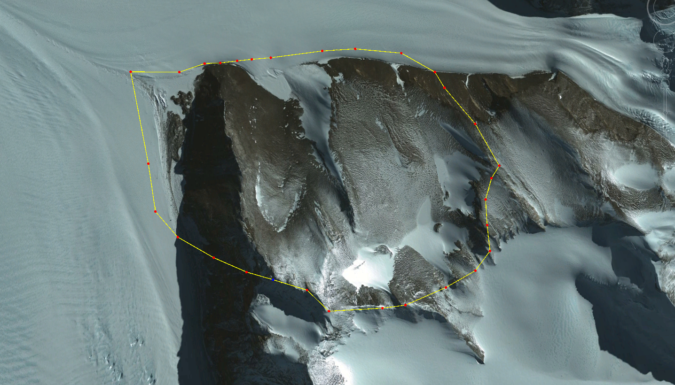
Thompson Peak (980 m)
Matusevich Glacier
L1
L2
L3
L4
L5
Moraine Ponds
Matusevich Glacier
1 km
N

Figure 1 – The Thompson Peak area, a possible representative catchment for Oates Land, Terre Adélie. Google Earth image obtained 7th February, 2012, annotated using Australian Division of National Mapping sheet SR57-58 (1:1,000,000).

References

Henjes-Kunst, F., Roland, N. W., Dunphy, J. M., & Fletcher, I. R. 2004. SHRIMP U–Pb dating of high-grade migmatites and related magmatites from Northwestern Oates Land (East Antarctica): evidence for a single high-grade event of Ross-Orogenic age. Terra Antartica, 11, 67-84.

Federico, L., Capponi, G., & Crispini, L. 2006. The Ross orogeny of the transantarctic mountains: a northern Victoria Land perspective. International Journal of Earth Sciences, 95, 759-770.

