SUPPLEMENTARY MATERIAL
RESULTS
Table S1. List of eDNA studies using soil samples to target Animalia and Plantae organisms. Literature was retrieved using ‘Google Scholar’. Ancient eDNA studies were not included in the list. Markers targeting other organisms (e.g., Bacteria, Fungi) were excluded from the list.
Title, Author, and publishing year | Sample volume (g) | Extraction method | Marker(s) | Target organisms
[1] Co-variation in soil biodiversity and biogeochemistry in northern and southern Victoria Land, Antarctica (Barrett et al. 2006) | 0.7 | CTAB |  | nematode, rotifers, and tardigrades
[2] Islands in the ice: detecting past vegetation on Greenlandic nunataks using historical records and sedimentary ancient DNA Meta‐barcoding (Jørgensen et al. 2012) | 10 | PowerMax® | trnL | Arctic plants
[3] Meta‐barcoding of ‘dirt’ DNA from soil reflects vertebrate biodiversity (Andersen et al. 2012) | 6.5 | PowerMax® | 16S | mammal
[4] New environmental metabarcodes for analysing soil DNA: potential for studying past and present ecosystems (Epp et al. 2012) | 7 – 10 | PowerMax® | multiple | Ancient plants and animals
[5] Tracking earthworm communities from soil DNA (Bienert et al. 2012) | 6 | PowerMax® | 16S | Earthworm
[6] DNA from soil mirrors plant taxonomic and growth form diversity (Yoccoz et al. 2012) | 6 | PowerMax® | trnL | plants
[7] Long-lasting modification of soil fungal diversity associated with the introduction of rabbits to a remote sub-Antarctic archipelago (Pansu et al. 2015b) | NA | NucleoSpin® | trnL | plants
[8] Landscape-scale distribution patterns of earthworms inferred from soil DNA (Pansu et al. 2015a) | 15 | NucleoSpin®+phosphate buffer | COI | earthworms
[9] A comparison of the wet and dry season DNA-based soil invertebrate community characteristics in large patches of the bromeliad Bromelia pinguin in a primary forest in Costa Rica (McGee & Eaton 2015) | 0.3 | PowerSoil® | COI | invertebrates
[10] Evaluating a multigene environmental DNA approach for biodiversity assessment (Drummond et al. 2015) | 1.5 | PowerSoil® | 18S, trnl, COI,16S | plants and animals
[11] Antarctic eukaryotic soil diversity of the Prince Charles Mountains revealed by high-throughput sequencing (Czechowski et al. 2016) | 400 |  | 18S | micro-eukaryotes
[12] Methodological considerations for detection of terrestrial small‐body salamander eDNA and implications for biodiversity conservation (Walker et al. 2017) | 0.25 | PowerSoil® |  | salamanders
[13] Suitability of PCR primers for characterizing invertebrate communities from soil and leaf litter targeting metazoan 18S ribosomal or cytochrome oxidase I (COI) genes (Horton et al. 2017) | 0.25 | PowerSoil® | 18S | metazoan
[14] DNA extraction replicates improve diversity and compositional dissimilarity in metabarcoding of eukaryotes in marine sediments (Lanzén et al. 2017) | 0.5 | PowerSoil® | 18S | marine invertebrates
[15] Evidence of plant and animal communities at exposed and subglacial (cave) geothermal sites in Antarctica (Fraser et al. 2018) | 0.9 | CTAB | COI,28S | Eukaryotes
[16] Sea-level rise in northern Australia’s Kakadu National Park: a survey of floodplain eukaryotes (Stephenson et al. 2018) | 5 | PowerMax® | 18S | Eukaryotes
[17] From microbial eukaryotes to metazoan vertebrates: Wide spectrum paleo‐diversity in sedimentary ancient DNA over the last~ 14,500 years (Kisand et al. 2018) | 0.25 | PowerSoil® | 18S | Eukaryotes
[18] Metabarcoding of modern soil DNA gives a highly local vegetation signal in Svalbard tundra (Edwards et al. 2018) | 10 | PowerMax® | trnL | plants
[19] A DNA metabarcoding approach to characterize soil arthropod communities (Oliverio et al. 2018) | 2 | PowerSoil® | COI
[20] Biodiversity assessments in the 21st century: The potential of insect traps to 5 complement environmental samples for estimating eukaryotic and prokaryotic diversity 6 using high-throughput DNA metabarcoding (Ritter et al. 2019) | 10 | PowerMax® | 16S,18S,COI | insects
[21] Establishing arthorpod community composition using metabarcoding of soil samples, and preservative ethanol and homogenate from Malaise trap catches: surprising inconsistencies between methods (Marquina et al. 2019) | 0.4 | NucleoSpin® | COI,16S | insects
[22] Divergent national-scale trends of microbial and animal biodiversity revealed across diverse temperate soil ecosystems (George et al. 2019) | 0.25 | PowerSoil® | 18S | Eukaryotes
[23] Predicting provenance of forensic soil samples: Linking soil to ecological habitats by metabarcoding and supervised classification (Fløjgaard et al. 2019) | NA | PowerMax® | 18S, mt16S | Eukaryotes, insects
[24] Altered rhizoctonia assemblages in grasslands on ex‐arable land support germination of mycorrhizal generalist, not specialist orchids (Vogt‐Schilb et al. 2020) | NA | PowerMax® |  | orchids
[25] Power and limitations of environmental DNA metabarcoding for surveying leaf litter eukaryotic communities (Lopes et al. 2021) | NA | NucleoSpin® | 18S,12S | Eukaryotes
[26] Effects of soil preservation for biodiversity monitoring using environmental DNA (Guerrieri et al. 2021) | NA | NucleoSpin®+phosphate buffer | Euka02 | Eukaryotes
[27] Comparison of eDNA metabarcoding to camera trapping for terrestrial vertebrate monitoring highlights the importance of substrate type, frequency of sampling and animal size (Ryan et al. 2020) | 0.25 | PowerSoil® | 16S and 12S | mammals
[28] eDNA‐based biomonitoring at an experimental German vineyard to characterize how management regimes shape ecosystem diversity (Agerbo Rasmussen et al. 2021) | 0.25 | PowerSoil® | COI | arthropods
[29] High-throughput sequencing of litter and moss eDNA reveals a positive correlation between the diversity of Apicomplexa and their invertebrate hosts across alpine habitats (Singer et al. 2020) | NA | PowerSoil® | 18S | animals
[30] A novel metabarcoding strategy for studying nematode communities (Sikder et al. 2020) | 0.25 | PowerLyzer® | 18S, COI | nematodes
[31] Comparison of an extracellular v. total DNA extraction approach for environmental DNA-based monitoring of sediment biota (Pansu et al. 2020) | 1 - 10 | NucleoSpin®+phosphate buffer and PowerMax® | 18S, COI | Eukaryotes, metazoans
[32] A small effect of conservation agriculture on soil biodiversity that differs between biological kingdoms and geographic locations (Giraldo-Perez et al. 2021) | 0.25 | Soil Microbe DNA Kit | 16S, ITS2, and COI | animals and fungi
[33] Cascading Effects of Moth Outbreaks on Subarctic Soil Food Webs (Calderón-Sanou et al. 2021) | 15 | NucleoSpin®+phosphate buffer | 18S, ITS1,16S | plants and parasites
[34] Soil depth matters: shift in composition and inter-kingdom co-occurrence patterns of microorganisms in forest soils (Mundra et al. 2021) | 1 | CTAB | 18S | micro-eukaryotes
[35] Unearthing the Potential of Soil eDNA metabarcoding – Towards Best Practice Advise for Invertebrate Biodiversity Assessment (Kirse et al. 2021) | NA | NucleoSpin®+phosphate buffer, and NucleoSpin® | 18S and COI | invertebrates
[36] Impacts of DNA extraction and PCR on DNA metabarcoding estimates of soil biodiversity (Dopheide et al. 2019) | 1.5 – 15 | PowerSoil®  NucleoSpin®PowerMax®,  others | 18S & COI | Eukaryota, metazoan

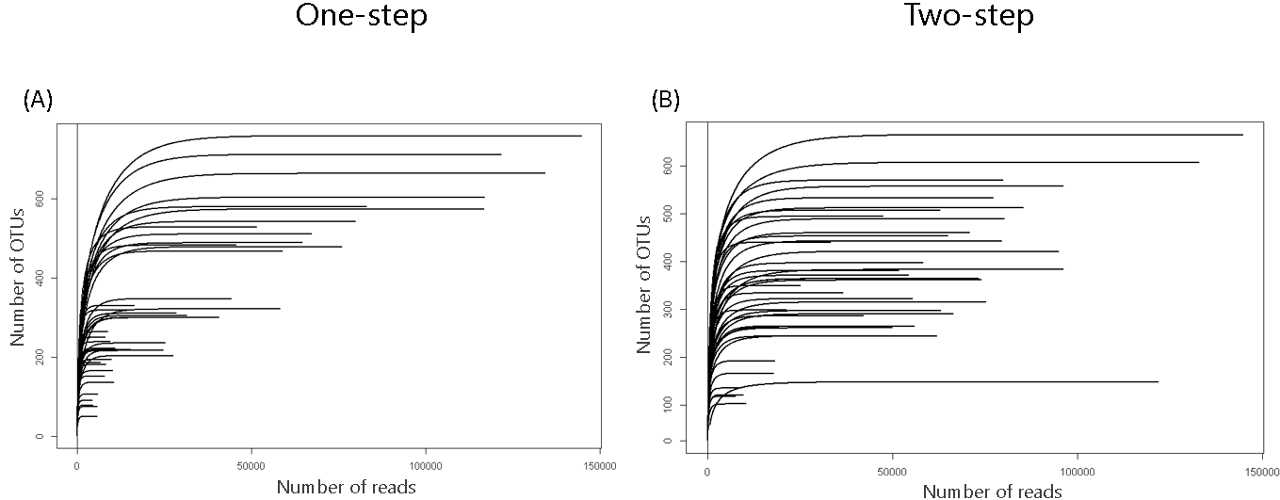

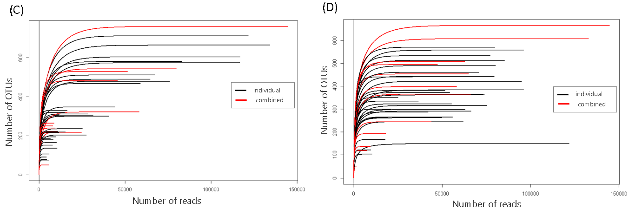

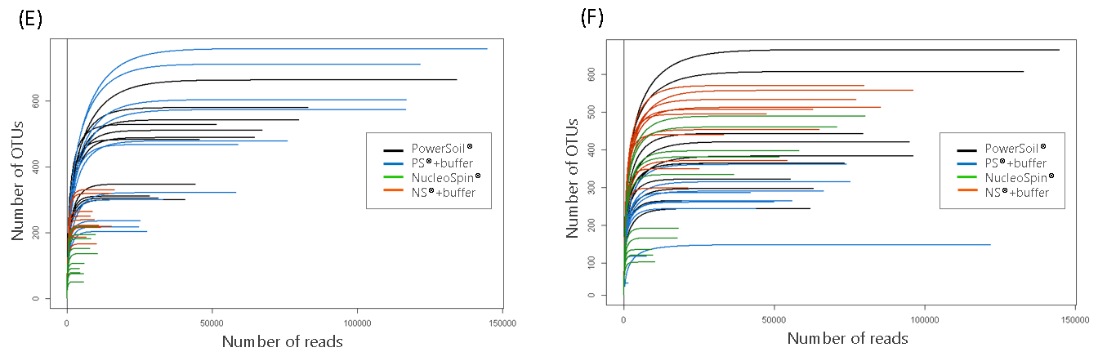

Figure S1. Rarefaction curves for one-step (i.e., A, C, and E) and two-step (B, D, and F) libraries.
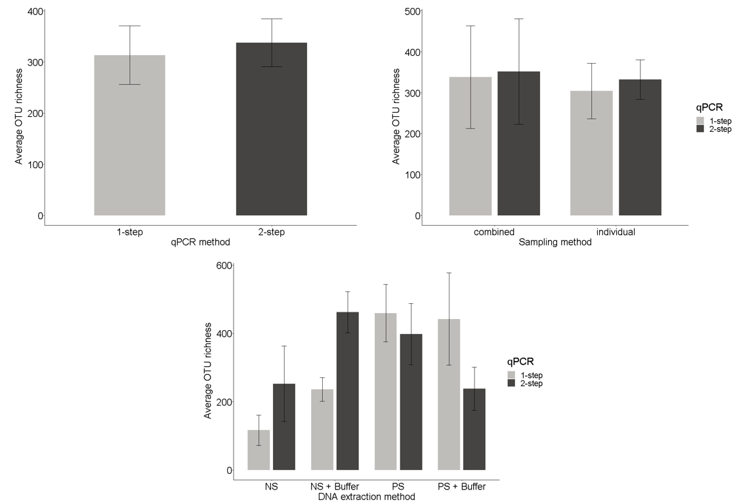
Figure S2. Mean of diversity estimates of OTUs assigned per replicate in each of the treatments. Error bars represent the 95% confidence intervals.

Kruskal-Wallis tests for the diversity estimates of the total amount of OTUs were like those of Eukaryota taxa assigned. Between the one-step and two-step approaches no significant differences were found (X² (3, N = 88) = 1.26, p = 0.26); in average, 313.5 ± 57.52 and 337.65 ± 46.73 OTUs were matched in GenBank, for the one-step and two-step approaches respectively. Also, there were no significant differences between individual and combined sampling processing treatments in both qPCR treatments (X² (1, N = 88) = 0.15, p = 0.7); individual and combined samples showed in average 304.218 ± 67.847 and 338.333 ± 125.826 number of OTUs, respectively, for the one-step qPCR and 332.343 ± 48.461 and 351.833 ± 128.837 for the two-step qPCR approach. In the case of DNA extraction protocols, significant differences (X² (3, N = 88) = 25.81, p < 0.001) were found among the four treatments, for both the one- and two-step qPCR, driven mainly by the significant differences of the NucleoSpin protocol against the other three extraction protocols.

Figure S3. Principal Coordinates Analysis (PCoA; Jaccard) of presence/absence of total OTUs of one-step and two-step sequencing libraries using the Jaccard similarity index method. Sample processing and DNA extraction protocol samples are represented by shapes and colours, respectively. Ellipses represent 95% confidence intervals for qPCR extraction methods. Scree plot shows eigenvalues which are the percentage of variation explained per dimension (axis).

In the case of the total OTUs found, principal coordinates analysis (suplementary material) showed distinct dissimilarity between qPCR library approaches, PERMANOVA : F_{1,82} = 6.62, p < 0.001). The two-step approach cluster showed more similarity among treatments. The PS and PS+buffer extraction methods of the one-step approach showed a separate cluster from the NS and NS+buffer extraction methods. PERMANOVA results showed significant differences (F_{3,82} = 2.28, p < 0.001) among DNA extraction kits. However, these differences might be an artifact of heterogeneous dispersions as given by PERMADIST results (F_{3,84} = 19.56, p < 0.001). Individual and combined samples showed no dissimilarity over the PCoA plot and no significant differences in the PERMANOVA analysis (F_{1,82} = 0.98, p > 0.5).
The scree plot shows that about 14% of the variation in Jaccard distances are explained within the first two dimensions, i.e., 8.3% axis 1 and 5.4% axis 2.

Similar results were given by analysis of similarity (ANOSIM). Specifically, higher similarity was found within each qPCR approach than between both (R:0.389, p < 0.001). Similarity was also greater within DNA extraction methods than between them (R: 0.1577, p < 0.001). A negative R value (R: -0.04488) for sampling methods indicated no difference among groups however results were not statistically significant (p = 0.763).

Indicator species analyses
When accounting for the total OTUs assigned, 199 and 151 OTUs were significantly (p < 0.05) associated with the one-step and two-step approaches, respectively. In the case of the one-step approach, 17 OTUs were assigned to taxa, which were mostly represented by bacteria, but also by the Trebouxiophycea (class) and Chlorophyta (phylum) groups. In the case of the two-step approach, 19 OTUs were assigned to taxa, again mostly to bacteria but also a Rotifera.

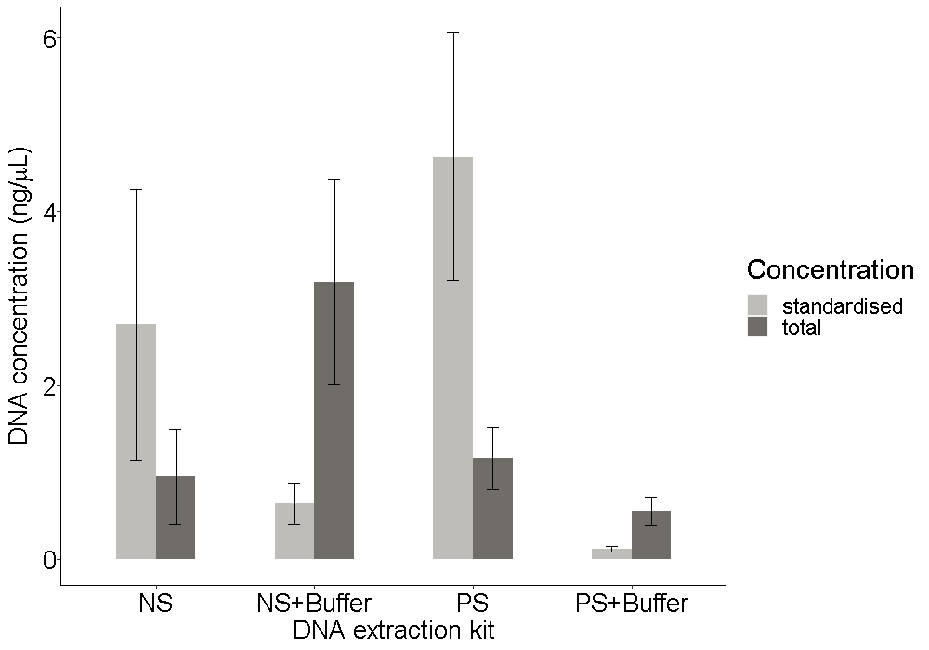
Figure S4. Total and standardised (i.e. total DNA concentration divided by the total volume of sample) concentrations of DNA for (a) commercial extraction kits and (b) commercial extraction kits in combination with saturated phosphate buffer.

PRIMERS USED AND SEQUENCING WORKFLOW

Table S2. List of primers used in the one-step qPCR approach. From 5’ ends, the primer contains a (1) Illumina flow-cell adapter, (2) primer pad (only forward primer), (3) index (6–8 bp length) and, (4) the specific primer sequence.
Name | Flow-cell Adapter | Flu-Pad | Index | Template Specific Primer
Forward | (P5)
1391f_1 | AATGATACGGCGACCACCGAGATCTACAC | TGACGACATGGTTCTACA | AACCGA | GTACACACCGCCCGTC
1391f_4 | AATGATACGGCGACCACCGAGATCTACAC | TGACGACATGGTTCTACA | AGACCT | GTACACACCGCCCGTC
1391f_45 | AATGATACGGCGACCACCGAGATCTACAC | TGACGACATGGTTCTACA | TGAGTA | GTACACACCGCCCGTC
1391f_297 | AATGATACGGCGACCACCGAGATCTACAC | TGACGACATGGTTCTACA | TCGTATAG | GTACACACCGCCCGTC
1391f_524 | AATGATACGGCGACCACCGAGATCTACAC | TGACGACATGGTTCTACA | TCTATGTC | GTACACACCGCCCGTC
Reverse | (P7)
EukBr_1 | CAAGCAGAAGACGGCATACGAGAT |  | AACCGA | TGATCCTTCTGCAGGTTCACCTAC
EukBr_2 | CAAGCAGAAGACGGCATACGAGAT |  | TAGAGC | TGATCCTTCTGCAGGTTCACCTAC
EukBr_3 | CAAGCAGAAGACGGCATACGAGAT |  | GAAGAG | TGATCCTTCTGCAGGTTCACCTAC
EukBr_8 | CAAGCAGAAGACGGCATACGAGAT |  | TGAACG | TGATCCTTCTGCAGGTTCACCTAC
EukBr_170 | CAAGCAGAAGACGGCATACGAGAT |  | TACGCTC | TGATCCTTCTGCAGGTTCACCTAC
EukBr_172 | CAAGCAGAAGACGGCATACGAGAT |  | TCATCTC | TGATCCTTCTGCAGGTTCACCTAC
EukBr_176 | CAAGCAGAAGACGGCATACGAGAT |  | ACGAGTC | TGATCCTTCTGCAGGTTCACCTAC
EukBr_315 | CAAGCAGAAGACGGCATACGAGAT |  | ATGACGTC | TGATCCTTCTGCAGGTTCACCTAC
EukBr_318 | CAAGCAGAAGACGGCATACGAGAT |  | ATACAGTC | TGATCCTTCTGCAGGTTCACCTAC
EukBr_590 | CAAGCAGAAGACGGCATACGAGAT |  | ACATGACG | TGATCCTTCTGCAGGTTCACCTAC

Table S3. List of primers used in the first and second rounds of the Two-step qPCR approach. From 5’ ends, primers for the first round contain a (1) Illumina flow cell adapter (P7), (2) Clustering enhancers as “N” segments and, (3) the specific primer sequence (Note that reverse complement of i7 sequences should be listed in sample sheet for MiSeq sample submissions). From 5’ ends, primers of the second round contain a (1) Illumina flow cell adapter (P5), (2) index (8 bp length) and, (3) Illumina flow cell adapter (P7).

First round | Illumina primer-binding P7 | Enhancer | Template Specific Primer
1391f_first | ACACTCTTTCCCTACACGACGCTCTTCCGATCT | NNNNNN | GTACACACCGCCCGTC
EukBr_first | GTGACTGGAGTTCAGACGTGTGCTCTTCCGATCT | NNNNNN | TGATCCTTCTGCAGGTTCACCTAC
Second Round | Illumina primer-binding P5 | Index | Illumina primer-binding P7
Forward |  | i5 indices
2nd_PCR_F_A501 | AATGATACGGCGACCACCGAGATCTACAC | TGAACCTT | ACACTCTTTCCCTACACGACGCTCTTCCGATCT
2nd_PCR_F_A502 | AATGATACGGCGACCACCGAGATCTACAC | TGCTAAGT | ACACTCTTTCCCTACACGACGCTCTTCCGATCT
2nd_PCR_F_A503 | AATGATACGGCGACCACCGAGATCTACAC | TGTTCTCT | ACACTCTTTCCCTACACGACGCTCTTCCGATCT
2nd_PCR_F_A504 | AATGATACGGCGACCACCGAGATCTACAC | TAAGACAC | ACACTCTTTCCCTACACGACGCTCTTCCGATCT
2nd_PCR_F_A505 | AATGATACGGCGACCACCGAGATCTACAC | CTAATCGA | ACACTCTTTCCCTACACGACGCTCTTCCGATCT
Reverse |  | i7 indices
2nd_PCR_R_A701 | CAAGCAGAAGACGGCATACGAGAT | GTCGTGAT | GTGACTGGAGTTCAGACGTGTGCTCTTCCGATCT
2nd_PCR_R_A702 | CAAGCAGAAGACGGCATACGAGAT | ACCACTGT | GTGACTGGAGTTCAGACGTGTGCTCTTCCGATCT
2nd_PCR_R_A703 | CAAGCAGAAGACGGCATACGAGAT | TGGATCTG | GTGACTGGAGTTCAGACGTGTGCTCTTCCGATCT
2nd_PCR_R_A704 | CAAGCAGAAGACGGCATACGAGAT | CCGTTTGT | GTGACTGGAGTTCAGACGTGTGCTCTTCCGATCT
2nd_PCR_R_A705 | CAAGCAGAAGACGGCATACGAGAT | TGCTGGGT | GTGACTGGAGTTCAGACGTGTGCTCTTCCGATCT
2nd_PCR_R_A706 | CAAGCAGAAGACGGCATACGAGAT | GAGGGGTT | GTGACTGGAGTTCAGACGTGTGCTCTTCCGATCT
2nd_PCR_R_A707 | CAAGCAGAAGACGGCATACGAGAT | AGGTTGGG | GTGACTGGAGTTCAGACGTGTGCTCTTCCGATCT
2nd_PCR_R_A708 | CAAGCAGAAGACGGCATACGAGAT | GTGTGGTG | GTGACTGGAGTTCAGACGTGTGCTCTTCCGATCT
2nd_PCR_R_A709 | CAAGCAGAAGACGGCATACGAGAT | TGGGTTTC | GTGACTGGAGTTCAGACGTGTGCTCTTCCGATCT
2nd_PCR_R_A710 | CAAGCAGAAGACGGCATACGAGAT | TGGTCACA | GTGACTGGAGTTCAGACGTGTGCTCTTCCGATCT

Table S4. For the two-step qPCR approach, index sequences list for ordering primers as well as sample sheet.

Index name | Index sequence – for ordering primers | Reverse complement – for sample sheet
i5
A501 | TGAACCTT | TGAACCTT
A502 | TGCTAAGT | TGCTAAGT
A503 | TGTTCTCT | TGTTCTCT
A504 | TAAGACAC | TAAGACAC
A505 | CTAATCGA | CTAATCGA
i7
A701 | GTCGTGAT | ATCACGAC
A702 | ACCACTGT | ACAGTGGT
A703 | TGGATCTG | CAGATCCA
A704 | CCGTTTGT | ACAAACGG
A705 | TGCTGGGT | ACCCAGCA
A706 | GAGGGGTT | AACCCCTC
A707 | AGGTTGGG | CCCAACCT
A708 | GTGTGGTG | CACCACAC
A709 | TGGGTTTC | GAAACCCA
A710 | TGGTCACA | TGTGACCA

Figure S5. Structure of forward and reverse primers used on the one-step qPCR approach (A) and, single-read sequencing workflow (B), (Amaral-Zettler et al. 2018).
Figure S6. Structure of forward and reverse primers used on the one-step qPCR approach (Miya et al. 2015).
PICTURES
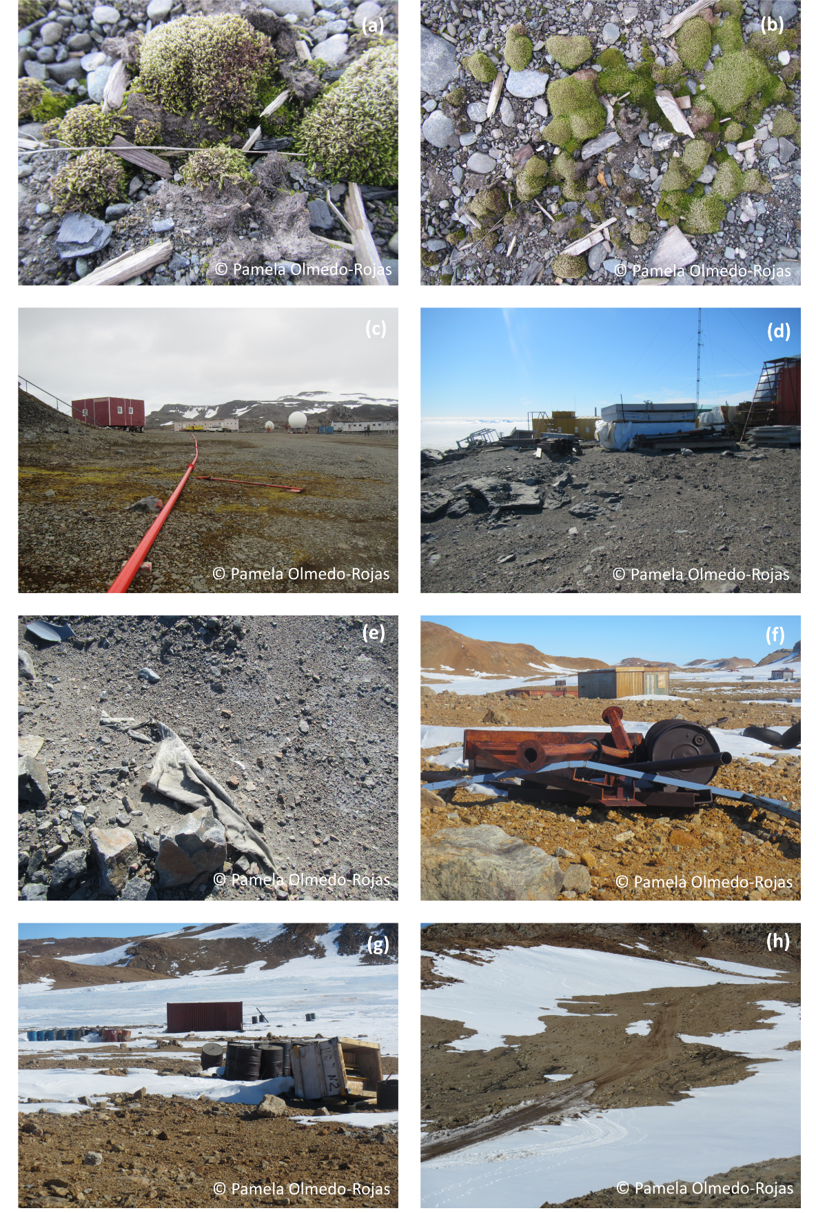
Figure S7. Anthropogenic pollution in Antarctica; (a-c), Julio Escudero Chilean station, (d-e) Davis Australian station, (f-g) Progress old Russian station, and (h) vicinity of Progress new Russian station.

PROTOCOLS

DNA extraction protocols

i) PowerSoil® DNA Isolation Kit (MO BIO Laboratories, Inc.)
- Add 0.25 grams of soil sample to a PowerBead Tube
- Vortex for 2 sec
- Add 60 μL of solution C1 (if solution C1 is precipitated, heat solution to 60°C until dissolved before use)
- Vortex in a horizontal position at maximum speed for 10 mins
- Centrifuge at 10,000 x g for 30 s at ambient temperature
- Transfer the supernatant to a clean 2 ml Collection tube
- Add 250 μL of solution C2 and vortex for 5 s
- Incubate at 4°C for 5 mins
- Centrifuge at room temperature for 1 min at 10,000 x g
- Transfer up to, but no more than, 600 μL of supernatant to a 2 ml Collection tube
- Add 200 μL of Solution C3
- Vortex
- Incubate at 4°C for 5 mins
- Centrifuge at room temperature for 1 minute at 10,000 x g
- Transfer up to, but no more than, 750 μL of supernatant to a 2 ml Collection tube
- Add 1200 μL of Solution C4 to the supernatant (shake Solution C4 before use)
- Vortex for 5 mins
- Load approximately 675 μL onto a Spin Filter
- Centrifuge at 10,000 x g for 1 min at room temperature
- Discard the flow-through
- Add 675 μL of supernatant to the Spin Filter
- Centrifuge at 10,000 x g for 1 min at room temperature
- Load the remaining supernatant onto the Spin Filter
- Centrifuge at 10,000 x g for 1 min at room temperature
- Add 500 μL of Solution C5
- Centrifuge at room temperature for 30 s at 10,000 x g
- Discard the flow-through
- Centrifuge at room temperature for 1 min at 10,000 x g
- Place the Spin Filter in a 2 ml Collection Tube (avoid splashing Solution C5 onto the Spin Filter)
- Add 100 μL of Solution C6 to the centre of the white filter membrane of the Spin Filter tube
- Centrifuge at room temperature for 30 s at 10,000 x g
- Discard the Spin Filter
- Store DNA at -20° to -80°C

ii) PowerSoil + saturaded phosphate buffer
- Prepare 1 L of saturated phosphate buffer by adding 1.97 g of NaH2PO4 and 14.7 g of Na2HPO4 to 1 L of ultra-pure water
- Add 5 grams of soil sample and 5 ml of saturated phosphate buffer to a 50 ml tube
- Mix for 15 mins manually
- Transfer 2 ml of the soil / saturated phosphate buffer mix into a 2 ml tube
- Centrifuge at maximum speed for 7 mins. This is now the Starting solution
- Follow instructions of PowerSoil® DNA Isolation Kit (Qiagen GmbH, Hilden, Germany) protocol.

iii) NucleoSpin® Soil (MACHERY-NAGEL GmbH & Co. KG)
- Add 0.35 grams of soil sample to a NucleoSpin® Bead Tube Type A
- Add 700 μL of buffer SL1
- Add 150 μL of Enhancer SX and close the cap
- Vortex horizontally position, at full speed and room temperature for 15 mins
- Centrifuge for 3 minutes at 11,000 x g
- Add 150 μL buffer SL3
- Vortex for 5 s
- Incubate for 5 mins at 0–4°C
- Centrifuge for 1 min at 11,000 x g
- Place a NucleoSpin® Inhibitor Removal Column (red ring) in a Collection Tube (2 ml, lid)
- Load up to 700 μL of the supernatant onto the filter of the NucleoSpin® Inhibitor Removal Column
- Centrifuge for 1 min at 11,000 x g
- Discard the NucleoSpin® Inhibitor Removal Column
- Add 250 μL Buffer SB
- Vortex for 5 s
- Place a NucleoSpin® Soil Column (green ring) in a Collection Tube (2 ml)
- Load 550 μL sample onto the column of the NucleoSpin® Soil Column tube
- Centrifuge for 1 min at 11,000 x g
- Discard flow-through and place the column back into the collection tube
- Load the remaining sample onto the column
- Centrifuge for 1 min at 11,000 x g
- Discard flow-through and place the column back into the collection tube
- Add 500 μL Buffer SB to the NucleoSpin® Soil Column
- Centrifuge for 30 s at 11,000 x g
- Discard flow-through and place the column back into the collection tube
- Add 550 μL Buffer SW1 to the NucleoSpin® Soil Column
- Centrifuge for 30 s at 11,000 x g
- Discard flow-through and place the column back into the collection tube
- Add 700 μL Buffer SW2 to the NucleoSpin® Soil Column
- Close the lid and vortex for 2 s
- Centrifuge for 30 s at 11,000 x g
- Discard flow-through and place the column back into the collection tube
- Add 700 μL Buffer SW2 to the NucleoSpin® Soil Column
- Close the lid and vortex for 2 s
- Centrifuge for 30 s at 11,000 x g
- Discard flow-through and place the column back into the collection tube
- Centrifuge for 2 mins at 11,000 x g
- Place the NucleoSpin® Soil Column into a new microcentrifuge tube
- Add 100 μL Buffer SE to the column
- Do not close the lid and incubate for 1 min at room temperature
- Close the lid and centrifuge for 30 s at 11,000 x g
- Discard the NucleoSpin® Soil Column
- Store DNA at -20° to -80°C

iv) NucleoSpin + saturaded phosphate buffer
- Prepare 1 L of saturated phosphate buffer by adding 1.97 g of NaH2PO4 and 14.7 g of Na2HPO4 to 1 L of ultra-pure water
- Add 5 grams of soil sample and 5 ml of saturated phosphate buffer to a 50 ml tube
- Mix for 15 mins manually
- Transfer 2 ml of the soil / saturated phosphate buffer mix into a 2 ml tube
- Centrifuge at maximum speed for 7 mins
- Transfer 400 μL of supernatant into a new 2 ml tube
- Add 250 μL of Buffer SB and mix using the pipette
- Place the NucleoSpin® Soil Column into a new microcentrifuge tube
- Transfer the 650 μL solution into the NucleoSpin® Soil Column
- Centrifuge for 10,000 x g for 30 s
- Discard flow-through and place the column back into the microcentrifuge tube
- Load 500 μL of Buffer SB
- Discard flow-through and place the column back into the microcentrifuge tube
- Load 550 μL of SW1
- Centrifuge for 10,000 x g for 30 s
- Discard flow-through and place the column back into the microcentrifuge tube
- Load 750 μL of SW2
- Centrifuge for 10,000 x g for 30 s
- Discard flow-through and place the column back into the microcentrifuge tube
- Place the NucleoSpin® Soil Column into a new microcentrifuge tube
- Add 100 μL of Buffer SE (heated at 80°C)
- Do not close the lid and incubate for 1 min at room temperature
- Centrifugate for 30 s at 11,000 x g
- Discard the NucleoSpin® Soil Column
- Store DNA at -20° to -80°C

Cleaning-up libraries
- Top-up library to 100 μL with ultra-pure water
- Vortex stock of magnetic beads (AMPure XP Beads; BioLabs Inc., USA)
- Add 120 μL of magnetic beads
- Vortex for 2 s
- Spin for 2 s
- Place tube in a tube rack
- Incubate for 5 mins at ambient temperature
- Place tube in a magnetic rack
- Incubate for 3 mins at ambient temperature
- Discard supernatant
- Place tube in a tube rack
- Add 150 μL of 85% ethanol
- Vortex for 5 s
- Place tube back in the magnetic rack
- Incubate for 3 mins at ambient temperature
- Discard supernatant
- Place tube in a tube rack
- Add 150 μL of 85% ethanol
- Vortex for 5 s
- Place tube in the magnetic rack
- Incubate for 3 mins at ambient temperature
- Discard supernatant
- Open the tube and incubate for 5 minutes at ambient temperature
- Add 20 μL of ultra-pure water
- Vortex for 5 s
- Spin for 5 s
- Place tube at 65°C for 3 mins
- Spin for 5 s
- Place tube in the magnetic rack
- Incubate for 2 mins at ambient temperature
- Transfer the supernatant to a 1.5 μL tube
- Quantify the concentration of DNA in each tube using a Qubit® 2.0 Fluorometer (Qubit® dsDNA HS Assay Kit)

Bioinformatic pipelines

Quality filtering:

One-step approach:

Locate and remove P7 adapter and any following base pair from sequencing reads (only one-step approach), using CUTADAPT v1.18 (Martin, 2011) in the command-line
```
cutadapt -a ATCTCGTATGCCGTCTTCTGCTTG --discard-untrimmed sequencing_file.fastq -o trimmed.fastq
```
--discard-untrimmed filename.fastq : discard reads from FASTQ file in which no adapter was found – example, sequencing_file.fastq
-o filename.fastq : output file of trimmed sequences in FASTQ file format – example, trimmed.fastq
2. Separate reads by barcodes and assign them to their corresponding samples, using Geneious Prime® 2020.1.2 (Kearse et al. 2012). No mismatches allowed

Two-step approach:

Merge paired-end sequences using PEAR (Zhang et al. 2014) in the command-line. Do the following command for every sequencing pair files
```
pear -f forward_R1_001.fastq.gz -r reverse_R2_001.fastq.gz -o merged.fastq
```
-f filename : specify the file containing the forward paired-end reads, i.e., forward_R1_001.fastq.gz
-r filename.gz : filename : specify the file containing the reverse paired-end reads, i.e., reverse_R2_001.fastq.gz
-o filename.fastq : FASTQ-formatted file output containing the merged reads specified in -f and -r

Continue with the following steps to analyse both the one-step and two-step qPCR approach sequencing files:

1. Identify and remove forward and reverse primers from each sequence. No mismatches allowed, also in Geneious Prime® 2020.1.2 (Kearse et al. 2012).

2. Relabel sequences reads based on samples information.
Use VSEARCH v2.15.0 (Rognes et al. 2016) in the command-line for this and the following steps
```
for fq in sequencing_reads_*; do vsearch --fastq_filter $fq --relabel $fq. --fastqout relabelled_$fq; done
cat relabeled_sequencing_reads_* > relabeled.fastq
```
for fq in prefix_* : start a loop and perform the following commands to all reads with the prefix ‘sequencing_reads_’. Note: The wildcard (*) is used to match all the sequencing reads begining with the specified prefix
do : do the following commands
--fastq_filter filename.fastq : shorten and/or filter sequences in the given FASTQ file
--relabel prefix_ : relabel sequences using the prefix relabelled_ and a ticker (1, 2, 3, etc.) to construct the new headers
--fastqout filename.fastq : write to the given FASTQ file the sequences passing the filter
done : end the loop
cat filenames_* : concatenate all files with the prefix ‘relabeled_sequencing_reads’

3. Keep only sequences with a number of base pairs between 80 and 160, using VSEARCH (Rognes et al. 2016) in the command-line. Sequences with a length between 80 and 160 base pairs were kept. No errors allowed in sequencing reads
```
vsearch --fastq_filter relabelled.fastq --fastq_maxee 1.0 --fastq_maxlen 160 --fastq_minlen 80 --fastq_maxns 0 --fastaout filtered.fasta --fastqout filtered.fastq
```
--fastq_filter filename.fastq : shorten and/or filter sequences in the given FASTQ file, i.e., relabelled.fastq
--fastq_maxee value : discard sequences with more than the specified number of expected errors, i.e., 1
--fastq_maxlen value : discard sequences with more than the specified number of bases, i.e., 160
--fastq_minlen value : discard sequences with less than the specified number of bases (default 1), i.e., 80
--fastq_maxns value : discard sequences with more than the specified number of N's (ambiguous bases), i.e., 0
--fastaout filename.fasta : the FASTA-formatted output where the sequences passing the filter are written, i.e., filtered.fasta
--fastqout filename.fastq : the FASTQ-formatted output where the sequences passing the filter are written , i.e., filtered.fastq

4. Find unique sequences to reduce computational effort in downstream analyses. Discard sequences with abundance less than 2 OTUs
```
vsearch --derep_fulllength filtered.fasta --output uniques.fasta --relabel Uniq. --sizeout --minuniquesize 2
```
--derep_fulllength filename.fasta : Merge strictly identical sequences contained in the FASTA file , i.e., filtered.fasta
--relabel prefix. : relabel sequences using the prefix 'Uniq.' and a ticker (1, 2, 3, etc.) to construct the new headers
--sizeout : preserve and report abundance annotations to the output fasta file (using the pattern ’;size=integer;’).
--minuniquesize value : discard all sequences with an abundance lower than the specified number, i.e., 2

5. Generate OTU list
```
vsearch --cluster_size uniques.fasta --centroids otus.fasta --relabel Otu. --id 0.97 --sizeout
```
--cluster_size file_name.fasta : clusterize the FASTA sequences in filename, automatically sort by decreasing sequence abundance beforehand
--centroids filename.fasta : output cluster centroid sequences to filename, in fasta format, i.e., otus.fasta. The centroid is the sequence that seeded the cluster (i.e. the first sequence of the cluster).
--relabel prefix : Relabel sequence identifiers (i.e., ‘Otu.’) in the output files produced by
--centroids.
--id value : Reject the sequence match if the pairwaise identity is lower than the specified value (value ranging from 0.0 to 1.0), i.e., 0.97
--sizeout : Add abundance annotations to the output file

6. Find and remove chimera sequences
```
vsearch --uchime3_denovo otus.fasta --nonchimeras otus_chimeras_removed.fasta --chimeras chimeras.fasta
```
--uchime3_denovo filename.fasta : detect chimeras present in the FASTA-formatted file (i.e., otus.fasta), using the UCHIME2 algorithm. The default minimum abundance skew value is 16.0, which means that the parents should be at least 16 times more abundant than their chimera.
--nonchimeras filename.fasta : output non-chimeric sequences to filename in FASTA format, i.e., otus_chimeras_removed.fasta
--chimeras filename.fasta : output chimeric sequences to filename in FASTA format, i.e., chimeras.fasta

7. Generate OTU table
```
vsearch --usearch_global filtered.fasta --db otus_chimeras_removed.fasta --strand plus --otutabout otutable.txt --id 0.97
```
--usearch_global filename.fasta : compare target sequences (i.e., otus_chimeras_removed.fasa; --db) to the FASTA-formatted query sequences contained in filename.fasta (i.e., filtered.fasta), using global pairwise alignment
--db filename.fasta : Compare query sequences specified with --usearch_global (i.e., filtered.fasta) to the FASTA-formatted target sequences contained in filename.fasta (i.e., otus_chimeras_removed.fasa), using global pairwise alignment.
--strand plus : when searching for similar sequences, check the plus strand only (default)
--otutabout filename : output an OTU table in the classic tab-separated plain text format as a matrix containing the abundances of the OTUs in the different samples

See the following websites for further details on the usage of each Software:

CUTADAPT https://cutadapt.readthedocs.io/en/stable/guide.html
PEAR https://cme.h-its.org/exelixis/web/software/pear/doc.html
GENEIOUS https://www.geneious.com/
VSEARCH https://usermanual.wiki/Document/vsearchmanual.523130275/html

STATISTICAL ANALYSES

####################
## Beta Diversity ##
####################

# Load Data
OTU # OTU table where columns are treatments and rows OTUs
ID # metadata for each factor (e.g. qPCR, extraction and sampling)

# Libraries
library(vegan)

# Ordination table
ordination.table <- t(OTU)#transpose binary table
ordination.distance <- vegdist(ordination.table, method = "jaccard")
ordination_mds <- wcmdscale(ordination.distance, eig = TRUE)
ordination_eigen <- ordination_mds$eig
# Eigen values
ordination_eigenvalue <- ordination_eigen/sum(ordination_eigen)
ordination_eigen_frame <- data.frame(Inertia = ordination_eigenvalue*100, Axes = c(1:204))

# PERMANOVA
adonis_abund <- adonis(ordination.distance ~ qPCR + extraction+sampling, data = ID, method = "jaccard")
adonis_abund

# PERMDISP
beta_pcr <- betadisper(ordination.distance, ID$qPCR) #example for 'qPCR' factor
permutest(beta_pcr)

#####################
## Alpha diversity ##
#####################

# Required Libraries
library(stats)

# Load Data
data # Number of OTUs for each treatment (i.e. presence)

kruskal.test(OTU_total ~ extraction, data = data)

pairwise.wilcox.test(data$OTU_total, data$extraction,
p.adjust.method = "BH")
REFERENCES

Agerbo Rasmussen, J., Nielsen, M., Mak, S.S.T., Döring, J., Klincke, F., Gopalakrishnan, S., Dunn, R.R., Kauer, R. & Gilbert, M.T.P. 2021. eDNA‐based biomonitoring at an experimental German vineyard to characterize how management regimes shape ecosystem diversity. Environmental DNA (Hoboken, N.J.), 3, 70–82, 10.1002/edn3.131.
Amaral-Zettler, L.A., Bauer, M., Berg-Lyons, D., Betley, J., Caporaso, G.J., Ducklow, H.W., Fierer, N., et al. 2018. EMP 18S Illumina Amplicon Protocol, 10.17504/protocols.io.nuvdew6.
Andersen, K., Bird, K.L., Rasmussen, M., Haile, J., Breuning-Madsen, H., Kjaer, K.H., Orlando, L., Gilbert, M.T.P. & Willerslev, E. 2012. Meta-barcoding of ‘dirt’DNA from soil reflects vertebrate biodiversity. Molecular Ecology, 21, 1966–1979.
Barrett, J.E., Virginia, R.A., Wall, D.H., Cary, S.C., Adams, B.J., Hacker, A.L. & Aislabie, J.M. 2006. Co-variation in soil biodiversity and biogeochemistry in northern and southern Victoria Land, Antarctica. Antarctic Science, 18, 535–548.
Bienert, F., De Danieli, S., Miquel, C., Coissac, E., Poillot, C., BRUN, J.-J. & Taberlet, P. 2012. Tracking earthworm communities from soil DNA. Molecular Ecology, 21, 2017–2030.
Calderón-Sanou, I., Münkemüller, T., Zinger, L., Schimann, H., Yoccoz, N.G., Gielly, L., Foulquier, A., et al. 2021. Cascading Effects of Moth Outbreaks on Subarctic Soil Food Web, 10.21203/rs.3.rs-228461/v1.
Czechowski, P., Clarke, L.J., Breen, J., Cooper, A. & Stevens, M.I. 2016. Antarctic eukaryotic soil diversity of the Prince Charles Mountains revealed by high-throughput sequencing. Soil biology & biochemistry, 95, 112–121, 10.1016/j.soilbio.2015.12.013.
Dopheide, A., Xie, D., Buckley, T.R., Drummond, A.J. & Newcomb, R.D. 2019. Impacts of DNA extraction and PCR on DNA metabarcoding estimates of soil biodiversity. Methods in Ecology and Evolution, 10, 120–133, 10.1111/2041-210X.13086.
Drummond, A.J., Newcomb, R.D., Buckley, T.R., Xie, D., Dopheide, A., Potter, B.C., Heled, J., et al. 2015. Evaluating a multigene environmental DNA approach for biodiversity assessment. Gigascience, 4, 46-, 10.1186/s13742-015-0086-1.
Edwards, M.E., Alsos, I.G., Yoccoz, N., Coissac, E., Goslar, T., Gielly, L., Haile, J., et al. 2018. Metabarcoding of modern soil DNA gives a highly local vegetation signal in Svalbard tundra. Holocene (Sevenoaks), 28, 2006–2016, 10.1177/0959683618798095.
Epp, L.S., Boessenkool, S., Bellemain, E.P., Haile, J., Esposito, A., Riaz, T., Erseus, C., Gusarov, V.I., Edwards, M.E. & Johnsen, A. 2012. New environmental metabarcodes for analysing soil DNA: potential for studying past and present ecosystems. Molecular ecology, 21, 1821–1833.
Fløjgaard, C., Frøslev, T.G., Brunbjerg, A.K., Bruun, H.H., Moeslund, J., Hansen, A.J. & Ejrnæs, R. 2019. Predicting provenance of forensic soil samples: Linking soil to ecological habitats by metabarcoding and supervised classification. PloS one, 14, e0202844–e0202844, 10.1371/journal.pone.0202844.
Fraser, C.I., Connell, L., Lee, C.K. & Cary, S.C. 2018. Evidence of plant and animal communities at exposed and subglacial (cave) geothermal sites in Antarctica. Polar biology, 41, 417–421, 10.1007/s00300-017-2198-9.
George, P.B.L., Lallias, D., Creer, S., Seaton, F.M., Kenny, J.G., Eccles, R.M., Griffiths, R.I., et al. 2019. Divergent national-scale trends of microbial and animal biodiversity revealed across diverse temperate soil ecosystems. Nature communications, 10, 1107–1107, 10.1038/s41467-019-09031-1.
Giraldo-Perez, P., Raw, V., Greven, M. & Goddard, M.R. 2021. A small effect of conservation agriculture on soil biodiversity that differs between biological kingdoms and geographic locations. iScience, 24, 102280, 10.1016/j.isci.2021.102280.
Guerrieri, A., Bonin, A., Münkemüller, T., Gielly, L., Thuiller, W. & Francesco Ficetola, G. 2021. Effects of soil preservation for biodiversity monitoring using environmental DNA. Molecular ecology, 30, 3313–3325, 10.1111/mec.15674.
Horton, D.J., Kershner, M.W. & Blackwood, C.B. 2017. Suitability of PCR primers for characterizing invertebrate communities from soil and leaf litter targeting metazoan 18S ribosomal or cytochrome oxidase I (COI) genes. European journal of soil biology, 80, 43–48, 10.1016/j.ejsobi.2017.04.003.
Jørgensen, T., Kjaer, K., Haile, J., Rasmussen, M., Boessenkool, S., Andersen, K., Coissac, E., et al. 2012. Islands in the ice: detecting past vegetation on Greenlandic nunataks using historical records and sedimentary ancient DNA Meta-barcoding. Molecular ecology, 21, 1980–1988, 10.1111/j.1365-294X.2011.05278.x.
Kearse, M., Moir, R., Wilson, A., Stones-Havas, S., Cheung, M., Sturrock, S., Buxton, S., Cooper, A., Markowitz, S. & Duran, C. 2012. Geneious Basic: an integrated and extendable desktop software platform for the organization and analysis of sequence data. Bioinformatics, 28, 1647–1649.
Kirse, A., Bourlat, S.J., Langen, K. & Fonseca, V.G. 2021. Unearthing the potential of soil eDNA metabarcoding—towards best practice advice for invertebrate biodiversity assessment. Frontiers in ecology and evolution, 9, 10.3389/fevo.2021.630560.
Kisand, V., Talas, L., Kisand, A., Stivrins, N., Reitalu, T., Alliksaar, T., Vassiljev, J., et al. 2018. From microbial eukaryotes to metazoan vertebrates: Wide spectrum paleo‐diversity in sedimentary ancient DNA over the last ~14,500 years. Geobiology, 16, 628–639, 10.1111/gbi.12307.
Lanzén, A., Lekang, K., Jonassen, I., Thompson, E.M. & Troedsson, C. 2017. DNA extraction replicates improve diversity and compositional dissimilarity in metabarcoding of eukaryotes in marine sediments. PloS one, 12, e0179443–e0179443, 10.1371/journal.pone.0179443.
Lopes, C.M., Baêta, D., Sasso, T., Vanzetti, A., Raquel Zamudio, K., Taberlet, P. & Haddad, C.F.B. 2021. Power and limitations of environmental DNA metabarcoding for surveying leaf litter eukaryotic communities. Environmental DNA (Hoboken, N.J.), 3, 528–540, 10.1002/edn3.142.
Marquina, D., Esparza‐Salas, R., Roslin, T. & Ronquist, F. 2019. Establishing arthropod community composition using metabarcoding: Surprising inconsistencies between soil samples and preservative ethanol and homogenate from Malaise trap catches. Molecular ecology resources, 19, 1516–1530, 10.1111/1755-0998.13071.
McGee, K.M. & Eaton, W.D. 2015. A comparison of the wet and dry season DNA-based soil invertebrate community characteristics in large patches of the bromeliad Bromelia pinguin in a primary forest in Costa Rica. Applied soil ecology : a section of Agriculture, ecosystems & environment, 87, 99–107, 10.1016/j.apsoil.2014.11.009.
Miya, M., Sato, Y., Fukunaga, T., Sado, T., Poulsen, J.Y., Sato, K., Minamoto, T., et al. 2015. MiFish, a set of universal PCR primers for metabarcoding environmental DNA from fishes: Detection of more than 230 subtropical marine species. Royal Society open science, 2, 150088–150088, 10.1098/rsos.150088.
Mundra, S., Kjønaas, O.J., Morgado, L.N., Krabberød, A.K., Ransedokken, Y. & Kauserud, H. 2021. Soil depth matters: shift in composition and inter-kingdom co-occurrence patterns of microorganisms in forest soils. FEMS microbiology ecology, 97, 10.1093/femsec/fiab022.
Oliverio, A.M., Gan, H., Wickings, K. & Fierer, N. 2018. A DNA metabarcoding approach to characterize soil arthropod communities. Soil biology & biochemistry, 125, 37–43, 10.1016/j.soilbio.2018.06.026.
Pansu, J., Chapman, M.B., Hose, G.C. & Chariton, A.A. 2020. Comparison of an extracellular v. total DNA extraction approach for environmental DNA-based monitoring of sediment biota. Marine and freshwater research, 10.1071/MF20269.
Pansu, J., De Danieli, S., Puissant, J., Gonzalez, J.-M., Gielly, L., Cordonnier, T., Zinger, L., et al. 2015a. Landscape-scale distribution patterns of earthworms inferred from soil DNA. Soil biology & biochemistry, 83, 100–105, 10.1016/j.soilbio.2015.01.004.
Pansu, J., Winkworth, R.C., Hennion, F., Gielly, L., Taberlet, P. & Choler, P. 2015b. Long-lasting modification of soil fungal diversity associated with the introduction of rabbits to a remote sub-Antarctic archipelago. Biology letters (2005), 11, 20150408–20150408, 10.1098/rsbl.2015.0408.
Ritter, C.D., Häggqvist, S., Karlsson, D., Sääksjärvi, I.E., Muasya, A.M., Nilsson, R.H. & Antonelli, A. 2019. Biodiversity assessments in the 21st century: The potential of insect traps to complement environmental samples for estimating eukaryotic and prokaryotic diversity using high-throughput DNA metabarcoding. Genome, 62, 147–159, 10.1139/gen-2018-0096.
Rognes, T., Flouri, T., Nichols, B., Quince, C. & Mahé, F. 2016. VSEARCH: a versatile open source tool for metagenomics. PeerJ (San Francisco, CA), 4, e2584–e2584, 10.7717/peerj.2584.
Ryan, E., Bateman, P., Heyde, M. van der, Fernandes, K. & Nevill, P. 2020. Comparison of eDNA metabarcoding to camera trapping for terrestrial vertebrate monitoring highlights the importance of substrate type, frequency of sampling and animal size. Preprints, 10.22541/au.160442291.13614413/v1.
Sikder, M.M., Vestergård, M., Sapkota, R., Kyndt, T. & Nicolaisen, M. 2020. A novel metabarcoding strategy for studying nematode communities. bioRxiv.
Singer, D., Duckert, C., Heděnec, P., Lara, E., Hiltbrunner, E. & Mitchell, E.A. 2020. High-throughput sequencing of litter and moss eDNA reveals a positive correlation between the diversity of Apicomplexa and their invertebrate hosts across alpine habitats. Soil biology & biochemistry, 147, 107837-, 10.1016/j.soilbio.2020.107837.
Stephenson, S.A., Nelson, T.M., Streten, C., Gibb, K.S., Williams, D., Greenfield, P. & Chariton, A.A. 2018. Sea-level rise in northern Australia’s Kakadu National Park: A survey of floodplain eukaryotes. Marine and freshwater research, 69, 1134–1145, 10.1071/MF18067.
Vogt‐Schilb, H., Těšitelová, T., Kotilínek, M., Sucháček, P., Kohout, P. & Jersáková, J. 2020. Altered rhizoctonia assemblages in grasslands on ex‐arable land support germination of mycorrhizal generalist, not specialist orchids. The New phytologist, 227, 1200–1212, 10.1111/nph.16604.
Walker, D.M., Leys, J.E., Dunham, K.E., Oliver, J.C., Schiller, E.E., Stephenson, K.S., Kimrey, J.T., Wooten, J. & Rogers, M.W. 2017. Methodological considerations for detection of terrestrial small‐body salamander eDNA and implications for biodiversity conservation. Molecular ecology resources, 17, 1223–1230, 10.1111/1755-0998.12667.
Yoccoz, N.G., Bråthen, K.A., Gielly, L., Haile, J., Edwards, M.E., Goslar, T., von Stedingk, H., Brysting, A.K., Coissac, E. & Pompanon, F. 2012. DNA from soil mirrors plant taxonomic and growth form diversity. Molecular ecology, 21, 3647–3655.
Zhang, J., Kobert, K., Flouri, T. & Stamatakis, A. 2014. PEAR: a fast and accurate Illumina Paired-End reAd mergeR. Bioinformatics, 30, 614–620.

