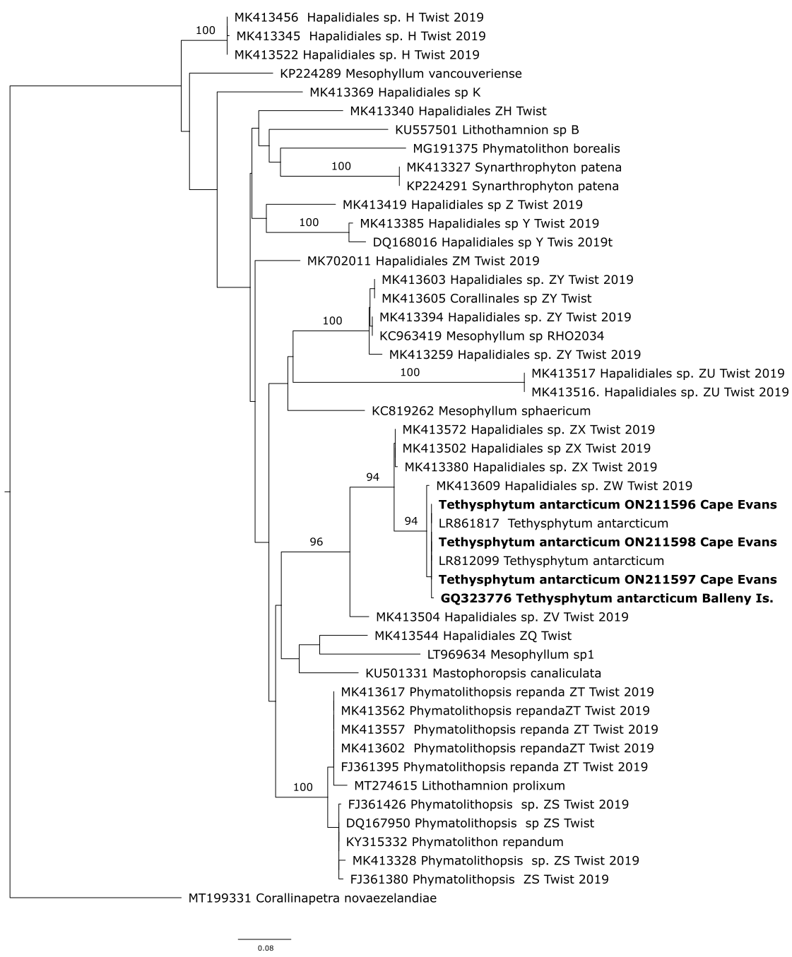Figure S1. Maximum-likelihood phylogeny (−log Ln = -4204.8994) of psbA sequences of Tethysphytum antarcticum and related sequences from GenBank. Model used for codons (First = TNe+I+G4; second = F81+F+I+G4; third = TPM3u+F+I+G4). Corallinapetra novaezelandiae used as outgroup
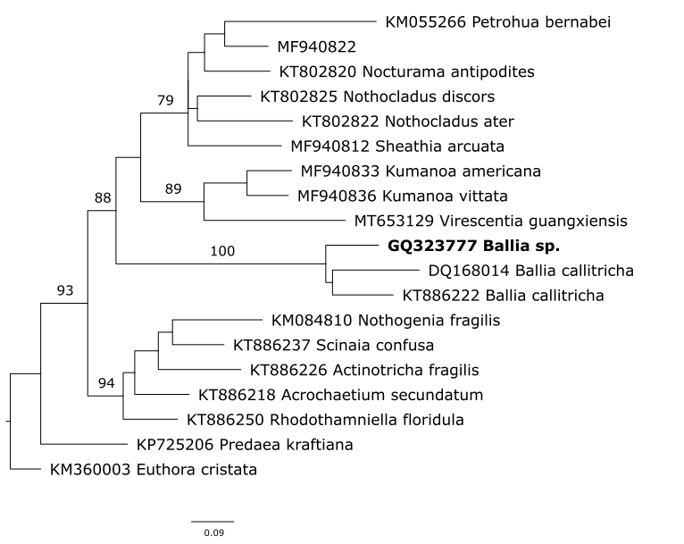

Figure S2. Maximum-likelihood phylogeny (−log Ln = -5128.7249) of psbA sequences of Ballia sp. and related sequences from GenBank. Model used for codons (First = TNe+I+G4; second = JC+I+G4; third = TVM+F+G4). Euthora cristata used as outgroup.

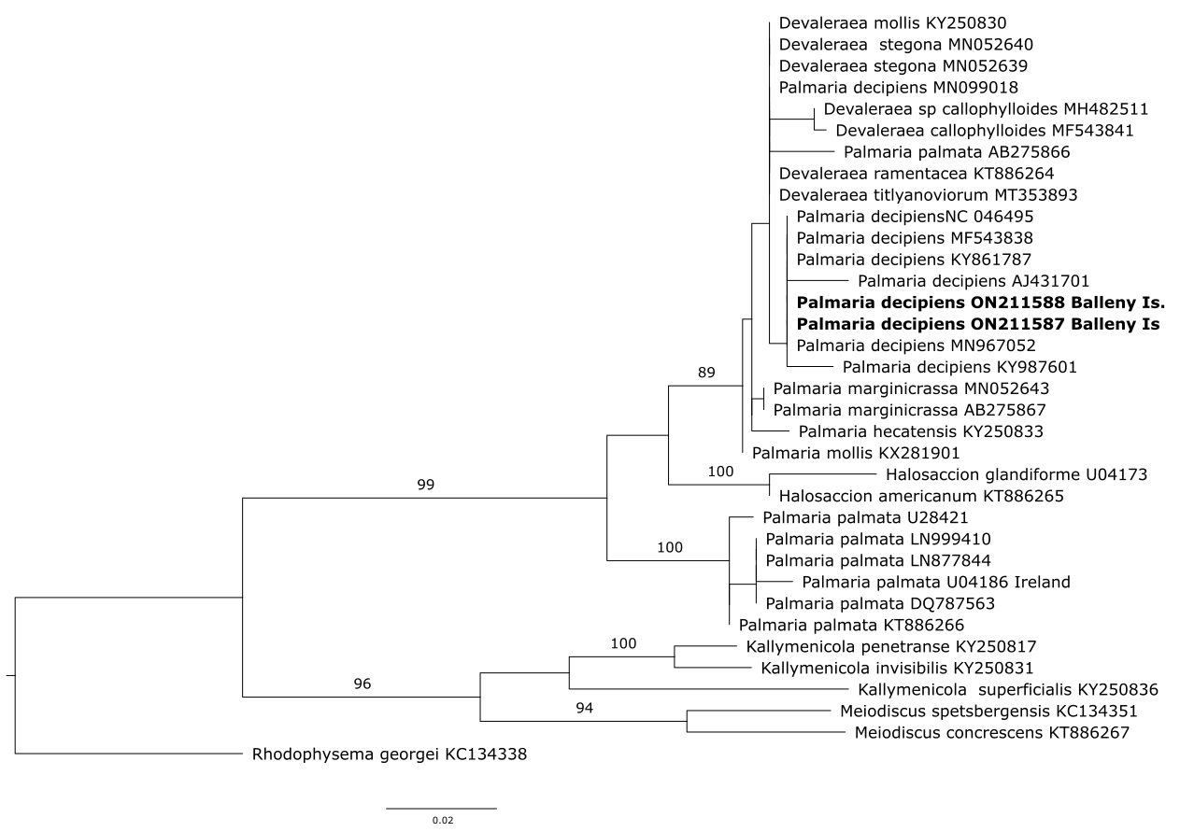
Figure S3. Maximum-likelihood phylogeny (−log Ln = -2469.9688) of rbcL sequences of Palmaria decipiens and related sequences from GenBank. Model used for codons (First = TN+F+G4; second = JC+I+G4; third = HKY+F+G4). Rhodophysema georgei used as outgroup.

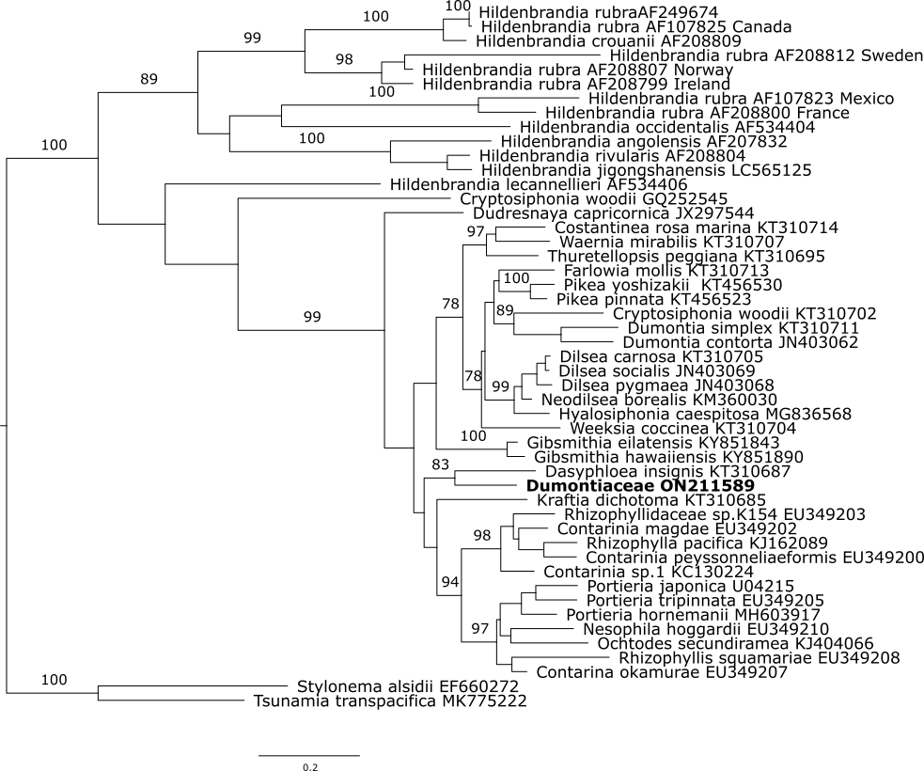
Figure S4. Maximum-likelihood phylogeny (−log Ln = -13281.8477) of rbcL sequences of Dumontiaceae and related sequences from GenBank. Model used for codons (First = TIM+F+I+G4; second = TVMe+I+G4; third = TIM2+F+I+G4). Stylonema alsidii and Tsunamia transpacifica used as outgroups.

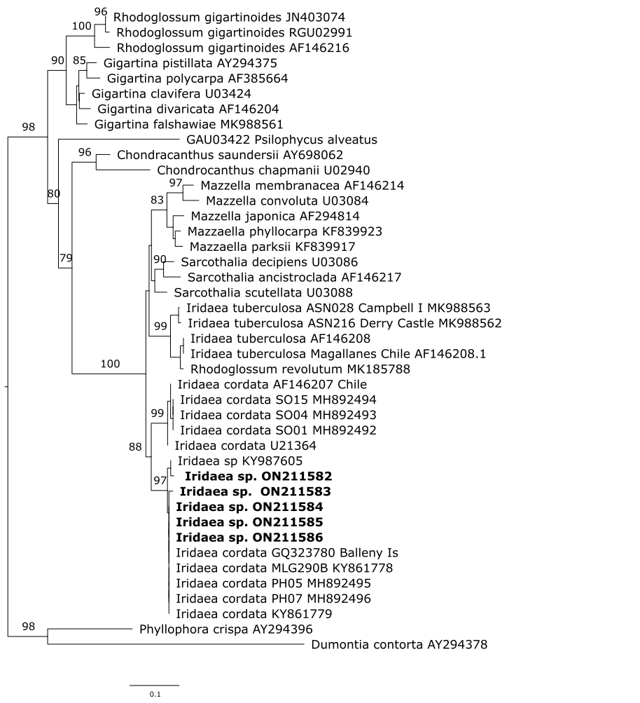
Figure S5. Maximum-likelihood phylogeny (−log Ln = -6040.8960) of rbcL sequences of Iridaea sp. and related sequences from GenBank. Model used for codons (First = TN+F+I+G4; second = F81+F+I+G4; third = HKY+F+G4). Phyllophora crispa and Dumontia contorta used as outgroups.

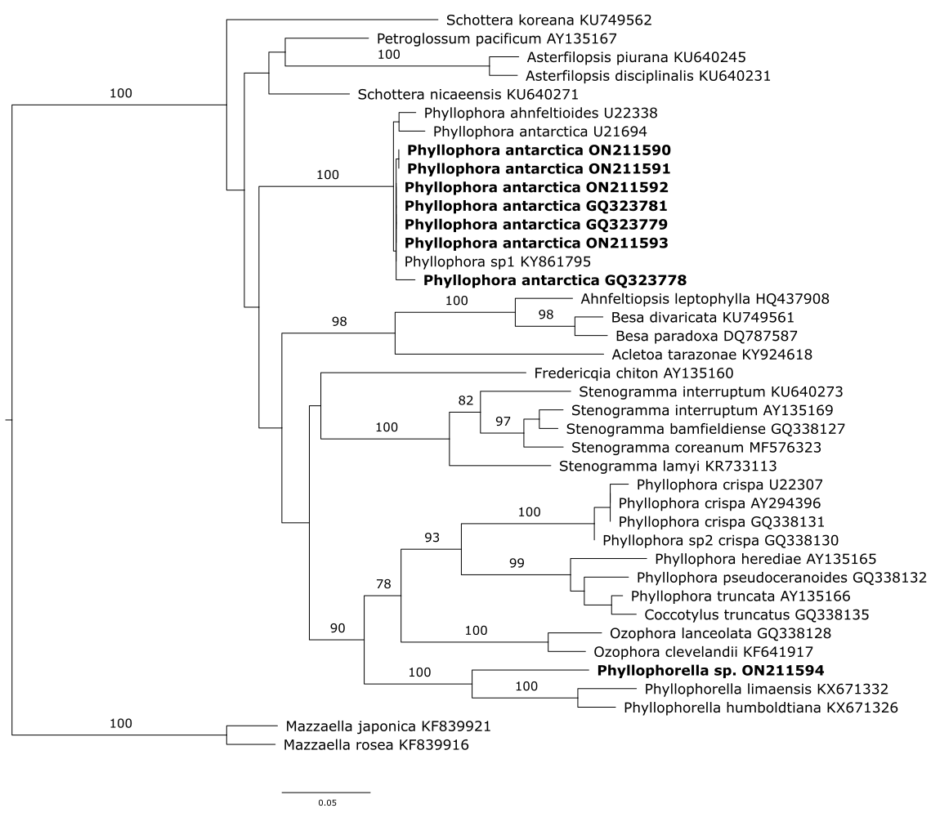
Figure S6. Maximum-likelihood phylogeny (−log Ln = -7152.9271) of rbcL sequences of Phyllophora antarctica and related sequences from GenBank. Model used for codons (First = TN+F+I+G4; second = TVM+F+I+G4; third = K3Pu+F+I+G4). Mazzaella japonica and M. rosea used as outgroups.

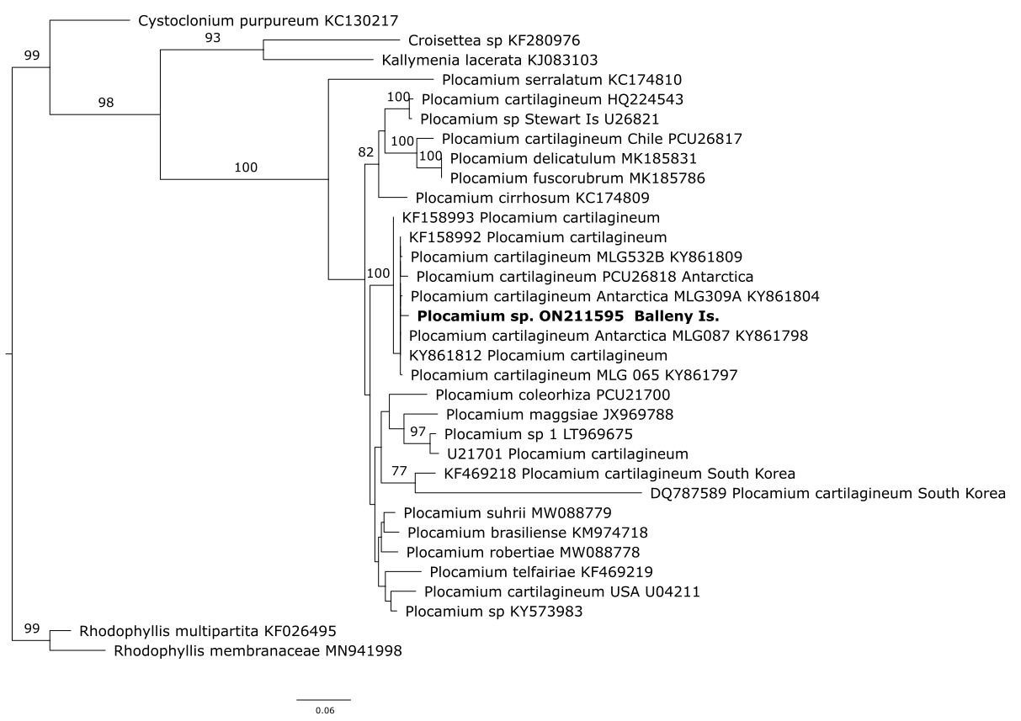
Figure S7. Maximum-likelihood phylogeny (−log Ln = -5658.2997) of rbcL sequences of Plocamium sp. and related sequences from GenBank. Model used for codons (First = TN+F+I+G4; second = K3P+I+G4; third = TN+F+G4). Rhodophyllis membranacea and R. multipartita used as outgroup.

