**Extreme summer marine heatwaves increase Chlorophyll-a in the Southern Ocean**

**Online Supplement**

**Methods**

**Heatwave data from the marine heatwave tracker**

Extreme marine heatwaves in the Southern Ocean were identified using the marine heatwave tracker (http://www.marineheatwaves.org/tracker.html). This digital tool use 30 years of global baseline data to determine moderate, strong, severe and extreme MHWs, as defined by Hobday *et al*. (2018). The tracker hosts all historic MHW records from 1st January 1982 to ca. two weeks before present day. It calculates MHWs based on the R version of the Hobday *et al.* (2016) marine heatwave definition. R data can be freely downloaded (https://robwschlegel.github.io/heatwaveR/articles/OISST_preparation.html) and MHWs can be detected using the online tutorial (https://robwschlegel.github.io/heatwaveR/articles/gridded_event_detection.html). This method has been used in several recent studies (Oliver *et al.* 2018, Smale *et al*. 2019). The reported MHWs are presented on a regular geographic grid with quarter degree grid cells dividing the Earth's surface into smaller squares forming a system of nodes. At high latitudes, these grid cells adopt an elongated trapeze shape. The shape of the MHW vector overlay may therefore not entirely overlap with the superimposed chl. *a* map. However, this vector overlay is only a visual guide showing the boundaries of the MHW with respect to the phytoplankton bloom, and it does not impact the analysis.

The global satellite product used in the MHW Tracker to detect temperature anomalies is the daily Optimally Interpolated Sea Surface Temperature (OISST) based on NOAA satellite measurements. These satellite data allow NOAA to monitor worldwide SST (Yang *et al.* 2013) and can be freely downloaded from https://www.ncdc.noaa.gov/oisst. Daily OSSIT is constructed by combining a series of platform observations, including satellites, ships and buoys, on a global grid. Interpolation methods create a spatially complete SST map. A key limitation to this product is that high latitudes *in situ* observations are sparse. The daily OSSIT data product is sourced from two sensor types to reduce potential errors: 1) the Advanced Very High Resolution Radiometer (AVHRR) which is a thermal infrared instrument that cannot see through clouds, and 2) the Advanced Microwave Scanning Radiometer (AMSR) which is a microwave instrument that can measure SST during most weather conditions. These records began in late 1981 and have continued to the present. In the polar regions, satellite derived sea ice concentrations aid in determining a proxy SST in the marginal ice zone using an empirically derived regression with respect to SST observations (Banzon *et al.* 2019).

The MHW Tracker allows zooming into a specific region and time period starting from January 1st, 1992. The user can also filter out different categories of MHWs from moderate to extreme events. Daily time series data are available for each pixel during a heatwave event. The information provided is the geographical location, duration, start date, peak date and end date of the MHW as well as various climatic data (such as temperature) (Schlegal 2018).

We interrogated the MHW tracker in great detail to identify extreme summer MHWs that were spatially extensive and occurred across more than 5 grid cells (>140 km2) rather than being just small hotspots of increased SST. The analysis focused on MHWs occurring in summer months (November to February) to avoid light limitation for phytoplankton and to minimize sea ice coverage as in Frölicher *et al.* (2018). Extreme MHWs were identified week by week starting January 1st, 2002 through to December 29th, 2018. A search was made for evidence of events on days 1, 8, 15, 22 and 29 (28 for February) of each month November to February. For each identified extreme MHW, the time series tool was used to extract associated data related to: (a) geographic location, (b) start date, (c) the average surface temperature, (d) the temperature for the peak date and (e) duration, (f) accumulated intensity, (g) maximum intensity and (h) mean intensity of the MHW.

Similar to Arrigo *et al.* (2008), we used sea ice extent to assign individual MHWs to four regions: the Sub-Antarctic Zone (SAZ), the Permanently Open Ocean Zone (POOZ), the Seasonal Sea Ice Zone (SSIZ) and the Coastal Zone (CZ), where the two latter zones are more influenced by sea ice. We used the National Snow and Ice Data Centre image archive (https://nsidc.org/data/seaice_index/archives) to determine province boundaries for the SSIZ and POOZ using maximum sea ice extents. The CZ was defined as being adjacent to land and the SAZ was defined as being between the Sub-Tropical Front and the Polar Front.

The 19 identified MHWs varied widely in maximum temperature (-0.75 to 15.92 ℃), duration (8-146 days), and cumulative (10-469 ℃ above 90% climatic record × days), maximum (1.15-4.48 ℃ above 90% climatic record) and mean (0.55-2.52 ℃ above 90% climatic record) intensity (Table S1). Furthermore, an Anova test confirmed that Climatic SST were colder for MHW-sites positioned in zones that are more influenced by sea ice (p < 0.001; pooled CZ and SSIZ = -0.27 ℃ ± 0.09 SE vs. pooled POOZ and SAZ = 5.12 ℃ ± 1.72 SE).

**Chlorophyll *a* from Aqua MODIS satellite images**

Next, we extracted high quality Aqua MODIS satellite imagery which coincided with the 19 identified extreme MHWs. Moderate Resolution Imaging Spectroradiometer (MODIS) is a sensor on the Aqua satellite that passes south to north over the Equator and covers the entire Earth’s surface every 1-2 days, acquiring data in 36 wavelength bands. MODIS products are operationally processed to level-2 (georeferenced and calibrated data with variables at the same resolution and location) and level-3 (as level 2, but with variables mapped on uniform space-time grid scales for completeness and constancy). Level-2 Ocean Colour data was obtained from the NASA Ocean Colour Level 1 & 2 Data Browser (https://oceancolor.gsfc.nasa.gov/cgi/browse.pl?sen=am) and processed using the ENVI Plugin for Ocean Colour (EPOC) (Fig. S1).

Aqua satellite data are available from 4th May 2002. The MODIS ocean colour data was used to determine the Chl. *a* concentration of surface waters in cloud free areas at a spatial resolution of 1 km. Aqua MODIS has several data products that can be used to measure large-scale phytoplankton dynamics, including the MODIS Chlorophyll *a* Concentration (chlor_a) product. The chlor_a product combines two algorithms: 1) the O’Reilly band ratio OC3/OC4 (OCx) algorithm, and 2) the Hu Colour Index (CI) algorithm. The chlor_a product returns the near-surface concentration of Chl. *a* in mg m-3. This metric is calculated using an empirical relationship derived from *in situ* measurements of Chl. *a* and blue-to-green band ratios of *in situ* Remote Sensing Reflectance (RSR) (Blondeau-Patissier *et al.* 2014). Implementation is contingent on the availability of three or more sensor bands spanning the 440-570 nm spectral regime. MODIS RSR is the ratio of upwelling radiance (light reflected by the ocean’s surface) to downwelling irradiance (density flux of energy per unit area). Chl. *a* algorithms use RSR coupled with *in situ* measurements of Chl. *a* to estimate concentrations in mg m-3 (Dutkiewicz *et al.* 2019, Werdell *et al.* 2018). The retrieved water-leaving radiance measured by each sensor is subsequently normalized to reduce effects of solar orientation and atmospheric attenuation of the down-welling radiation. This produces a normalized water-leaving radiance commonly expressed as radiance reflectance (Rsr). Information regarding the Aqua MODIS sensor and data product algorithms was accessed from the NASA MODIS website (<https://modis.gsfc.nasa.gov/>).

Aqua MODIS ocean products were analysed in ENVI 5.5 (Exelis Visual Information Solutions, Boulder, Colorado, Fig. S1) using the ENVI Plugin for Ocean Colour (EPOC) extension. This plugin was downloaded from the GitHub toolbox (https://github.com/dawhite/ENVIPlugins) and contains the software package SeaDAS (https://seadas.gsfc.nasa.gov/). NASA SeaDAS aids in the processing, display, analysis and quality control of remote sensing Earth data. SeaDAS can correct for and calibrate atmospheric components to determine Earth/ocean surface level signals. Ultimately, EPOC is a Hierarchical Data Format (HDF) and NetCDF file conversion, re-projection and georeferencing utility for NASA ocean colour datasets such as the chlor_a product used in this study.

The central location and peak date derived for each of 19 identified extreme MHWs, was used to identify the corresponding chlorophyll satellite data that was downloaded in the Network Common Data Form format from the NASA Ocean Colour Level 1 & 2 Data Browser. First, the correct date was allocated on the browser. Then, the visible region was specified to ‘Antarctic’ and the central coordinates were indicated. If chlorophyll images had high cloud or ice cover on the peak MHW date, the nearest date was chosen instead within five days of the peak with a high-quality image. The time series tool in the MHW tracker was then used to extract data on the average temperature, threshold temperature and extreme temperature for this new date.

**Control vs. Impact analysis of MHW effects**

We analysed if phytoplankton abundance (chl. *a* concentrations) was affected by MHWs by comparing Chl. *a* concentrations within the spatial location of the centre of an extreme MHW (Impacted area) to Chl. *a* concentrations in an adjacent region with ‘normal’ SSTs (Control area). A vector overlay was created using geographic latitude and longitude coordinates for the extreme MHWs (vector overlays of the severe and strong MHWs were also included for reference of location). As noted before, the shape of the MHW may have contained minor distortions due to the ¼ degree grid used on the MHW Tracker website compared to the geographic projection in ENVI. It was not essential that the vector overlay was exact as this was only a general indication for where the extreme, severe and strong sea surface temperatures anomalies were positioned in comparison with normal SSTs. Once the general position of the marine heatwave was identified then impacted and control measurements could be extracted using the region of interest (ROI) tool.

From the spatial centre of the MHW, 250 km and 500 km transect lines were drawn along 16 equidistant directions (see Fig. S2). Control locations of 25 × 25 km ROIs were chosen at distances of 250 and 500 km along these transects, if >80% cloud-free. These two distances were chosen to provide a more robust and replicated impact analysis, analogous to Ortiz-Ahumada *et al.* (2018) who sampled two 300 km long transects off different coasts for SST, chl. *a* and primary production. Measurement resolution was also similar (18 × 18 km) (Ortiz-Ahumada *et al.* 2018). The impacted area was defined as a >80% cloud free, 25 × 25 km ROI. The ROI was taken at the centre of the MHW. If the centre of the MHW exceeded 20% cloud cover, the ROI was shifted to the closest region that was >80% cloud-free. Finally, mean and standard deviation of Chl. *a* (mg m-3) were extracted for both the impacted region and all corresponding control sites.

**Correlation analysis**

Correlation analyses were done on Log response ratio effect sizes (Ln RR), where Ln RR = Ln (Chl. *a* impact/Chl. *a* control). Positive Ln RR values indicate that MHWs had positive effects on chl. *a* concentration. Ln RR values were correlated against: (a) the temperature at the impact site, (b) the difference between the MHW and climatic mean temperature (‘delta-temperature’), and against (c) the duration, (e) maximum intensity, (f) mean intensity and (g) cumulative intensity of each of the 19 individual MHWs (Fig. S3).

**Online supplement Tables.**

**Table S1.** Attributes of 19 extreme summer marine heatwaves (MHW) in the Southern Ocean observed between 2002 to 2018 in November to February. CZ = coastal zone, SSIZ = seasonal sea ice zone, POOZ = permanently open ocean zone and SAZ = Sub-Antarctic zone. Temperature = °C, Duration = days, Intensity = °C, Chl. *a* concentration = mg m-3. N = number of replicated control sites for each distance.

|  |  |  |  |  |  |  |  |  |  |  |  |  |  |  |  |
| --- | --- | --- | --- | --- | --- | --- | --- | --- | --- | --- | --- | --- | --- | --- | --- |
| **MHW**  **I.D.** | **Zone** | **Longitude** | **Latitude** | **Image**  **Acquisition**  **Date** | **Climate**  **Temp.** | **MHW**  **Temp.** | **MHW**  **Duration** | **MHW**  **Cumulative**  **Intensity** | **MHW**  **Maximum**  **Intensity** | **MHW**  **Mean**  **Intensity** | **MHW**  **Impact**  **Chl.a** | **Control**  **250 km**  **Chl.a** | **Control**  **500 km**  **Chl.a** | **N**  **250 km** | **N**  **500 km** |
| 1 | SSIZ | -134.875 | -66.375 | 26/11/2002 | -1.55 | -0.75 | 98 | 31.12 | 1.42 | 0.55 | 0.23 | 0.11 | NA | 1 | 0 |
| 2 | CZ | 166.875 | -75.625 | 15/12/2004 | -1.26 | 0.98 | 37 | 51.3 | 2.64 | 1.65 | 3.25 | 1.66 | 0.21 | 2 | 1 |
| 3 | CZ | 10.625 | -68.875 | 8/01/2005 | -0.92 | 2.13 | 21 | 37.65 | 3.3 | 1.64 | 2.98 | 0.19 | NA | 3 | 0 |
| 4 | CZ | 165.625 | -74.375 | 12/01/2006 | -1.37 | 0.64 | 37 | 57.31 | 2.2 | 1.51 | 9.29 | 0.325 | 0.728 | 4 | 4 |
| 5 | SAZ | -131.625 | -49.125 | 15/11/2009 | 7.93 | 11.37 | 90 | 189.9 | 3.47 | 2.11 | 0.18 | 0.134 | 0.115 | 5 | 2 |
| 6 | SSIZ | -158.375 | -66.625 | 13/12/2009 | -1.33 | 0.41 | 8 | 9.77 | 2.31 | 1.22 | 2.12 | 1.057 | 0.377 | 3 | 3 |
| 7 | SAZ | -139.625 | -47.625 | 24/12/2009 | 10.39 | 14.59 | 104 | 256.22 | 4.35 | 2.46 | 0.39 | 0.286 | 0.25 | 8 | 2 |
| 8 | CZ | -97.125 | -71.375 | 5/02/2010 | -1.62 | -0.37 | 105 | 87.21 | 1.25 | 0.79 | 1.5 | 0.315 | 2.595 | 2 | 2 |
| 9 | CZ | 105.875 | -65.625 | 30/01/2011 | -1.32 | 2.06 | 59 | 97.61 | 3.38 | 1.65 | 2.19 | 0.746 | 0.298 | 5 | 4 |
| 10 | SSIZ | -129.125 | -69.625 | 8/01/2013 | -1.18 | 0.74 | 109 | 138.67 | 2.08 | 1.27 | 4.2 | 0.44 | 0.19 | 1 | 2 |
| 11 | CZ | -95.375 | -71.625 | 21/02/2013 | -1.65 | -0.52 | 146 | 100.39 | 1.15 | 0.68 | 1.28 | 0.15 | 0.1 | 1 | 1 |
| 12 | CZ | 169.375 | -76.375 | 24/02/2013 | -0.8 | 1.56 | 32 | 39.87 | 2.2 | 1.53 | 1.63 | 0.813 | 0.27 | 3 | 1 |
| 13 | CZ | 104.625 | -64.625 | 28/12/2013 | -0.96 | 1.75 | 11 | 17.05 | 2.33 | 1.21 | 1.72 | 0.19 | 0.237 | 1 | 3 |
| 14 | SAZ | 151.625 | -46.375 | 15/12/2015 | 11.85 | 15.92 | 52 | 469.62 | 4.48 | 2.52 | 0.84 | 0.496 | 0.303 | 7 | 3 |
| 15 | SAZ | -176.875 | -51.625 | 7/11/2016 | 7.63 | 11.08 | 49 | 83.01 | 3.45 | 1.69 | 0.26 | 0.237 | 0.11 | 3 | 2 |
| 16 | POOZ | 159.875 | -57.375 | 8/11/2016 | 1.92 | 5.46 | 75 | 163.06 | 3.54 | 1.71 | 0.14 | 0.2 | 0.165 | 6 | 2 |
| 17 | POOZ | 0.875 | -58.875 | 2/01/2017 | -0.38 | 2.55 | 124 | 175.62 | 2.75 | 1.46 | 1.07 | 0.494 | 0.345 | 5 | 2 |
| 18 | SAZ | 11.125 | -53.625 | 20/02/2017 | 1.13 | 3.41 | 17 | 24.4 | 2.5 | 1.35 | 0.16 | 0.27 | 0.175 | 4 | 2 |
| 19 | POOZ | 83.125 | -55.125 | 7/11/2017 | 0.46 | 3.59 | 33 | 49.12 | 3.02 | 1.44 | 1.04 | 0.278 | 0.205 | 5 | 2 |

**Table S2.** Anova testing for effects of marine heatwaves (MHW; impacted site vs. control sites positioned either 250 or 500 km from the centre of the MHW) on Chl. *a* concentrations in two types of waters (cold plus strong influence by sea ice vs. warmer plus less influence by sea ice) with two regions nested within each type of water (CZ and SSIZ were nested within the cold zone; POOZ and SAZ within the warmer zone). Significant results are in bold.

|  |  |  |  |  |  |
| --- | --- | --- | --- | --- | --- |
| Control distance | Test factor | SS | DF | F | P |
| 250 km | Sea temperature | 9.443 | 1 | 14.042 | **0.001** |
|  | Region(Sea temperature) | 1.009 | 2 | 0.750 | 0.480 |
|  | MHW | 11.150 | 1 | 16.581 | **0.000** |
|  | Sea temperature x MHW | 4.190 | 1 | 6.231 | **0.018** |
|  | Total | 47.311 | 37 |  |  |
| 500 km | Sea temperature | 11.567 | 1 | 17.210 | **0.000** |
|  | Region(Sea temperature) | 1.435 | 2 | 1.067 | 0.357 |
|  | MHW | 15.036 | 1 | 22.372 | **0.000** |
|  | Sea temperature x MHW | 2.949 | 1 | 4.387 | **0.045** |
|  | Total | 52.253 | 35 |  |  |

**Table S3.** Spearman’s rank correlation analysis between Ln RR and six marine heat waves (MHW) attributes. Ln RR = Ln (Chl. *a*Impact-site/Chl. *a*Control-sites), where control sites were analysed separately for 250 and 500 km distances from the impact site. N250 km = 19, N500 km = 17, see Table S1 for details. Significant results are in bold. Delta T = Temperature difference between the temperature at the peak of the MHW and the climatic mean SST at the same location.

|  |  |  |  |  |
| --- | --- | --- | --- | --- |
| Independent variable | r 250 Km | P 250 Km | r 500 Km | P 500Km |
| Temperature MHW impacted site | -0.584 | **0.009** | -0.525 | **0.031** |
| Delta T | -0.482 | **0.036** | -0.453 | 0.068 |
| MHW Duration | 0.061 | 0.803 | -0.056 | 0.830 |
| MHW Cumulative Intensity | -0.212 | 0.383 | -0.243 | 0.348 |
| MHW Max Intensity | -0.552 | **0.014** | -0.462 | 0.062 |
| MHW Mean Intensity | -0.522 | **0.022** | -0.296 | 0.249 |

**Online supplement Figures.**

**Figure S1.** Processing summary for analysis in ENVI 5.5, including identification of an extreme marine heatwave event, determination of Southern Ocean location and raster image download (ovals), and usage of EPOC extension (rounded rectangles), general image modifications (circles), experimental design (rectangles) and data collection (white rectangle).

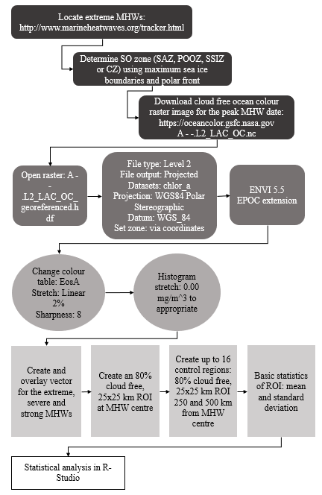

**Figure S2.** The spatial design outlining ourControl vs. Impact analysis. A hypothetical pixelated extreme MHW is shown with maximum intensity in the centre (red = I = impact site). This image was superimposed on a chlorophyll-a map (with a minimum of 80% cloud-free). Data were extracted from a single 25 x 25 km area at the centre of the extreme MHW and from up to a maximum of 32 control regions (C). Controls were taken at 16 compass directions at 250 km and 500 km from the heatwave centre. The figure shows an ideal example where all 32 control sites could be analysed but in the actual data this was reduced to 0 to 8 at each of 250 and 500 km due to ice and/or cloud cover (see Table S1 for details).

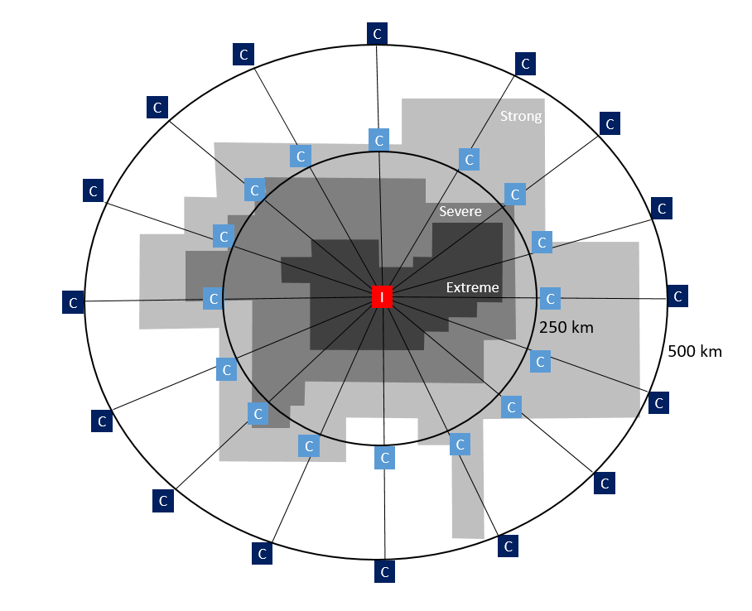

**Figure S3.** Scatter plots of Ln RR effect sizes vs. six MHW attributes, where Ln RR = Ln (Chl. aImpact-site/Chl. aControl-sites) - calculated using control sites both 250 and 500 km away from the impact site.



**References**

Arrigo, K. R., van Dijken, G. L., & Bushinsky, S. (2008). Primary production in the Southern Ocean, 1997-2006. *Journal of Geophysical Research: Oceans, 113*(8). <https://doi.org/10.1029/2007JC004551>

Banzon, V., Reynolds, R. & National Centre for Atmospheric Research Staff (Eds). Last modified 25 June 2019. “The Climate Data Guide: SST data: NOAA High-resolution (0.25x0.25) Blended Analysis of Daily SST and Ice OISSTv2.” Retrieved from [https://climatedataguide.ucar.edu/climate-data/sst-data-noaa-high-resolution-025x025-blended-analysis-daily-sst-and-ice-oisstv2](https://climatedataguide.ucar.edu/climate-data/sst-data-noaa-high-resolution-025x025-blended-analysis-daily-sst-and-ice-oisstv2%20)

Blondeau-Patissier, D., Gower, J. F. R., Dekker, A. G., Phinn, S. R., & Brando, V. E. (2014, 2014/04/01/). A review of ocean color remote sensing methods and statistical techniques for the detection, mapping and analysis of phytoplankton blooms in coastal and open oceans. *Progress in Oceanography, 123*, 123-144. [https://doi.org/https://doi.org/10.1016/j.pocean.2013.12.008](https://doi.org/https:/doi.org/10.1016/j.pocean.2013.12.008)

Dutkiewicz, S., Hickman, A. E., Jahn, O., Henson, S., Beaulieu, C., & Monier, E. (2019). Ocean colour signature of climate change. *Nature Communications, 10*(1). <https://doi.org/10.1038/s41467-019-08457-x>

Frölicher, T. L., Fischer, E. M., & Gruber, N. (2018). Marine heatwaves under global warming. *Nature, 560*(7718), 360-364. <https://doi.org/10.1038/s41586-018-0383-9\>

Hobday, A. J., Alexander, L. V., Perkins, S. E., Smale, D. A., Straub, S. C., Oliver, E. C. J., . . . Wernberg, T. (2016). A hierarchical approach to defining marine heatwaves. Progress in Oceanography, 141, 227-238. https://doi.org/10.1016/j.pocean.2015.12.014

Hobday, A. J., Oliver, E. C. J., Gupta, A. S., Benthuysen, J. A., Burrows, M. T., Donat, M. G., . . . Smale, D. A. (2018). Categorizing and naming marine heatwaves. *Oceanography, 31*(2 Special Issue), 162-173. <https://doi.org/10.5670/oceanog.2018.205>

NASA Goddard Space Flight Centre, Ocean Biology Processing Group. (2014). Moderate Resolution Imaging Spectroradiometer (MODIS) Ocean Colour Data, NASA OB.DAAC. Accessed June 6, 2019, from <https://oceancolor.gsfc.nasa.gov/cgi/browse.pl?sen=am>

NASA Goddard Space Flight Centre. *Moderate Resolution Imaging Spectroradiometer (MODIS).* Retrieved August 22, 2019, from <https://modis.gsfc.nasa.gov/about/>

NASA Goddard Space Flight Centre. *SeaDAS.* Retrieved August 22, 2019, from <https://seadas.gsfc.nasa.gov/about/>

National Snow & Ice Data Centre. (2019). *Sea Ice Index: Data Archive.* Retrieved June 6, 2019, from <https://nsidc.org/data/seaice_index/archives>

NOAA National Centers for Environmental Information. *Optimum Interpolation Sea Surface Temperature (OISST).* Retrieved November 20, 2019, from <https://www.ncdc.noaa.gov/oisst>

Oliver, E. C. J., Donat, M. G., Burrows, M. T., Moore, P. J., Smale, D. A., Alexander, L. V., . . . Wernberg, T. (2018). Longer and more frequent marine heatwaves over the past century. *Nature Communications, 9*(1). <https://doi.org/10.1038/s41467-018-03732-9>

Ortiz-Ahumada, J. C., Álvarez-Borrego, S., & Gómez-Valdés, J. (2018). Effects of seasonal and interannual events on satellite-derived phytoplankton biomass and production in the southernmost part of the California Current System during 2003-2016. *Ciencias Marinas, 44*(1), 1-20. <https://doi.org/10.7773/cm.v44i1.2743>

Schlegel, R. W. (2020). Marine Heatwave Tracker. http://www.marineheatwaves.org/tracker. doi: 10.5281/zenodo.3787872

Smale, D. A., Wernberg, T., Oliver, E. C. J., Thomsen, M., Harvey, B. P., Straub, S. C., . . . Moore, P. J. (2019, 2019/03/04). Marine heatwaves threaten global biodiversity and the provision of ecosystem services. *Nature Climate Change*. <https://doi.org/10.1038/s41558-019-0412-1>

Werdell, P. J., McKinna, L. I. W., Boss, E., Ackleson, S. G., Craig, S. E., Gregg, W. W., . . . Zhang, X. (2018). An overview of approaches and challenges for retrieving marine inherent optical properties from ocean color remote sensing. *Progress in Oceanography, 160*, 186-212. <https://doi.org/10.1016/j.pocean.2018.01.001>

Yang, J., Gong, P., Fu, R., Zhang, M., Chen, J., Liang, S., . . . Dickinson, R. (2013, 09/15/online). The role of satellite remote sensing in climate change studies. *Nature Climate Change, 3*, 875. <https://doi.org/10.1038/nclimate1908>