Antarctic sea anemone distribution, abundance and relationships with habitat composition, community structure, and anthropogenic disturbance
Leslie A. Watson*¹, Jonathan S Stark², Glenn Johnstone², Erik Wapstra¹ Karen Miller^{1,3}
¹School of Natural Sciences, University of Tasmania, Private bag 55, Hobart, Tasmania, 7001 Australia
²Australian Antarctic Division, 203 Channel Hwy, Kingston, Tasmania, 7050 Australia
³Australian Institute of Marine Science, 35 Stirling Hwy, Crawley, Western Australia, 6009, Australia
*Corresponding author
Email: Leslie.Watson@utas.edu.au
Phone: +61 4 6654 8719
ORCiD - 0000-0002-3391-4533

ORCiD:
Jonathan S. Stark - 0000-0002-4268-8072
Erik Wapstra - 0000-0002-2050-8026
Supplementary Material
Table 1: Overlapping external morphological identifies used to classify sea anemones groupings at Casey Station and Davis Station, Antarctica.
Species | Tentacle numbers | Tentacle Shape | Colour | Size | Depth Range | References | Sea anemone grouping
Urticinopsis antarctrica | 120-800 | Short and conical, sometimes rounded at the end | Sandy Colour | Body column = 15 cm | 6-223+m | Brueggeman (1998) | Peach sea anemones
Isotealia antarctica | 168-192 | Blunt and conical | Brown-violet or salmon | Pedal disc = 2-3cm | 15-600m | Brueggeman (1998) | Peach sea anemones
Glyphoperidium bursa | 338-551 | Long, and flexible | red | Body column = 0.7-4cm | 9-400 m | Sanamyan et al. (2015) | Peach sea anemones
Stomphia Selaginella | 64-68 | Stout, conical, pointed | Marbled orange and white | Body column = 3-4cm | 25-1674m | Sanamyan et al. (2015) | Marbled sea anemones
Hormosoma scotti | 48 (juvenile) | long, tapering, pointed | Marbled orange and white | Body column = 2.7cm  Basal disc = 8 cm | 16 - 769 m | Sanamyan et al. (2015) | Marbled sea anemones

Brueggeman, P. 1998. Cnidaria – Anthozoa: anemones, soft coral: Underwater field guide to Ross Island & McMurdo Sound, Antarctica. The National Science Foundation.
Sanamyan, N., Sanamyan, K. & Schories, D. 2015. Shallow water Actiniaria and Corallimorpharia (Cnidaria: Anthozoa) from King George Island, Antarctica. Invertebrate Zoology, 12, 1-51.

Sample photoquadrate images of peach sea anemone group and marbled sea anemone group.
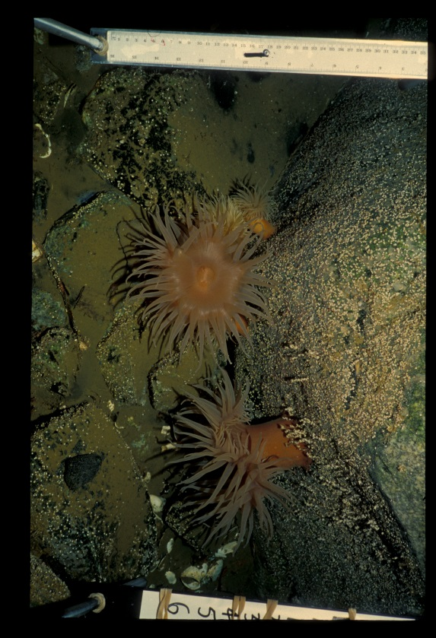
Figure 1: Peach sea anemone from Casey Station.
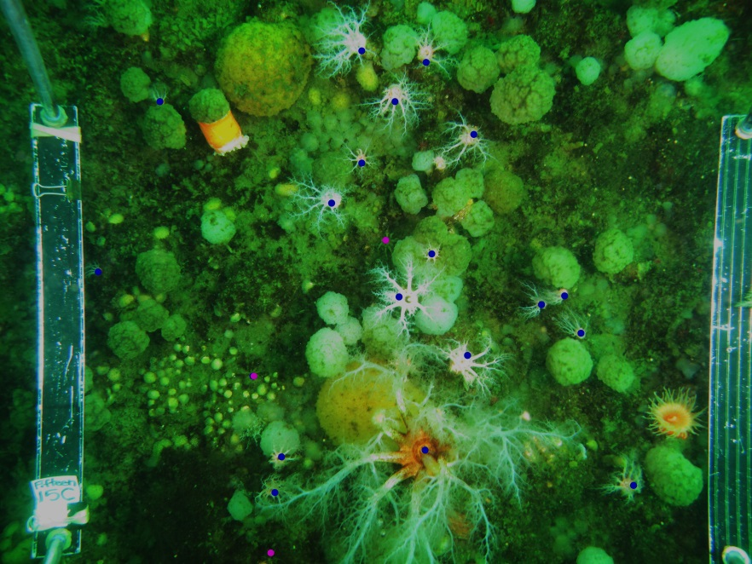
Figure 2: Marbled sea anemone at Davis station.

