- b.
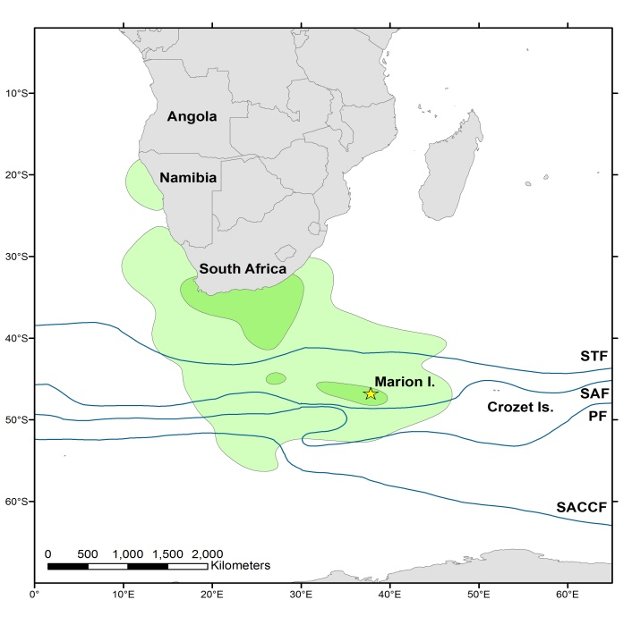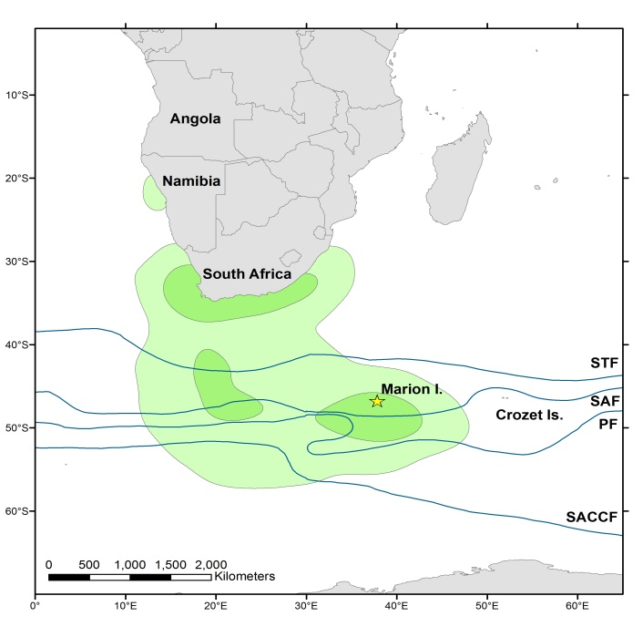
Appendix 1 Year-round 50% (dark green) and 95% (light green) density kernels of female (a; n = 4) and male (b; n = 6) white-chinned petrels breeding at Marion Island. = Breeding colony on Marion Island, STF = Subtropical Front, SAF = Subantarctic Front, PF = Polar Front, and SACCF = Southern Antarctic Circumpolar Current Front.

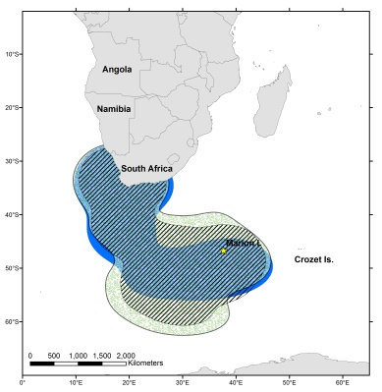
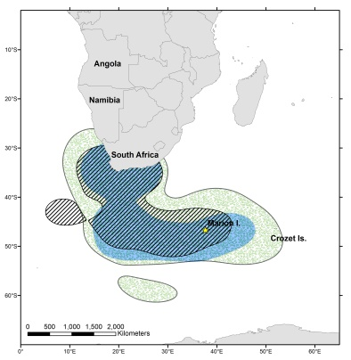
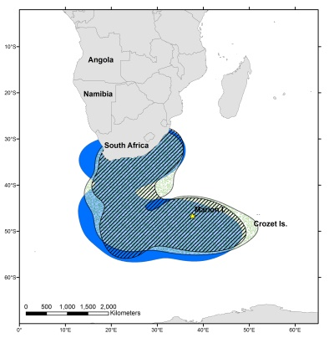
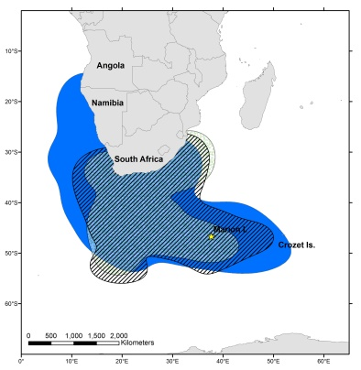
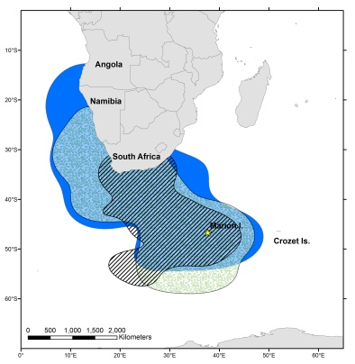
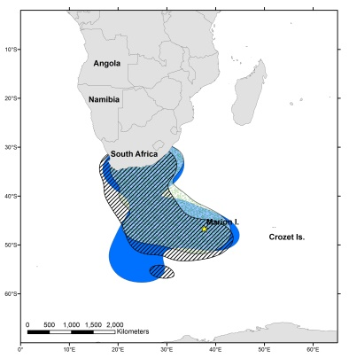
Bird 1
Bird 2
Bird 3
Bird 4
Bird 5
Bird 6

Appendix 2 95% density kernels of white-chinned petrels from Marion Island, during 2009/2010 (green dots), 2011 (diagonal stripes) and 2012 (solid blue).= Breeding colony on Marion Island.
Bird 7
Bird 8
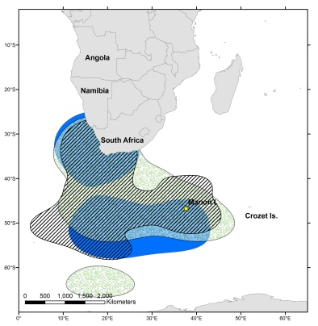
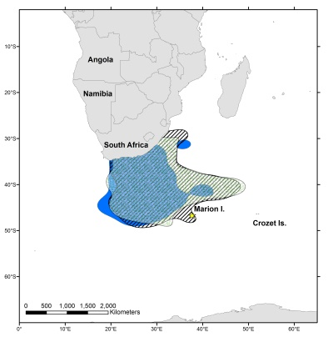
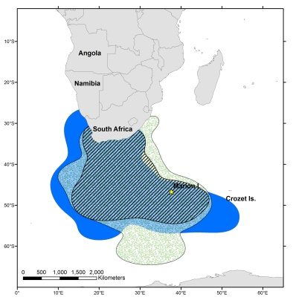
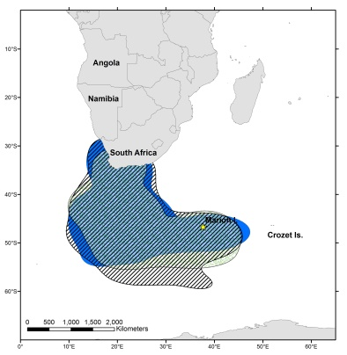
Bird 9

Bird 10

Appendix 2 (continued)

