Supplementary Material
Supplementary Figure SF1: Soil pH of surface horizons across the three studied landscapes. Regressions for Ong Valley horizon 2, Mount Achernar Horizon 2, and Dominion Range horizon 1 are significant (p < 0.05).

Supplementary Table ST1: Example soil profiles within soil units.
Typical soil profile (Dominion Range and Mount Achernar) |  | Typical soil profile (Ong Valley)
Map unit A:  1: 0-4 cm; light yellowish brown (2.5 Y 6/3) slightly gravelly, silty fine to coarse sand; over massive ice. | 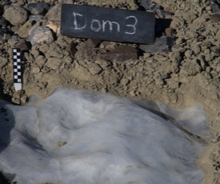  Location: S 85°16.091  E 164°39.510  Glacic Haploturbel | Map unit E:  1: 0-1 cm; (5Y 6/2) stony, cobbley, gravelly, slightly silty fine to coarse sand;  2: 1-15 cm; light yellowish brown (2.5Y 6/3) gravelly, silty fine sand;  3:15+ cm; massive ice. | 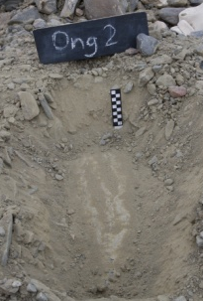  Location: S 83°13.995  E 157°40.213  Glacic Haploturbel
Map unit B:  1: 0-2 cm; light gray (2.5 Y 7/2) slightly cobbley, gravelly fine to medium sand;  2: 2-13 cm; gray (2.5 Y 6/1) very fine gravelly, slightly silty very fine to medium sand;  3: 13+ cm; massive ice. | 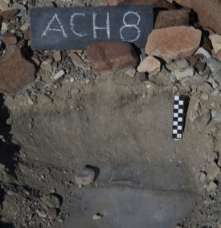  Location: S 84°11.773  E 161°13.394  Glacic Haplorthel | Map unit F:  1: 0-0.5 cm; pale yellow (2.5Y 7/3) slightly boulder, stony, cobbley, very gravelly medium sand;  2:0.5-13 cm; pale yellow (2.5Y 7/3) fine to coarse gravelly, fine and medium sand, soft;  3: 13-60 cm; pale yellow (2.5Y 7/3) fine to coarse gravelly, fine and medium sand, loose;  4: 60+ cm; massive ice. | 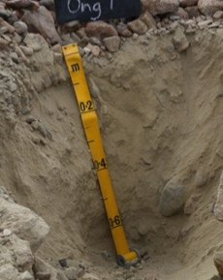  Location: S 83°15.027  E 157°43.701  Glacic Anhyorthel
Map unit C:  1: 0-5 cm; pale yellow (2.5 Y 7/3) slightly stony, slightly cobbley, gravelly very fine to coarse sand, moderately hard and massive;  2: 5-60 cm; pale yellow (2.5 Y 7/3) slightly cobbley, slightly fine gravelly very fine to medium sand;  3: 60+ cm; massive ice. | 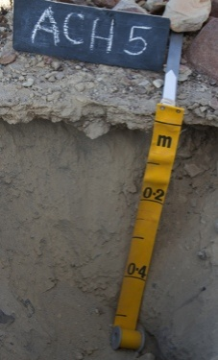  Location: S 84°13.199  E 161°11.861  Glacic Haploturbel | Map unit G:  1: 0-4 cm; light yellowish brown (2.5 Y 6/3) slightly boulder, cobbley, very gravelly medium to coarse sand, loose;  2: 4-30 cm; light yellowish brown (2.5Y 6/3.5) gravelly fine to coarse sand, soft;  3: 30-80+ cm;light yellowish brown (2.5Y 6/3.5) slightly gravelly fine to medium sand, soft; | 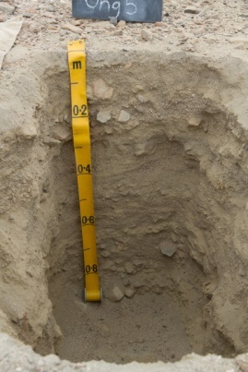Location: S 83°15.896  E 157°37.947  Typic Anhyturbel
Map unit D:  1: 0-1 cm; light gray (2.5 Y 7/2) slightly cobbley, very gravelly fine to coarse sand, slightly hard and platy;  2: 1-10 cm; pale yellow (2.5 Y 7/3) slightly cobbley fine to coarse sand;  3: 10-60 cm; light brownish gray (2.5 Y 6/2) slightly fine gravelly, silty, very fine to medium sand;  4: 60 + cm; massive ice. | 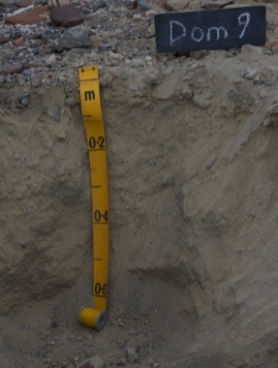  Location: S 85°15.989  E 164°53.703  Glacic Haplorthel | Map unit H:  1: 0-1 cm; light yellowish brown (2.5 Y 6/3) very gravelly coarse sand;  2: 1-4 cm; pale yellow (2.5Y 7/4) slightly gravelly silt, soft;  3: 4-35 cm; pale yellow (2.5Y 7/4) gravelly, silty fine sand, soft;  4: 35-80+ cm; light yellowish brown (2.5 Y 6/3) slightly boulder slightly stony, slightly cobbley, very gravelly, silty fine sand, soft. | 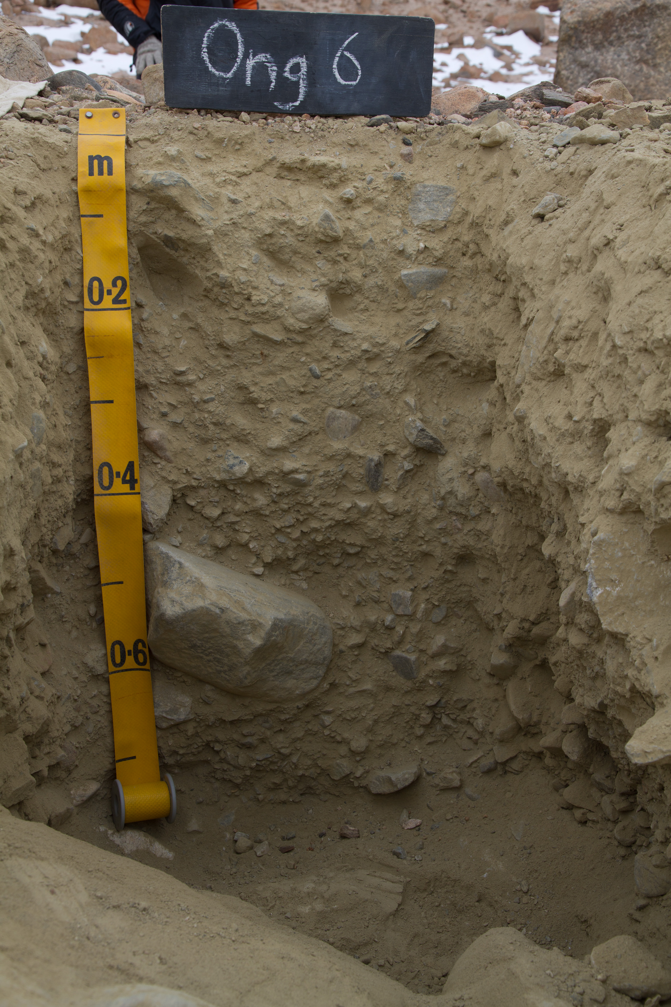  Location: S 83°16.263  E 157°37.493  Typic Anhyorthel
 |  | Map unit I:  1: 0-4 cm; greyish brown (2.5Y 5/2) slightly boulder, slightly stony, slightly cobbley, very gravelly coarse sand, loose;  2: 4-38 cm; pale yellow (2.5Y 7/4) slightly cobbley, gravelly medium to coarse sand, loose;  3: 38-44 cm; light yellowish brown (10YR 6/4) cobbley, gravelly fine to coarse sand, soft;  4: 44-70+ cm; light yellowish brown (2.5Y 6/4) slightly bouldery, slightly stony, slightly cobbley, very fine gravelly fine to coarse sand, soft; | 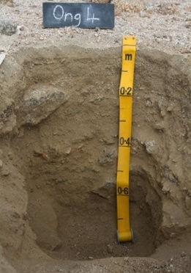  Location: S 83°16.422  E 157°36.107  Typic Anhyorthel
Supplementary Table ST2: Chemical and physical properties of Mount Achernar site soil horizons.
Map unit |  |  |  | A |  | B | C |  |  |  |  | D
 |  |  |  | Ach 3 | Ach 4 | Ach 8 | Ach 9 | Ach 7 | Ach 6 | Ach 5 | Ach 1 | Ach 2
Distance from ice edge (m) |  |  |  | 550 | 800 | 1500 | 2200 | 2900 | 3600 | 4200 | 5300 | 5500
 |  |  | Horizon
Moisture Content (% dry weight) |  |  | 1 | 2.85 | 2.91 | 3.01 | 2.20 | 2.25 | 1.99 | 1.79 | 1.23 | 0.89
 |  |  | 2 | 3.15 | 3.57 | 4.35 | 2.07 | 1.89 | 2.37 | 1.69 | 2.24 | 1.83
 |  |  | 3 |  |  |  | 2.52 | 1.90 |  |  | 2.33 | 1.96
 |  |  | 4 |  |  |  |  |  |  |  |  | 2.75
pH |  |  | 1 | 8.19 | 8.26 | 8.07 | 8.16 | 8.15 | 8.16 | 8.26 | 8.36 | 8.96
 |  |  | 2 | 8.63 | 8.53 | 8.56 | 7.87 | 8.15 | 8.22 | 8.22 | 7.94 | 8.15
 |  |  | 3 |  |  |  | 8.21 | 8.33 |  |  | 7.97 | 8.13
 |  |  | 4 |  |  |  |  |  |  |  |  | 8.22
EC (dS/m) |  |  | 1 | 0.56 | 0.62 | 1.31 | 1.95 | 2.24 | 2.75 | 2.30 | 0.26 | 0.36
 |  |  | 2 | 0.30 | 0.21 | 0.62 | 2.89 | 2.10 | 1.64 | 1.47 | 3.60 | 3.77
 |  |  | 3 |  |  |  | 1.27 | 0.97 |  |  | 2.34 | 4.39
 |  |  | 4 |  |  |  |  |  |  |  |  | 1.70
Total C (%) |  |  | 1 | 0.27 | 0.63 | 0.54 | 0.18 | 0.13 | 0.24 | 0.13 | 0.30 | 0.26
 |  |  | 2 | 0.33 | 0.71 | 0.73 | 0.35 | 0.22 | 0.38 | 0.34 | 0.33 | 0.33
 |  |  | 3 |  |  |  | 0.83 | 0.42 |  |  | 1.97 | 0.31
 |  |  | 4 |  |  |  |  |  |  |  |  | 1.71
Total N (%) |  |  | 1 | 0.04 | 0.04 | 0.07 | 0.04 | 0.04 | 0.08 | 0.05 | 0.01 | 0.01
 |  |  | 2 | 0.03 | 0.03 | 0.05 | 0.07 | 0.09 | 0.05 | 0.04 | 0.08 | 0.07
 |  |  | 3 |  |  |  | 0.07 | 0.04 |  |  | 0.13 | 0.16
 |  |  | 4 |  |  |  |  |  |  |  |  | 0.11
Water soluble cations (mg/kg) | Na |  | 1 | 109 | 54 | 193 | 173 | 248 | 360 | 523 | 134 | 257
 |  |  | 2 | 159 | 95 | 425 | 261 | 303 | 372 | 184 | 796 | 554
 |  |  | 3 |  |  |  | 179 | 204 |  |  | 667 | 635
 |  |  | 4 |  |  |  |  |  |  |  |  | 312
 | Mg |  | 1 | 29 | 12 | 49 | 55 | 67 | 96 | 118 | 11 | 13
 |  |  | 2 | 8 | 5 | 12 | 136 | 110 | 42 | 30 | 184 | 111
 |  |  | 3 |  |  |  | 30 | 43 |  |  | 102 | 95
 |  |  | 4 |  |  |  |  |  |  |  |  | 31
 | K |  | 1 | 24 | 12 | 25 | 11 | 13 | 8 | 14 | 7 | 6
 |  |  | 2 | 13 | 11 | 18 | 18 | 19 | 10 | 6 | 12 | 8
 |  |  | 3 |  |  |  | 13 | 15 |  |  | 14 | 5
 |  |  | 4 |  |  |  |  |  |  |  |  | 3
 | Ca |  | 1 | 249 | 109 | 494 | 650 | 1050 | 1110 | 1130 | 79 | 69
 |  |  | 2 | 73 | 65 | 186 | 1170 | 756 | 426 | 375 | 1540 | 1600
 |  |  | 3 |  |  |  | 259 | 342 |  |  | 681 | 953
 |  |  | 4 |  |  |  |  |  |  |  |  | 184
Water soluble anions (mg/kg) | Cl |  | 1 | 79 | 107 | 141 | 103 | 72 | 121 | 69 | 45 | 193
 |  |  | 2 | 127 | 78 | 63 | 258 | 191 | 103 | 100 | 377 | 474
 |  |  | 3 |  |  |  | 252 | 140 |  |  | 625 | 398
 |  |  | 4 |  |  |  |  |  |  |  |  | 734
 | SO4 |  | 1 | 322 | 444 | 1400 | 3790 | 3760 | 4410 | 3600 | 506 | 227
 |  |  | 2 | 81 | 107 | 677 | 5630 | 1490 | 2270 | 2690 | 2790 | 4160
 |  |  | 3 |  |  |  | 1070 | 1150 |  |  | 2370 | 2490
 |  |  | 4 |  |  |  |  |  |  |  |  | 388
 | NO3-N |  | 1 | 91 | 171 | 323 | 142 | 269 | 577 | 432 | 26 | 69
 |  |  | 2 | 97 | 38 | 109 | 473 | 795 | 397 | 237 | 605 | 754
 |  |  | 3 |  |  |  | 409 | 231 |  |  | 750 | 1560
 |  |  | 4 |  |  |  |  |  |  |  |  | 640
Particle size distribution of < 2 mm fraction |  | % Sand (63-2000 um) | 1 | 72.7 | 61.6 | 92.7 | 78.2 | 89.7 | 85.7 | 68.5 | 86.7 | 82.3
 |  |  | 2 | 69.8 | 73 | 49.6 | 62.8 | 86.9 | 81.6 | 86.6 | 95.8 | 94.4
 |  |  | 3 |  |  |  | 68.7 | 83.7 |  |  | 77.6 | 79
 |  |  | 4 |  |  |  |  |  |  |  |  | 85.2
 |  | % Silt (3.9-63 um) | 1 | 14 | 21.3 | 5.1 | 10.4 | 7.2 | 7.9 | 19.4 | 9.9 | 9.4
 |  |  | 2 | 19.5 | 18.3 | 28 | 19.4 | 9.4 | 12.7 | 7.6 | 3.1 | 3.8
 |  |  | 3 |  |  |  | 15.6 | 9.5 |  |  | 14.2 | 16
 |  |  | 4 |  |  |  |  |  |  |  |  | 11.6
 |  | % Clay (0.06-3.9 um) | 1 | 12.8 | 16.6 | 2.3 | 11.3 | 3.1 | 6.4 | 11.8 | 3.4 | 8.3
 |  |  | 2 | 10.7 | 8.7 | 21.9 | 17.4 | 3.7 | 5.8 | 5.7 | 1.1 | 1.8
 |  |  | 3 |  |  |  | 15.2 | 6.8 |  |  | 8.1 | 5
 |  |  | 4 |  |  |  |  |  |  |  |  | 3.2

Supplementary Table ST3: Chemical and physical properties of Ong Valley site soil horizons.
Map unit |  |  |  | E | F | G | H | I
 |  |  |  | Ong 2 | Ong 1 | Ong 5 | Ong 6 | Ong 4
Distance from ice edge (m) |  |  |  | 1500 | 3600 | 4800 | 5500 | 5700
 |  |  | Horizon
Moisture Content (% dry weight) |  |  | 1 | 1.26 | 0.59 | 0.34 | 1.96 | 0.40
 |  |  | 2 | 1.60 | 0.65 | 0.47 | 3.03 | 0.67
 |  |  | 3 |  | 0.64 | 0.40 | 3.12 | 0.89
 |  |  | 4 |  |  |  | 2.18 | 0.45
pH |  |  | 1 | 8.82 | 8.59 | 8.70 | 8.37 | 8.25
 |  |  | 2 | 9.13 | 8.50 | 8.56 | 8.31 | 8.42
 |  |  | 3 |  | 8.57 | 8.58 | 8.44 | 8.44
 |  |  | 4 |  |  |  | 8.43 | 8.80
EC (dS/m) |  |  | 1 | 0.28 | 0.81 | 0.48 | 2.38 | 0.04
 |  |  | 2 | 0.17 | 1.93 | 2.10 | 7.39 | 2.60
 |  |  | 3 |  | 1.41 | 1.62 | 5.20 | 2.80
 |  |  | 4 |  |  |  | 3.21 | 1.04
Total C (%) |  |  | 1 | 0.08 | 0.08 | 0.02 | 0.07 | 0.01
 |  |  | 2 | 0.08 | 0.06 | 0.02 | 0.21 | 0.01
 |  |  | 3 |  | 0.09 | 0.03 | 0.16 | 0.02
 |  |  | 4 |  |  |  | 0.11 | 0.02
Total N (%) |  |  | 1 | 0.00 | 0.01 | 0.00 | 0.06 | 0.00
 |  |  | 2 | 0.00 | 0.06 | 0.03 | 0.30 | 0.04
 |  |  | 3 |  | 0.03 | 0.02 | 0.24 | 0.03
 |  |  | 4 |  |  |  | 0.14 | 0.02
Water soluble cations (mg/kg) | Na |  | 1 | 53 | 169 | 38 | 470 | 55
 |  |  | 2 | 68 | 528 | 348 | 3630 | 852
 |  |  | 3 |  | 260 | 224 | 2010 | 326
 |  |  | 4 |  |  |  | 812 | 91
 | Mg |  | 1 | 24 | 27 | 12 | 112 | 4
 |  |  | 2 | 9 | 79 | 50 | 578 | 103
 |  |  | 3 |  | 84 | 44 | 716 | 95
 |  |  | 4 |  |  |  | 404 | 18
 | K |  | 1 | 33 | 53 | 42 | 67 | 19
 |  |  | 2 | 23 | 78 | 98 | 299 | 137
 |  |  | 3 |  | 71 | 75 | 313 | 175
 |  |  | 4 |  |  |  | 178 | 47
 | Ca |  | 1 | 137 | 477 | 400 | 1480 | 13
 |  |  | 2 | 61 | 752 | 1140 | 2760 | 1230
 |  |  | 3 |  | 779 | 1190 | 1810 | 1560
 |  |  | 4 |  |  |  | 1060 | 126
Water soluble anions (mg/kg) | Cl |  | 1 | 22 | 44 | 16 | 151 | 21
 |  |  | 2 | 32 | 108 | 49 | 679 | 86
 |  |  | 3 |  | 80 | 50 | 551 | 82
 |  |  | 4 |  |  |  | 443 | 74
 | SO4 |  | 1 | 267 | 1460 | 898 | 3160 | 25
 |  |  | 2 | 146 | 1800 | 1880 | 2820 | 3670
 |  |  | 3 |  | 1240 | 2220 | 123 | 4000
 |  |  | 4 |  |  |  | 83 | 1760
 | NO3-N |  | 1 | 39 | 81 | 8 | 560 | 3
 |  |  | 2 | 17 | 702 | 289 | 3850 | 509
 |  |  | 3 |  | 285 | 121 | 2390 | 249
 |  |  | 4 |  |  |  | 1280 | 203
Particle size distribution of < 2 mm fraction |  | % Sand (63-2000 um) | 1 | 64.9 | 84.2 | 94.4 | 94.8 | 89.5
 |  |  | 2 | 64.1 | 91 | 96.1 | 92.3 | 56.9
 |  |  | 3 |  | 86.3 | 94.5 | 91.6 | 64.9
 |  |  | 4 |  |  |  | 93.6 | 75.3
 |  | % Silt (3.9-63 um) | 1 | 25.2 | 11.6 | 5.5 | 5.2 | 9.3
 |  |  | 2 | 28.2 | 8.2 | 3.9 | 7.6 | 35.5
 |  |  | 3 |  | 12.4 | 5.3 | 8 | 27.1
 |  |  | 4 |  |  |  | 6.1 | 19.5
 |  | % Clay (0.06-3.9 um) | 1 | 9.9 | 4.2 | 0.1 | 0 | 1.1
 |  |  | 2 | 7.7 | 0.8 | 0 | 0.1 | 7.6
 |  |  | 3 |  | 1.3 | 0.2 | 0.3 | 8
 |  |  | 4 |  |  |  | 0.2 | 5.2

Supplementary Table ST4: Chemical and physical properties of Dominion Range site soil horizons.
Map unit |  | A |  |  |  |  | B |  |  |  |  |  |  |  |  |  | D
 |  | Dom 2 |  | Dom 3 |  | Dom 4 |  | Dom 5 |  | Dom 6 |  | Dom 7 |  | Dom 8 |  | Dom 1 |  | Dom 9
Distance from ice edge (m) |  | 750 | 1250 |  | 1550 |  | 1850 |  | 2100 |  | 2500 |  | 2650 |  | 2870 |  | 3300
Moisture Content (% dry weight) |  | 4.04 | 2.25 |  | 2.13 |  | 1.87 |  | 1.66 |  | 1 |  | 1.68 |  | 1.26 |  | 1.96
pH |  | 9.22 | 9.08 |  | 8.77 |  | 8.57 |  | 8.59 |  | 8.93 |  | 8.65 |  | 8.55 |  | 8.37
EC (dS/m) |  | 0.09 | 0.51 |  | 0.97 |  | 1.57 |  | 1.49 |  | 1.29 |  | 2.23 |  | 1.63 |  | 3.86
Total C (%) |  | 0.08 | 0.07 |  | 0.13 |  | 0.25 |  | 0.12 |  | 0.17 |  | 0.19 |  | 0.18 |  | 0.96
Total N (%) |  | 0.02 | 0.02 |  | 0.02 |  | 0.05 |  | 0.05 |  | 0.04 |  | 0.06 |  | 0.04 |  | 0.12
Water soluble cations (mg/kg) | Na | 64 | 415 |  | 738 |  | 504 |  | 503 |  | 570 |  | 885 |  | 357 |  | 1000
 | Mg | 3 | 14 |  | 49 |  | 155 |  | 50 |  | 62 |  | 149 |  | 74 |  | 438
 | K | 13 | 11 |  | 13 |  | 21 |  | 9 |  | 9 |  | 15 |  | 6 |  | 27
 | Ca | 41 | 57 |  | 137 |  | 289 |  | 159 |  | 149 |  | 420 |  | 196 |  | 1460
Water soluble anions (mg/kg) | Cl | 33 | 52 |  | 46 |  | 241 |  | 325 |  | 395 |  | 307 |  | 483 |  | 656
 | SO4 | 1 | 611 |  | 1550 |  | 1680 |  | 1600 |  | 998 |  | 1230 |  | 1690 |  | 3780
 | NO3-N | 2 | 73 |  | 122 |  | 441 |  | 492 |  | 404 |  | 486 |  | 540 |  | 740
% Sand (63-2000 um) |  | 66.2 | 80.7 |  | 79.3 |  | 82.1 |  | 87.8 |  | 96 |  | 89.4 |  | 93.8 |  | 89.6
% Silt (3.9-63 um) |  | 16.6 | 11.7 |  | 11 |  | 10.3 |  | 7 |  | 2.6 |  | 5.6 |  | 4.2 |  | 7.4
% Clay (0.06-3.9 um) |  | 16.8 | 7.6 |  | 9.6 |  | 7.7 |  | 5.2 |  | 1.4 |  | 5.1 |  | 1.9 |  | 3.1

Supplementary Table ST5: Relative clast abundances of Mount Achernar site soil horizons.
Soil profile (glacier to leftmost of profile sequence)
Map unit |  |  | A |  | B | C |  |  |  |  | D
 |  |  | Ach 3 | Ach 4 | Ach 8 | Ach 9 | Ach 7 | Ach 6 | Ach 5 | Ach 1 | Ach 2
Distance from ice edge (m) |  |  | 550 | 800 | 1500 | 2200 | 2900 | 3600 | 4200 | 5300 | 5500
 |  | Horizon
Depth (cm) |  | 1 | 0-2.5 | 0-1 | 0-2 | 0-2 | 0-4 | 0-5 | 0-5 | 0-0.5 | 0-0.5
 |  | 2 | 2.5-8.5 | 1-8 | 2-15 | 2-8 | 4-30 | 5-70 | 5-60 | 0.5-4 | 0.5-5
 |  | 3 | - | - | - | 8-65 | 30-100+ | - | - | 4-65 | 5-10
 |  | 4 | - | - | - | - | - | - | - | - | 10-51
Relative clast abundance | Boulders (>63 cm) | 1 | 0 | 0 | 0 | 0 | 0 | 0 | 0 | 0 | 0
 |  | 2 | 0 | 0 | 0 | 0 | 0 | 0 | 0 | 0 | 0
 |  | 3 | - | - | - | 0 | 0 | - | - | 0 | 0
 |  | 4 | - | - | - | - | - | - | - | - | 0
 | Stones (20-63 cm) | 1 | 0 | * | 0 | * | * | * | * | 0 | 0
 |  | 2 | 0 | 0 | 0 | 0 | 0 | 0 | 0 | * | 0
 |  | 3 | - | - | - | 0 | 0 | - | - | 0 | 0
 |  | 4 | - | - | - | - | - | - | - | - | 0
 | Cobbles (7.6-20 cm) | 1 | ** | * | * | * | * | ** | * | 0 | 0
 |  | 2 | 0 | 0 | 0 | 0 | 0 | 0 | * | * | 0
 |  | 3 | - | - | - | 0 | 0 | - | - | * | 0
 |  | 4 | - | - | - | - | - | - | - | - | *
 | Gravels (2-76 mm) | 1 | ** | *** | ** | ** | ** | ** | ** | ** | **
 |  | 2 | ** | ** | ** | ** | ** | ** | * | ** | **
 |  | 3 | - | - | - | ** | ** | - | - | ** | **
 |  | 4 | - | - | - | - | - | - | - | - | **
Clast abundance estimates, eg: * slightly gravelly - 15-30%; ** gravelly - 35-60%; *** very gravelly - 60+ %

Supplementary Table ST6: Relative clast abundances of Ong Valley site soil horizons.
Soil profile (glacier to leftmost of profile sequence)
Map unit |  |  | E | F | G | H | I
 |  |  | Ong 2 | Ong 1 | Ong 5 | Ong 6 | Ong 4
Distance from ice edge (m) |  |  | 1500 | 3600 | 4800 | 5500 | 5700
 |  | Horizon
Depth (cm) |  | 1 | 0-1 | 0-0.5 | 0-4 | 0-1 | 0-4
 |  | 2 | 1-15 | 0.5-13 | 4-30 | 1-4 | 4-38
 |  | 3 | - | 13-70 | 30-80+ | 4-35 | 38-44
 |  | 4 | - | - | - | 35-80+ | 44-70+
Relative clast abundance | Boulders (>63 cm) | 1 | 0 | * | * | 0 | *
 |  | 2 | 0 | 0 | 0 | 0 | 0
 |  | 3 | - | 0 | 0 | 0 | 0
 |  | 4 | - | - | - | * | *
 | Stones (20-63 cm) | 1 | ** | ** | 0 | 0 | *
 |  | 2 | 0 | 0 | 0 | 0 | 0
 |  | 3 | - | 0 | 0 | 0 | 0
 |  | 4 | - | - | - | * | *
 | Cobbles (7.6-20 cm) | 1 | ** | ** | ** | 0 | *
 |  | 2 | 0 | 0 | 0 | 0 | *
 |  | 3 | - | 0 | 0 | 0 | **
 |  | 4 | - | - | - | * | *
 | Gravels (2-76 mm) | 1 | ** | *** | *** | *** | ***
 |  | 2 | ** | ** | ** | * | **
 |  | 3 | - | ** | * | ** | **
 |  | 4 | - | - | - | *** | ***
Clast abundance estimates, eg: * slightly gravelly - 15-30%; ** gravelly - 35-60%; *** very gravelly - 60+ %

