Supplementary material
Protocol S1.
Detailed description of the analysis of three calibration model runs in OXCAL v. 4.1 and CLAM v. 2.1 (100,000 iterations, smoothing = 0.3; Tables I & II, Fig. 5). The radiocarbon ages from the marine-influenced section of the core were challenging, indicating a potential offset between bulk and macrofossil ages. To test the effect of the age-depth model on the timing of isolation, we undertook three calibration model runs in OXCAL and in CLAM: Model 1 (no bulk-macro offsets applied to bulk marine sediment; best-fit age-depth curve based solely on radiocarbon as measured radiocarbon data), Model 2 (no bulk-macro offsets applied to bulk marine sediment; bulk and macrofossil ‘as-measured’ radiocarbon ages at 227 and 253 cm combined into a single calibrated age range), and Model 3 (an additional 300 ± 100 ¹⁴C years offset applied to all bulk sediment ‘as-measured’ radiocarbon age data before calibration). Model 1 produced too many age-reversals in the marine-influenced section to be usable. Therefore, only Model 2 and Model 3 were considered ‘reasonable’.
The calibrated median ages of bulk marine sediments were 370 ± 180 and 360 ± 190 cal. yr BP older than those of the sponge spicules and carbonate shells (Tables I & II). The bulk-macrofossil offset is, therefore, consistent at two independent depths, and could indicate that bulk sediment ages are 300-400 years too old, but it is a small dataset. However, as there is a significant overlap between the bulk marine sediment and the equivalent sponge spicule calibrated age ranges, bulk and macrofossil ages could be considered to be statistically indistinguishable. Because a bulk-macrofossil age offset cannot be entirely ruled out, we have retained both Model 2 as a maximum possible age-depth sequence, and Model 3 as a minimum possible age-depth sequence (Fig. 5). Model 3 could be considered more reliable, but it would require significantly more data from the region to unequivocally determine the existence and scale of a bulk sediment age offset. Therefore, in this paper, we use Model 2 median calibrated ages.
Terrestrial data (Calibration curve B) was used as baseline input data for CLAM age-depth model runs, with full post-bomb (Calibration curve A) and marine probability distributions (Calibration curve C) for individual calibrated ages generated in OXCAL and imported into CLAM as text files at specified depths. All marine ages in model runs 1-3 were calibrated using a ∆R value of 720 ± 100 (reflecting the regional marine reservoir correction of 1120 ± 100 for the Lützow Holm Bay region; Yoshida & Moriwaki 1979) in OXCAL and imported into CLAM. For model runs 1-3, a smooth-spline curve produced the best-fit to data (as shown by comparatively lower -log values) (Fig. 5).

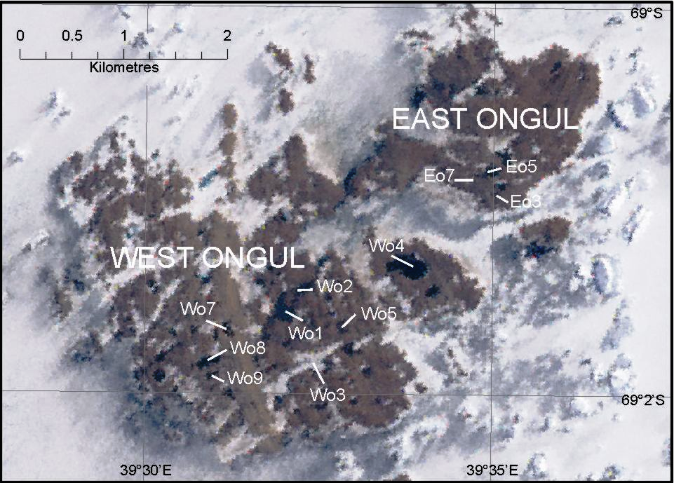
Figure S1. Detailed map of East and West Ongul Island (Lützow Holm Bay, East Antarctica). Study lakes on which the transfer function is based are indicated with codes Eo3, Eo5, Eo7, and Wo1-9.

Figure S2. Detailed map of Langhovde (Lützow Holm Bay, East Antarctica). Study lakes on which the transfer function is based are indicated with codes La2, La6, La8, and La10.
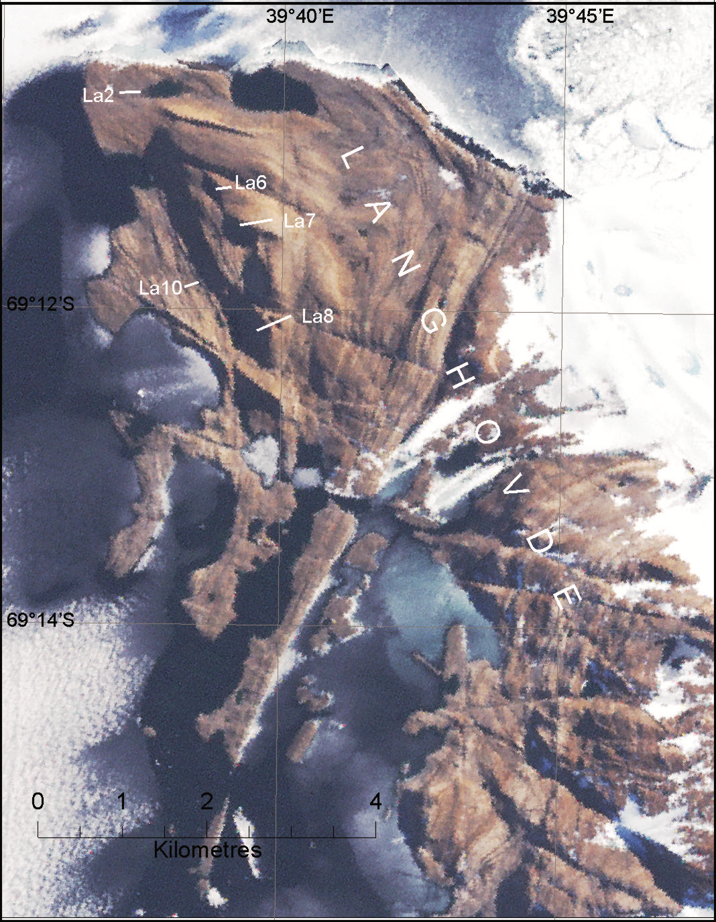
Figure S3. Residuals (predicted minus observed values) versus observed specific conductance (mS/cm). Trends in the residuals are highlighted with a polynomial trendline.
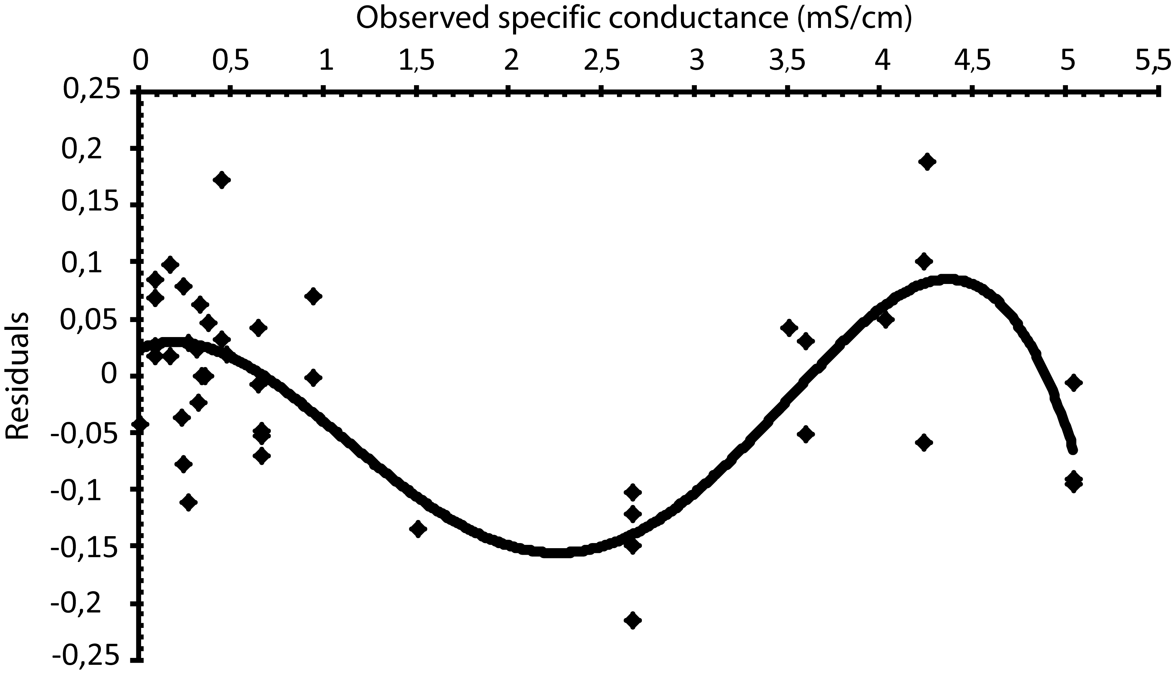

Figure S4. Plot showing inferred and observed specific conductance for the samples of the surface dataset from Lützow Holm Bay, used to construct the transfer function.
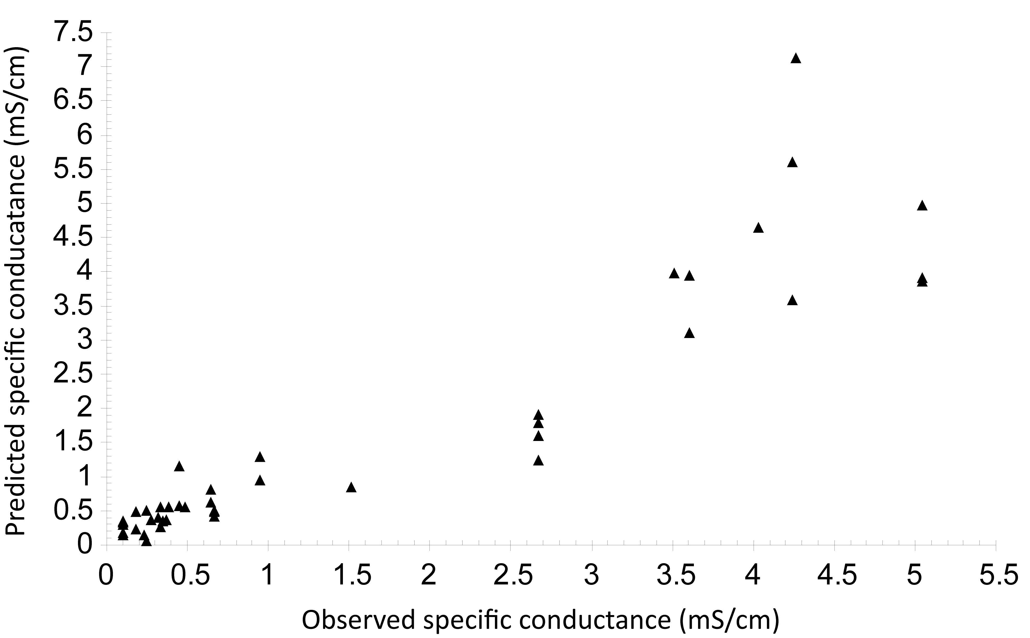

Figure S5. Pictures of the unidentified Fragilaria sp. from the sediments of Mago Ike, Skarvsnes, Lützow Holm Bay.
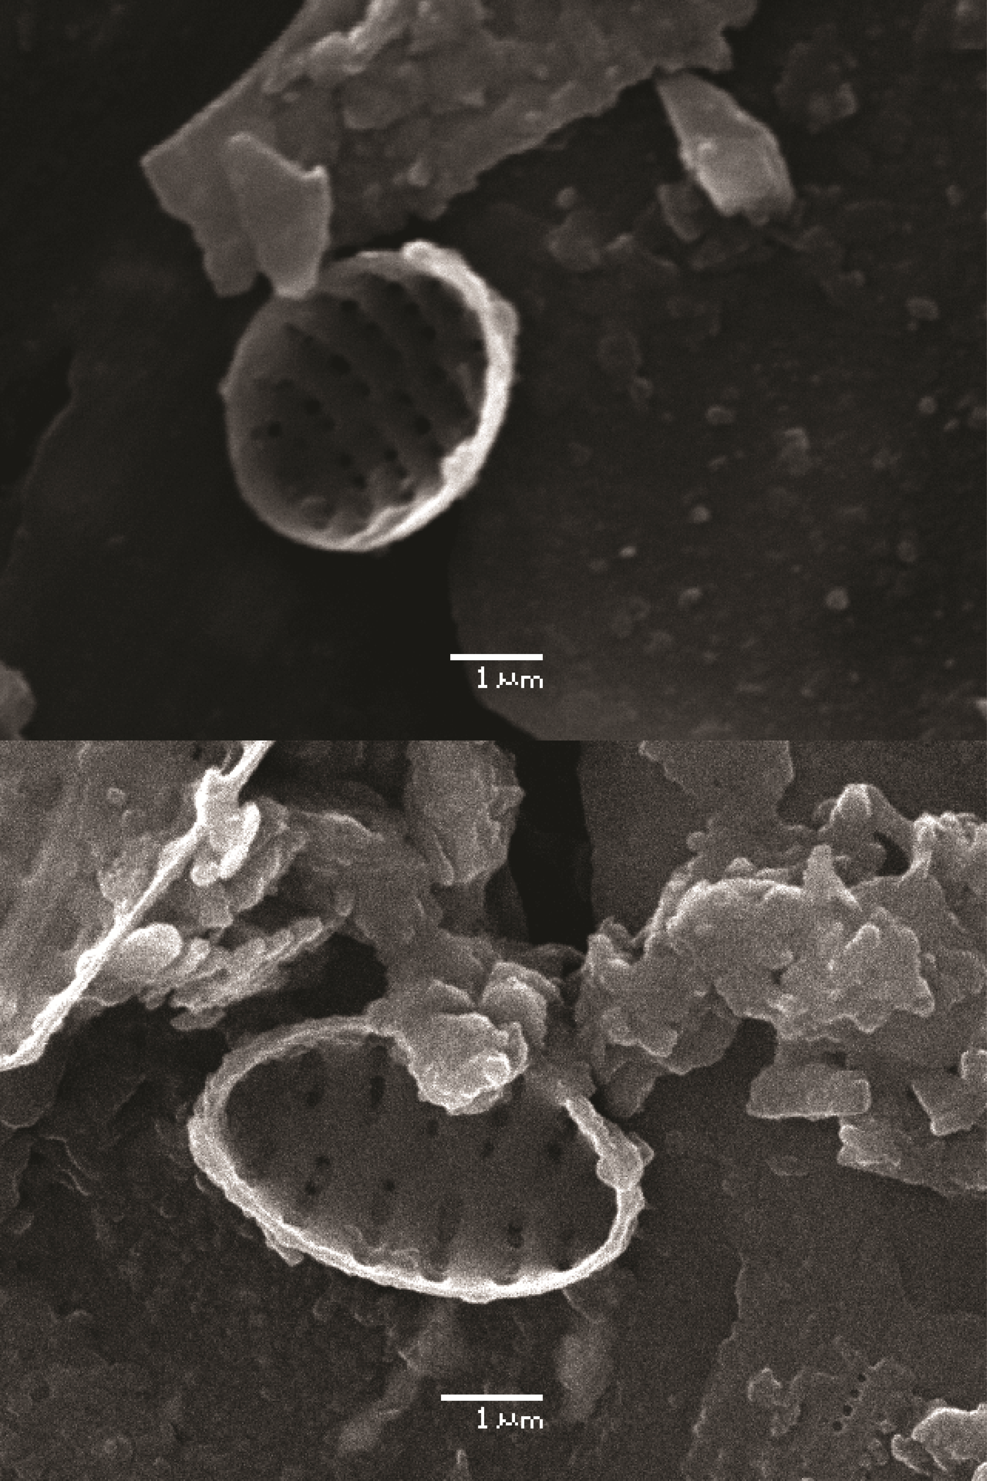

Table S1. Overview of the apparent r², jack-knifed r² and RMSEP of different East Antarctic transfer functions. VH = Vestfold Hills, BI = BØlingen Islands, LH = Larsemann Hills, RI = Rauer Islands, WI = Windmill Islands. References: (a) ROBERTS, D. & MCMINN A. 1998. A weighted-averaging regression and calibration model for inferring lakewater salinity from fossil diatom assemblages in saline lakes of the Vestfold Hills: a new tool for interpreting Holocene lake histories in Antarctica. Journal of Paleolimnology, 19, 99-113; (b) VERLEYEN, E., HODGSON, D.A., VYVERMAN, W., ROBERTS, D., MCMINN, A., VANHOUTTE, K. &SABBE, K. 2003. Modelling diatom responses to climate induced fluctuations in the moisture balance in continental Antarctic lakes. Journal of Paleolimnology, 30, 195-215; (c) ROBERTS, D., MCMINN, A., CREMER, H., GORE, D.B. & MELLES, M. 2004. The Holocene evolution and palaeosalinity history of Beall Lake, Windmill Islands (East Antarctica) using an expanded diatom-based weighted averaging model. Palaeogeography, Palaeoclimatology, Palaeoecology, 208, 121-140.
Region(s) | Model | Apparent r² | Jack-knifed r² | RMSEP | Reference
Syowa Oasis | WA-PLS1 | 0.84 | 0.79 | 0.12 | This study
Syowa Oasis | WA-PLS2 | 0.90 | 0.85 | 0.10 | This study
saline lakes VH |  | 0.80 | 0.73 | 0.37 | a
BI, LH, RI, VH, WI |  | 0.86 | 0.83 | 0.31 | b
VH, WI |  | 0.85 | 0.79 | 0.36 | c

Table S2. WA optima and tolerances for specific conductance of the lacustrine species.



