Supplemental Material

In order to better determine the localization for brain activations elicited by spatial frequency and contrast manipulations related to visual eccentricity, we projected functional activations obtained in AMD patients and controls during LSF and HSF scenes processing and according to luminance contrast onto 3D cortical templates on which boundaries corresponding to the representation of 2° and 8.5° of eccentricity in the visual field were delineated. These boundaries were defined based on an independent fMRI retinotopic mapping experiment in one subject (male, 59 years) who did not participate in the present experiment. We used a standard phase encoding paradigm (Engel, Glover, & Wandell, 1997; Sereno et al., 1995). The detailed description of the design and data processing are given elsewhere (Bordier, Hupé, & Dojat, 2015). Stimuli are continuous expanding and contracting rings which continuously sweeped the visual field from 2° to 8.5° of eccentricity, and vice versa, with a period of 32 s. The rings consisted of a black and white radial checkboard flickering at 4 Hz. Stimuli were created using the Psychophysics Toolbox (Brainard, 1997) in MATLAB 7. In addition, to improve fixation stability, we added a fixation grid (Schira et al., 2009; Schira et al., 2007). Stimuli were back-projected on the translucent screen positioned at the rear of the magnet.
We acquired two retinotopic functional scans, one for each of the directions of motion of the rings. The functional data acquired were obtained using a T2*-weighted EPI gradient fast field echo (FFE) with the following main parameters. Thirty contiguous axial slices angulated about the left-right axis in order to be approximately parallel to the calcarine sulcus were acquired in a sequential mode. Slice thickness was 3 mm. The in-plane voxel size was 3×3 mm (240×240 mm field of view acquired with a 80×80 pixel data matrix). The main sequence parameters were: TR = 2000 ms, TE = 30 ms, flip angle = 80°. Acquisition time per functional scan was 8 min, allowing the acquisition of 240 volumes. For brain surface reconstruction, a T1-weighted high-resolution three-dimensional anatomical volume was acquired by using a 3D-MDEFT sequence (number of slices = 160, TE = 4 ms, TR = 25 ms, flip angle = 15°, field of view = 256×240×160 mm, resolution 0.94×1.03×1.00 mm, acquisition matrix 192×128×128 pixels, reconstruction matrix 256×128×128 pixels).
Data analysis was performed using SPM12 implemented in MATLAB 7 and BrainVoyager QX (BV) 2.4.0 (BrainInnovation, www.brainvoyager.com). In SPM12, functional volumes were realigned, coregistered to the high-resolution anatomical scans, and normalized to the MNI space. Then, anatomical and functional scans were exported from SPM to BV using in-house Matlab scripts. Anatomical scans were used to reconstruct surfaces of both cortical hemispheres using an inhomogeneity correction of signal intensity and a segmentation of the white and gray matter border. For functional data, we applied a low trend removal and a high pass temporal filter (2/cycle) to each functional dataset (expansion and contraction rings). Using Matlab, we averaged the two ring scan recordings to generate modulated sinusoidal signals within the visual cortex and to cancel-out phase errors caused by hemodynamic delays (Warnking et al., 2002). We computed correlation analyses with 16 sinusoidal functions with different phases (phase difference of 0.2 rad between two consecutive functions) to obtain power and phase maps for eccentricity mapping. A threshold of 0.2 was used for phase maps correlations (corresponding to a t-value = 3.15 and p < 0.01 False Discovery Rate) and projected on the cortical flat maps. Finally, we delineated central (from 0° to 2°) and peripheral (8.5°) stimulation borders using the projection of the eccentricity map within the inflated reconstruction of the occipital cortex (Supplementary Figure 1a).
We projected functional activations obtained in AMD patients and controls during non-filtered, LSF and HSF scenes processing and according to luminance contrast onto BV template. The anatomical scans and spmT statistical maps of each AMD and control participant (in MNI space) were coregistered to the high-resolution anatomical scan in MNI space used for surface reconstruction. Next, using in-house Matlab scripts, the reorientation parameters used for eccentricity maps were applied to spmT statistical maps and projected onto the inflated reconstruction of the occipital cortex containing borders for eccentricity stimulation. For controls (Supplementary Figure 1b), activations corresponding to the categorization of the LSF and HSF scenes, in both the LUM and RMS conditions, were located in retinotopic areas encoding the central visual field (< 2° of eccentricity) and the peripheral visual field (from 2° to 8.5° of eccentricity), respectively. For all patients with AMD (Supplementary Figure 1c), no activation was observed in the visual areas encoding the central visual field, irrespective of the experimental condition. This is consistent with the central vision loss of patients. The categorization of LSF scenes in the LUM and RMS conditions elicited activation systematically located in the visual areas corresponding to the peripheral visual field from 2° to 8.5°, but also beyond 8.5°. For the categorization of the HSF scenes in the LUM condition, we observed a reduced activation for patient AMD1 and an absence of activation for patients AMD2, AMD3 and AMD4 in comparison to controls in the visual areas dedicated to the peripheral visual field. However, for the categorization of HSF scenes in the RMS condition, we observed an increased activation in the visual areas encoding the peripheral visual field for all patients, which extends to the boundary corresponding to the representation 2° of eccentricity for patients AMD1, AMD2 and AMD3.”

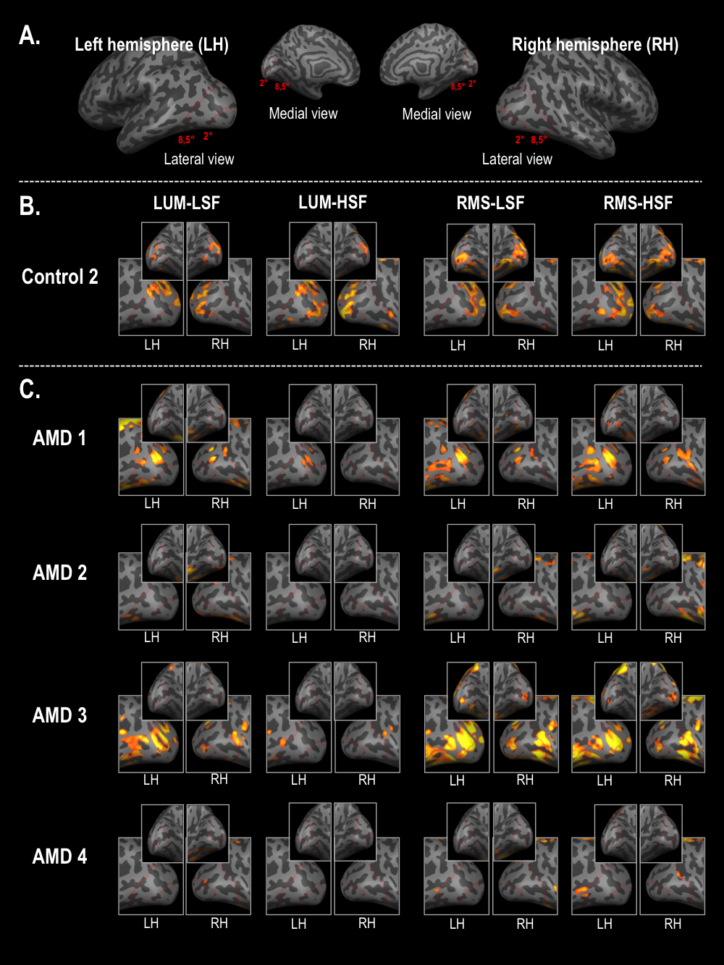
Supplementary Figure 1: (A) Red lines on 3D cortical templates represent the 2° and 8.5° (radius) of eccentricity in each visual field. These boundaries were drawn based on an independent retinotopic mapping in a subject who did not participate in the present study. Functional activations obtained by contrasting low-spatial frequency (LSF), and high-spatial frequency (HSF) scenes to fixation periods in LUM and RMS conditions are projected onto 3D cortical templates (B) for one representative control participant (Control 2) and (C) for all patients with AMD.

