Epidemiology and Infection

Factors associated with SARS-CoV-2 formation in Danish schools: a nationwide register-based cohort study
Tjede Funk, Laura Espenhain, Frederik Trier-Møller, Steen Ethelberg

Supplementary material
Supplementary Figure S1. Number of cases per 1000 school children per reporting week in lower and higher class levels
Supplementary Figure S2. Number of clusters per 1000 school children per reporting week in lower and higher class levels
Supplementary Figure S3. Number of tests (PCR and antigen combined) per 1000 school children per reporting week in lower and higher class levels
Supplementary Figure S4. Vaccination coverage of school children over study period

Supplementary Figure S1. Number of cases per 1000 school children per reporting week in lower and higher class levels
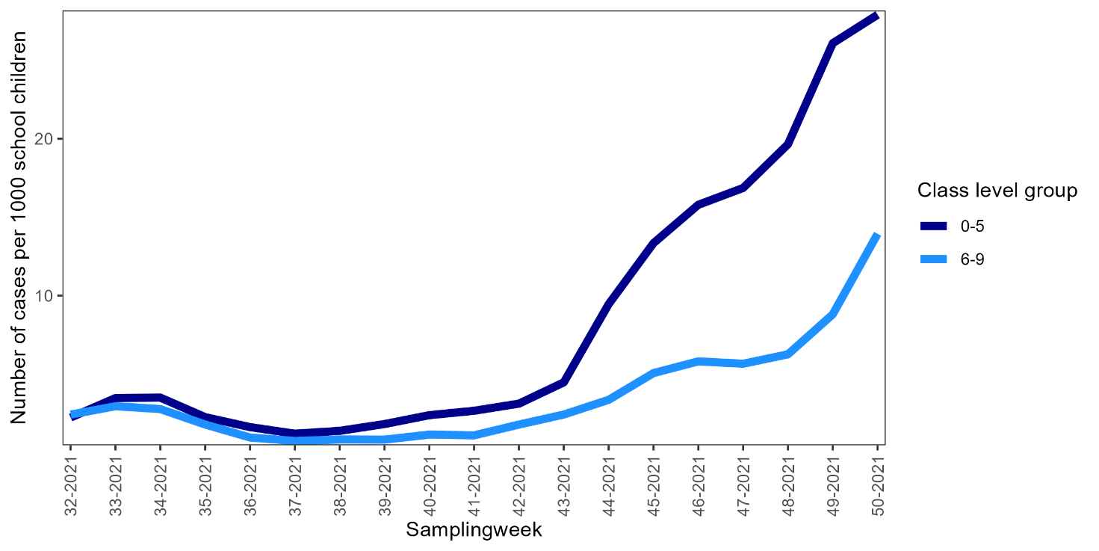
Note that in week 42 was the week of the school autumn holidays

Supplementary Figure S2. Number of clusters per 1000 school children per reporting week in lower and higher class levels
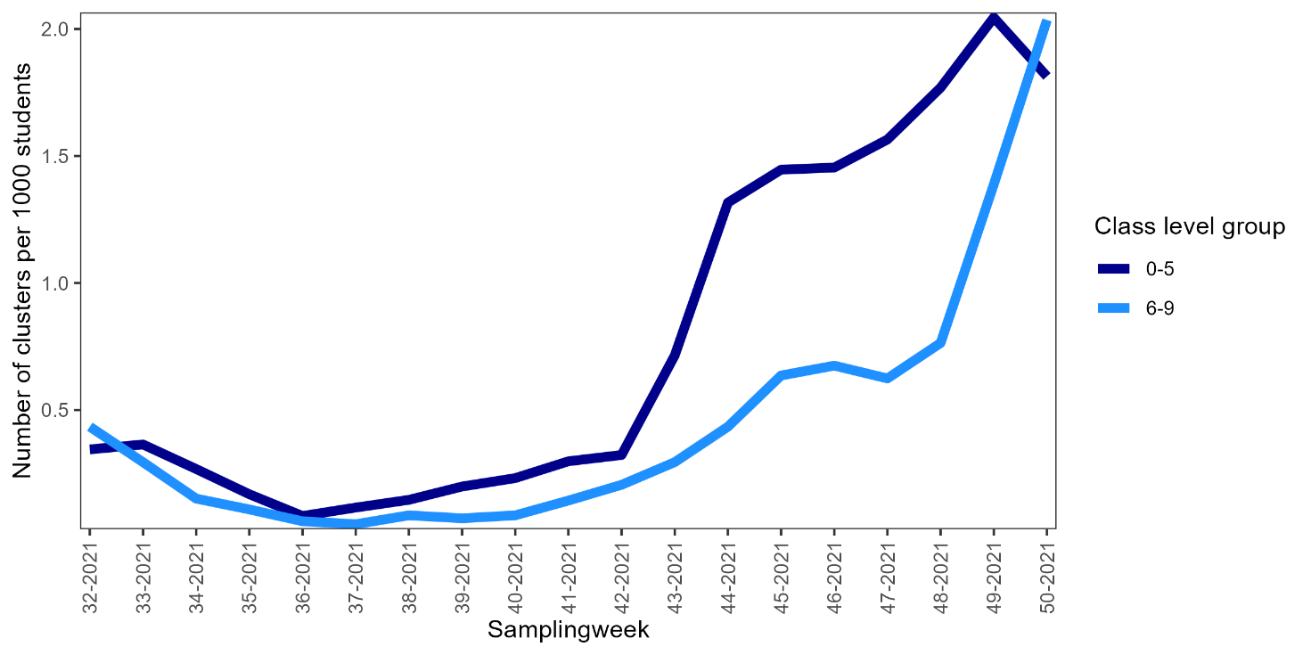
Note that in week 42 was the week of the school autumn holidays
Supplementary Figure S3. Number of tests (PCR and antigen combined) per 1000 school children per reporting week in lower and higher class levels
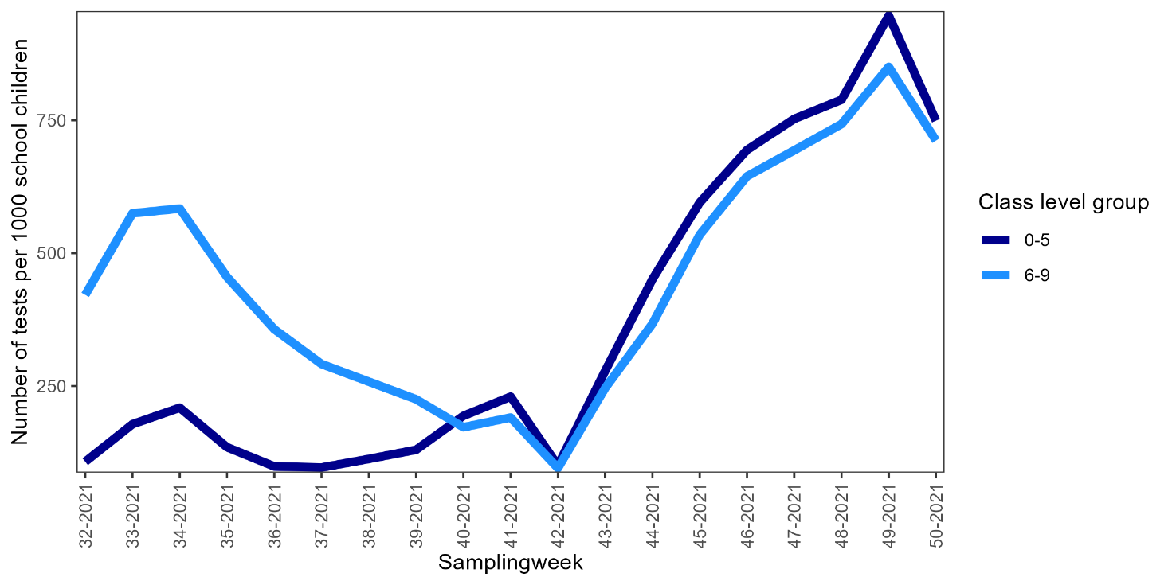
Note that in week 42 was the week of the school autumn holidays

Supplementary Figure S4. Vaccination coverage of school children over study period
