Supplementary Material
Search strategies:
We searched the PubMed databases for air travel-associated transmission of SARS-CoV-2 infection January 1, 2020, to July 2, 2022, using the following strategies:
#1 ((((((((((((((((((((((((aircraft[Title/Abstract]) OR aeroplane[Title/Abstract]) OR airline[Title/Abstract]) OR flight[Title/Abstract]) OR aircrew[Title/Abstract]) OR airflight[Title/Abstract]) OR airplane[Title/Abstract]) OR aviation[Title/Abstract]) OR airport[Title/Abstract]) OR aeroport[Title/Abstract]) OR aero transport[Title/Abstract]) OR airport[Title/Abstract]) OR steward[Title/Abstract]) OR stewardess[Title/Abstract]) OR flight[Title/Abstract]) OR flights[Title/Abstract]) OR inflight[Title/Abstract]) OR in-flight[Title/Abstract]) OR cabin crew[Title/Abstract]) OR cabin[Title/Abstract]) OR cabins[Title/Abstract]) OR fly[Title/Abstract]) OR flying[Title/Abstract]) OR tour[Title/Abstract]) OR travel[Title/Abstract]) OR journal[Title/Abstract]) OR passenger[Title/Abstract])
#2 ((((((COVID-19[Title/Abstract]) OR SARS-CoV-2[Title/Abstract]) OR coronavirus 2019[Title/Abstract]) OR coronavirus disease 2019[Title/Abstract]))
#3 ("2020/01/01"[Date - Publication]: "3000"[Date - Publication])
#4 #1 AND #2 AND #3
Limits: not limits

Figure S1. Funnel plot results of the of the SARS-CoV-2 flight transmission meta-analysis.
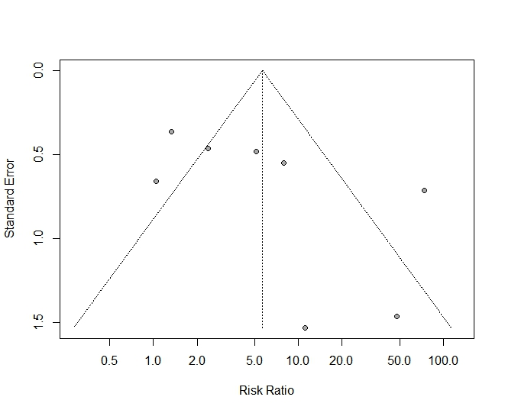

Figure S2. Sensitivity analysis results of the SARS-CoV-2 flight transmission meta-analysis.
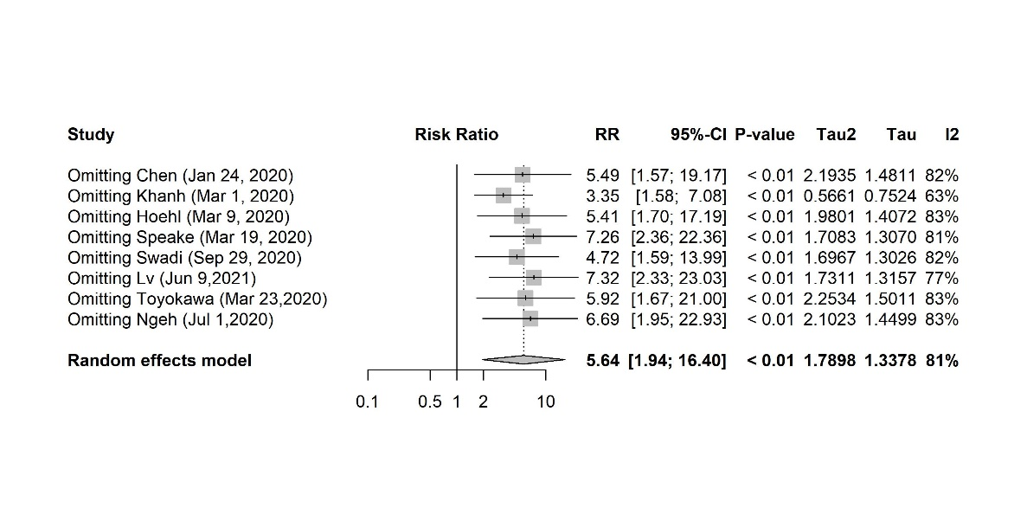

Supplementary Table S1. Summary of inflight influenza A(H1N1) pdm09 virus transmission from literatures
First author | Departure date | Flight duration | Passengers Aboard | Passengers Traced | Index Cases | Secondary Cases Identified | Attack Rate % | Secondary Cases Within 2 Rows | Attack Rate in 2 Rows % | Diagnosis method# | Include in meta analysis
Shankar ^{[1]} | Apr 20, 2009 | 9.5 h | 278 | 43 | 1 | 5 | 1.8 | 1 | 2.6 | L | Yes
Zhang ^{[2]}  Case 1 | May 27, 2009 | 20h 20m | 260 | 82 | 1 | 9 | 3.5 | NA | NA | L | No
Zhang ^{[2]}  Case 2 | May 28, 2009 | 1h 40m | 136 | 136 | 1 | 0 | 0 | 0 | 0 | L | No
Neatherlin^{[3]}Case 1 | Apr 3, 2009 | 3h 20m | 265 | 146 | 1 | 8 | 3.0 | 3 | 6.5 | L | No
Neatherlin^{[3]} Case 2 | Apr 19, 2009 | 4h 5m | 129 | 121 | 1 | 6 | 5.8 | 3 | 14.3 | S | No
Catala^{[4]} | Apr 23, 2009 | 11h | 165 | 159 | 6 | 4 | 2.5 | 2 | NA | L | No
Foxwell^{[5]} Case 1 | Mar 24, 2009 | 14h | 445 | 188 | 6 | 2 | 0.5 | 2 | 1.4 | L | Yes
Foxwell^{[5]} Case 2 | Mar 23, 2009 | 8h | 293 | 131 | NA | 1 | NA | 4 | NA | S+L | No
Ooi^{[6]} | NA | NA | 596 | 25 | 1 | 5 | 0.8 | 2 | NA | L | No
Kim ^{[7]} | Apr 25, 2009 | 13h | 315 | 176 | 1 | 1 | 0.3 | 0 | 0 | L | Yes
Baker ^{[8]} | Apr 25, 2009 | 13h | 379 | 121 | 9 | 2 | 0.5 | 2 | 3.2 | L | Yes
Han ^{[9]} Case 1 | Jun 2, 2009 | 2h 35m | 92 | 91 | 1 | 0 | 0 | 0 | 0 | L | No
Han ^{[9]} Case 2 | Jun 3, 2009 | 45m | 111 | 87 | 1 | 0 | 0 | 0 | 0 | L | No
Han ^{[9]} Case 3 | Jun 5, 2009 | 45m | 111 | 87 | 2 | 1 | 1.2 | 1 | NA | L | No
Bin ^{[10]} | May 9, 2009 | NA | 142 | 141 | 1 | 0 | 0 | 0 | 0 | L | No
Total* |  |  | 1417 | 528 | 17 | 10 | 0.7 | 5 | 1.7
NA, not available, months are abbreviated using the first three letters.
* Only studies included in the meta-analysis are included.
#L=laboratory confirmed, S=symptoms confirmed.

Supplementary Table S2. Summary of inflight SARS-CoV-1 transmission from literatures.
First author | Departure date | Flight duration | Passengers Aboard | Passengers  Traced | Index Cases | Secondary Cases Identified | Attack Rate % | Secondary Cases Within 2 Rows | Attack Rate in 2 Rows % | Include in meta analysis
Olsen ^{[11]} Flight 1 | Feb 21, 2003 | 1h 30m | 315 (including crew) | 74 | 1 | 0 | 0 | 0 | 0 | No
Olsen ^{[11]}  Flight 2 | Mar 15, 2003 | 3h | 112 | 65 | 1 | 18 | 16.2 | 6 | 26.1 | Yes
Olsen ^{[11]} Flight 3 | Mar 21, 2003 | 1h 30m | 246(including crew) | 166 | 4 | 0 | 0 | 0 | 0 | No
Vogt ^{[12]} | 7 flights with 1 index patient per flight | NA | 1766 contacted | 312 interviewed/ 127 serology | 1 per flight | 0 | 0 | 0 | 0 | No
Wilder-  Smith ^{[13]} | Mar 14, 2003 | NA | NA | NA | 1 | 0 | 0 | 0 | 0 | No
Total* |  |  | 112 | 65 | 1 | 18 | 16.2 | 6 | 26.1
NA, not available, months are abbreviated using the first three letters.
* Only studies included in the meta-analysis are included.

References
[1] Shankar AG, et al. (2014) Contact tracing for influenza A(H1N1) pdm09 virus-infected passenger on international flight. Emerging infectious diseases; 20:118-120. doi:10.3201/eid2001.120101.
[2] Zhang L, et al. (2013) Protection by face masks against influenza A(H1N1) pdm09 virus on trans-Pacific passenger aircraft, 2009. Emerging infectious diseases; 19:1403. doi:10.3201/eid1909.121765.
[3] Neatherlin J, et al. (2013) Influenza A(H1N1) pdm09 during air travel. Travel Medicine and Infectious Disease; 11:110-118. doi:10.1016/j.tmaid.2013.02.004.
[4] Catala L, et al. (2012) Pandemic A/H1N1 influenza: transmission of the first cases in Spain. Enfermedades Infecciosas y Microbiología Clínica; 30:60-63. doi:10.1016/j.eimc.2011.06.007.
[5] Foxwell AR, et al. (2011) Transmission of influenza on international flights, may 2009. Emerging infectious diseases; 17:1188-1194. doi:10.3201/eid1707.101135.
[6] Ooi PL LF, et al. (2010) Clinical and molecular evidence for transmission of novel influenza A(H1N1/2009) on a commercial airplane. Archives of Internal Medicine; 170:913-915. doi:10.1001/archinternmed.2010.127.
[7] Kim JH, et al. (2010) In-Flight Transmission of Novel Influenza A (H1N1). Epidemiology and Health; 32: e2010006. doi:10.4178/epih/e2010006.
[8] Baker MG, et al. (2010) Transmission of pandemic A/H1N1 2009 influenza on passenger aircraft: retrospective cohort study. British Medical Journal; 340:c2424. doi:10.1136/bmj.c2424.
[9] Han K, et al. (2009) Lack of airborne transmission during outbreak of pandemic (H1N1) 2009 among tour group members, China, June 2009. Emerging infectious diseases; 15: 1578-1581. doi:10.3201/eid1510.091013.
[10] Bin C, et al. (2009) Clinical and epidemiologic characteristics of 3 early cases of influenza A pandemic (H1N1) 2009 virus infection, People's Republic of China, 2009. Emerging infectious diseases; 15:1418-1422. doi:10.3201/eid1509.090794.
[11] Olsen SJ, et al. (2003) Transmission of the severe acute respiratory syndrome on aircraft. New England Journal of Medicine; 349:2416-2422. doi:10.1056/NEJMoa031349.
[12] Vogt TM, et al. (2006) Risk of severe acute respiratory syndrome-associated coronavirus transmission aboard commercial aircraft. Journal of Travel Medicine; 13:268-272. doi:10.1111/j.1708-8305.2006.00048.x.
[13] Wilder-Smith A LH, Villacian JS. (2003) In-flight transmission of Severe Acute Respiratory Syndrome(SARS): a case report. Journal of Travel Medicine; 10:299-300. doi:10.2310/7060.2003.2737.

