Supplementary material for

“Estimates of mpox effective reproduction number in Spain, April-August 2022”

David García-García^{1,2,†}, Diana Gómez-Barroso^{1,2, †,*}, Victoria Hernando^{1,3}, Marta Ruiz-Algueró^{1,3}, Lorena Simón¹, María Sastre^{1,2}, María José Sierra^{3,4}, Pere Godoy^{2,5}, Asunción Diaz^{1,3}

- National Centre of Epidemiology, Carlos III Health Institute, Madrid, Spain
- CIBER in Epidemiology and Public Health (CIBERESP), Madrid, Spain
- CIBER in Infectious Diseases (CIBERINFEC), Madrid, Spain
- Coordinating Centre for Health Alerts and Emergencies, Directorate General of Public Health, Ministry of Health, Madrid, Spain
- Lleida Biomedical Research Institute (IRBLleida). University of Lleida, Lleida, Spain

† These authors contributed equally to this work and share first authorship
* Corresponding author

Sensitivity analysis
Figure S1 shows the variations in R_{t} estimate for different choices of smoothing window. As expected, wider windows lead to smoother curves, while shorter curves yield noisier estimates.
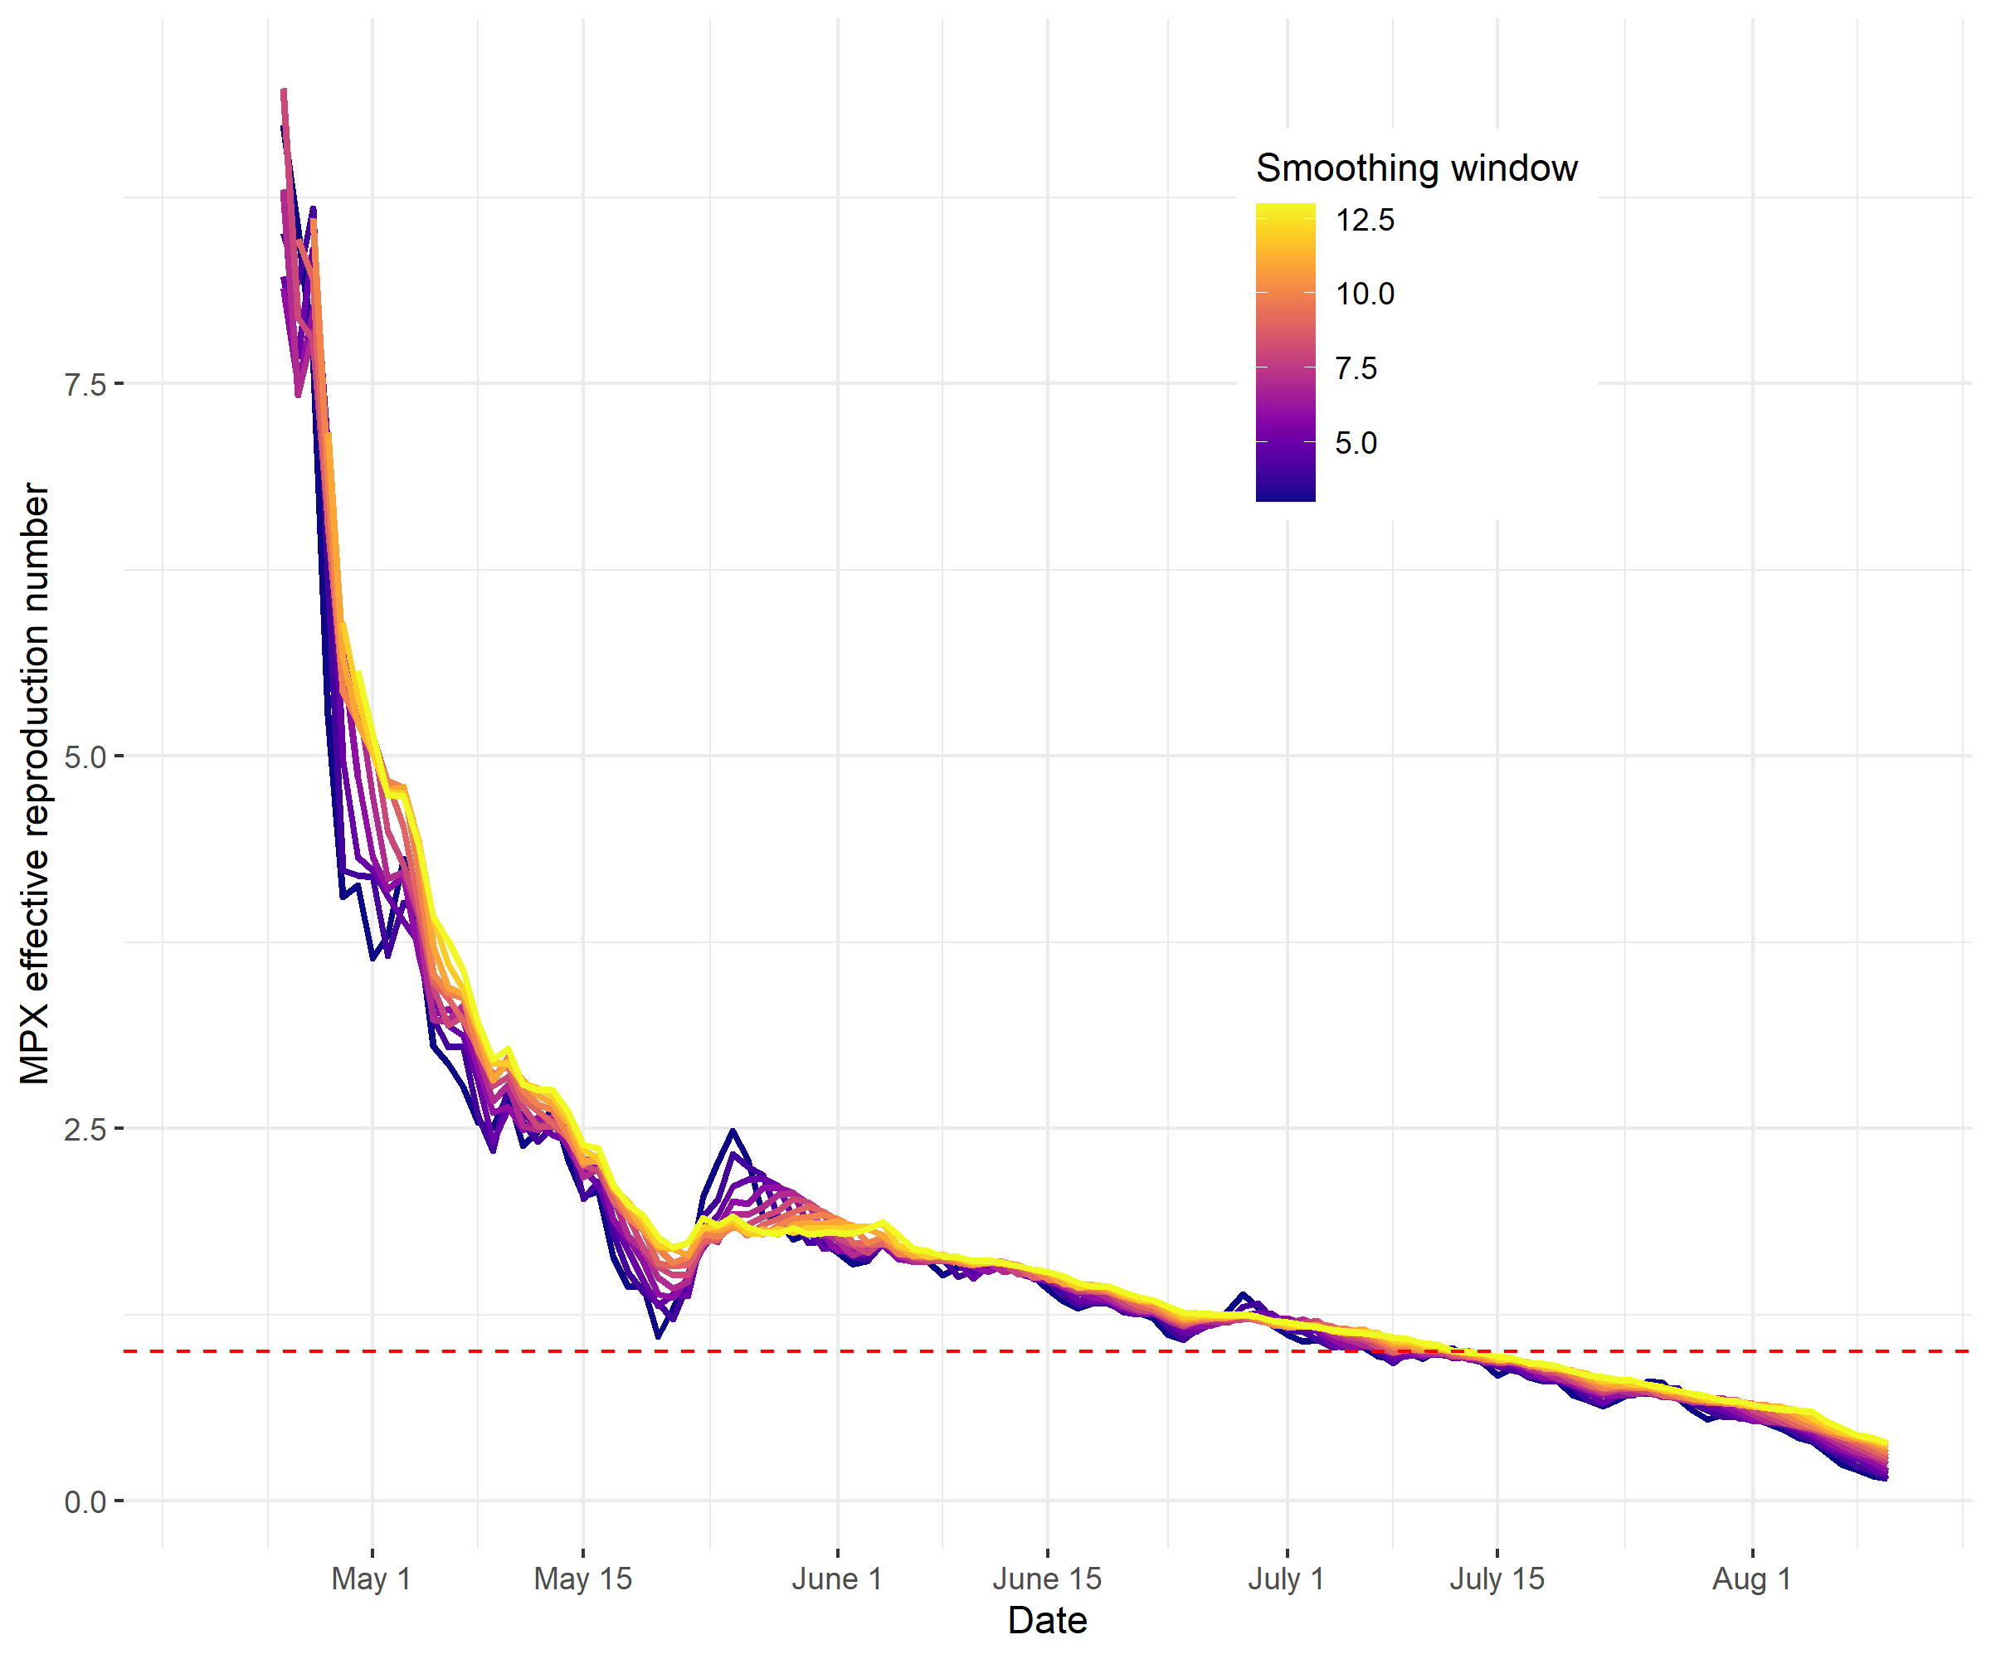
Figure S1. R_{t} curves resulting from a sensitivity analysis on the length of the smoothing window, ranging from a 3- to a 13-day long window.

Mobility-based communities
R_{t} estimates were computed for “communities” in Spain, based on a mobility-based analysis [30]. Table S1 shows the cumulative number of mpox cases reported at each of these communities during the study period. Figures S2 and S3 show the geographic disitribution of the communities and their epidemic curves, respectively. Figure 4 shows R_{t} estimates for each of these communities, computed from the series of cases shown in Figure S3.
Community | Provinces | Number of MPX cases, April 25 – August 19, 2022
Canary Islands | Las Palmas, Santa Cruz de Tenerife | 143
Central East | Albacete, Alicante, Ciudad Real, Cuenca, Guadalajara, Illes Balears, Madrid, Soria, Toledo, Valencia | 2796
Central West | Asturias, Ávila, Cáceres, León, Palencia, Salamanca, Segovia, Valladolid, Zamora | 113
North | Araba, Bizkaia, Burgos, Cantabria, Guipuzkoa, Navarra, La Rioja | 264
Northeast | Barcelona, Castellón, Girona, Huesca, Lleida, Tarragona, Teruel, Zaragoza | 1925
Northwest | A Coruña, Lugo, Orense, Pontevedra | 98
South | Almería, Badajoz, Cádiz, Córdoba, Granada, Huelva, Jaén, Málaga, Murcia, Sevilla | 824

Table S1. Mobility-based communities in Spain, provinces in each of these communities, and cumulative number of MPX cases during April 25 – August 19, 2022.

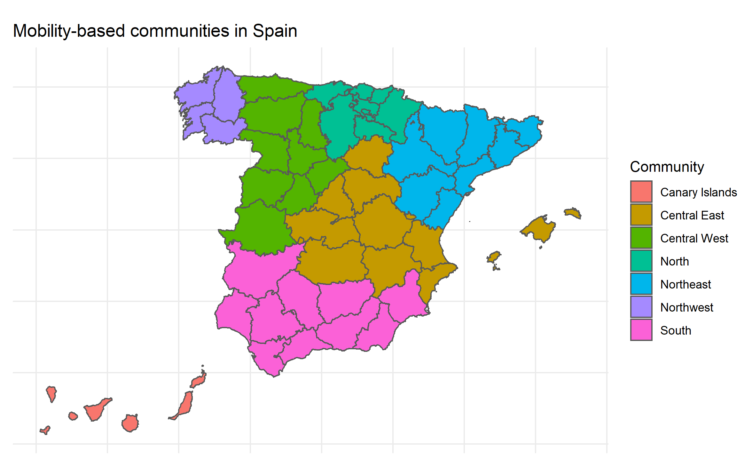
Figure S2. Mobility-based “communities” in Spain, based in the results in [30].

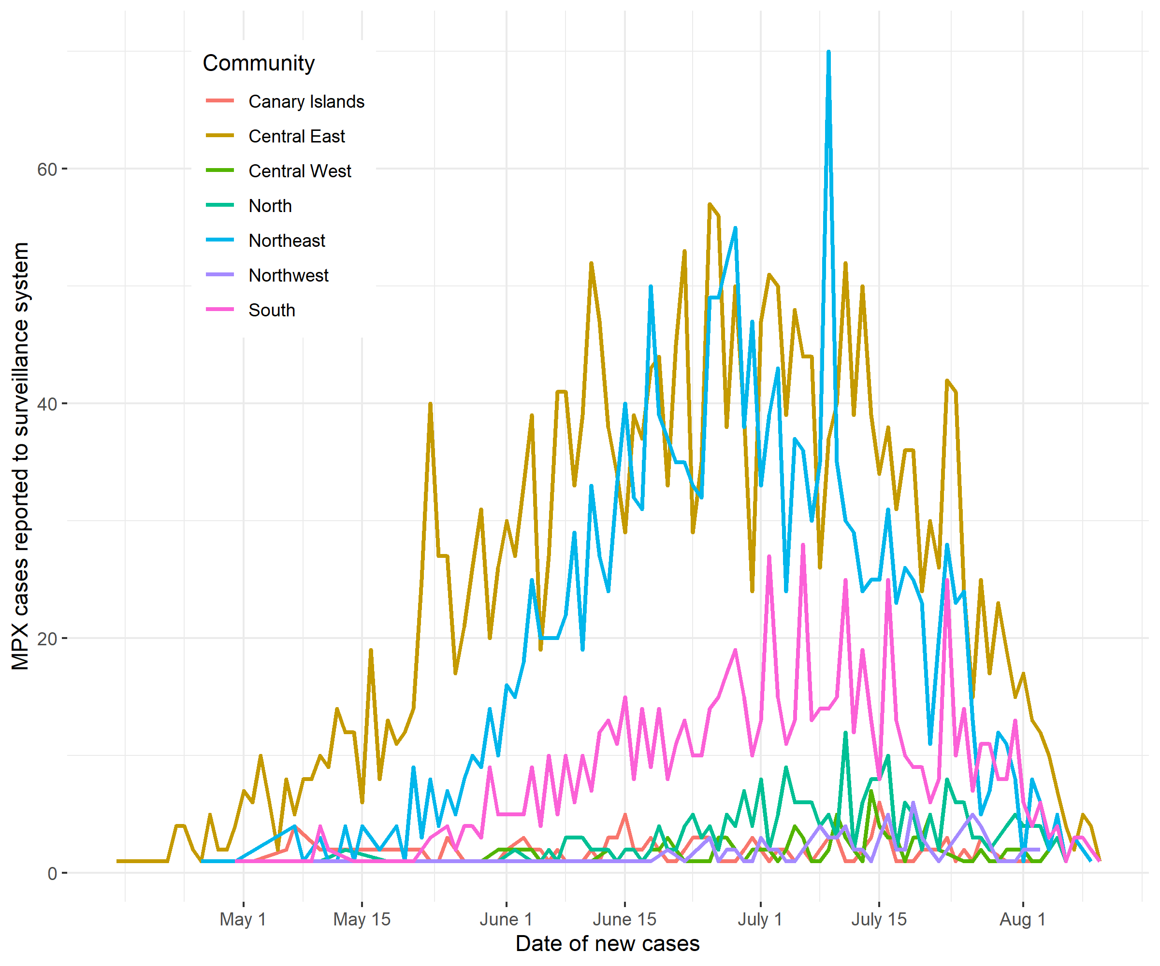
Figure S3. MPX cases by mobility-based community in Spain, April 25 - August 19, 2022.

