Appendix (Supplementary Tables and Figures)
Table 1A. Main transmission routes of pathogens included in the study.
Pathogen | Main transmission route
Campylobacter | - Foodborne (ingestion of contaminated food and water)  - Some person-to-person transmission
Cryptosporidium hominis | - Waterborne (contamination of recreational and municipal water supplies)  - Occasionally foodborne
Cryptosporidium parvum | - Waterborne (contamination of recreational and municipal water supplies)  - Zoonotic (cattle infections)  - Occasionally foodborne
Giardia | - Waterborne (frequently through ingestion of contaminated water and food)  - Some person-to person transmission
Norovirus | - Person-to-person transmission  - Contaminated surfaces
Non-typhoidal Salmonella | - Foodborne (ingestion of contaminated food and water)
Salmonella typhi/paratyphi | - Person-to-person (Fecal-oral route via contaminated water, undercooked foods, fomites of infected patients)
Other Shigella | - Person-to-person (Fecal-oral route)
Shigella flexneri | - Person-to-person (Fecal-oral route)  - Sexual transmission, especially in men who have sex with men
Shigella sonnei | - Person-to-person (Fecal-oral route)  - Sexual transmission, especially in men who have sex with men

Table 2A. Descriptive characteristics of study sample.
Number of cases
% of subtotal
 |  | All pathogens | Campylobacter | Cryptosporidium | Giardia | Norovirus | Non-typhoidal  Salmonella | Salmonella typhi/paratyphi | Shigella
TOTAL |  | 314,381 | 208,016 | 18,743 | 18,114 | 26,361 | 26,361 | 8,690 | 8,096
 |  | 100% | 100% | 100% | 100% | 100% | 100% | 100% | 100%
IMD quintile | 1 (most deprived) | 51,858 | 31,077 | 3,067 | 2,702 | 5,668 | 5,466 | 2,002 | 1,876
 |  | 16% | 15% | 16% | 15% | 22% | 21% | 23% | 23%
 | 2 | 58,717 | 37,433 | 3,381 | 3,120 | 5,399 | 5,549 | 1,923 | 1,912
 |  | 19% | 18% | 18% | 17% | 20% | 21% | 22% | 24%
 | 3 | 67,071 | 44,582 | 4,108 | 4,049 | 5,517 | 5,411 | 1,690 | 1,714
 |  | 21% | 21% | 22% | 22% | 21% | 21% | 19% | 21%
 | 4 | 68,390 | 46,995 | 4,184 | 4,015 | 5,233 | 5,029 | 1,549 | 1,385
 |  | 22% | 23% | 22% | 22% | 20% | 19% | 18% | 17%
 | 5 (least deprived) | 68,211 | 47,895 | 4,000 | 4,219 | 4,543 | 4,870 | 1,505 | 1,179
 |  | 22% | 23% | 21% | 23% | 17% | 18% | 17% | 15%
 | Missing | 134 | 34 | 3 | 9 | 1 | 36 | 21 | 30
 |  | 0% | 0% | 0% | 0% | 0% | 0% | 0% | 0%
Sex | Female | 146,397 | 92,902 | 10,588 | 7,667 | 14,527 | 13,166 | 4,182 | 3,365
 |  | 47% | 45% | 56% | 42% | 55% | 50% | 48% | 42%
 | Male | 167,299 | 114,900 | 8,128 | 10,394 | 11,636 | 13,085 | 4,469 | 4,687
 |  | 53% | 55% | 43% | 57% | 44% | 50% | 51% | 58%
 | Unknown | 685 | 214 | 27 | 53 | 198 | 110 | 39 | 44
 |  | 0% | 0% | 0% | 0% | 1% | 0% | 0% | 1%
Age (years) | <1 | 2,701 | 917 | 175 | 46 | 674 | 733 | 131 | 25
 |  | 1% | 0% | 1% | 0% | 3% | 3% | 2% | 0%
 | 1-4 | 25,274 | 11,043 | 3,477 | 1,587 | 3,544 | 3,707 | 1,339 | 577
 |  | 8% | 5% | 19% | 9% | 13% | 14% | 15% | 7%
 | 5-9 | 12,596 | 5,646 | 2,461 | 841 | 580 | 1,727 | 818 | 523
 |  | 4% | 3% | 13% | 5% | 2% | 7% | 9% | 6%
 | 10-19 | 19,256 | 12,216 | 2,340 | 686 | 538 | 2,200 | 844 | 432
 |  | 6% | 6% | 12% | 4% | 2% | 8% | 10% | 5%
 | 20-29 | 41,502 | 27,967 | 3,403 | 2,474 | 901 | 3,933 | 1,365 | 1,459
 |  | 13% | 13% | 18% | 14% | 3% | 15% | 16% | 18%
 | 30-39 | 36,788 | 23,167 | 3,356 | 3,699 | 930 | 2,886 | 1,038 | 1,712
 |  | 12% | 11% | 18% | 20% | 4% | 11% | 12% | 21%
 | 40-49 | 35,928 | 25,432 | 1,637 | 3,115 | 875 | 2,710 | 832 | 1,327
 |  | 11% | 12% | 9% | 17% | 3% | 10% | 10% | 16%
 | 50-59 | 43,263 | 33,391 | 857 | 2,549 | 1,382 | 3,244 | 830 | 1,010
 |  | 14% | 16% | 5% | 14% | 5% | 12% | 10% | 12%
 | 60-69 | 39,710 | 31,472 | 571 | 1,885 | 1,936 | 2,567 | 701 | 578
 |  | 13% | 15% | 3% | 10% | 7% | 10% | 8% | 7%
 | 70-79 | 31,346 | 23,979 | 307 | 840 | 3,710 | 1,731 | 489 | 290
 |  | 10% | 12% | 2% | 5% | 14% | 7% | 6% | 4%
 | ≥80 | 25,450 | 12,511 | 141 | 335 | 11,223 | 838 | 279 | 123
 |  | 8% | 6% | 1% | 2% | 43% | 3% | 3% | 2%
 | Missing | 567 | 275 | 18 | 57 | 68 | 85 | 24 | 40
 |  | 0% | 0% | 0% | 0% | 0% | 0% | 0% | 0%
Region | East Midlands | 24,503 | 16,608 | 1,709 | 1,449 | 2,101 | 1,850 | 622 | 164
 |  | 8% | 8% | 9% | 8% | 8% | 7% | 7% | 2%
 | East of England | 33,693 | 22,488 | 2,206 | 1,388 | 3,522 | 2,768 | 844 | 477
 |  | 11% | 11% | 12% | 8% | 13% | 11% | 10% | 6%
 | London | 38,007 | 21,465 | 1,038 | 1,848 | 3,465 | 5,353 | 1,806 | 3,032
 |  | 12% | 10% | 6% | 10% | 13% | 20% | 21% | 37%
 | North East | 17,831 | 12,582 | 1,280 | 970 | 1,092 | 1,296 | 410 | 201
 |  | 6% | 6% | 7% | 5% | 4% | 5% | 5% | 2%
 | North West | 35,807 | 24,439 | 2,453 | 1,831 | 1,979 | 3,394 | 946 | 765
 |  | 11% | 12% | 13% | 10% | 8% | 13% | 11% | 9%
 | South East | 56,311 | 40,241 | 2,745 | 3,587 | 2,336 | 4,244 | 1,463 | 1,695
 |  | 18% | 19% | 15% | 20% | 9% | 16% | 17% | 21%
 | South West | 43,306 | 26,893 | 2,601 | 4,127 | 5,871 | 2,492 | 857 | 465
 |  | 14% | 13% | 14% | 23% | 22% | 9% | 10% | 6%
 | West Midlands | 31,331 | 21,701 | 2,237 | 1,443 | 1,989 | 2,294 | 944 | 723
 |  | 10% | 10% | 12% | 8% | 8% | 9% | 11% | 9%
 | Yorkshire and The Humber | 33,592 | 21,599 | 2,474 | 1,471 | 4,006 | 2,670 | 798 | 574
 |  | 11% | 10% | 13% | 8% | 15% | 10% | 9% | 7%
Travel abroad | No | 67,209 | 43,211 | 4,139 | 3,851 | 5,034 | 7,002 | 2,317 | 1,655
 |  | 21% | 21% | 22% | 21% | 19% | 27% | 27% | 20%
 | Yes | 12,743 | 515 | 72 | 95 | 11 | 8,132 | 2,174 | 1,744
 |  | 4% | 0% | 0% | 1% | 0% | 31% | 25% | 22%
 | Unsure | 234,429 | 164,290 | 14,532 | 14,168 | 21,316 | 11,227 | 4,199 | 4,697
 |  | 75% | 79% | 78% | 78% | 81% | 43% | 48% | 58%
Rural/urban | Urban | 249,802 | 162,179 | 14,313 | 14,227 | 21,962 | 22,378 | 7,402 | 7,341
 |  | 79% | 78% | 76% | 79% | 83% | 85% | 85% | 91%
 | Rural | 64,445 | 45,803 | 4,427 | 3,878 | 4,398 | 3,947 | 1,267 | 725
 |  | 20% | 22% | 24% | 21% | 17% | 15% | 15% | 9%
 | Missing | 134 | 34 | 3 | 9 | 1 | 36 | 21 | 30
 |  | 0% | 0% | 0% | 0% | 0% | 0% | 0% | 0%

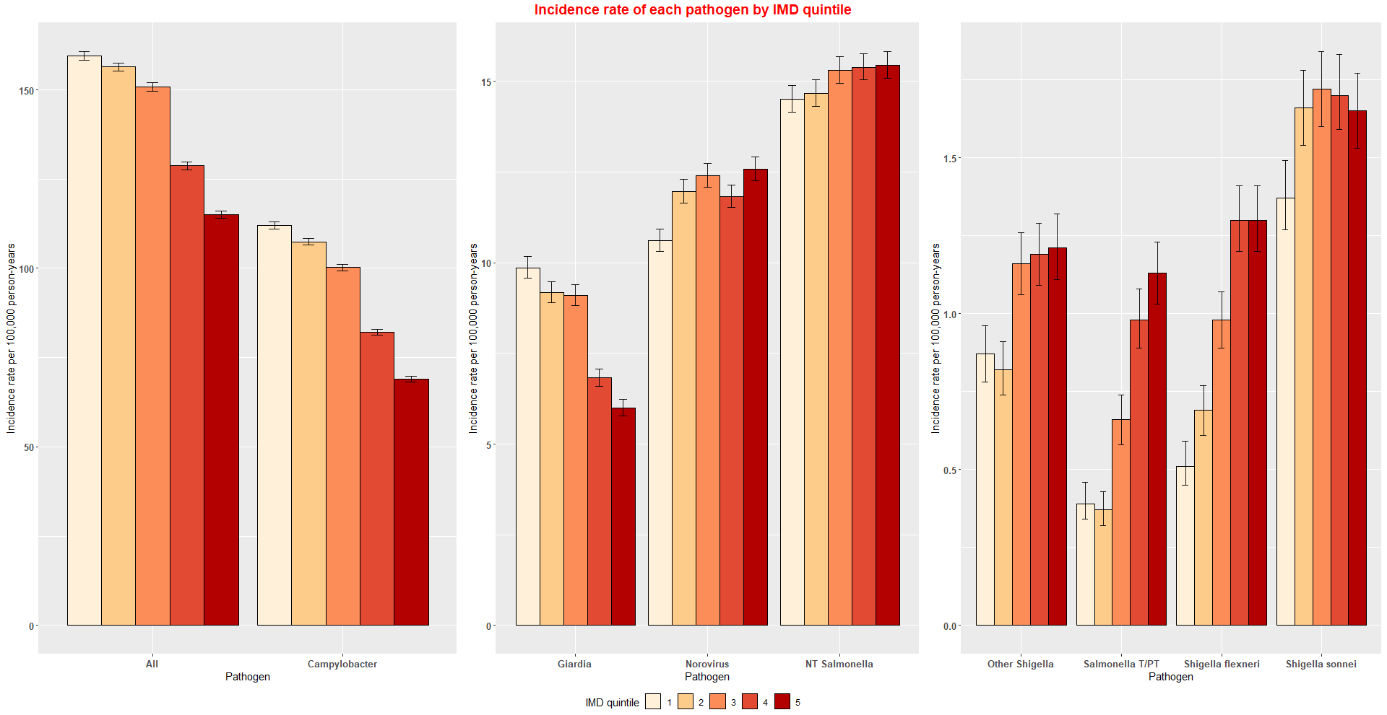
Figure 1A. Incidence rate per 100,000 person-years by IMD quintile for each pathogen.

