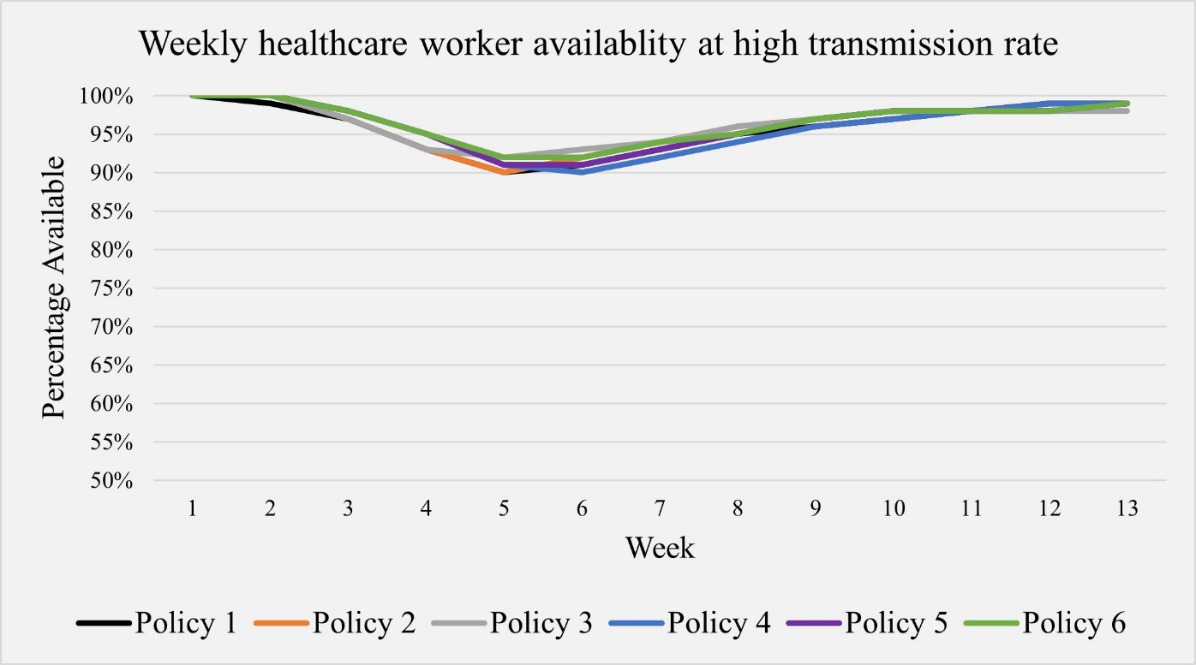
Supplemental Figure S1. Weekly healthcare worker (HCW) availability at a high transmission rate with a 75% vaccination.

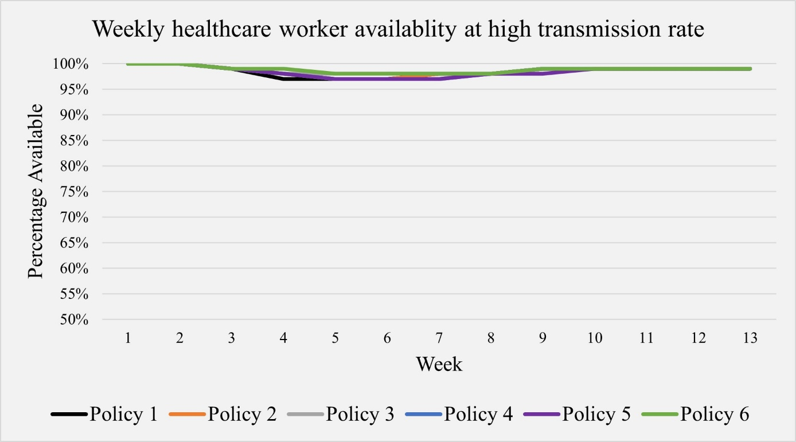
Supplemental Figure S2. Weekly healthcare worker (HCW) availability at a high transmission rate with a 90% vaccination.

Supplemental Table S1. Average weekly healthcare worker (HCW) availability for low and high transmission rates with a 75% vaccination.
Transmission  Rate | Week | Policy 1 | Policy 2 | Policy 3 | Policy 4 | Policy 5 | Policy 6
Low Transmission  Rate | 1 | 100% | 100% | 100% | 100% | 100% | 100%
 | 2 | 100% | 100% | 100% | 100% | 100% | 100%
 | 3 | 100% | 100% | 100% | 100% | 100% | 100%
 | 4 | 99% | 99% | 99% | 99% | 99% | 99%
 | 5 | 98% | 98% | 98% | 98% | 97% | 98%
 | 6 | 97% | 97% | 98% | 96% | 97% | 98%
 | 7 | 96% | 97% | 98% | 96% | 96% | 97%
 | 8 | 96% | 97% | 98% | 95% | 96% | 98%
 | 9 | 96% | 97% | 98% | 96% | 97% | 98%
 | 10 | 96% | 97% | 98% | 96% | 97% | 98%
 | 11 | 97% | 98% | 98% | 97% | 97% | 98%
 | 12 | 97% | 98% | 98% | 97% | 98% | 98%
 | 13 | 98% | 98% | 98% | 98% | 98% | 98%
High Transmission  Rate | 1 | 100% | 100% | 100% | 100% | 100% | 100%
 | 2 | 99% | 100% | 100% | 100% | 100% | 100%
 | 3 | 97% | 97% | 97% | 98% | 98% | 98%
 | 4 | 93% | 93% | 93% | 95% | 95% | 95%
 | 5 | 90% | 90% | 92% | 91% | 91% | 92%
 | 6 | 91% | 92% | 93% | 90% | 91% | 92%
 | 7 | 93% | 94% | 94% | 92% | 93% | 94%
 | 8 | 95% | 96% | 96% | 94% | 95% | 95%
 | 9 | 96% | 97% | 97% | 96% | 97% | 97%
 | 10 | 97% | 98% | 98% | 97% | 98% | 98%
 | 11 | 98% | 98% | 98% | 98% | 98% | 98%
 | 12 | 99% | 98% | 98% | 99% | 98% | 98%
 | 13 | 99% | 99% | 98% | 99% | 99% | 99%

Supplemental Table S2. Average weekly healthcare worker (HCW) availability for low and high transmission rates with a 90% vaccination.
Transmission  Rate | Week | Policy 1 | Policy 2 | Policy 3 | Policy 4 | Policy 5 | Policy 6
Low Transmission  Rate | 1 | 100% | 100% | 100% | 100% | 100% | 100%
 | 2 | 100% | 100% | 100% | 100% | 100% | 100%
 | 3 | 100% | 100% | 100% | 100% | 100% | 100%
 | 4 | 100% | 100% | 100% | 100% | 100% | 100%
 | 5 | 99% | 99% | 100% | 99% | 99% | 100%
 | 6 | 99% | 99% | 99% | 99% | 99% | 99%
 | 7 | 99% | 99% | 99% | 99% | 99% | 99%
 | 8 | 99% | 99% | 99% | 99% | 99% | 99%
 | 9 | 99% | 99% | 99% | 99% | 99% | 99%
 | 10 | 99% | 99% | 99% | 99% | 99% | 99%
 | 11 | 99% | 99% | 99% | 99% | 99% | 99%
 | 12 | 99% | 99% | 99% | 99% | 99% | 99%
 | 13 | 99% | 99% | 99% | 99% | 99% | 99%
High Transmission  Rate | 1 | 100% | 100% | 100% | 100% | 100% | 100%
 | 2 | 100% | 100% | 100% | 100% | 100% | 100%
 | 3 | 99% | 99% | 99% | 99% | 99% | 99%
 | 4 | 97% | 98% | 98% | 98% | 98% | 99%
 | 5 | 97% | 97% | 98% | 97% | 97% | 98%
 | 6 | 97% | 97% | 98% | 97% | 97% | 98%
 | 7 | 98% | 98% | 98% | 97% | 97% | 98%
 | 8 | 98% | 98% | 98% | 98% | 98% | 98%
 | 9 | 99% | 99% | 99% | 99% | 98% | 99%
 | 10 | 99% | 99% | 99% | 99% | 99% | 99%
 | 11 | 99% | 99% | 99% | 99% | 99% | 99%
 | 12 | 99% | 99% | 99% | 99% | 99% | 99%
 | 13 | 99% | 99% | 99% | 99% | 99% | 99%

