Epidemiology and Infection

Is Early Time to Positivity of Blood Culture Associated with Clinical Prognosis in Patients with Klebsiella pneumoniae Bloodstream Infection?
Weiwei Hou^{a, 1}, Tiantian Han^{b, 1}, Guangbo Qu^{c}, Yehuan Sun^{c, d, e}, Dianyu Yangª, Yan Lin^{b, *}

Supplementary Material

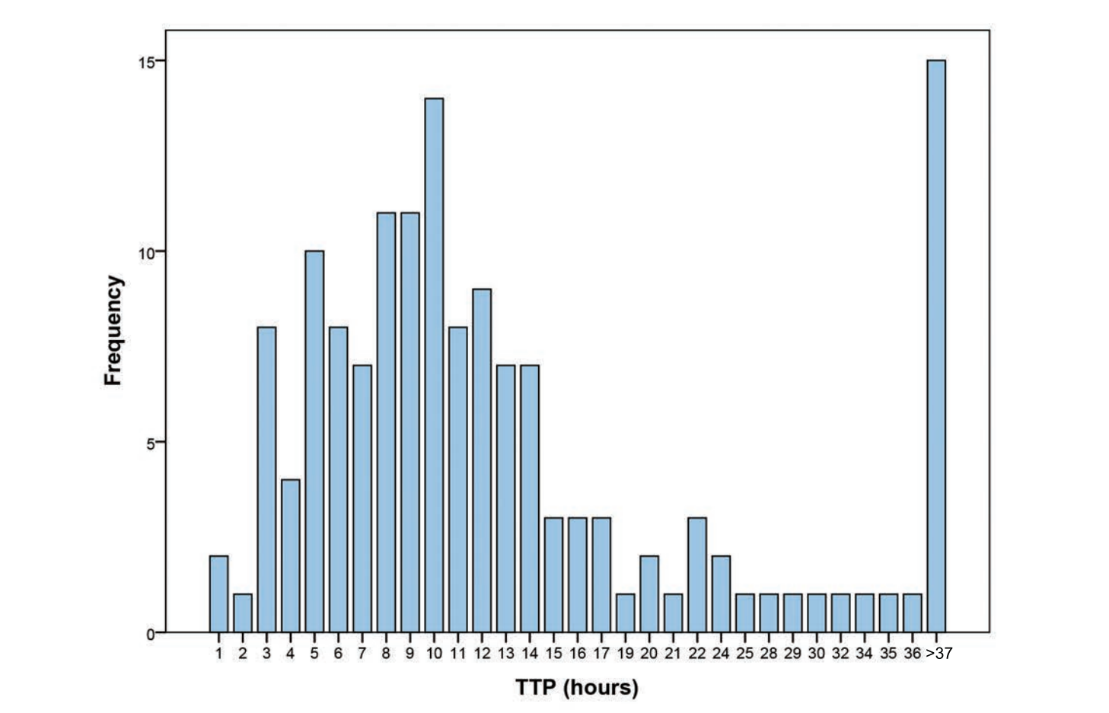
Figure S1. Distribution of TTP among patients with K. pneumoniae BSI.

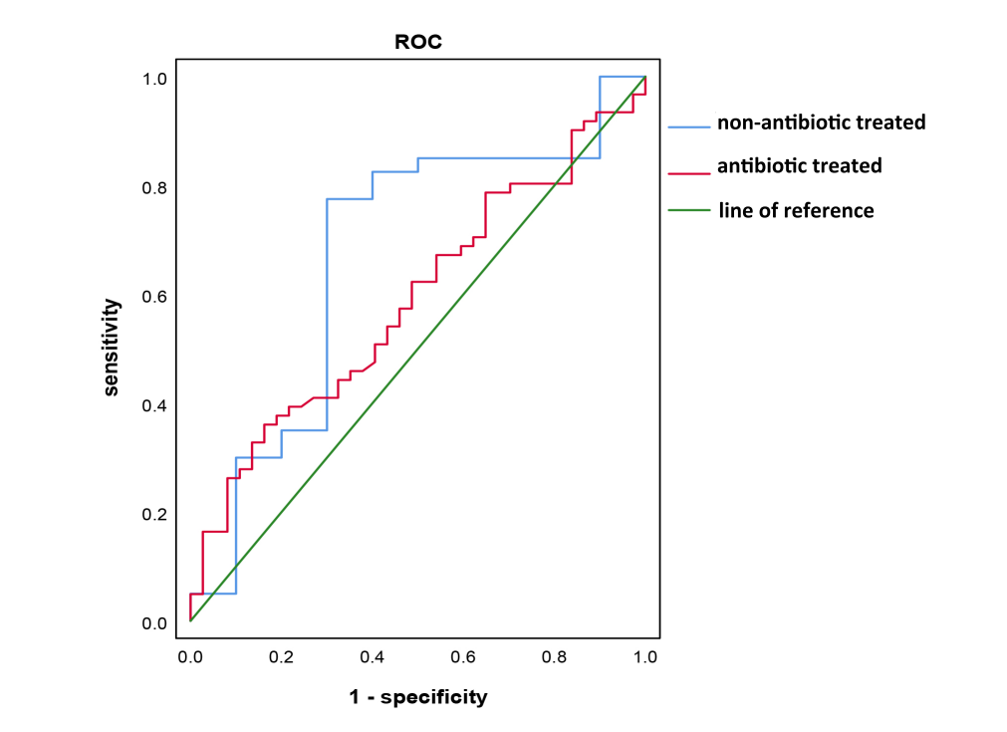
Figure S2. ROC curve of TTP on in-hospital mortality among non-antibiotic and antibiotic treated patients.

Table S1. Comparison of clinical characteristics between early TTP and late TTP groups among patients with K. pneumoniae BSI.
Variables | TTP≥9.4h (N=94) |  | TTP<9.4h (N=54) |  | p
 | N | M(P25-P75) / % | N | M(P25-P75) / %
Age (years) | 94 | 69.5 (55.8-79.0) | 54 | 67.0 (60.0-80.5) | 0.82
Gender |  |  |  |  | 0.53
Male | 64 | 68.1 | 34 | 63.0
Female | 30 | 31.9 | 20 | 37.0
Comorbidity | 93 | 98.9 | 54 | 100.0 | 1.00*
SCR (μmol/L) | 93 | 79.0 (57.5-109.5) | 54 | 75.5 (56.0-140.0) | 0.78
TBIL (μmol/L) | 92 | 17.3 (10.4-29.1) | 52 | 22.80 (14.0-55.5) | 0.02
MAP (mmHg) | 94 | 93.3 (87.2-99.8) | 54 | 93.3 (83.3-96.8) | 0.22
PLT(10⁹/L) | 94 | 160.5 (96.5-236.0) | 54 | 88.5 (19.3-172.5) | <0.01
PCT (ng/ml) | 91 | 2.2 (0.3-14.6) | 49 | 1.4 (0.2-14.0) | 0.57
WBC (10⁹/L) | 94 | 12.4 (9.2-16.5) | 54 | 7. 9 (3.0-13.1) | <0.01
CRP (mg/L) | 94 | 129.4 (65.8-182.5) | 54 | 117.6 (57.3-168.0) | 0.53
Hospital stay (d) | 94 | 22.0 (12.8-42.0) | 54 | 21.5 (10.0-48.8) | 0.77
Drug resistance |  |  |  |  | 0.66
No | 53 | 56.4 | 34 | 63.0
CRKP | 31 | 33.0 | 14 | 25.9
MDRKP | 10 | 10.6 | 6 | 11.1
Antibiotic therapy¹ | 61 | 64.9 | 37 | 68.5 | 0.65
Hemodialysis | 2 | 2.1 | 0 | 0.0 | 0.53*
Transfusion | 55 | 58.5 | 42 | 77.8 | 0.02
Surgery | 50 | 53.2 | 39 | 72.2 | 0.02
ICU admission | 26 | 28.0 | 16 | 29.6 | 0.26
Septic shock | 8 | 8.8 | 8 | 14.8 | 0.26
Death | 23 | 24.5 | 24 | 44.4 | 0.01
Annotation: *, Fisher’s exact probability; ¹, antibiotic therapy before blood collection.

