Epidemiology and Infection

Characteristics of patients with SARS-COV-2 PCR re-positivity after recovering from COVID-19

Cheng-Yi Hu, Yi Lei, Yu-Wen Tang, Wen-Shuai Cui, Pei-Lian Wu, Yan-Fang Li, Yan Zhou, Xin-Yan Li, Hao Cui, Lu-Shan Xiao, Zhu-Xiang Zhao

Supplementary Materials

Supplementary Table S1. The time frame for retesting positive for the cited studies
Research | Time interval from discharge to test re-positive | Time interval from diagnosis to test re-positive | Detection frequency
Lan L, et al.[1] | 5 to 13 days | not mentioned | Three times in 4-5 days
Liotti FM, et al.[2] | not mentioned | about 48 to 57 days | not mentioned
Ren X, et al.[3] | most were within 30 days | not mentioned | not mentioned
Cento V, et al.[4] | 90.5% of cases were within one month | not mentioned | not mentioned
Wu X, et al.[5] | 1 to 165 days | not mentioned | once per month
Shui TJ, et al.[6] | 6 to 8 days | 23 to 27 days | not mentioned
Li T, et al.[7] | about within 28 days | not mentioned | not mentioned
Yang C, et al.[8] | about 8 days | not mentioned | 1 to 3 times per week
Wu J, et al.[9] | 3 to 15 days | not mentioned | once per 3 days
Zou Y, et al.[10] | 1 to 12 days | not mentioned | not mentioned
Chen J, et al.[11] | 3 to 18 days | 16 to 64 days | not mentioned
Mei Q, et al.[12] | 4 to 38 days | not mentioned | not mentioned
Wong J, et al.[13] | 11 to 18 days | not mentioned | not mentioned
Deng W, et al.[14] | most were within 14 days | not mentioned | not mentioned
Zheng J, et al.[15] | 5 to 8 days | not mentioned | once per 2-3 days
Zheng KI, et al.[16] | within 7 days | not mentioned | not mentioned

References
1. Lan L, et al. (2020) Positive RT-PCR Test Results in Patients Recovered From COVID-19. JAMA 323(15), 1502-1503.
2. Liotti FM, et al. (2021) Assessment of SARS-CoV-2 RNA Test Results Among Patients Who Recovered From COVID-19 With Prior Negative Results. JAMA Intern Med 181(5), 702-704.
3. Ren X, et al. (2021) A systematic review and meta-analysis of discharged COVID-19 patients retesting positive for RT-PCR. EClinicalMedicine 34, 100839.
4. Cento V, et al. (2020) Persistent positivity and fluctuations of SARS-CoV-2 RNA in clinically-recovered COVID-19 patients. The Journal of infection 81(3), e90-e92.
5. Wu X, et al. (2021) A follow-up study shows that recovered patients with re-positive PCR test in Wuhan may not be infectious. BMC Med 19(1), 77.
6. Shui TJ, et al. (2020) Characteristics of recovered COVID-19 patients with recurrent positive RT-PCR findings in Wuhan, China: a retrospective study. BMC Infect Dis 20(1), 749.
7. Li T, et al. (2022) Clinical characteristics and risks of the convalescent COVID-19 patients with re-detectable positive RNA test: a 430 patients with Omicron infected cross-sectional survey in Tianjin, China. J Infect Public Health 15(12), 1409-1414.
8. Yang C, et al. (2020) Viral RNA level, serum antibody responses, and transmission risk in recovered COVID-19 patients with recurrent positive SARS-CoV-2 RNA test results: a population-based observational cohort study. Emerg Microbes Infect 9(1), 2368-2378.
9. Wu J, et al. (2020) Clinical characteristics and outcomes of discharged COVID-19 patients with reoccurrence of SARS-CoV-2 RNA. Future Virol 15(10), 663-671.
10. Zou Y, et al. (2020) The Issue of Recurrently Positive Patients Who Recovered From COVID-19 According to the Current Discharge Criteria: Investigation of Patients from Multiple Medical Institutions in Wuhan, China. J Infect Dis 222(11), 1784-1788.
11. Chen J, et al. (2020) Clinical course and risk factors for recurrence of positive SARS-CoV-2 RNA: a retrospective cohort study from Wuhan, China. Aging (Albany NY) 12(17), 16675-16689.
12. Mei Q, et al. (2020) Assessment of patients who tested positive for COVID-19 after recovery. Lancet Infect Dis 20(9), 1004-1005.
13. Wong J, et al. (2020) Probable causes and risk factors for positive SARS-CoV-2 test in recovered patients: Evidence from Brunei Darussalam. J Med Virol 92(11), 2847-2851.
14. Deng W, et al. (2020) Positive results for patients with COVID-19 discharged form hospital in Chongqing, China. BMC Infect Dis 20(1), 429.
15. Zheng J, et al. (2020) Incidence, clinical course and risk factor for recurrent PCR positivity in discharged COVID-19 patients in Guangzhou, China: A prospective cohort study. PLoS Negl Trop Dis 14(8), e0008648.
16. Zheng KI, et al. (2020) A Case Series of Recurrent Viral RNA Positivity in Recovered COVID-19 Chinese Patients. J Gen Intern Med 35(7), 2205-2206.

Supplementary Table S2. Area under the curve of the model and independent risk factors for SARS-CoV-2 re-positivity
independent risk factor | AUC | p
The model | 0.800(0.776-0.824) | p<0.001
the doses of the COVID-19 vaccine | 0.530(0.498-0.562) | 0.062
cumulative frequency of infection with COVID-19 | 0.524(0.493-0.555) | 0.135
eGFR# | 0.542(0.511-0.573) | 0.009
SARS-CoV-2 IgM# | 0.606(0.575-0.638) | <0.001
SARS-CoV-2 IgG* | 0.713(0.682-0.743) | <0.001
SARS-CoV-2 IgM* | 0.584(0.552-0.616) | <0.001
WBC* | 0.578(0.547-0.610) | 0.091
eGFR: estimated glomerular filtration rate; WBC: white blood cell.
# The result during quarantine observation and rehabilitation training
* The result at the time of diagnosis

Supplementary Table S3. Comparison between the area under the curve of the models and each independent risk factor for SARS-CoV-2 re-positivity.
Comparison | p
The model vs. the doses of the COVID-19 vaccine | P < 0.0001
The model vs. cumulative frequency of infection with COVID-19 | P < 0.0001
The model vs. eGFR# | P < 0.0001
The model vs. SARS-CoV-2 IgM# | P < 0.0001
The model vs. SARS-CoV-2 IgG* | P < 0.0001
The model vs. SARS-CoV-2 IgM* | P < 0.0001
The model vs. WBC* | P < 0.0001
eGFR: estimated glomerular filtration rate; WBC: white blood cell.
# The result during quarantine observation and rehabilitation training
* The result at the time of diagnosis

Supplementary Table S4. Demographics and clinical characteristics of the patients in the verification group
characteristics | verification group (n=71)
Age(year) | 35(29-43)
Sex(man) | 56(78.9%)
re-positive patients | 31(43.7%)
The doses of the COVID-19 vaccine
0-1 | 6(8.5%)
2-4 | 65(91.5%)
Number of episodes of COVID-19
1 | 66(93.0%)
2 | 5(7.0%)
Laboratory findings
White blood cell(10^9/L)* | 6.01(4.94-6.98)
eGFR(ml/(min×1.73 m²))#
<90 | 57(80.3%)
≥90 | 14(19.7%)
SARS-CoV-2 IgM(S/CO)# | 0.66 (0.18- 5.76)
SARS-CoV-2 IgG(S/CO)* | 146.80(52.32- 211.47)
SARS-CoV-2 IgM(S/CO)* | 0.60(0.08- 3.69)

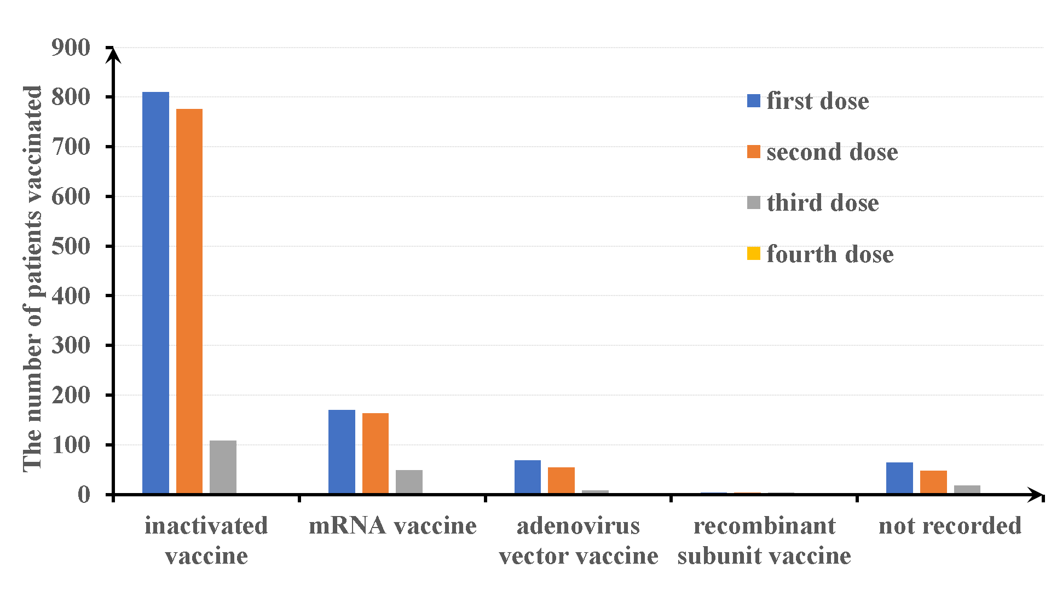Supplementary Figure S1. Vaccination status in the training group

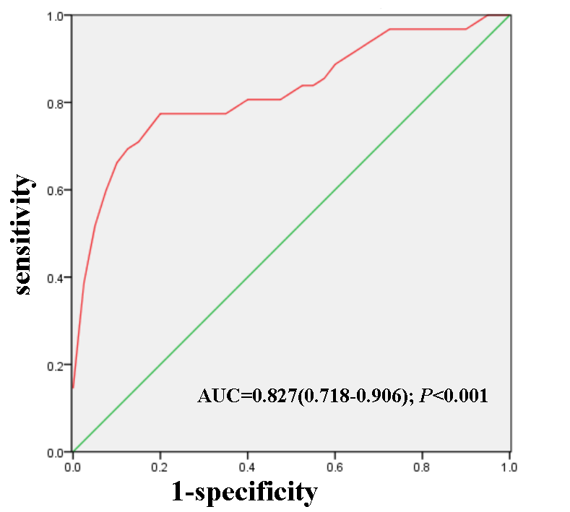Supplementary Figure S2. Area under the curve in the verification group

