Appendix
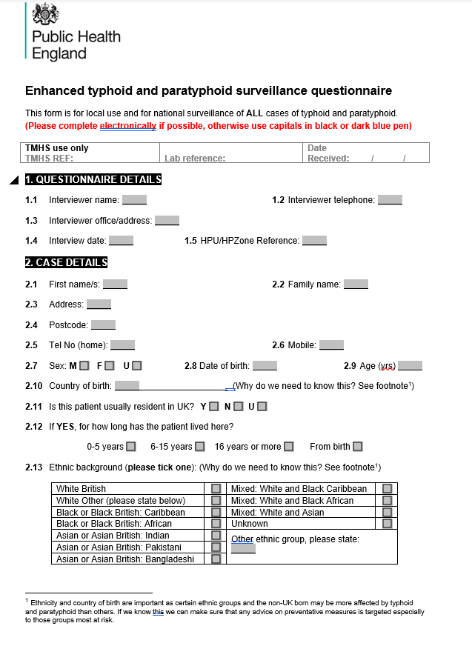
Supplementary Questionnaire. Enhanced Enteric Fever Questionnaire
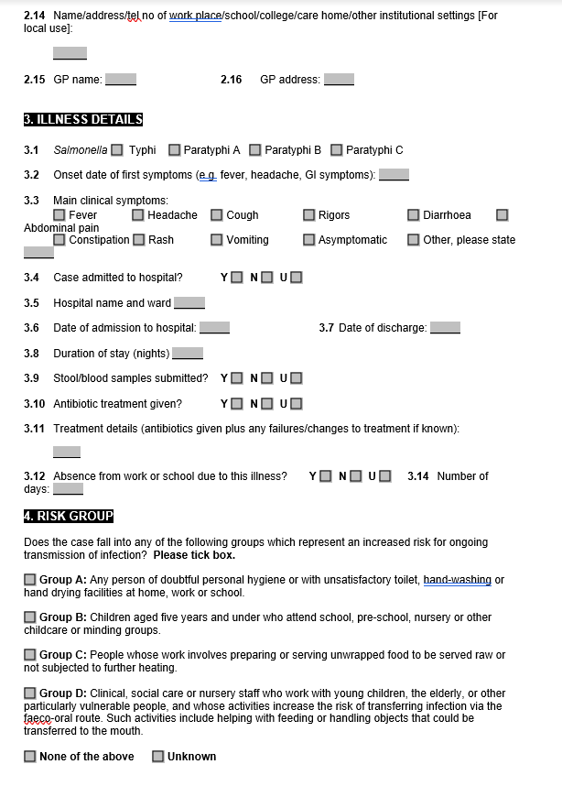
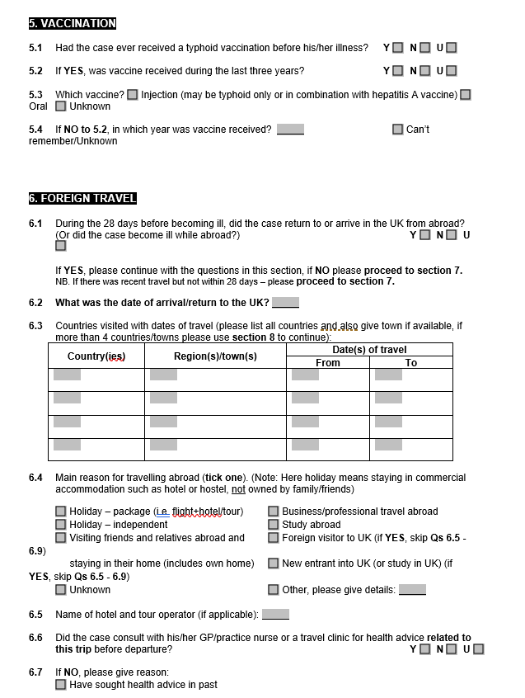
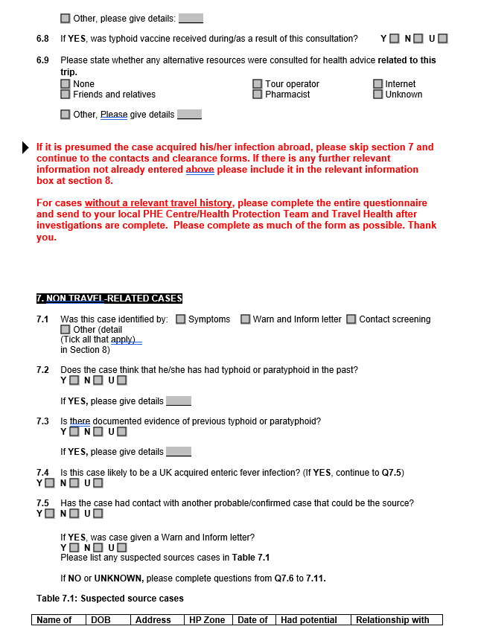
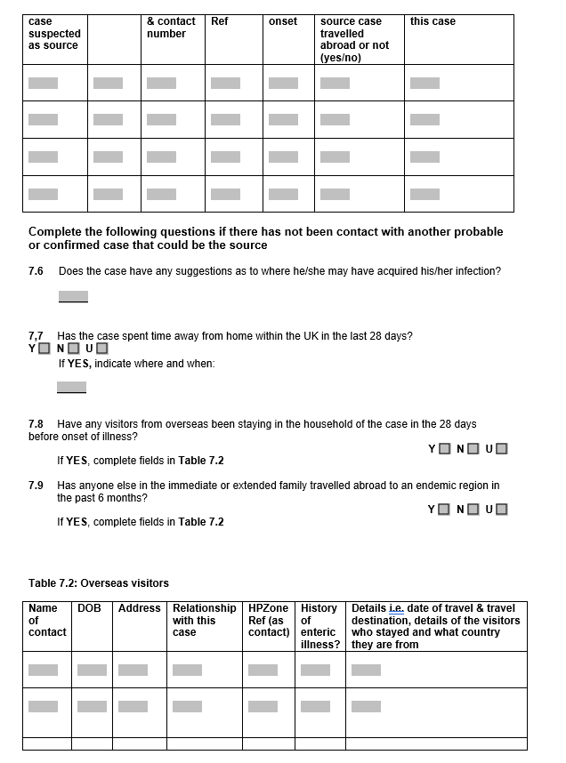
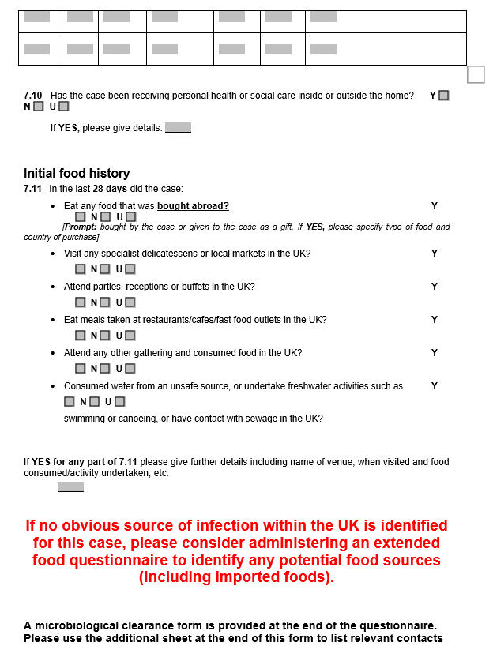
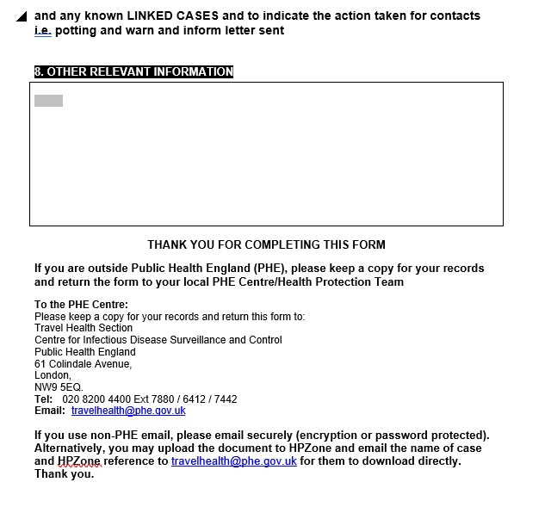
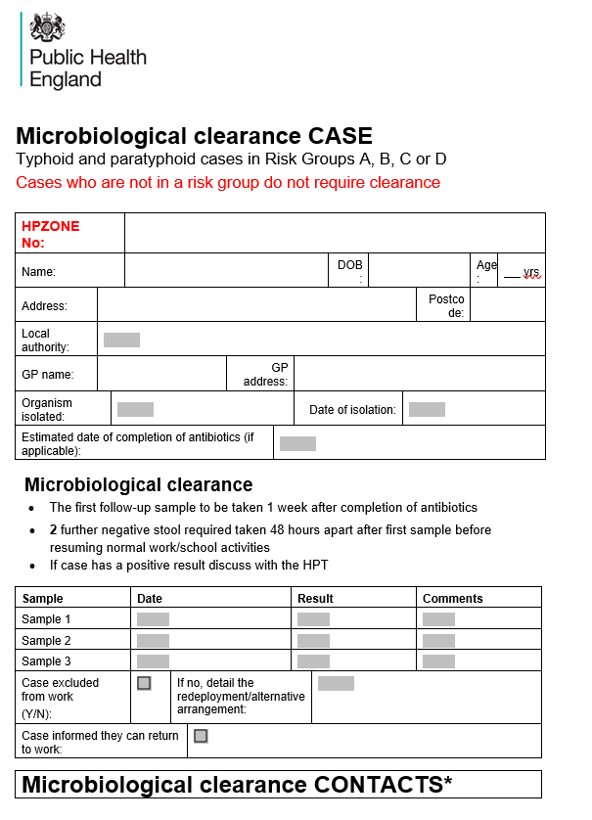
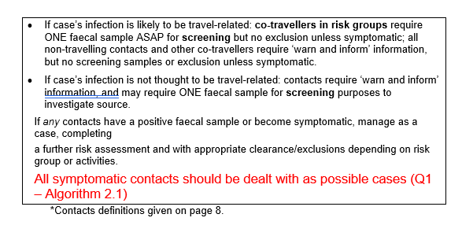

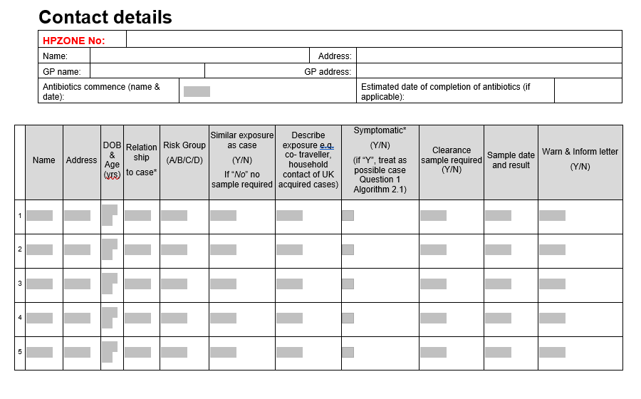

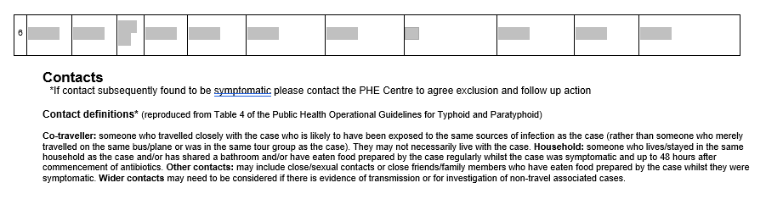

Supplementary Table 1. Enteric fever incidence rates per 100,000 person-years described by IMD, sex and age (n=1412).
 | IMD Quintile (95% CI¹)
 | 1 (most deprived) | 2 | 3 | 4 | 5 (least deprived) | Total
Total | 0.83  (0.76, 0.91) | 0.84  (0.77, 0.92) | 0.48  (0.43, 0.54) | 0.34  (0.29, 0.39) | 0.32  (0.28, 0.37) | 0.57  (0.54, 0.60)
Sex
Females | 0.81  (0.71, 0.92) | 0.83  (0.73, 0.94) | 0.45  (0.38, 0.54) | 0.32  (0.26, 0.39) | 0.30  (0.28, 0.42) | 0.55  (0.51, 0.59)
Males | 0.86  (0.75, 0.97) | 0.85  (0.75, 0.97) | 0.51  (0.43, 0.61) | 0.36  (0.29, 0.44) | 0.34  (0.28, 0.42) | 0.59  (0.55, 0.64)
Age
0-4 | 1.07  (1.04, 1.77) | 0.84  (0.57, 1.19) | 0.69  (0.43, 1.04) | 0.31  (0.14, 0.59) | 0.26  (0.10, 0.53) | 0.69  (0.57, 0.82)
5-9 | 1.37  (1.04, 1.77) | 1.30  (0.95, 1.72) | 1.02  (0.70, 1.43) | 0.58  (0.34, 0.91) | 0.41  (0.22, 0.70) | 0.97  (0.83, 1.13)
10-14 | 0.89  (0.61, 1.25) | 1.12  (0.78, 1.55) | 0.55  (0.31, 0.89) | 0.38  (0.19, 0.67) | 0.32  (0.15, 0.59) | 0.66  (0.54, 0.80)
15-24 | 1.06  (0.84, 1.32) | 1.28  (1.04, 1.57) | 0.75  (0.56, 1.00) | 0.67  (0.48, 0.91) | 0.65  (0.46, 0.90) | 0.91  (0.81, 1.02)
25-44 | 1.04  (0.89, 1.20) | 1.15  (1.00, 1.33) | 0.67  (0.55, 0.82) | 0.53  (0.41, 0.67) | 0.61  (0.48, 0.77) | 0.83  (0.77, 0.90)
45-64 | 0.54  (0.42, 0.70) | 0.47  (0.36, 0.60) | 0.27  (0.19, 0.37) | 0.21  (0.14, 0.25) | 0.16  (0.11, 0.24) | 0.32  (0.28, 0.36)
65+ | 0.16  (0.08, 0.28) | 0.18  (0.10, 0.30) | 0.12  (0.06, 0.21) | 0.08  (0.04, 0.15) | 0.08  (0.03, 0.14) | 0.11  (0.08, 0.15)
1-95% CI were calculated using Byar approx. Poisson

Supplementary Table 2. Enteric fever incidence rates per 100,000 person-years described by ethnicity, sex and age (n=1412).
 | Ethnicity (95% CI¹)
 | Bangladeshi | Black (African/  Caribbean) | Indian | Pakistani | Other/Other Asian | White (British/  Other) | Total
Total | 5.68  (4.74, 6.76) | 0.70  (0.54, 0.89) | 7.81  (7.18, 8.49) | 9.89  (9.08, 10.75) | 0.78  (0.64, 0.93) | 0.07  (0.06, 0.08) | 0.57  (0.54, 0.60)
Sex
Females | 5.27  (3.99, 6.83) | 0.64  (0.44, 0.91) | 7.96  (7.05, 8.96) | 9.70  (8.57, 10.94) | 0.87  (0.70, 1.11) | 0.06  (0.05, 0.08) | 0.54  (0.50, 0.58)
Males | 6.06  (4.73, 7.66) | 0.76  (0.52, 1.06) | 7.67  (6.79, 8.63) | 10.07  (8.94, 11.29) | 0.69  (0.51, 0.90) | 0.08  (0.06, 0.09) | 0.59  (0.55, 0.63)
Age
0-4 | 2.74  (1.10, 5.65) | 0.23  (0.03, 0.82) | 6.25  (4.25, 8.87) | 10.19  (7.88, 12.96) | 0.51  (0.23, 0.96) | 0.01  (0.00, 0.04) | 0.66  (0.55, 0.80)
5-9 | 6.69  (3.90, 10.72) | 0.77  (0.28, 1.67) | 14.25  (10.82, 18.42) | 13.31  (10.55, 16.57) | 0.58  (0.25, 1.15) | 0.01  (0.00, 0.04) | 1.08  (0.06, 1.70)
10-14 | 8.44  (5.08, 13.18) | 0.27  (0.03, 0.99) | 6.11  (3.87, 9.17) | 10.04  (7.47, 13.19) | 0.57  (0.23, 1.17) | 0.02  (0.01, 0.07) | 0.64  (0.53, 0.78)
15-24 | 5.81  (3.72, 8.64) | 0.56  (0.24, 1.10) | 8.61  (6.89, 10.61) | 12.01  (9.92, 14.42) | 0.83  (0.53, 1.23) | 0.15  (0.11, 0.20) | 0.82  (0.73, 0.92)
25-44 | 5.36  (3.87, 7.25) | 0.73  (0.46, 1.10) | 8.50  (7.44, 9.67) | 9.37  (8.06, 10.82) | 1.09  (0.82, 1.42) | 0.12  (0.09, 0.15) | 0.79  (0.73, 0.86)
45-64 | 6.75  (3.77, 11.13) | 1.23  (0.77, 1.87) | 6.14  (4.95, 7.54) | 7.93  (5.99, 10.29) | 0.65  (0.36, 1.09) | 0.04  (0.02, 0.06) | 0.31  (0.27, 0.36)
65+ | 3.62  (0.73, 10.57) | 0.35  (0.04, 1.25) | 5.39  (3.66, 7.65) | 2.02  (0.65, 4.71) | 0.00  (0.00, 0.00) | 0.03  (0.02, 0.06) | 0.12  (0.09, 0.16)
1-95% CI were calculated using Byar approx. Poisson

Supplementary Table 3. Enteric fever incidence rates per 100,000 person-years described by ethnicity and IMD (n=1412).
 | Ethnicity (95% CI¹)
 | Bangladeshi | Black (African/  Caribbean) | Indian | Pakistani | Other  /Other Asian | White  (British/Other)
IMD Quintile
1 (most deprived) | 4.42  (3.21, 5.93) | 0.43  (0.24, 0.72) | 7.43  (6.05, 9.04) | 7.82  (6.81, 8.93) | 0.57  (0.37, 0.84) | 0.05  (0.03, 0.07)
2 | 6.03  (4.34, 8.15) | 0.49  (0.27, 0.80) | 8.11  (6.89, 9.48) | 11.40  (9.69, 13.32) | 0.59  (0.39, 0.86) | 0.07  (0.05, 0.10)
3 | 4.54  (2.34, 7.92) | 0.53  (0.23, 1.04) | 7.77  (6.46, 9.27) | 9.09  (7.04, 11.54) | 0.48 (0.28, 0.77) | 0.04  (0.02, 0.06)
4 | 5.07  (2.03, 10.45) | 0.81  (0.29, 1.76) | 5.51  (4.23, 7.05) | 9.62  (6.84, 13.15) | 0.56 (0.31, 0.92) | 0.07  (0.05, 0.09)
5 (least deprived) | 11.48  (5.50, 21.11) | 0.92  (0.25, 2.35) | 6.48  (4.96, 8.30) | 10.42  (6.92, 15.06) | 0.50 (0.25, 0.89) | 0.08  (0.06, 0.11)
1-95% CI were calculated using Byar approx. Poisson

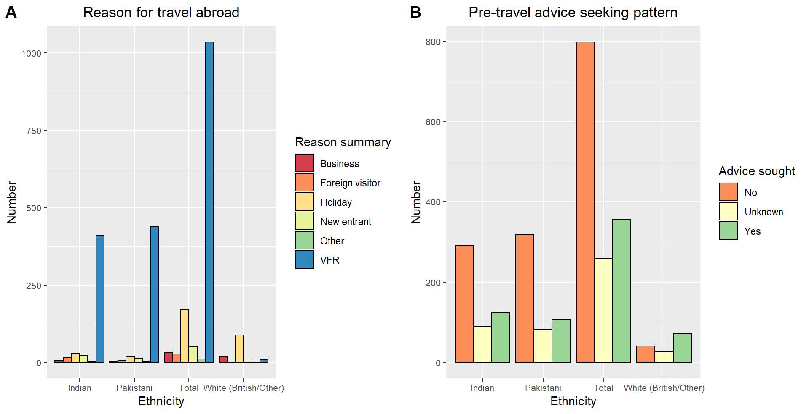
Supplementary Figure 1. Individuals travelling abroad of Indian, Pakistani, White (British/Other) and total ethnicities, grouped by reason for travelling (A) and grouped by advice seeking pattern (B) (n=1412).

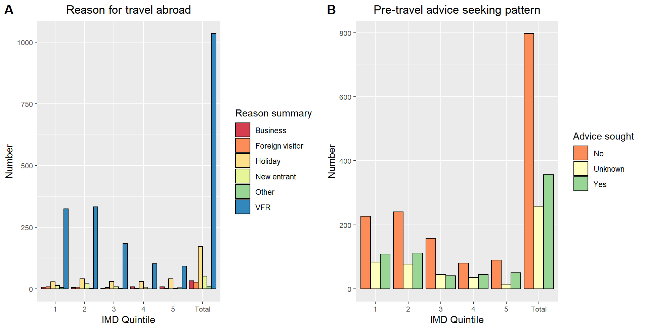
Supplementary Figure 2. Individuals travelling abroad from each IMD quintile and total IMD, grouped by reason for travelling (A) and grouped by advice seeking pattern (B) (n=1412).

Supplementary Table 4. Negative binomial regression models with case number as an outcome, ethnicity and IMD as explanatory variables and person-years as an offset (n=1412).
 | IMD and ethnicity only Model |  | IMD, ethnicity and IMD-ethnicity interaction Model
Variable | Incidence risk ratio  (95% CI) | p-value¹ | Incidence risk ratio  (95% CI) | p-value
Ethnicity
White (British/Other) | Ref |  | Ref
Bangladeshi | 87.64 (68.09-112.81) | <0.001*** | 94.20 (55.00, 161.33) | <0.001***
Pakistani | 154.39 (127.13, 187.50) | <0.001*** | 166.58 (104.22, 266.26) | <0.001***
Indian | 117.88 (97.57, 142.42) | <0.001*** | 158.36 (96.97, 258. 63) | <0.001***
Black (African/Caribbean) | 8.56 (6.15, 11.93) | <0.001*** | 9.24 (4.70, 18.19) | <0.001***
Other/Other Asian | 8.98 (6.92, 11.65) | <0.001*** | 12.15 (6.72, 21.95) | <0.001***
IMD Quintile
1 (most deprived) | Ref |  | Ref
2 | 1.31 (1.14, 1.50) | <0.001*** | 1.50 (0.84, 2.66) | 0.170
3 | 1.10 (0.93, 1.29) | 0.259 | 0.78 (0.41, 1.50) | 0.459
4 | 1.05 (0.87, 1.27) | 0.611 | 1.42 (0.81, 2.51) | 0.223
5 (least deprived) | 1.23 (1.02, 1.50) | 0.031* | 1.76 (1.02, 3.03) | 0.043*
IMD-Ethnicity interaction |  |  |  | 0.1448²
1-*p<0.05 **p<0.01 ***p<0.001
2-Wald’s test with significance level at p<0.05.

Supplementary Table 5. Proportion of cases from each ethnicity in each IMD quintile (n=1412).
 | IMD Quintile (%)
Ethnicity | 1 | 2 | 3 | 4 | 5 | Total
Bangladeshi | 44 (38.3) | 42 (36.5) | 12 (10.4) | 7 (6.1) | 10 (8.7) | 115 (100.0)
Black (African/Caribbean) | 15 (31.3) | 15 (31.3) | 8 (16.7) | 6 (12.5) | 4 (8.3) | 48 (100.0)
Indian | 100 (19.8) | 158 (31.2) | 123 (24.3) | 63 (12.5) | 62 (12.3) | 506 (100.0)
Other/Other Asian | 26 (26.8) | 28 (28.9) | 17 (17.5) | 15 (15.5) | 11 (11.3) | 97 (100.0)
Pakistani | 216 (42.5) | 158 (31.1) | 67 (13.2) | 39 (7.7) | 28 (5.5) | 508 (100.0)
White (British/Other) | 19 (13.8) | 30 (21.7) | 17 (12.3) | 32 (23.2) | 40 (29.0) | 138 (100.0)
Total | 420 (29.8) | 431 (30.5) | 244 (17.3) | 162 (11.5) | 155 (11.0) | 1412 (100.0)

Supplementary Table 6. Model 3 repeated for 3 outcomes (hospital admission, absence from school/work and symptom severity) with interaction terms added: ethnicity-travel abroad, IMD-residence and IMD-ethnicity.
 | Hospital Admission  (n=1412) | Absence from school/work  (n=1020) | Symptom Severity  (n=1412)
Variable | p-value¹
Ethnicity-Travel abroad | 0.444² | 0.714 | 0.148
IMD Quintile-Residence | 0.500 | 0.970 | 0.686
IMD Quintile-Ethnicity | 0.951 | 0.816 | 0.381
1-*p<0.05 **p<0.01 ***p<0.001
2-Wald’s test with significance level at p<0.05.

Supplementary Table 7. Binary and ordinal logistic regressions with ethnicity and IMD as the explanatory variables and hospital admission, absence from school/work and symptom severity as main outcomes.
 | Unadjusted model (outcomes only) |  | Model 1¹ |  | Model 2² |  | Model 3³
Variable | Odds ratios  (95% CI) | p-value⁴ | Odds ratios  (95% CI) | p-value | Odds ratios  (95% CI) | p-value | Odds ratios  (95% CI) | p-value
Outcome: Hospital Admission (n=1342 for Unadjusted Model, Model 1 and Model 2 and n=1143 for Model 3)
Ethnicity
White (British/Other) | Ref |  |  |  | Ref |  | Ref
Bangladeshi | 2.26 (1.18, 4.35) | 0.014* |  |  | 2.40 (1.23, 4.69) | 0.011* | 1.81 (0.21, 15.26) | 0.586
Pakistani | 3.98 (2.39, 6.62) | <0.001*** |  |  | 4.28 (2.50, 7.31) | <0.001*** | 1.14 (0.30, 4.30) | 0.842
Indian | 2.49 (1.56, 3.97) | <0.001*** |  |  | 2.79 (1.72, 4.52) | <0.001*** | 2.30 (0.92, 5.77) | 0.076
Black (African/Caribbean) | 1.81 (0.76, 4.33) | 0.182 |  |  | 2.23 (0.91, 5.45) | 0.078 | 0.60 (0.12, 2.92) | 0.526
Other/Other Asian | 4.00 (1.81, 8.88) | 0.001** |  |  | 4.21 (1.86, 9.43) | <0.001*** | 2.74 (0.96, 7.81) | 0.060
IMD Quintile
1 (most deprived) | Ref |  |  |  | Ref |  | Ref
2 | 0.65 (0.43, 0.98) | 0.039* |  |  | 0.63 (0.42, 0.95) | 0.029* | 0.73 (0.46, 1.18) | 0.198
3 | 0.77 (0.47, 1.25) | 0.285 |  |  | 0.76 (0.47, 1.25) | 0.286 | 0.76 (0.44, 1.33) | 0.339
4 | 1.17 (0.65, 2.12) | 0.603 |  |  | 1.15 (0.63, 2.10) | 0.638 | 1.29 (0.63, 2.64) | 0.480
5 (least deprived) | 0.77 (0.45, 1.32) | 0.342 |  |  | 0.75 (0.44, 1.30) | 0.310 | 0.88 (0.46, 1.67) | 0.688
Sex
Male |  |  | Ref |  | Ref |  | Ref
Female |  |  | 0.94  (0.69, 1.27) | 0.691 | 0.92 (0.67, 1.25) | 0.589 | 0.92 (0.64, 1.33) | 0.664
Age
25-44 |  |  | Ref |  | Ref |  | Ref
0-4 |  |  | 1.00  (0.54, 1.85) | 0.997 | 0.74 (0.39, 1.39) | 0.348 | 0.79 (0.38, 1.67) | 0.542
5-9 |  |  | 0.90  (0.54, 1.50) | 0.696 | 0.71 (0.42, 1.20) | 0.206 | 1.08 (0.57, 2.05) | 0.821
10-14 |  |  | 1.01  (0.54, 1.91) | 0.973 | 0.81 (0.42, 1.55) | 0.523 | 1.07 (0.50, 2.30) | 0.858
15-24 |  |  | 1.47  (0.92, 2.34) | 0.110 | 1.50 (0.92, 2.42) | 0.101 | 2.16 (1.19, 3.95) | 0.012*
45-64 |  |  | 0.58  (0.38, 0.89) | 0.012* | 0.59 (0.38, 0.92) | 0.021 | 0.61 (0.37, 1.00) | 0.048*
65+ |  |  | 0.51  (0.22, 1.18) | 0.118 | 0.61 (0.26, 1.43) | 0.253 | 0.56 (0.22, 1.45) | 0.234
Residence
Urban |  |  |  |  |  |  | Ref
Rural |  |  |  |  |  |  | 1.51 (0.56, 4.06) | 0.418
Antibiotic Administration
No |  |  |  |  |  |  | Ref
Yes |  |  |  |  |  |  | 23.95  (10.04, 57.14) | <0.001***
Organism
Salmonella Typhi |  |  |  |  |  |  | Ref
Salmonella Paratyphi A |  |  |  |  |  |  | 0.61 (0.41, 0.90) | 0.014*
Salmonella Paratyphi B |  |  |  |  |  |  | 0.22 (0.06, 0.90) | 0.034*
Presumed region of infection
Africa |  |  |  |  |  |  | Ref
South Asia (India) |  |  |  |  |  |  | 0.43 (0.09, 2.00) | 0.282
South Asia (Pakistan) |  |  |  |  |  |  | 1.44 (0.23, 8.96) | 0.695
South Asia (Bangladesh) |  |  |  |  |  |  | 0.38 (0.03, 4.54) | 0.447
Europe/North America/Oceania/East Asia |  |  |  |  |  |  | 0.19 (0.02, 1.70) | 0.136
More than one region/continent |  |  |  |  |  |  | 0.67 (0.11, 4.12) | 0.668
South Asia (other countries) |  |  |  |  |  |  | 0.27 (0.04, 1.85) | 0.183
South/Central America |  |  |  |  |  |  | 0.91 (0.11, 7.27) | 0.928
Southeast Asia |  |  |  |  |  |  | 0.58 (0.09, 3.52) | 0.552
Western Asia |  |  |  |  |  |  | 1.29 (0.13, 12.85) | 0.829
Advice sought
No |  |  |  |  |  |  | Ref
Yes |  |  |  |  |  |  | 1.36 (0.90, 2.05) | 0.141
Reason for travelling
VFR |  |  |  |  |  |  | Ref
Foreign Visitor |  |  |  |  |  |  | 1 (empty)
Holiday |  |  |  |  |  |  | 0.85 (0.43, 1.67) | 0.641
New entrant |  |  |  |  |  |  | 0.49 (0.09, 2.68) | 0.408
Other |  |  |  |  |  |  | 4.01 (0.25, 63.55) | 0.324
Business |  |  |  |  |  |  | 1.25 (0.38, 4.16) | 0.713
Outcome: Absence from school/ work (n=974 for Unadjusted Model, Model 1 and Model 2 and n=854 for Model 3)
Ethnicity
White (British/Other) | Ref |  |  |  | Ref |  | Ref
Bangladeshi | 1.52 (0.71, 3.25) | 0.285 |  |  | 1.08 (0.49, 2.38) | 0.857 | 1.14 (0.14, 9.59) | 0.903
Pakistani | 1.11 (0.65, 1.90) | 0.695 |  |  | 0.90 (0.51, 1.58) | 0.704 | 1.87 (0.48, 7.28) | 0.365
Indian | 1.35 (0.79, 2.29) | 0.270 |  |  | 1.23 (0.71, 2.14) | 0.463 | 2.62 (0.86, 8.03) | 0.091
Black (African/Caribbean) | 1.80 (0.56, 5.78) | 0.323 |  |  | 1.66 (0.50, 5.44) | 0.406 | 2.56 (0.17, 38.03) | 0.496
Other/Other Asian | 1.95 (0.86, 4.40) | 0.110 |  |  | 1.73 (0.75, 4.01) | 0.201 | 3.50 (1.01, 12.16) | 0.049
IMD Quintile
1 | Ref |  |  |  | Ref |  | Ref
2 | 1.06 (0.70, 1.60) | 0.794 |  |  | 1.07 (0.69, 1.64) | 0.774 | 0.89 (0.55, 1.43) | 0.632
3 | 1.00 (0.61, 1.65) | 0.984 |  |  | 1.07 (0.63, 1.80) | 0.811 | 0.85 (0.48, 1.51) | 0.579
4 | 0.64 (0.38, 1.07) | 0.089 |  |  | 0.61 (0.35, 1.04) | 0.069 | 0.51 (0.27, 0.96) | 0.036
5 | 0.80 (0.47, 1.37) | 0.425 |  |  | 0.78 (0.45, 1.36) | 0.379 | 0.62 (0.34, 1.16) | 0.136
Sex
Male |  |  | Ref |  | Ref |  | Ref
Female |  |  | 0.71 (0.52, 0.99) | 0.040* | 0.70 (0.50, 0.96) | 0.029* | 0.74 (0.51, 1.07) | 0.108
Age
25-44 |  |  | Ref |  | Ref |  | Ref
0-4 |  |  | 0.30 (0.52, 0.99) | <0.001*** | 0.31 (0.17, 0.56) | <0.001*** | 0.29 (0.15, 0.58) | <0.001***
5-9 |  |  | 2.64 (1.35, 5.16) | 0.004** | 2.74 (1.39, 5.40) | 0.004** | 2.80 (1.34, 5.84) | 0.006**
10-14 |  |  | 1.94 (0.89, 4.23) | 0.093 | 2.05 (0.93, 4.50) | 0.075 | 2.68 (1.08, 6.69) | 0.034*
15-24 |  |  | 0.63 (0.42, 0.95) | 0.027* | 0.67 (0.44, 1.02) | 0.059 | 0.62 (0.39, 0.99) | 0.044*
45-64 |  |  | 0.66 (0.40, 1.07) | 0.093 | 0.65 (0.40, 1.08) | 0.096 | 0.68 (0.39, 1.20) | 0.184
65+ |  |  | 0.07 (0.01, 0.25) | <0.001*** | 0.06 (0.02, 0.23) | <0.001*** | 0.07 (0.02, 0.30) | <0.001***
Residence
Urban |  |  |  |  |  |  | Ref
Rural |  |  |  |  |  |  | 2.50 (0.81, 7.70) | 0.112
Antibiotic Administration
No |  |  |  |  |  |  | Ref
Yes |  |  |  |  |  |  | 1.12 (0.39, 3.25) | 0.829
Organism
Salmonella Typhi |  |  |  |  |  |  | Ref
Salmonella Paratyphi A |  |  |  |  |  |  | 0.79 (0.53, 1.17) | 0.240
Salmonella Paratyphi B |  |  |  |  |  |  | 0.68 (0.19, 2.46) | 0.552
Presumed region of infection
Africa |  |  |  |  |  |  | Ref
South Asia (India) |  |  |  |  |  |  | 1.00 (0.09, 14.04) | 0.998
South Asia (Pakistan) |  |  |  |  |  |  | 1.01 (0.06, 15.95) | 0.994
South Asia (Bangladesh) |  |  |  |  |  |  | 2.31 (0.09, 58.96) | 0.611
Europe/North America/Oceania/East Asia |  |  |  |  |  |  | 0.50 (0.02, 11.41) | 0.663
More than one region/continent |  |  |  |  |  |  | 5.04 (0.18, 138.66) | 0.339
South Asia (other countries) |  |  |  |  |  |  | 0.98 (0.05, 18.15) | 0.991
South/Central America |  |  |  |  |  |  | 1.12 (0.06, 21.91) | 0.941
Southeast Asia |  |  |  |  |  |  | 1.44 (0.10, 22.38) | 0.796
Western Asia |  |  |  |  |  |  | 0.33 (0.02, 6.06) | 0.455
Advice sought
No |  |  |  |  |  |  | Ref
Yes |  |  |  |  |  |  | 0.86 (0.57, 1.30) | 0.486
Reason for travelling
VFR |  |  |  |  |  |  | Ref
Foreign Visitor |  |  |  |  |  |  | 0.57 (0.05, 6.69) | 0.656
Holiday |  |  |  |  |  |  | 2.33 (0.97, 5.59) | 0.058
New entrant |  |  |  |  |  |  | 0.88 (0.15, 5.14) | 0.888
Other |  |  |  |  |  |  | 3.09 (0.74, 12.85) | 0.121
Business
Outcome: Symptom Severity (n=1342 for Unadjusted Model, Model 1 and Model 2 and n=1150 for Model 3)
Ethnicity
White (British/Other) | Ref |  |  |  | Ref |  | Ref
Bangladeshi | 0.65 (0.40, 1.05) | 0.078 |  |  | 0.68 (0.41, 1.11) | 0.125 | 0.44 (0.13, 1.51) | 0.192
Pakistani | 0.53 (0.36, 0.77) | 0.001** |  |  | 0.55 (0.37, 0.82) | 0.003** | 0.74 (0.36, 1.54) | 0.425
Indian | 0.54 (0.37, 0.79) | 0.001** |  |  | 0.56 (0.38, 0.82) | 0.003** | 1.03 (0.56, 1.89) | 0.925
Black (African/Caribbean) | 0.43 (0.22, 0.84) | 0.013* |  |  | 0.45 (0.23, 0.88) | 0.020* | 0.69 (0.22, 2.12) | 0.512
Other/Other Asian | 0.53 (0.32, 0.88) | 0.013* |  |  | 0.52 (0.37, 0.82) | 0.014* | 0.55 (0.36, 1.54) | 0.068
IMD Quintile
1 | Ref |  |  |  | Ref |  | Ref
2 | 0.86 (0.67, 1.12) | 0.269 |  |  | 0.84 (0.65, 1.09) | 0.192 | 0.85 (0.64, 1.13) | 0.263
3 | 0.98 (0.71, 1.34) | 0.885 |  |  | 0.97 (0.71, 1.34) | 0.874 | 0.91 (0.64, 1.28) | 0.579
4 | 0.99 (0.70, 1.42) | 0.976 |  |  | 0.99 (0.69, 1.41) | 0.935 | 0.95 (0.63, 1.42) | 0.786
5 | 0.84 (0.58, 1.20) | 0.327 |  |  | 0.81 (0.57, 1.17) | 0.258 | 0.75 (0.50, 1.12) | 0.164
Sex
Male |  |  | Ref |  | Ref |  | Ref
Female |  |  | 1.19 (0.97, 1.46) | 0.089 | 1.21 (0.99, 1.48) | 0.064 | 1.10 (0.88, 1.38) | 0.387
Age
25-44 |  |  | Ref |  | Ref |  | Ref
0-4 |  |  | 0.39 (0.26, 0.58) | <0.001*** | 0.40 (0.27, 0.61) | <0.001*** | 0.35 (0.22, 0.55) | <0.001***
5-9 |  |  | 0.92 (0.65, 1.29) | 0.628 | 0.97 (0.68, 1.37) | 0.858 | 0.90 (0.62, 1.32) | 0.602
10-14 |  |  | 0.63 (0.42, 0.95) | 0.028* | 0.66 (0.44, 0.99) | 0.046* | 0.58 (0.37, 0.92) | 0.020*
15-24 |  |  | 1.11 (0.84, 1.47) | 0.454 | 1.10 (0.83, 1.45) | 0.516 | 1.20 (0.88, 1.65) | 0.245
45-64 |  |  | 0.65 (0.47, 0.89) | 0.007** | 0.64 (0.47, 0.88) | 0.006** | 0.64 (0.45, 0.92) | 0.014*
65+ |  |  | 0.42 (0.22, 0.81) | 0.009** | 0.40 (0.21, 0.77) | 0.006** | 0.45 (0.21, 0.94) | 0.034*
Residence
Urban |  |  |  |  |  |  | Ref
Rural |  |  |  |  |  |  | 2.15 (1.11, 4.16) | 0.023*
Antibiotic Administration
No |  |  |  |  |  |  | Ref
Yes |  |  |  |  |  |  | 1.52 (0.77, 3.01) | 0.230
Organism
Salmonella Typhi |  |  |  |  |  |  | Ref
Salmonella Paratyphi A |  |  |  |  |  |  | 0.64 (0.50, 0.82) | <0.001***
Salmonella Paratyphi B |  |  |  |  |  |  | 0.54 (0.22, 1.32) | 0.177
Presumed region of infection
Africa |  |  |  |  |  |  | Ref
South Asia (India) |  |  |  |  |  |  | 1.25 (0.45, 3.47) | 0.672
South Asia (Pakistan) |  |  |  |  |  |  | 1.80 (0.60, 5.38) | 0.295
South Asia (Bangladesh) |  |  |  |  |  |  | 3.70 (0.83, 16.41) | 0.085
Europe/North America/Oceania/East Asia |  |  |  |  |  |  | 3.48 (0.57, 21.04) | 0.175
More than one region/continent |  |  |  |  |  |  | 2.14 (0.67, 6.85) | 0.198
South Asia (other countries) |  |  |  |  |  |  | 2.10 (0.54, 8.14) | 0.284
South/Central America |  |  |  |  |  |  | 1.72 (0.44, 6.73) | 0.436
Southeast Asia |  |  |  |  |  |  | 1.26 (0.39, 4.06) | 0.695
Western Asia |  |  |  |  |  |  | 3.32 (0.80, 13.63) | 0.096
Advice sought
No |  |  |  |  |  |  | Ref
Yes |  |  |  |  |  |  | 1.25 (0.97, 1.60) | 0.086
Reason for travelling
VFR |  |  |  |  |  |  | Ref
Foreign Visitor |  |  |  |  |  |  | 0.25 (0.06, 1.09) | 0.064
Holiday |  |  |  |  |  |  | 1.52 (0.99, 2.33) | 0.055
New entrant |  |  |  |  |  |  | 1.58 (0.47, 5.26) | 0.459
Other |  |  |  |  |  |  | 0.93 (0.25, 3.45) | 0.912
Business |  |  |  |  |  |  | 2.54 (1.12, 5.60) | 0.026*
1-Outcome, sex and age group included in the model
2-Outcome, explanatory variables, sex and age included in the model
3-Outcome, explanatory variables, sex, age, residence, antibiotic administration, presumed region of infection, health advice sought, reason for travelling and organism included in the model
4-*p<0.05 **p<0.01 ***p<0.001

Supplementary Table 8. Binary and ordinal logistic regressions with ethnicity and IMD as the explanatory variables and alternative symptom severity (without multiplicated values) as the main outcome (n=1412).

 | Unadjusted model  (explanatory variables only) |  | Model 1¹ |  | Model 2² |  | Model 3³
Variable | Odds ratios  (95% CI) | p-value⁴ | Odds ratios  (95% CI) | p-value | Odds ratios  (95% CI) | p-value | Odds ratios  (95% CI) | p-value
Ethnicity
White (British/Other) | Ref |  |  |  | Ref |  | Ref
Bangladeshi | 0.65 (0.41, 1.04) | 0.070 |  |  | 0.67 (0.41, 1.08) | 0.100 | 0.68 (0.41, 1.12) | 0.128
Pakistani | 0.61 (0.42, 0.88) | 0.008** |  |  | 0.62 (0.42, 0.91) | 0.015* | 0.62 (0.41, 0.94) | 0.023*
Indian | 0.60 (0.42, 0.86) | 0.006** |  |  | 0.61 (0.42, 0.88) | 0.008** | 0.63 (0.42, 0.94) | 0.025*
Black (African/Caribbean) | 0.51 (0.27, 0.95) | 0.035* |  |  | 0.54 (0.29, 1.03) | 0.062 | 0.48 (0.25, 0.92) | 0.028*
Other/Other Asian | 0.72 (0.44, 1.18) | 0.190 |  |  | 0.71 (0.43, 1.17) | 0.179 | 0.71 (0.43, 1.17) | 0.179
IMD Quintile
1 | Ref |  |  |  | Ref |  | Ref
2 | 0.90 (0.70, 1.16) | 0.407 |  |  | 0.86 (0.67, 1.11) | 0.262 | 0.86 (0.67, 1.11) | 0.251
3 | 0.92 (0.68, 1.25) | 0.589 |  |  | 0.91 (0.67, 1.24) | 0.554 | 0.86 (0.63, 1.17) | 0.325
4 | 1.03 (0.73, 1.46) | 0.858 |  |  | 1.01 (0.71, 1.44) | 0.937 | 0.94 (0.66, 1.34) | 0.749
5 | 0.87 (0.61, 1.24) | 0.449 |  |  | 0.84 (0.59, 1.20) | 0.341 | 0.78 (0.54, 1.12) | 0.180
Sex
Male |  |  | Ref |  | Ref |  | Ref
Female |  |  | 1.18 (0.97, 1.44) | 0.093 | 1.19 (0.98, 1.45) | 0.078 | 1.23 (1.01, 1.50) | 0.043*
Age
25-44 |  |  | Ref |  | Ref |  | Ref
0-4 |  |  | 0.42 (0.29, 0.63) | <0.001*** | 0.44 (0.29, 0.65) | <0.001*** | 0.40 (0.27, 0.60) | <0.001***
5-9 |  |  | 0.97 (0.69, 1.35) | 0.838 | 1.01 (0.72, 1.43) | 0.936 | 1.01 (0.72, 1.43) | 0.935
10-14 |  |  | 0.66 (0.44, 0.98) | 0.039* | 0.68 (0.45, 1.01) | 0.057 | 0.66 (0.44, 1.00) | 0.048*
15-24 |  |  | 1.14 (0.87, 1.50) | 0.335 | 1.13 (0.86, 1.49) | 0.377 | 1.12 (0.85, 1.47) | 0.423
45-64 |  |  | 0.63 (0.46, 0.86) | 0.004** | 0.63 (0.46, 0.86) | 0.004** | 0.63 (0.46, 0.86) | 0.004**
65+ |  |  | 0.47 (0.25, 0.87) | 0.017* | 0.45 (0.24, 0.84) | 0.012* | 0.45 (0.24, 0.84) | 0.012*
Residence
Urban |  |  |  |  |  |  | Ref
Rural |  |  |  |  |  |  | 2.16 (1.23, 3.79) | 0.007**
Travel Abroad
No |  |  |  |  |  |  | Ref
Yes |  |  |  |  |  |  | 1.03 (0.64, 1.65) | 0.911
Antibiotic Administration
No |  |  |  |  |  |  | Ref
Yes |  |  |  |  |  |  | 1.74 (0.97, 3.12) | 0.063
Organism
Salmonella Typhi |  |  |  |  |  |  | Ref
Salmonella Paratyphi A |  |  |  |  |  |  | 0.68 (0.55, 0.84) | <0.001***
Salmonella Paratyphi B |  |  |  |  |  |  | 0.72 (0.41, 1.27) | 0.253
1-Outcome, sex and age group included in the model
2-Outcome, explanatory variables, sex and age included in the model
3-Outcome, explanatory variables, sex, age, residence, travel abroad, antibiotic administration and organism included in the model
4-*p<0.05 **p<0.01 ***p<0.001

