Epidemiology and Infection

Supplementary material for: “Decrease in overdispersed secondary transmission of COVID-19 over time in Japan”

Takeshi Miyama, Sung-mok Jung, Hiroshi Nishiura

Sensitivity analysis using the ascending epidemic phase data of wave 2

The epidemic phases of waves 2 and 4 were different, i.e. wave 2 included the data from the entire wave (both the ascending and declining phases), whereas wave 4 only included data from the ascending phase, to exclude the effect of stringent interventions that were taken in the declining phase of wave 4. Thus, to check a potential bias caused by utilizing different epidemic phases, we conducted a sensitivity analysis to estimate the R and k of wave 2 using the only ascending epidemic phase data of wave 2 (from 12 July–29 August). In consideration of the small sample size produced when analysing only the ascending phase data, we conducted only a zero-included data analysis (see Estimation of the reproduction number (R) and overdispersion parameter (k) in Methods in the main text) for this sensitivity analysis.
The estimated R and k for wave 2 produced using only the ascending epidemic phase data were: R = 0.33 (95% confidence interval, 0.13–0.60), k = 0.15 (0.06–0.62), which are comparable to the main result (i.e. the result from our analysis using the full set of data of wave 2, R = 0.47 (0.32–0.66), k = 0.21 (0.13–0.36)) and smaller than those of wave 4 (produced using the ascending epidemic phase data, R = 0.64 (0.52–0.76), k = 0.32 (0.24–0.54); Supplementary Table 1).

Supplementary Table S1. Sensitivity analysis for dispersion parameter, k, and reproduction number, R, estimated using different epidemic phase data
Epidemic phase | R | k
Wave 2
Entire wave* | 0.47 (0.32–0.66) | 0.21 (0.13–0.36)
Ascending phase | 0.33 (0.13–0.60) | 0.15 (0.06–0.62)
Wave 4
Ascending phase* | 0.64 (0.52–0.76) | 0.32 (0.24–0.54)
*Reprint from the main analysis

Supplementary figures

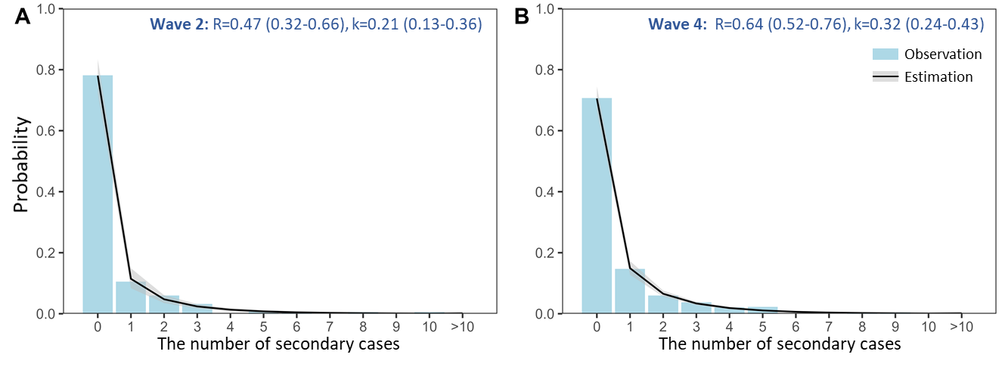
Supplementary Figure S1. Epidemic period-dependent offspring distributions for the zero-included data, conducted using the censoring data exclusion method (method 1 in Right censoring adjustment for infection trajectory chain, Methods in the main text). Estimations are displayed as the solid line (median) and grey shading (95% confidence interval). The light blue bars show the observations used for making the estimations. (A–B) Analyses for wave 2 (A) and wave 4 (B).

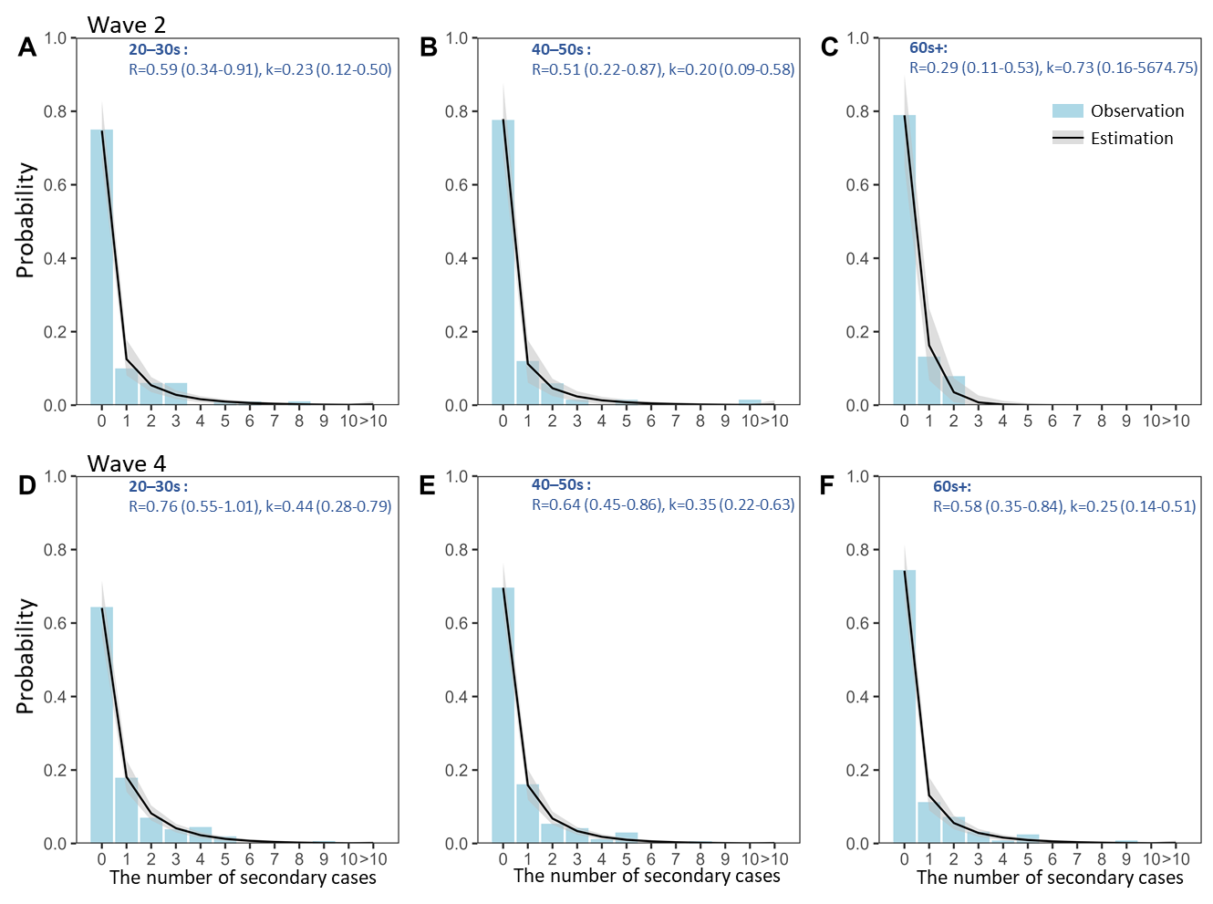
Supplementary Figure S2. Age- and epidemic period-dependent offspring distributions for the zero-included data, conducted using the censoring data exclusion method (method 1 in Right censoring adjustment for infection trajectory chain, Methods in the main text). Estimations are displayed as the solid line (median) and grey shading (95% confidence interval). The light blue bars show the observations used for making the estimations (A–C) Analyses for those aged 20–39 (A), 40–59 (B), and over 60 (C) years in wave 2. (D–F) Analyses for those aged 20–39 (D), 40–59 (E), and over 60 (F) years in wave 4.
Supplementary Figure S3. Epidemic period-dependent offspring distributions for the zero-truncated data. Estimations are displayed as the solid line (median) and grey shading (95% confidence interval). The light blue bars show the observations used for making the estimations, and the blank bars are truncated and were not used for making the estimations. (A–B) Analyses for waves 2 (A) and 4 (B), conducted using the censoring data exclusion method (method 1 in Right censoring adjustment for infection trajectory chain, Methods in the main text). (C–D) Analyses for waves 2 (C) and 4 (D), conducted using the censoring data adjustment method (method 2 in Right censoring adjustment for infection trajectory chain, Methods in the main text).

Supplementary Figure S4. Age-dependent offspring distributions for the zero-truncated data. Estimations are displayed as the solid line (median) and grey shading (95% confidence interval). The light blue bars show the observations used for making the estimations, and the blank bars are truncated and were not used making for the estimations. (A–C) Analyses for those aged 20–39 (A), 40–59 (B), and over 60 (C) years, conducted using the censoring data exclusion method (method 1 in Right censoring adjustment for infection trajectory chain, Methods in the main text). (D–F) Analyses for those aged 20–39 (D), 40–59 (E), and over 60 (F) years, conducted using the censoring data adjustment method (method 2 in Right censoring adjustment for infection trajectory chain, Methods in the main text).

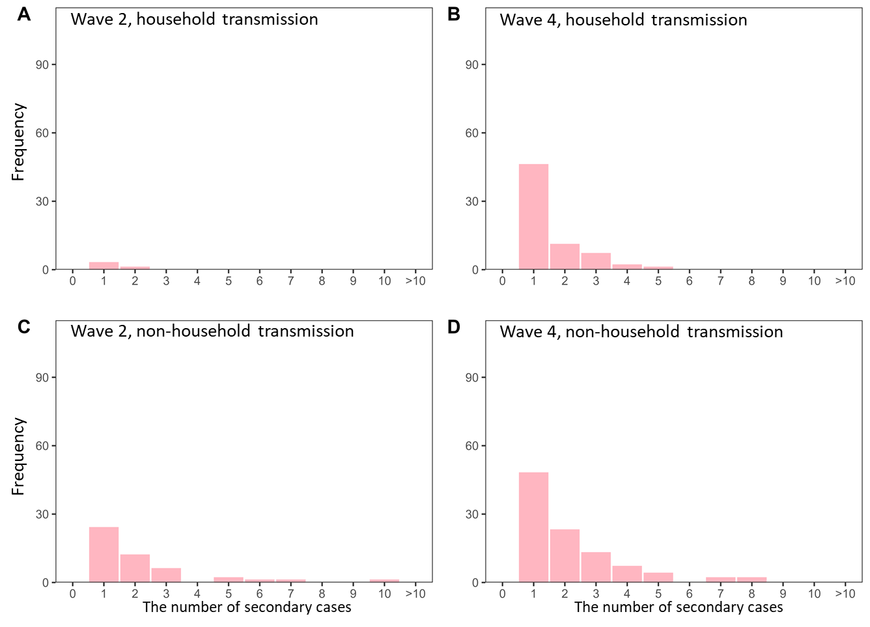
Supplementary Figure S5. Observed epidemic period- and transmission setting- (household/non-household) dependent offspring distributions for the zero-truncated data. (A–D) Household (A–B) and non-household (C–D) transmission for wave 2 (A, C) and wave 4 (B, D).

