Supplementary materials

Supplementary Figure 1
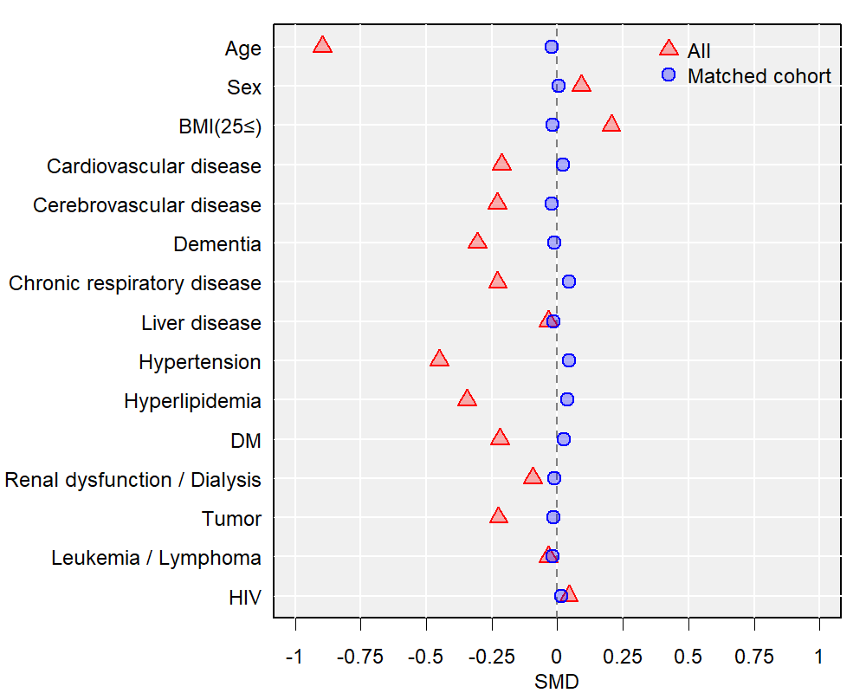
Abbreviations: DM, diabetes mellitus; HIV, human immunodeficiency virus; SMD, standardized mean difference

Supplementary Figure 2
