SUPPLEMENTARY MATERIAL
Supplementary Table 1. Demographics and medical history of participants
 | Patients enrolled pre-Zika outbreak (N=24) | Patients enrolled during Zika outbreak (N=30) | p-value
Age (years)
Mean (SD) | 41.70 (16.16) | 42.2 (15.57) | 0.898
Sex
Female | 7 (29.17%) | 9 (30%) | 0.947
Male | 17 (70.83%) | 21 (70%)
Civil Status
Single | 9 (37.50%) | 14 (46.67%) | 0.312
Married | 13 (54.17%) | 16 (53.33%)
Divorced/Widow | 2 (8.33%) | 0 (0%)
Education Level
Did not go to school | 2 (8.33) | 2 (6.67) | 0.392
Grades 1-6 (Primary) | 12 (50) | 10 (33.33)
Grades 7-9 | 4 (16.67) | 9 (30.00)
Grades 10-12 | 3 (12.50%) | 8 (26.67%)
University | 3 (12.50%) | 1 (3.33%)
Diabetes Mellitus 2 | 3 (!2.50%) | 3 (10.00) | 0.552
High Blood Pressure | 6 (25.00%) | 5 (16.67%) | 0.510
History of GI Infection | 7(29.17%) | 4 (13.33%) | 0.151
Days between symptoms onset and neurologic symptoms | 4.6 (2.3) | 5.5 (1.91) | 0.572
History of ARI | 5 (20.83) | 3 (10.00) | 0.265
Days between symptoms onset and neurologic symptoms | 12.25 (6.64) | 13 (14.93) | 0.94
History Rash/Conjunctivitis | 0 (0.00) | 12 (40.00) | 0.001
Days between symptoms onset and rash | - | 7 (1-30)
Diagnostic characteristics and outcomes
Initial Hughes Scale
2 | 0 (0%) | 1 (3.33%) | 0.504
3 | 2 (8.33%) | 4 (13.33%)
4 | 21 (87.50%) | 21 (70.0%)
5 | 1(4.17%) | 4 (13.33%)
Brighton criteria (diagnostic certainty level)
1 | 14(58.33%) | 8 (26.67%) | 0.043
2 | 4 (16.67%) | 3 (10.00%)
3 | 5(20.83%) | 14 (46.67%)
4 | 1(4.17%) | 5 (16.67%)
Flaccid paralysis (bilateral flaccid weakness) | 24 (100%) | 29 (96.67%) | 0.367
GBS variant/type
Acute Flaccid Paralysis | 19 (79.17%) | 24 (80.00) | 1.00
Pharyngeal-Cervico-Brachial/Miller Fisher | 5 (20.83%) | 6 (20.00)
Hyporeflexia/ areflexia | 24 (100%) | 30 (100%)
Cerebrospinal Fluid exam | 22 (91.67%) | 27 (90%) | 0.834
Hyperproteinorraquia | 16 (76.19%) | 20 (80%) | 0.755
Pleocytosis | 0 (0%) | 1 (4%)
Albuminocytological dissociation | 17 (80.95%) | 20 (83.33%) | 0.835
Nerve Conduction Studies performed | 20 (83.33%) | 9 (30%) | <0.001
Axonal | 12 (60%) | 5 (55.56%)
Demyelinating | 8 (40%) | 4 (44.44%)
Intravenous immune globulin treatment | 20 (83.33%) | 28 (93.33%) | 0.245
Adverse Event to IVIG treatment | 1 (4.17%) | 0 (0.0%) | 0.259
Length of hospitalization | 11.62 (14.08) | 15.26 (20.23) | 0.458
UCI | 4 (16.67%) | 11 (36.67%) | 0.103
Days in UCI | 10 (5.35) | 11 (6.6) | 0.191
Ventilatory Support Initiation | 4 (16.67%) | 9 (30%) | 0.255
Ventilatory Support Duration | 15.75 (9.21) | 32 (31.01) | 0.336
Death | 2 (8.34) | 2 (6.67) | 0.816

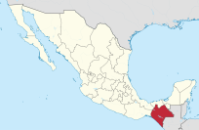
Supplementary Figure 1. Municipalities of origin of patients with conjunctivitis / rash during the outbreak (October 2015-August 2016).
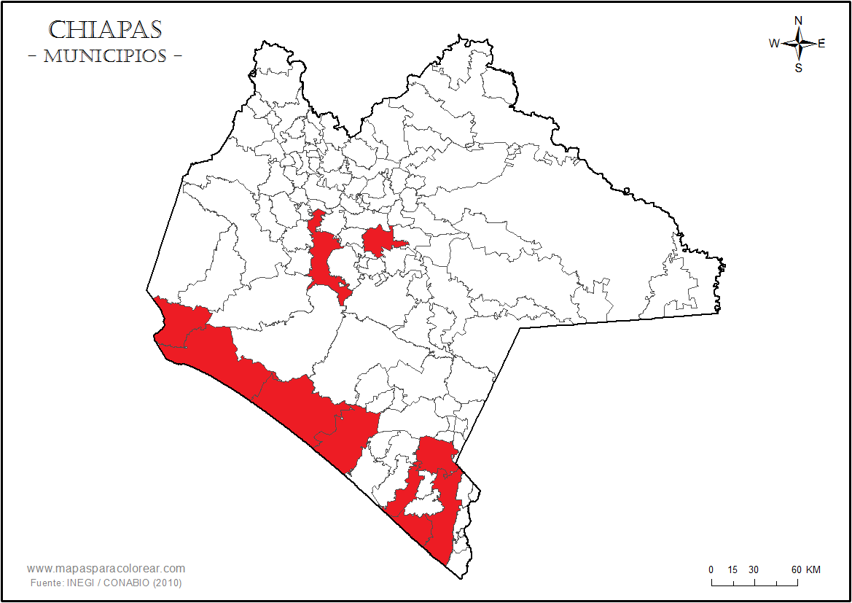

Supplementary Figure 2. Frequency of acute diarrheal and respiratory infections in Southern Mexico (January 2013-August 2016).
