Epidemiology and Infection

Estimation of the incidence of hospitalization for non-invasive pneumococcal pneumonia in the Norwegian population aged 50 years and older

Trude Marie Lyngstad*^{1,2}, Anja Bråthen Kristoffersen¹, Brita Askeland Winje¹ and Anneke Steens¹
¹Norwegian Institute of Public Health, Oslo, Norway
² European Programme for Intervention Epidemiology Training (EPIET), European Centre for Disease Prevention and Control (ECDC), Stockholm, Sweden

Supplementary Material

Table S1. Number of invasive pneumococcal disease cases by age group (aged 50 years and older), notified to the Surveillance System for Communicable Diseases (MSIS), 2015-2019.
Age | Invasive pneumococcal disease
 | 2015 | 2016 | 2017 | 2018 | 2019
50-59 | 59 | 56 | 79 | 81 | 68
60-69 | 137 | 134 | 130 | 120 | 132
70-79 | 112 | 145 | 130 | 152 | 153
80+ | 123 | 153 | 121 | 130 | 124
Total for the entire population | 522 | 599 | 560 | 581 | 599
*Data source: Surveillance System for Communicable Diseases (MSIS)

Table S2. Overview of the variables, odds ratio (OR) with the 95% confidence interval (CI) and p-value obtained in the quasi-Poisson regression model for invasive pneumococcal disease (2015-2019).
Variables | OR | low95CI | high95CI | p-value
February | 0.83 | 0.66 | 1.03 | 0.102
March | 0.72 | 0.57 | 0.90 | 0.007
April | 0.84 | 0.67 | 1.05 | 0.130
May | 0.84 | 0.67 | 1.05 | 0.127
June | 0.57 | 0.45 | 0.73 | 0.000
July | 0.44 | 0.34 | 0.58 | 0.000
August | 0.33 | 0.25 | 0.45 | 0.000
September | 0.66 | 0.52 | 0.84 | 0.001
October | 0.70 | 0.55 | 0.88 | 0.004
November | 0.80 | 0.64 | 1.00 | 0.053
December | 1.18 | 0.96 | 1.44 | 0.121
*January is the reference months with OR = 1
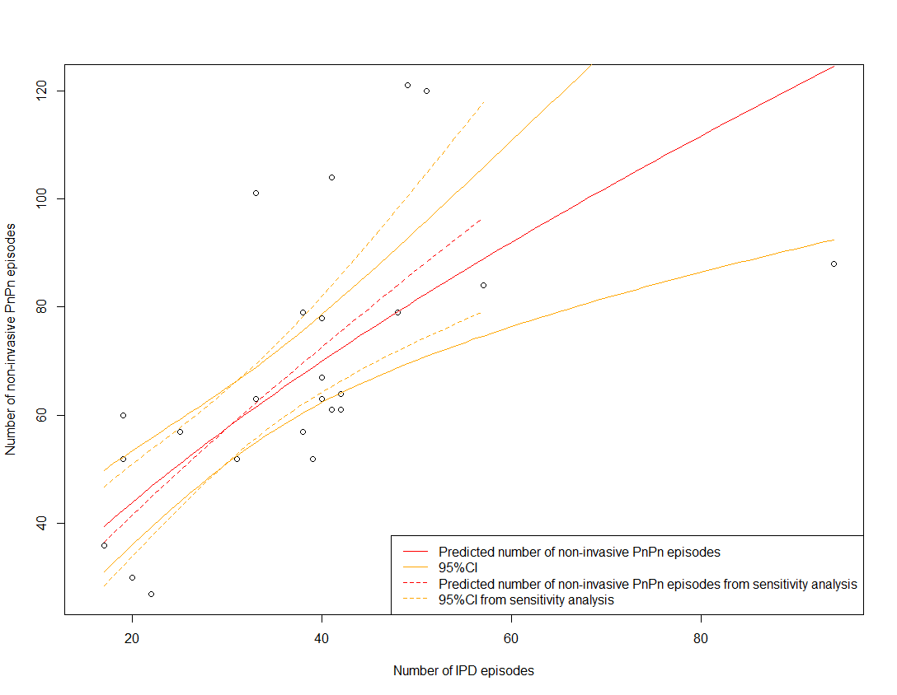

Figure S1. Plot of the monthly number of invasive pneumococcal disease episodes (IPD) in the population aged 50 years (50+) on the x-axis and non-invasive pneumococcal disease (PnPn) episodes in the population aged 50+ years on the y-axis (black dots) with the model predictions (in red), 95% confidence intervals (in orange) with sensitivity analysis (model run without month with maximum IPD episodes, dashed lines), in Norway. Data source: Norwegian Patient Register (NPR) and Surveillance System for Communicable Diseases (MSIS).
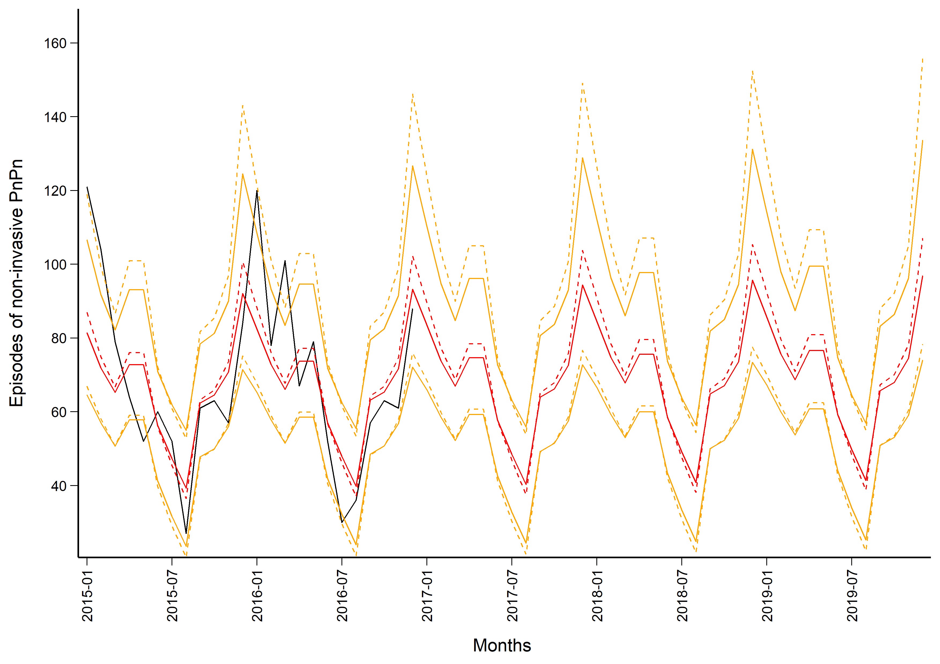

Figure S2. Observed (in black) and predicted (in red) monthly number of non-invasive pneumococcal pneumonia (PnPn) episodes in the population aged 50 years and older in Norway (2015 to 2019) with 95% confidence intervals (in orange) with sensitivity analysis (model run without month with maximum IPD episode, dashed lines). Data source: Norwegian Patient Register and Surveillance System for Communicable Diseases.

