Epidemiology and Infection

Increased transmission of SARS-CoV-2 in Denmark during UEFA European championships.
Marc Bennedbæk , Mia Sarah Fischer Button , Lise Birk Nielsen, Jonas Bybjerg-Grauholm , Christina Wiid Svarrer, Karina Lauenborg Møller , Brian Kristensen, Rebecca Legarth, Vithiagaran Gunalan Ditte Rechter Zenas , Irfatha Irshad, Sophie Gubbels, Raphael N. Sieber , Marc Stegger , Palle Valentiner-Branth, Morten Rasmussen , Camilla Holten Møller, Jannik Fonager , Frederik Trier Moller.

Supplementary Materials

Supplementary figure s1
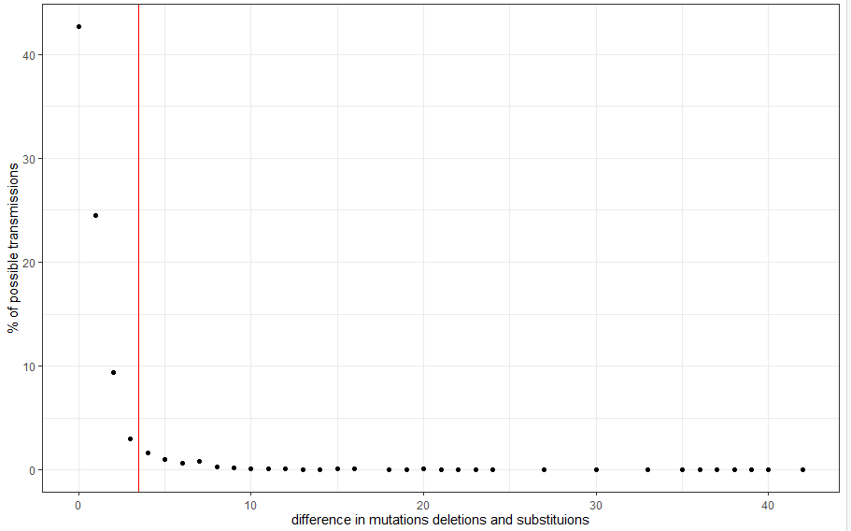
Figure S one: show the difference I mutations deletions and substitutions, for transmission between household cases, optimized according to serial interval, the red line depicts the chosen cut-off
Supplementary figure S2
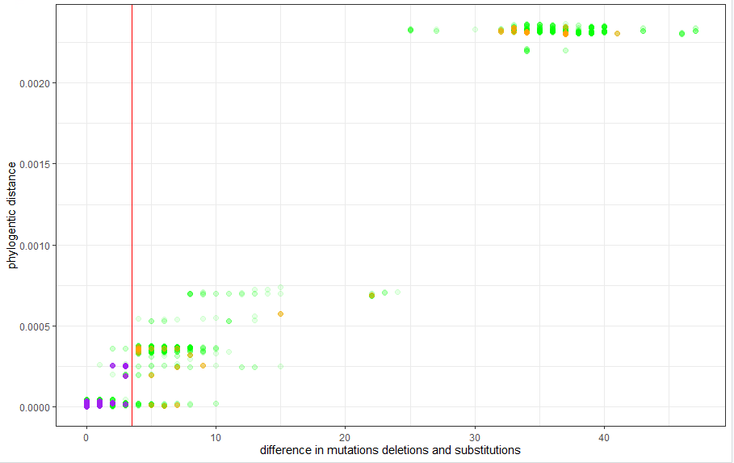
Figure S two: show phylogenetic distances plottet against the difference in number of substitutions and deletions, for cases attending events at the national arena or bigs-screen events. Purple points are the case- case transmission used for analysis, orange points are when the max difference of 3 is not used. Green dots are all possible transmissions.

Supplementary figure S3
Panel a
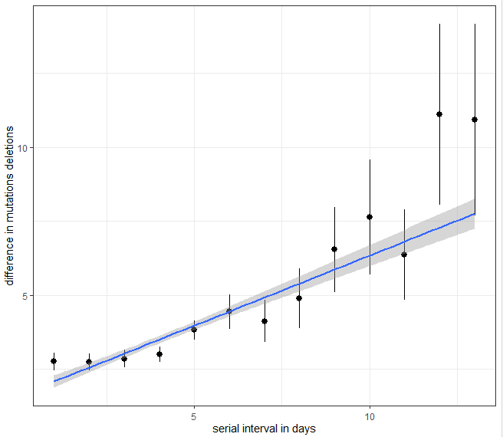
Panel b
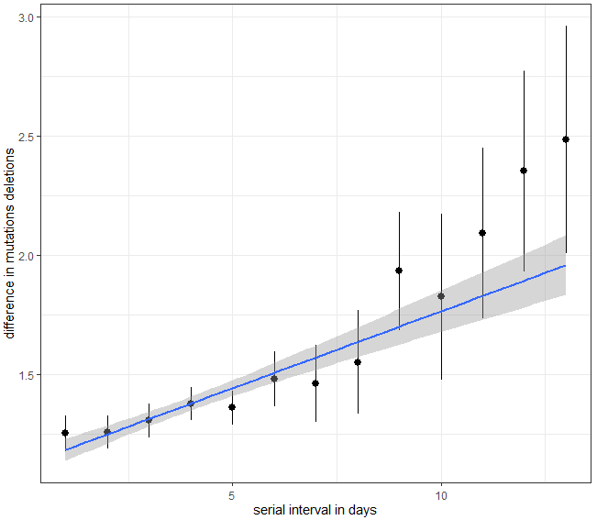
Figure S 3: panel a and b shows the difference in mutations and deletions by the serial interval in days between cases before and after pruning the case-case pairs, so that a case can be infected by only one other case.

Supplementary sensitivity analysis
Supplementary table S 1- Incidence rate ratio (IRR) of the number of covid-19 transmissions in the Danish population from May 30th to July 25th
 | IRR | Lower CI (2.5 %) | Upper CI (97.5 %) | analysis
Infectious at match days vs not infectious at matchday | 1.55 | 1.45 | 1.66 | crude
Male sex vs female sex | 0.93 | 0.87 | 0.98 | crude
Number of days infectious | 1.14 | 1.12 | 1.16 | crude
One vaccine versus no vaccine | 0.93 | 0.86 | 1.02 | crude
One vaccine after 14 days versus no vaccine | 0.74 | 0.68 | 0.81 | crude
Two vaccines versus no vaccine | 0.44 | 0.36 | 0.52 | crude
Two vaccines after 14 days versus no vaccine | 0.63 | 0.55 | 0.72 | crude
Symptoms vs no symptoms | 1.72 | 1.61 | 1.83 | crude
Effect of no of infectious days for match days | 1.21 | 1.18 | 1.23 | crude
Infectious at match days vs not infectious at match day | 1.16 | 1.00 | 1.34 | adjusted
Male sex vs female sex | 0.95 | 0.90 | 1.01 | adjusted
Number of days infectious | 1.04 | 1.02 | 1.06 | adjusted
One vaccine versus no vaccine | 0.84 | 0.77 | 0.91 | adjusted
One vaccine after 14 days versus no vaccine | 0.68 | 0.62 | 0.74 | adjusted
Two vaccines versus no vaccine | 0.43 | 0.36 | 0.52 | adjusted
Two vaccines after 14 days versus no vaccine | 0.60 | 0.52 | 0.68 | adjusted
Symptoms vs no symptoms | 1.56 | 1.45 | 1.67 | adjusted
Effect of no of infectious days for non match days | 1.10 | 1.08 | 1.12 | adjusted
Interaction with effect of no of infectious days for match days | 1.06 | 1.02 | 1.10 | adjusted

Supplementary Table S 2- Incidence rate ratio (IRR) of the number of covid-19 transmissions in the Danish population from May 30th to July 25th
 | IRR | Lower CI (2.5 %) | Upper CI (97.5 %) | analysis
Tested positive within 2 days after match days | 1.27 | 1.17 | 1.38 | crude
Male sex vs female sex | 0.93 | 0.87 | 0.98 | crude
Number of days infectious | 1.14 | 1.12 | 1.16 | crude
One vaccine versus no vaccine | 0.93 | 0.86 | 1.02 | crude
One vaccine after 14 days versus no vaccine | 0.74 | 0.68 | 0.81 | crude
Two vaccines versus no vaccine | 0.44 | 0.36 | 0.52 | crude
Two vaccines after 14 days versus no vaccine | 0.63 | 0.55 | 0.72 | crude
Symptoms vs no symptoms | 1.72 | 1.61 | 1.83 | crude
Tested positive within 2 days after match days | 1.25 | 1.15 | 1.36 | adjusted
Male sex vs female sex | 0.96 | 0.90 | 1.01 | adjusted
Number of days infectious | 1.07 | 1.05 | 1.09 | adjusted
One vaccine versus no vaccine | 0.86 | 0.79 | 0.93 | adjusted
One vaccine after 14 days versus no vaccine | 0.69 | 0.63 | 0.75 | adjusted
Two vaccines versus no vaccine | 0.43 | 0.35 | 0.51 | adjusted
Two vaccines after 14 days versus no vaccine | 0.60 | 0.52 | 0.68 | adjusted
Symptoms vs no symptoms | 1,57 | 1,46 | 1,69 | adjusted

Supplementary Table S 3- Incidence rate ratio (IRR) of the number of covid-19 transmissions in the Danish population from May 30th to July 25th age groups included. All estimates are adjusted.
Estimate | IRR | Lower CI (2.5 %) | Upper CI (97.5 %)
(Intercept) | 0,17 | 0,15 | 0,19
Infectious at match days vs not infectious at matchday | 1,41 | 1,32 | 1,51
Male sex vs female sex | 0,97 | 0,91 | 1,03
Number of days infectious | 1,05 | 1,04 | 1,07
agegrp10-19 | 1,30 | 1,13 | 1,51
agegrp20-29 | 0,76 | 0,66 | 0,88
agegrp30-39 | 1,23 | 1,06 | 1,43
agegrp40-49 | 1,31 | 1,11 | 1,54
agegrp50-59 | 0,97 | 0,80 | 1,17
agegrp60-69 | 0,83 | 0,62 | 1,11
agegrp70-79 | 0,74 | 0,47 | 1,15
agegrp80-89 | 0,84 | 0,41 | 1,65
agegrp90+ | 0,80 | 0,11 | 3,82
One vaccine versus no vaccine | 0,90 | 0,83 | 0,98
One vaccine after 14 days versus no vaccine | 0,71 | 0,65 | 0,78
Two vaccines versus no vaccine | 0,43 | 0,36 | 0,52
Two vaccines after 14 days versus no vaccine | 0,66 | 0,57 | 0,77
Symptoms vs no symptoms | 1,59 | 1,48 | 1,71

Model check main model

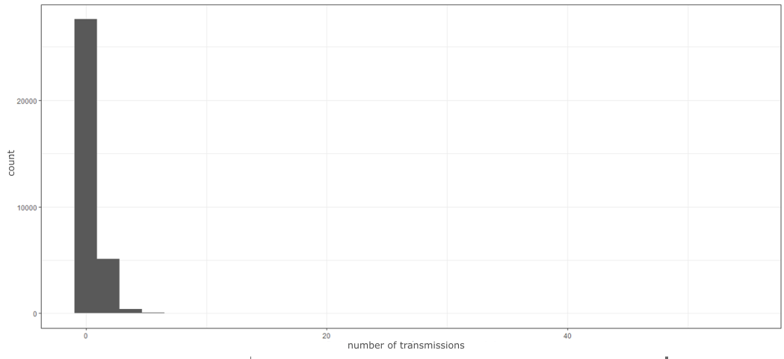
Figure s 4: Shows distribution of number of transmissions from cases

Supplementary Table S 3 number of possible transmissions identified for each case:
tranmissions | 0 | 1 | 2 | 3 | 4 | 5 | 6 | 7 | 8 | 9 | 10 | 11
cases | 27574 | 4240 | 881 | 277 | 103 | 48 | 23 | 17 | 10 | 8 | 8 | 5
tranmissions | 12 | 13 | 14 | 15 | 16 | 18 | 19 | 20 | 21 | 23 | 24 | 28
cases | 2 | 4 | 3 | 5 | 2 | 3 | 2 | 1 | 2 | 1 | 1 | 1
tranmissions | 29 | 34 | 54
cases | 1 | 1 | 1

The observed variance in the data was 0.8556281
The mean number of contacts was 0.2596382
The predicted number of zero in the model was 25870
The dispersion statistic was 1.488728
The deviance residuals was:
Min 1Q Median 3Q Max
-1.0830 -0.6562 -0.5662 -0.4734 8.6787
Null deviance: 16492 on 31262 degrees of freedom
Residual deviance: 15892 on 31254 degrees of freedom
(1964 observations deleted due to missingness)
AIC: 3902
Number of Fisher Scoring iterations: 1
Theta: 0.31531
Std. Err.: 0.00910

