Epidemiology and Infection

Streptococcus bovis-bacteremia: subspecies distribution and association with colorectal cancer – a retrospective cohort study
Jonas Öberg*, MD; Magnus Rasmussen, MD, Prof; Pamela Buchwald, MD, PhD; Bo Nilson, PhD; Malin Inghammar, MD, PhD.

Supplementary material
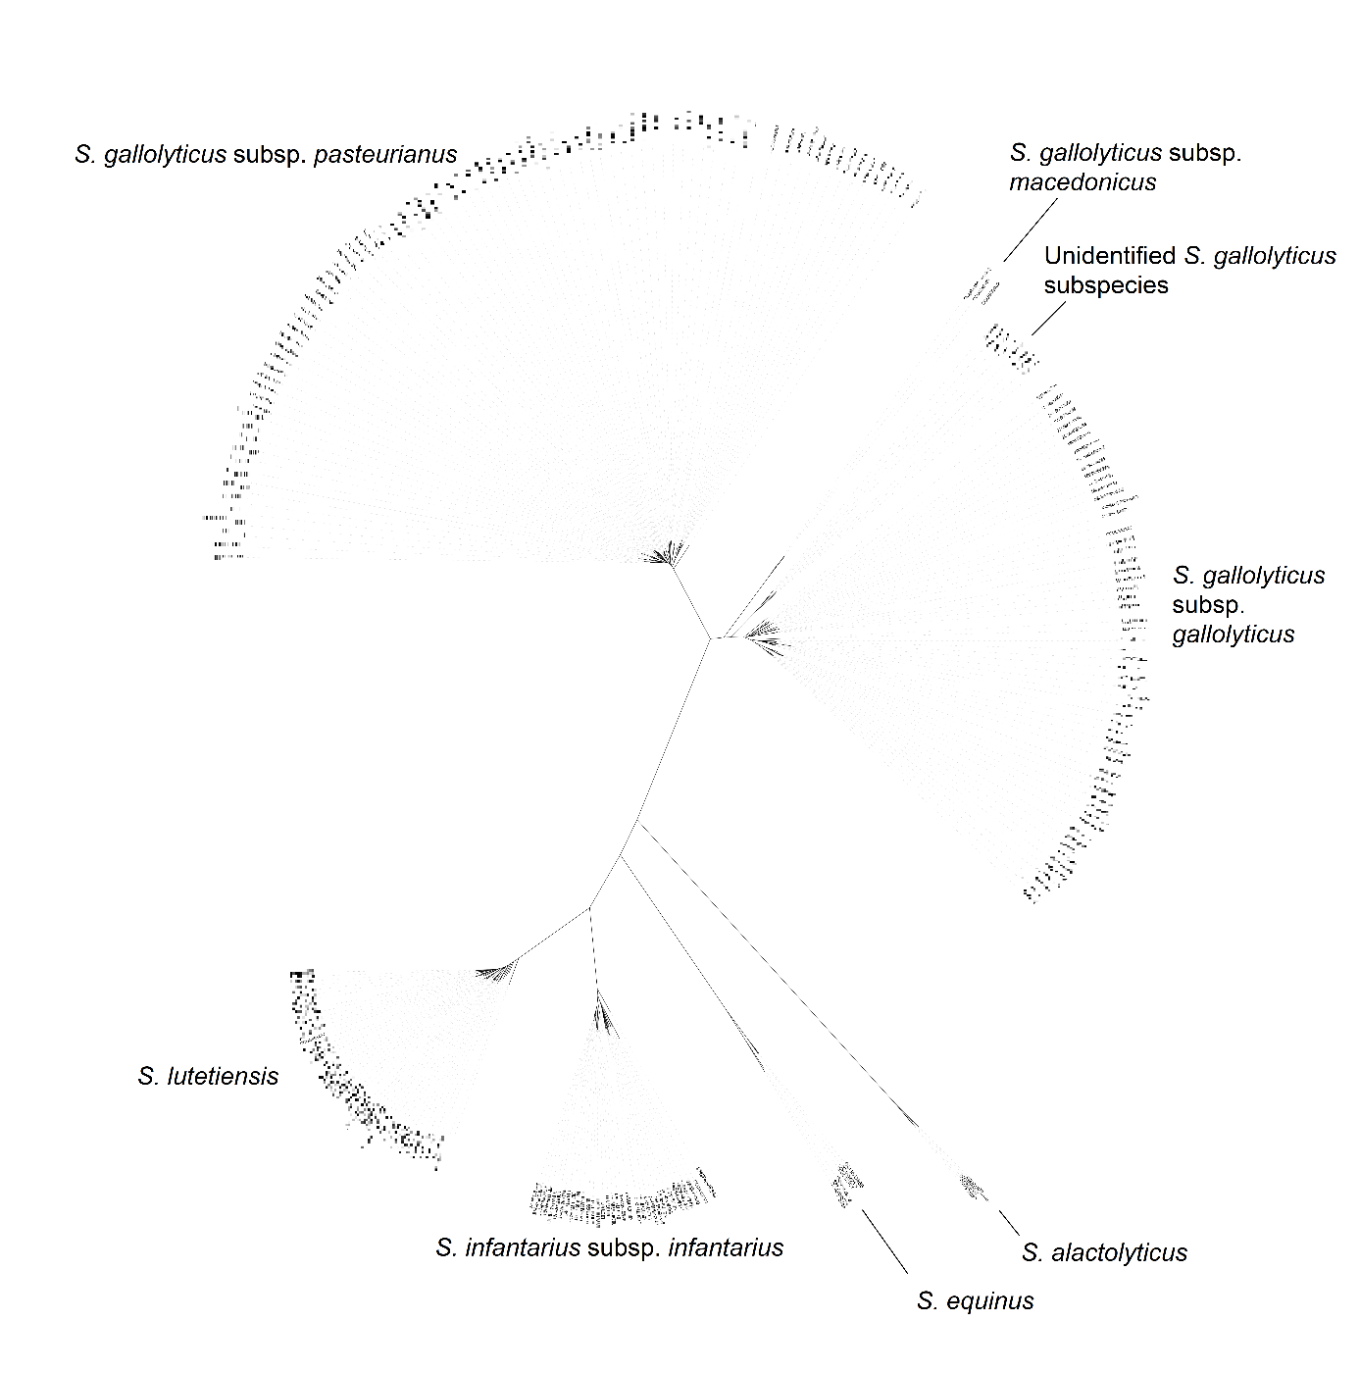Figure S1. Clustering of subspecies in neighbor-joining phylogenetic tree. Reference type- and library strains are included for validation purposes. Laboratory numbers are blurred due to patient confidentiality.
Table S1. Reference type strains used.
Name of type strain | Species
CCUG 27297T | Streptococcus alactolyticus
CCUG 27302T | Streptococcus equinus
CCUG 35224T | Streptococcus gallolyticus subsp. gallolyticus
CCUG 39970T | Streptococcus gallolyticus subsp. macedonicus
CCUG 46150T | Streptococcus gallolyticus subsp. pasteurianus
CCUG 43820T | Streptococcus infantarius subsp. infantarius
CCUG 46149T | Streptococcus lutetiensis

Table S2. Incidence of SBSEC-bacteremia in the Skåne Region since introduction of MALDI-TOF MS.
Year | SBSEC episodes | Population¹⁾ | Incidence Rate (per 100 000)
2012 | 17 | 1 263 088 | 1.35
2013 | 20 | 1 274 069 | 1.57
2014 | 26 | 1 288 908 | 2.02
2015 | 28 | 1 303 627 | 2.15
2016 | 39 | 1 324 565 | 2.94
2017 | 31 | 1 344 689 | 2.31
2018 | 27 | 1 362 164 | 1.98
¹⁾ 31 December, Statistics Sweden [18].

Table S3. Colonoscopy/CT colonography findings within 12 months after bacteremia ^{1, 2)}.
 | S. gallolyticus subsp. pasteurianus  (n = 26) | S. gallolyticus subsp. gallolyticus (n = 30) | S. lutetiensis (n = 7) | S. infantarius subsp. infantarius (n = 9) | Other subspec-ies  (n = 5) | P
Colorectal cancer | 2 (8) | 9 (30) | 0 (0) | 1 (11) | 0 (0) | 0.08
High grade colorectal adenoma³⁾ | 0 (0) | 4 (13) | 2 (29) | 3 (33) | 0 (0) | 0.04
Low-medium grade and non-biopsied colorectal adenoma and polyps⁴⁾ | 4 (15) | 11 (37) | 5 (71) | 5 (56) | 4 (80) | <0.01
Colorectal neoplasia, total⁵⁾ | 6 (23) | 24 (80) | 7 (100) | 9 (100) | 4 (80) | <0.001
¹⁾ All patients who underwent examination regardless of prior cancer diagnosis. ²⁾ Categorical variables are presented as n (% of examined). ³⁾ All were tubular-, villous-, or tubulovillous adenoma. ⁴⁾ Biopsy was not performed in four examinations. All other findings were of tubular-, villous-, or tubulovillous adenoma, while one was also of serrated adenoma. ⁵⁾ CRC, all registered adenoma or polyps in total.

