**Supplementary data S3**

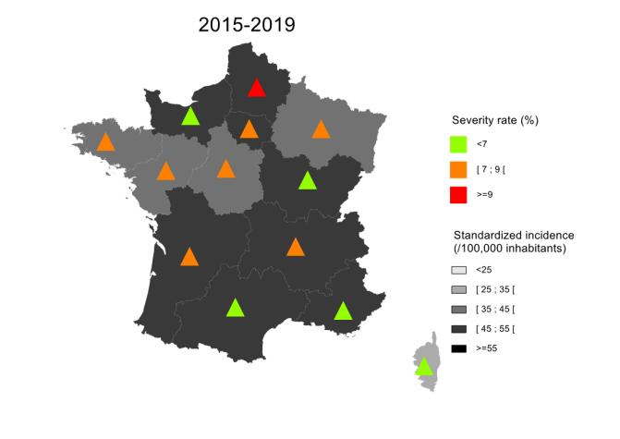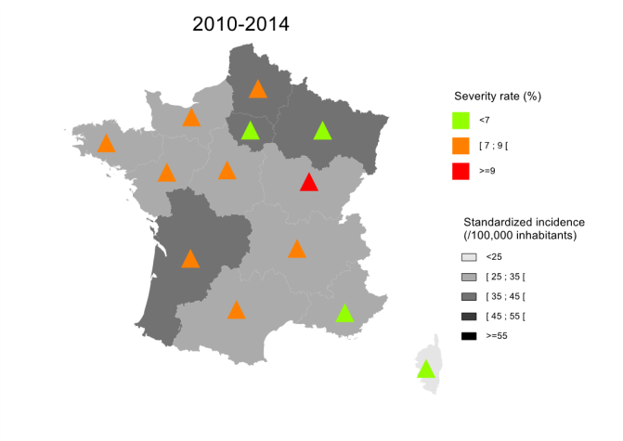

**S3 - Evolution of 5-year incidence standardized by age and sex and evolution of severity profile* by regions, over two 5-year periods, France**

*\*severity defined by coding severe sepsis and/or admission in intensive care unit or step unit*