Supplementary Materials: Role of saliva use during masturbation in the transmission of Chlamydia trachomatis in men who have sex with men

Literature review
We searched PubMed, up to the 13th of January 2021, for reports of studies assessing the role that masturbation plays in transmitting C. trachomatis. We used the search terms (chlamydia [Title/Abstract] OR C. trachomatis [Title/Abstract]) AND (masturbation [Title/Abstract] OR masturbation [MeSH]). Of the eight identified sources, no study assessed the role of masturbation in the transmission of C. trachomatis.

Methods

Study design

To reflect the C. trachomatis infection status, the model incorporated eight compartments: (1) susceptible MSM; (2) infection at the oropharynx only; (3) infection at the urethra only; (4) infection at the anorectum only; (5) infection at the oropharynx and urethra only; (6) infection at the oropharynx and anorectum; (7) infection at the urethra and anorectum; and (8) infection at the oropharynx and urethra and anorectum.
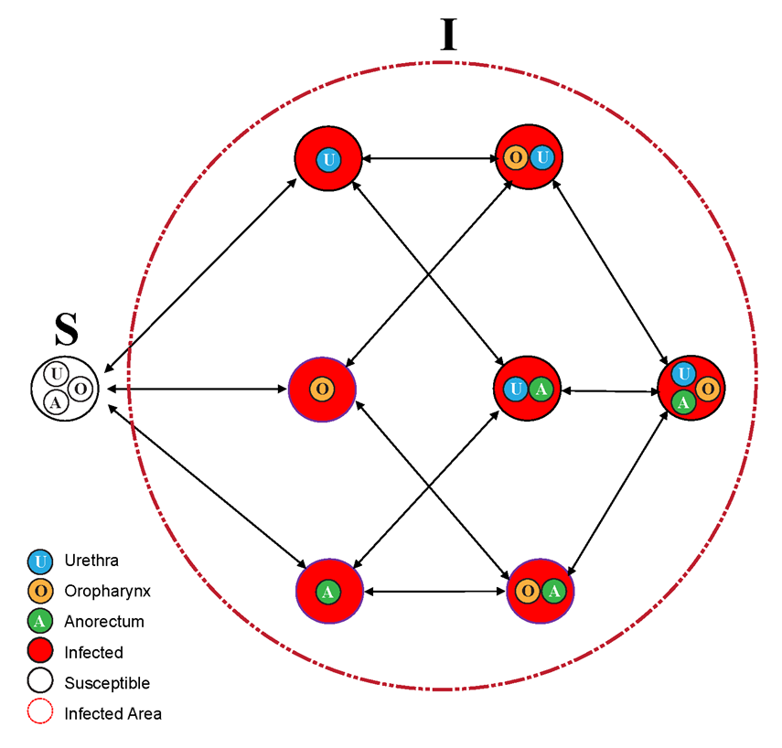

Supplementary Figure S1. A compartmental model for the transmission dynamics of Chlamydia trachomatis in men who have sex with men.
U: only urethral infections; O: only oropharyngeal infections; A: only anorectal infections; Anorectum (A); OU: only oropharyngeal and urethral infections; UA: only urethral and anorectal infections; OA: only oropharyngeal and anorectal infections; OUA: oropharyngeal, urethral and anorectal infections; arrow signifies the direction of infection and clearance.

Differential equations
S = S(t) is the number of susceptible MSM;
I = I(t) is the number of infected MSM;
I_{o} is the number of MSM with oropharyngeal infection only;
I_{u} is the number of MSM with urethral infection only;
I_{a} is the number of MSM with rectal infection only;
I_{ou} is the number of MSM with oropharyngeal and urethral infection only;
I_{ua} is the number of MSM with rectal and urethral infection only;
I_{oa} is the number of MSM with oropharyngeal and rectal infection only;
I_{oua} is the number MSM with oropharyngeal, rectal, and urethral infection;
P_{o} is the Chlamydia trachomatis prevalence of infected only at oropharyngeal;
P_{u} is the Chlamydia trachomatis prevalence of infected only at urethral;
P_{a} is the Chlamydia trachomatis prevalence of infected only at rectal site;
P_{ou} is the Chlamydia trachomatis prevalence of infected only at oropharyngeal and urethral sites;
P_{ua} is the Chlamydia trachomatis prevalence of infected only at rectal and urethral sites;
P_{oa} is the Chlamydia trachomatis prevalence of infected only at oropharyngeal and rectal sites;
P_{oua} is the Chlamydia trachomatis prevalence of infected at oropharyngeal, rectal, and urethral sites.
P represents the prevalence of Chlamydia trachomatis;
$β$represents the per-act transmission;
$C$is the percentage of condom use in anal intercourse;
$ε_{c}$ is the efficacy of condom in preventing transmission of sexually transmitted infections.
$f$ is the frequency of sexual acts that may facilitate transmission. $f$is calculated based on the frequency of sexual acts data [1].
λ: rate of conversion from susceptible to infected individuals, it is a function of per-act transmission probability, frequency of sex acts, condom use and condom efficacy; the product of λ and site-specific prevalence defines the ‘force of infection’ at the specific site;
$λ_{ij}$: the rate of conversion from the site i to j;
λ_{ao}: rimming (anorectum to oropharynx);
λ_{oa}: rimming (oropharynx to anorectum);
λ_{au}: anal sex (anorectum to urethra);
λ_{ua}: anal sex (urethra to anorectum);
λ_{uo}: oral sex (urethra to oropharynx);
λ_{ou}: oral sex (oropharynx to urethra);
The rate of conversion at various sites due to sequential sexual practices
λ_{ooa}: conversion at anorectum due to sequential oral sex followed by anal sex;
λ_{aoa}: conversion at oropharynx due to sequential anal sex followed by oral sex;
λ_{uua}: conversion at anorectum due to sequential oral sex followed by riming;
λ_{aua}: conversion at urethra due to sequential riming followed by oral sex;
λ_{ohu1}: conversion at urethra due to solo masturbation;
λ_{ohu}2: conversion at urethra due to mutual masturbation;
$β_{ij}$: The per-act transmission probability from the site i to j;
$ε_{c}$: The efficacy of condom in preventing transmission of infection;
C: The percentage of condom use in anal sex;
$f_{ij}$: The frequency of sexual practices from the site i to j (including oral sex, anal sex, kissing, and rimming);
γ: The rate of infection clearance;
γ_{u}: The rate of oropharyngeal infection clearance;
γ_{a}: The rate of anorectal infection clearance;
γ_{o}: The rate of urethral infection clearance

Force of infection
The force of infection $Λ$takes the following form[1, 2]:
$$Λ=λ⋅P$$
$$λ=({1-\left(1-β∙(1-ε_{c}∙C)\right)}^{\frac{f}{2}})$$
$$N=S+I_{o}+I_{u}+I_{a}+I_{ou}+I_{ua}+I_{oa}+I_{oua}$$
$$P_{o}=I_{o}/N$$
$$P_{u}=I_{u}/N$$
$$P_{a}=I_{a}/N$$
$$P_{ou}=I_{ou}/N$$
$$P_{ua}=I_{ua}/N$$
$$P_{oa}=I_{oa}/N$$
$$P_{oua}=I_{oua}/N$$
$$P_{o_all}=P_{o}+P_{ou}+P_{oa}+P_{oua}$$
$$P_{a_all}=P_{a}+P_{oa}+P_{ua}+P_{oua}$$
$$P_{u_all}=P_{u}+P_{ou}+P_{ua}+P_{oua}$$
$$P_{ou_all}=P_{ou}+P_{oua}$$
$$P_{ua_all}=P_{ua}+P_{oua}$$
$$P_{oa_all}=P_{oa}+P_{oua}$$
$$a1=λ_{ao}∙P_{a_all}+λ_{uo}{∙P}_{u_all}$$
$$a2=λ_{oa}∙P_{o_all}+λ_{ua}{∙P}_{u_all}$$
$$a3=λ_{ou}{∙P}_{o_all}+λ_{au}{∙P}_{a_all}$$

Differential equations of model 1: with sequential sex practice but without masturbation
Compartment S
$$\frac{dP_{s}}{dt}=-a1∙P_{s}+γ_{o}∙P_{o}-a2∙P_{s}+γ_{a}∙P_{a}-a3∙P_{s}+γ_{u}∙P_{u}$$
Compartment O: Oropharynx
$$\frac{dP_{o}}{dt}=a1∙P_{s}-γ_{o}∙P_{o}-a2∙P_{o}+γ_{a}∙P_{oa}-a3∙P_{o}+γ_{u}∙P_{ou}-λ_{ooa}∙P_{o}$$
Compartment U: Urethral
$$\frac{dP_{u}}{dt}=a3∙P_{s}-γ_{u}∙P_{u}-a1∙P_{u}+γ_{o}∙P_{ou }-a2∙P_{u}+γ_{a}∙P_{ua}-λ_{uua}∙P_{u}$$
Compartment A: Anorectum
$$\frac{dP_{a}}{dt}=a2∙P_{s}-γ_{a}∙P_{a}-a1∙P_{a}+γ_{o}∙P_{oa}-a3∙P_{a}+γ_{u}∙P_{ua}-λ_{aoa}∙P_{a}-λ_{aua}∙P_{a}$$
Compartment OU: Oropharynx & Urethra
$$\frac{dP_{ou}}{dt}=a1∙P_{u}-γ_{o}∙P_{ou}+a3∙P_{o}-γ_{u}∙P_{ou}-a2∙P_{ou}+γ_{a}∙P_{oua}$$
Compartment OA: Oropharynx & Anorectum
$$\frac{dP_{oa}}{dt}= a2∙P_{o}-γ_{a}∙P_{oa}+a1∙P_{a}-γ_{o}∙P_{oa}-a3∙P_{oa}+γ_{u}∙P_{oua}+λ_{ooa}∙P_{o}+λ_{aoa}∙P_{a}$$
Compartment UA: Urethra & Anorectum
$$\frac{dP_{ua}}{dt}=a2∙P_{u}-γ_{a}∙P_{ua}+a3∙P_{a}-γ_{u}∙P_{ua}-a1∙P_{ua}+γ_{o}∙P_{oua}+λ_{uua}∙P_{u}+λ_{aua}∙P_{a}$$
Compartment OUA: Oropharynx & Urethra & Anorectum
$$\frac{dP_{oua}}{dt}=a2∙P_{ou}-γ_{a}∙P_{oua}+a1∙P_{ua}-γ_{o}∙P_{oua}+a3∙P_{oa}-γ_{u}∙P_{oua}$$

Differential equations of model 2: model 1 + masturbation
Compartment S
$$\frac{dP_{s}}{dt}=-a1∙P_{s}+γ_{o}∙P_{o}-a2∙P_{s}+γ_{a}∙P_{a}-a3∙P_{s}+γ_{u}∙P_{u}- λ.ohu2{∙P}_{o_all}$$
Compartment O: Oropharynx
$$\frac{dP_{o}}{dt}=a1∙P_{s}-γ_{o}∙P_{o}-a2∙P_{o}+γ_{a}∙P_{oa}-a3∙P_{o}+γ_{u}∙P_{ou}-λ_{ooa}∙P_{o}- λ.ohu1∙P_{o}$$
Compartment U: Urethral
$$\frac{dP_{u}}{dt}=a3∙P_{s}-γ_{u}∙P_{u}-a1∙P_{u}+γ_{o}∙P_{ou }-a2∙P_{u}+γ_{a}∙P_{ua}-λ_{uua}∙P_{u}+λ.ohu2{∙P}_{o_all}$$
Compartment A: Anorectum
$$\frac{dP_{a}}{dt}=a2∙P_{s}-γ_{a}∙P_{a}-a1∙P_{a}+γ_{o}∙P_{oa}-a3∙P_{a}+γ_{u}∙P_{ua}-λ_{aoa}∙P_{a}-λ_{aua}∙P_{a}-λ.ohu2{∙P}_{o_all}$$
Compartment OU: Oropharynx & Urethra
$$\frac{dP_{ou}}{dt}=a1∙P_{u}-γ_{o}∙P_{ou}+a3∙P_{o}-γ_{u}∙P_{ou}-a2∙P_{ou}+γ_{a}∙P_{oua}+(λ.ohu1∙P_{o})$$
Compartment OA: Oropharynx & Anorectum
$$\frac{dP_{oa}}{dt}= a2∙P_{o}-γ_{a}∙P_{oa}+a1∙P_{a}-γ_{o}∙P_{oa}-a3∙P_{oa}+γ_{u}∙P_{oua}+λ_{ooa}∙P_{o}+λ_{aoa}∙P_{a}-(λ.ohu1∙P_{oa})-λ.ohu2{∙P}_{o_all}$$
Compartment UA: Urethra & Anorectum
$$\frac{dP_{ua}}{dt}=a2∙P_{u}-γ_{a}∙P_{ua}+a3∙P_{a}-γ_{u}∙P_{ua}-a1∙P_{ua}+γ_{o}∙P_{oua}+λ_{uua}∙P_{u}+λ_{aua}∙P_{a}+λ.ohu2{∙P}_{o_all}$$
Compartment OUA: Oropharynx & Urethra & Anorectum
$$\frac{dP_{oua}}{dt}=a2∙P_{ou}-γ_{a}∙P_{oua}+a1∙P_{ua}-γ_{o}∙P_{oua}+a3∙P_{oa}-γ_{u}∙P_{oua}+(λ.ohu1∙P_{oa})+ λ.ohu2{∙P}_{o_all}$$

Differential equations of model 3: model 2 - sequential sex practices
Compartment S
$$\frac{dP_{s}}{dt}=-a1∙P_{s}+γ_{o}∙P_{o}-a2∙P_{s}+γ_{a}∙P_{a}-a3∙P_{s}+γ_{u}∙P_{u}- λ.ohu2{∙P}_{o_all}$$
Compartment O: Oropharynx
$$\frac{dP_{o}}{dt}=a1∙P_{s}-γ_{o}∙P_{o}-a2∙P_{o}+γ_{a}∙P_{oa}-a3∙P_{o}+γ_{u}∙P_{ou}- λ.ohu1∙P_{o}$$
Compartment U: Urethral
$$\frac{dP_{u}}{dt}=a3∙P_{s}-γ_{u}∙P_{u}-a1∙P_{u}+γ_{o}∙P_{ou }-a2∙P_{u}+γ_{a}∙P_{ua}+λ.ohu2{∙P}_{o_all}$$
Compartment A: Anorectum
$$\frac{dP_{a}}{dt}=a2∙P_{s}-γ_{a}∙P_{a}-a1∙P_{a}+γ_{o}∙P_{oa}-a3∙P_{a}+γ_{u}∙P_{ua}-λ.ohu2{∙P}_{o_all}$$
Compartment OU: Oropharynx & Urethra
$$\frac{dP_{ou}}{dt}=a1∙P_{u}-γ_{o}∙P_{ou}+a3∙P_{o}-γ_{u}∙P_{ou}-a2∙P_{ou}+(λ.ohu1∙P_{o})$$
Compartment OA: Oropharynx & Anorectum
$$\frac{dP_{oa}}{dt}= a2∙P_{o}-γ_{a}∙P_{oa}+a1∙P_{a}-γ_{o}∙P_{oa}-a3∙P_{oa}-(λ.ohu1∙P_{oa})-λ.ohu2{∙P}_{o_all}$$
Compartment UA: Urethra & Anorectum
$$\frac{dP_{ua}}{dt}=a2∙P_{u}-γ_{a}∙P_{ua}+a3∙P_{a}-γ_{u}∙P_{ua}-a1∙P_{ua}+λ.ohu2{∙P}_{o_all}$$
Compartment OUA: Oropharynx & Urethra & Anorectum
$$\frac{dP_{oua}}{dt}=a2∙P_{ou}-γ_{a}∙P_{oua}+a1∙P_{ua}-γ_{o}∙P_{oua}+a3∙P_{oa}-γ_{u}∙P_{oua}+(λ.ohu1∙P_{oa})+ λ.ohu2{∙P}_{o_all}$$

Data resource

Table S1. Site-specific prevalence of chlamydia
Country/region | Sample size | Prevalence/ Mean value (95%CI)
 |  | Oropharynx only | Urethral only | Rectal  only | Oropharynx and urethra both | Oropharynx and rectum both | Urethra and rectum both | Oropharynx and urethra and rectum both
Xu [2] | 4888 | 0.76  (0.54-1.06) | 1.86  (1.51-2.29) | 7.53  (6.81-8.31) | Footnote b,  0.00  (0.00-0.00) | 1.19  (0.91-1.55) | 1.19  (0.91-1.55) | 0.16  (0.07-0.33)
Pol [3] | 393 | 0.51  (0.09-2.03) | 2.29  (1.12-4.46) | 6.36  (4.24-9.37) | Footnote b,  0.00  (0.-0.00) | 1.53  (0.62-3.47) | 0.76  (0.20-2.40) | Footnote b,  0.00  (0.00-0.00)
van Liere [4] |  | 0.51  (0.48-0.54) | 2.30  (2.23-2.37) | 6.29  (6.17-6.41) | 0.06  (0.05-0.07) | 0.54  (0.51-0.58) | 1.02  (0.97-1.07) | 0.10  (0.09-0.12)
Hiransuthikul [5] | 1610 | 1.74  (1.18-2.54) | 4.84  (3.87-6.03) | 11.86  (10.34-13.56) | 0.06  (0.00-0.40) | 1.76  (0.69-1.80) | 1.99  (1.39-2.83) | 0.06  (0.00-0.40)
Footman [6] | 179 | Footnote b,  0.00  (0.-0.00) | 1.68  (0.44-5.22) | 12.85  (8.49-18.86) | Footnote b,  0.00  (0.-0.00) | Footnote b,  0.00  (0.-0.00) | 1.12  (0.19-4.41) | Footnote b,  0.00  (0.-0.00)
Footnote:
- MSHC started screening for throat chlamydia in mid-2017, so we used chlamydia data for 2018-19.
- Since the positivity is zero, we assumed the upper bound of 95% confidence interval was 1/1000000 (one person in a million) and the lower bound of 95% was 0.0000000 in the simulation.

Model parameters

Table S2. Biological and behavioural data of Chlamydia trachomatis for model parameterization and calibration
Parameters | Value (uncertainty bounds) | References/Remarks
%, Consistent condom usage in anal sex in past 12 months | 46.90 (34.50- 59.30) | [1]
%, Condom efficacy in preventing transmission | 87.50 (80.00-95.00) | [1, 7]
Frequency of oral sex (days) | 13.53 (0.00-28.11) | [1]
Frequency of rimming (days) | 38.57 (0.00-80.15) | [1]
Frequency of anal sex (days) | 26.44 (0.00-54.94) | [1]
weeks, Infection duration of Chlamydia trachomatis at the throat (asymptomatic infection) | 95.29 (24.87-245.44) | [8, 9].
weeks, Infection duration of Chlamydia trachomatis at urethral (symptomatic infection) | 1.57 (1.00-2.00) | Footnote a, [10]
weeks, Infection duration of Chlamydia trachomatis at urethral (asymptomatic infection) | 57.72 (19.60-158.08) | [11]
%, proportion of urethral infections that are asymptomatic | 85.00 (75.00-95.00) | Footnote b, [12]
%, Proportion of anal Chlamydia trachomatis infections that are asymptomatic | 87.50 (60.41-97.80) | Footnote c, [13]
weeks, Infection duration of Chlamydia trachomatis at the anus | 82.68 (50.02-134.16) | [11]
%, Proportion of MSM received throat swab in the past 12 months | 79.65 (63.70-95.60) | Footnote d, [14]
%, Proportion of MSM received anal swab in the past 12 months | 79.65 (63.70-95.60) | Footnote d, [14]
%, Proportion of MSM received urine test in the past 12 months | 79.65 (63.70-95.60) | Footnote d, [14]
%, proportion of 'oral sex and anal sex' in the same sex episode | 29.41 (24.82-34.00) | Footnote e, [15]
%, proportion of 'oral sex and rimming' in the same sex episode | 70.5 (67.94-72.94) | Footnote f, [16]
%, proportion of receptive oral sex (individual’s mouth in contact with a partner’s penis) followed by partner's insertive anal sex (individual’ penis in contact with partner’ anus) | 80.00 (80.00-80.00) | Footnote g [17]
%, proportion of insertive oral sex (individual’s penis in contact with a partner’s mouth) followed by partner's insertive rimming (individual’s mouth in contact with a partner’s anus) | 80.00 (80.00-80.00) | Estimate from Melbourne Sexual Health Centre
Masturbation parameters
Frequency of solo masturbation (days) | 2.0 (1.4-3.5) | Footnote h, [18]
Frequency of mutual masturbation (days) | 5.36 (3.5 – 80.15) | Footnote i, [19, 20].
Proportion of saliva use for solo masturbation, % | 37.7 (33.3-42.3) | Footnote j, [21].
Proportion of saliva use for mutual masturbation, % | 33.6 (29.4-38.1) | Footnote k, [21].
Footnote:
- The duration time is estimated by the time between the first symptom and treatment. Among Men, the mean time was 11 Days =1.57 weeks, range (7-14) days.
- We estimated the value from a previous study. A case-control study of MSM attending Seattle & King County STD Clinic between 2001 and 2013 found that clinicians diagnosed a total of 6464 urethral infections, only 61% of chlamydial infections were symptomatic and asymptomatic chlamydial infections were 39%.
- 16 MSM was infected with anal Chlamydia trachomatis, of which 14 were asymptomatic.
- We used the proportion of gay and bisexual men attending sexual health clinic for a chlamydia test in 2017 (95.60%) as the upper bound. We used the proportion of gay and bisexual men attending general practice clinic tested for chlamydia in 2017 (63.70%) as the lower bound. The mean value of proportion = (upper bound+ lower bound)/2.
- The proportion of 'oral sex and anal sex' in the same sex episode was not available from published data. We used the prevalence of insertive anal sex (34.00%) as the upper bound. We also used the value of the prevalence of anal sex (34.00%) multiply the prevalence of oral sex (73.00%) as the lower bound. The mean value of proportion = (upper bound+ lower bound)/2.
- The proportion of 'oral sex and rimming' in the same sex episode was not available from published data. About 70.5% (95%CI67.94-72.94) reported rimming. According to the advice of sexually transmitted infections specialist at the Melbourne Sexual Health Centre, rimming is always accompanied by oral sex. We are using the mean value and 95%CI for rimming as the mean and bound for the proportion of 'oral sex and rimming' in the same sex episode.
- The proportion of receptive oral sex (individual’ mouth in contact with partner’ penis) followed by partner's insertive anal sex (individual’ penis in contact with partner’ anus) was not available from published data. The sequence of receptive oral sex followed by partner's insertive anal sex was most common among oral sex and anal sex combinations. Based on the advice of sexually transmitted infections specialist at the Melbourne Sexual Health Centre, we made the assumption.
- Males masturbated approximately two to five times a week. We estimated the frequency of solo masturbation was 3.5(2.0-5.0) times per week. Therefore, the estimated frequency of solo masturbation was 2.0 (1.4-3.5) days.
- According to results of the Durex Global Sex Survey 2005, the frequency of sex in Australia was 108[19]. The proportion of for mutual masturbation was 63.0%[20]. The mean proportion of frequency of mutual masturbation was 365/ (108*63.0%) =365/68=5.36 days. Solo masturbation is more common than mutual masturbation. The lower bound was the upper bound of solo masturbation. The upper bound of (kissing, oral sex, rimming, or anal sex) was 80.15; therefore, we choose this as the upper bound of mutual masturbation.
- Among 446 participants, the proportion of using saliva as lube when masturbating was 168 (37.7%).
- Among 446 participants, the proportion of masturbated my partner off using my saliva as lube was 149 (33.4%). The proportion of my partner masturbating me off with his saliva as lube was 151 (33.9%). Therefore, we got the proportion of saliva use for mutual masturbation was (149+151)/446=150 (33.6%).

Sensitivity Analysis

Table S3. Masturbation parameters of sensitivity analysis
Group | Parameters | Values
1 | Increased to double the frequency of solo masturbation | 4.00 (2.80-7.00)
2 | Increased to double the frequency of mutual masturbation | 10.72 (7.00-160.30)
3 | Increased to double the proportion of saliva used for solo masturbation | 75.40 (66.60-84.60)
4 | Increased to double the proportion of saliva use for mutual masturbation | 67.20 (58.80-76.20)
5 | Decreased to half the frequency of solo masturbation | 1.00 (0.70-1.75)
6 | Decreased to half the frequency of mutual masturbation | 2.68 (1.75-40.08)
7 | Decreased to half the proportion of saliva used for solo masturbation | 18.85 (16.65-21.15)
8 | Decreased to half the proportion of saliva use for mutual masturbation | 16.8 (14.7-19.05)

Results

Table S4. Root mean squared error and Cohen's d effect size of calibrated chlamydia models with or without masturbation across five different datasets
Models | Root mean squared error | T test, Absolute value of Cohens’ d
Xu [2]
Model 1 | 0.0048(95%CI 0.0042 to 0.0050) | Ref.
Model 2 | 0.0070(95%CI0.0058 to 0.0073) | Model 2 vs. model 1, p value <0.01, d = 6.90
Model 3 | 0.0118(95%CI0.0111 to 0.0122) | Model 3 vs. model 1, p value <0.01, d= 28.13  Model 3 vs. model 2, p value<0.01, d= 14.68
Model 4 | 0.0113(95%CI 0.0106 to 0.0116) | Model 4 vs. model 1, p value<0.01, d = 27.20  Model 4 vs. model 3, p value<0.01, d = 2.03
van Liere [4]
Model 1 | 0.0038(95%CI0.0035 to 0.0039) | Ref.
Model 2 | 0.0055(95%CI 0.0047 to 0.0058) | Model 2 vs. model 1, p value<0.01, d = 8.19
Model 3 | 0.0105(95%CI 0.0100 to 0.0106) | Model 3 vs. model 1, p value<0.01, d = 48.02  Model 3 vs. model 2, p value<0.01, d = 21.55
Model 4 | 0.0101(95%CI 0.0098 to 0.0102) | Model 4 vs. model 1, p value<0.01, d = 61.25  Model 4 vs. model 3, p value <0.01, d = 2.45
Hiransuthikul [5]
Model 1 | 0.0028(95%CI 0.0016 to 0.0033) | Ref.
Model 2 | 0.0061(95%CI0.0045 to 0.0069) | Model 2 vs. model 1, p value<0.01, d = 5.68
Model 3 | 0.0140(95%CI 0.0119 to 0.0151) | Model 3 vs. model 1, p value<0.01, d = 14.82  Model 3 vs. model 2, p value<0.01, d= 9.73
Model 4 | 0.0131(95%CI 0.0090 to 0.0140) | Model 4 vs. model 1, p value<0.01, d = 10.10  Model 4 vs. model 3, p value<0.01, d = 1.11
Pol [3]
Model 1 | 0.0070(95%CI0.0028 to 0.0086) | Ref.
Model 2 | 0.0097(95%CI0.0062 to 0.0109) | Model 2 vs. model 1, p value<0.01, d = 1.76
Model 3 | 0.0134(95%CI0.0098 to 0.0155) | Model 3 vs. model 1, p value<0.01, d= 4.34  Model 3 vs. model 2, p value<0.01, d= 2.74
Model 4 | 0.0125(95%CI 0.0097 to 0.0142) | Model 4 vs. model 1, p value <0.01, d = 3.97  Model 4 vs. model 3, p value <0.01, d = 0.63
Footman [6]
Model 1 | 0.0054(95%CI0.0015 to 0.0058) | Ref.
Model 2 | 0.0051(95%CI0.0039 to 0.0053) | Model 2 vs. model 1, p value<0.01, d = 0.48
Model 3 | 0.0070(95%CI0.0046 to 0.0085) | Model 3 vs. model 1, p value<0.01, d = 1.54  Model 3 vs. model 2, p value<0.01, d = 2.03
Model 4 | 0.0076(95%CI 0.0053 to 0.0090) | Model 4 vs. model 1, p value<0.01, d = 2.25  Model 4 vs. model 3, p value <0.01, d = 0.63
Note: Chlamydia Model 1: Anal sex, oral sex, rimming, sequential oral/anal sex and sequential oral sex/riming; model 2 (Model 1 + masturbation); (Model 3 removed sequential practices but added masturbation). Dataset 1: Xu; Dataset 2: van Liere; Dataset 3: Hiransuthikul; Dataset 4: Pol; Dataset 5: Footman.

Table S5. Proportion of chlamydia incidence by masturbation across five different datasets
 | Proportion of incidence by masturbation, %
 | Solo Masturbation | Mutual masturbation | Overall masturbation
Xu [2]
Model 2 | 5.2 (95%CI 2.4 to 8.4) | 0.5(95%CI 0.1 to 4.1) | 6.0(95%CI 3.0to 10.6)
Model 3 | 7.3(95%CI 4.2 to15.0) | 1.1(95%CI 0.1 to 4.6) | 8.8(95%CI 4.4to 17.6)
van Liere [4]
Model 2 | 5.5(95%CI 3.6 to 8.6) | 0.5(95%CI 0.0 to 4.0) | 6.2(95%CI 3.8to 10.5)
Model 3 | 7.1(95%CI 3.7 to 10.1) | 1.0(95%CI 0.2 to 4.4) | 8.2(95%CI 4.9to 12.6)
Hiransuthikul [5]
Model 2 | 3.5(95%CI 1.7 to 6.1) | 0.3(95%CI 0.0 to 1.5) | 3.9(95%CI 2.0to 6.8)
Model 3 | 4.3(95%CI 3.0 to 6.8) | 0.3(95%CI 0.1 to 1.6) | 4.8(95%CI 3.3to 7.5)
Pol [3]
Model 2 | 5.4(95%CI 2.8 to 11.3) | 0.4(95%CI 0.1 to 1.9) | 5.8(95%CI 3.2to 12.8)
Model 3 | 7.1(95%CI 4.0 to 13.1) | 0.7(95%CI 0.1 to 4.0) | 7.8(95%CI 4.3to 15.6)
Footman [6]
Model 2 | 4.2(95%CI 2.6 to 11.3) | 1.1(95%CI 0.1 to 3.6) | 5.7(95%CI 3.1to 13.7)
Model 3 | 4.7(95%CI 2.5 to 9.8) | 1.5(95%CI 0.2 to 4.2) | 6.2(95%CI 3.1to 13.2)
Note: Chlamydia Model 1: Anal sex, oral sex, rimming, sequential oral/anal sex and sequential oral sex/riming; model 2 (Model 1 + masturbation); (Model 3 removed sequential practices but added masturbation). Dataset 1: Xu; Dataset 2: van Liere; Dataset 3: Hiransuthikul; Dataset 4: Pol; Dataset 5: Footman.

Table S6. The model-estimated per-act transmissibility of masturbation
Models | Solo Masturbation | Mutual masturbation
Xu [2]
Model 2 | 0.0316 (95%CI 0.0145 to 0.0808) | 0.0007(95%CI 0.0001 to 0.0061)
Model 3 | 0.0539 (95%CI 0.0261 to 0.2981) | 0.0015(95%CI 0.0002 to 0.0090)
van Liere [4]
Model 2 | 0.0265 (95%CI 0.0170 to 0.0668) | 0.0006(95%CI 0.0000 to 0.0049)
Model 3 | 0.0398(95%CI 0.0185 to 0.0841) | 0.0012(95%CI 0.0002 to 0.0050)
Hiransuthikul [5]
Model 2 | 0.0109 (95%CI 0.0055 to 0.0278) | 0.0002 (95%CI 0.0000 to 0.0013)
Model 3 | 0.0153 (95%CI 0.0081 to 0.0321) | 0.0003(95%CI 0.0000 to 0.0018)
Pol [3]
Model 2 | 0.0176 (95%CI 0.0058 to 0.0909) | 0.0003 (95%CI 0.0000 to 0.0029)
Model 3 | 0.0338 (95%CI 0.0127 to 0.4625) | 0.0007 (95%CI 0.0001 to 0.0066)
Footman [6]
Model 2 | 0.2269 (95%CI 0.0376 to 0.9952) | 0.0045 (95%CI 0.0003 to 0.0290)
Model 3 | 0.2783 (95%CI 0.0621 to 0.9997) | 0.0058 (95%CI 0.0008 to 0.0207)
Footnote: Dataset 1: Xu; Dataset 2: van Liere; Dataset 3: Hiransuthikul; Dataset 4: Pol; Dataset 5: Footman.
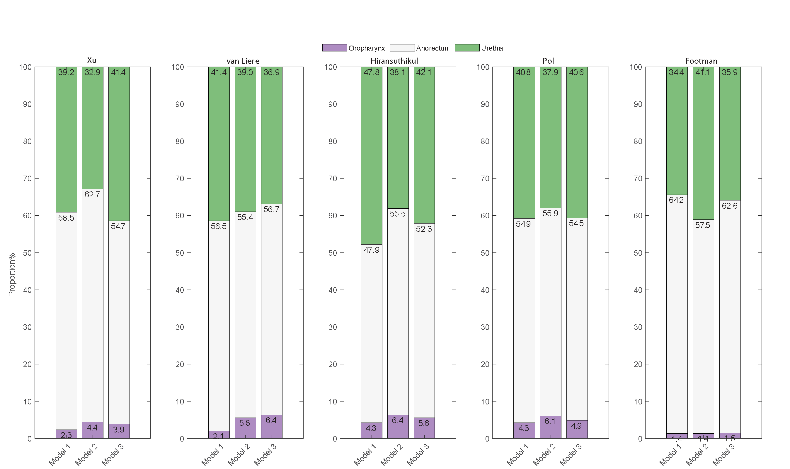

Figure S2. Estimated proportion of chlamydia incidence at oropharynx, urethra and anorectum
Model 1: anal sex, oral sex, rimming, sequential oral/anal sex and sequential oral sex/riming; model 2 (Model 1 + masturbation); (Model 3 removed sequential practices and added masturbation). Dataset 1: Xu; Dataset 2: van Liere; Dataset 3: Hiransuthikul; Dataset 4: Pol; Dataset 5: Footman.

Sensitivity analysis
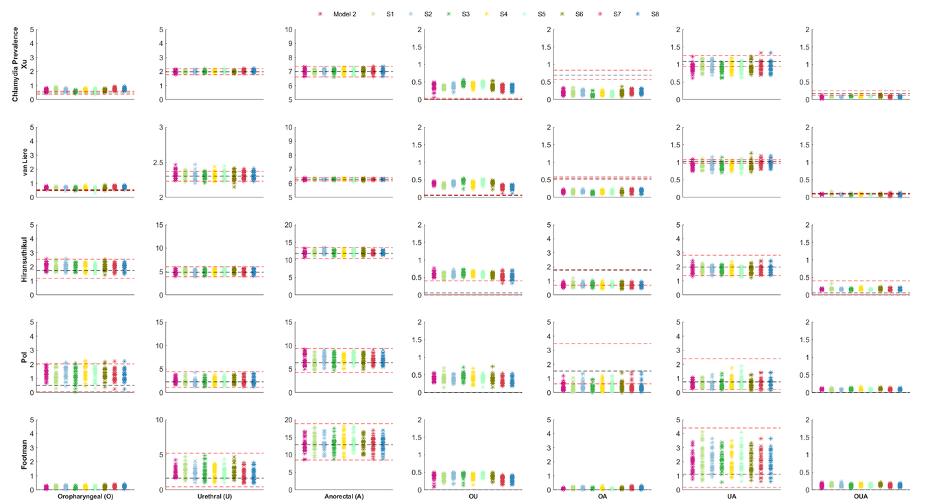

Figure S3. Model 2 calibration and chlamydia data fitting to site-specific infection across five different datasets.
Red dashed lines denote 95% confidence intervals. Black dashed lines denote the mean value; Xu[2], van Liere [4], Hiransuthikul [5], Pol [3], and Footman [6]. 1) S1: increased to double the days of the frequency of solo masturbation; 2) S2: increased to double the days of the frequency of mutual masturbation; 3)S3: increased to double the proportion of saliva used for solo masturbation; 4) S4: increased to double the proportion of saliva use for mutual masturbation; 5) S5: decreased to half the days of the frequency of solo masturbation; 6) S6: decreased to half the days of the frequency of mutual masturbation; 7) S7: decreased to half the proportion of saliva used for solo masturbation; 8) S8: decreased to half the proportion of saliva use for mutual masturbation.

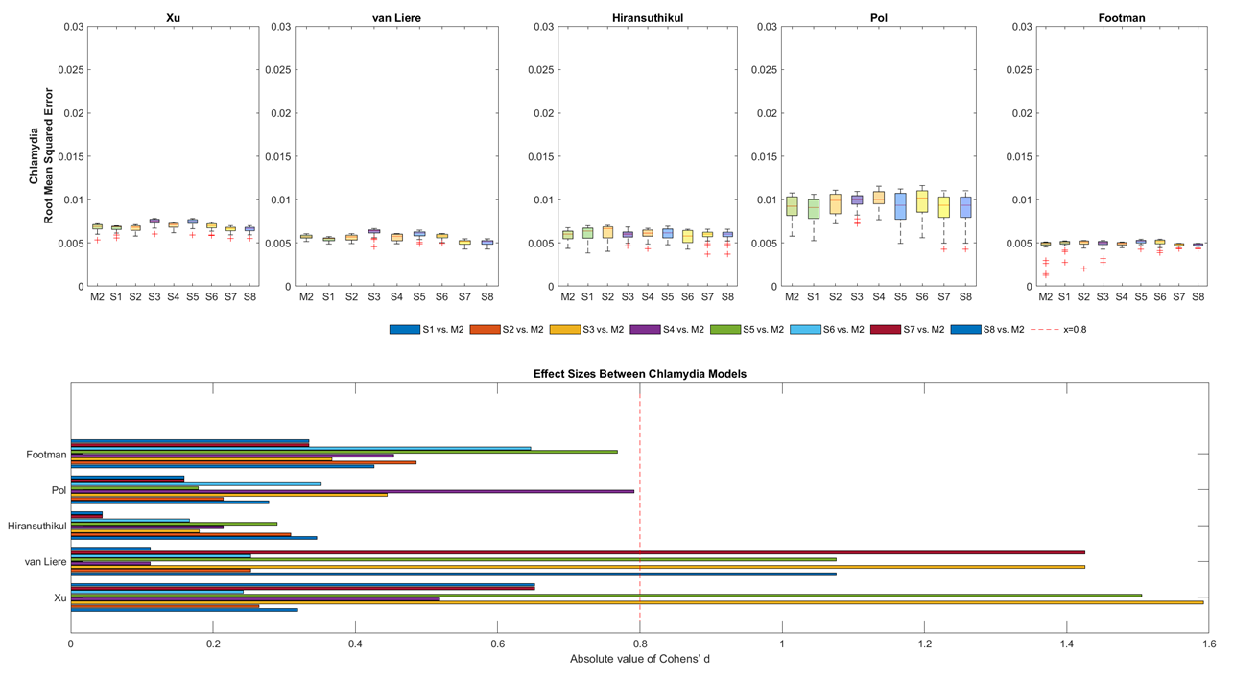

Figure S4. Sensitivity analysis of root mean squared error and effect size of calibrated chlamydia model 2 with or without masturbation across five different datasets
Xu[2], van Liere [4], Hiransuthikul [5], Pol [3], and Footman [6]; 1) S1: increased to double the days of the frequency of solo masturbation; 2) S2: increased to double the days of the frequency of mutual masturbation; 3) S3: increased to double the proportion of saliva used for solo masturbation; 4) S4: increased to double the proportion of saliva use for mutual masturbation; 5) S5: decreased to half the days of the frequency of solo masturbation; 6) S6: decreased to half the days of the frequency of mutual masturbation; 7) S7: decreased to half the proportion of saliva used for solo masturbation; 8) S8: decreased to half the proportion of saliva use for mutual masturbation.

Reference
(1) Zhang L, et al. Neisseria gonorrhoeae Transmission Among Men Who Have Sex With Men: An Anatomical Site-Specific Mathematical Model Evaluating the Potential Preventive Impact of Mouthwash. Sex Transm Dis 2017; 44(10): 586-592.
(2) Xu X, et al. Chlamydia trachomatis transmission between the oropharynx, urethra and anorectum in men who have sex with men: a mathematical model. BMC Med 2020; 18(1): 326.
(3) Pol BVD. Extragenital CT/GC in MSM. In. The 20th International Union against Sexually Transmitted Infections- Asia Pacific Conference (IUSTI-AP), 2019.
(4) van Liere G, et al. What is the optimal testing strategy for oropharyngeal Neisseria gonorrhoeae in men who have sex with men? Comparing selective testing versus routine universal testing from Dutch STI clinic data (2008-2017). Clin Infect Dis 2019.
(5) Hiransuthikul A, et al. Correlations of chlamydia and gonorrhoea among pharyngeal, rectal and urethral sites among Thai men who have sex with men: multicentre community-led test and treat cohort in Thailand. BMJ Open 2019; 9(6): e028162.
(6) Footman A, et al. Performance of 4 Molecular Assays for Detection of Chlamydia and Gonorrhea in a Sample of Human Immunodeficiency Virus-Positive Men Who Have Sex With Men. Sex Transm Dis 2020; 47(3): 158-161.
(7) Tuli K, Kerndt PR. Preventing sexually transmitted infections among incarcerated men who have sex with men: a cost-effectiveness analysis. Sex Transm Dis 2009; 36(2 Suppl): S41-48.
(8) Templeton DJ, et al. Prevalence, incidence and risk factors for pharyngeal chlamydia in the community based Health in Men (HIM) cohort of homosexual men in Sydney, Australia. Sex Transm Infect 2008; 84(5): 361-363.
(9) Chow EP, et al. Duration of gonorrhoea and chlamydia infection at the pharynx and rectum among men who have sex with men: a systematic review. Sex Health 2016; 13(3): 199-204.
(10) Andersen B, et al. Prediction of costs, effectiveness, and disease control of a population-based program using home sampling for diagnosis of urogenital Chlamydia trachomatis Infections. Sex Transm Dis 2006; 33(7): 407-415.
(11) Jin F, et al. Incidence and risk factors for urethral and anal gonorrhoea and chlamydia in a cohort of HIV-negative homosexual men: the Health in Men Study. Sex Transm Infect 2007; 83(2): 113-119.
(12) Barbee LA, et al. An estimate of the proportion of symptomatic gonococcal, chlamydial and non-gonococcal non-chlamydial urethritis attributable to oral sex among men who have sex with men: a case-control study. Sex Transm Infect 2016; 92(2): 155-160.
(13) Rebe K, et al. A Cross Sectional Analysis of Gonococcal and Chlamydial Infections among Men-Who-Have-Sex-with-Men in Cape Town, South Africa. PLoS One 2015; 10(9): e0138315.
(14) Institute. TK. HIV, viral hepatitis and sexually transmissible infections in Australia: annual surveillance report 2018. In, 2018.
(15) Fairley CK, et al. Models of gonorrhoea transmission from the mouth and saliva. The Lancet Infectious Diseases 2019.
(16) Chow EPF, et al. Saliva use as a lubricant for anal sex is a risk factor for rectal gonorrhoea among men who have sex with men, a new public health message: a cross-sectional survey. Sex Transm Infect 2016; 92(7): 532-536.
(17) Rosenberger JG, et al. Sexual behaviors and situational characteristics of most recent male-partnered sexual event among gay and bisexually identified men in the United States. J Sex Med 2011; 8(11): 3040-3050.
(18) Bőthe B, et al. Hypersexuality, Gender, and Sexual Orientation: A Large-Scale Psychometric Survey Study. Arch Sex Behav 2018; 47(8): 2265-2276.
(19) Network D. The Face of Global Sex 2005; 2005.
(20) Rosenberger JG, et al. Sexual Behaviors and Situational Characteristics of Most Recent Male‐Partnered Sexual Event among Gay and Bisexually Identified Men in the United States. The Journal of Sexual Medicine 2011; 8(11): 3040-3050.
(21) Chow EPF, et al. Antiseptic mouthwash for gonorrhoea prevention (OMEGA): a randomised, double-blind, parallel-group, multicentre trial. Lancet Infect Dis 2021.

