Scenario 1

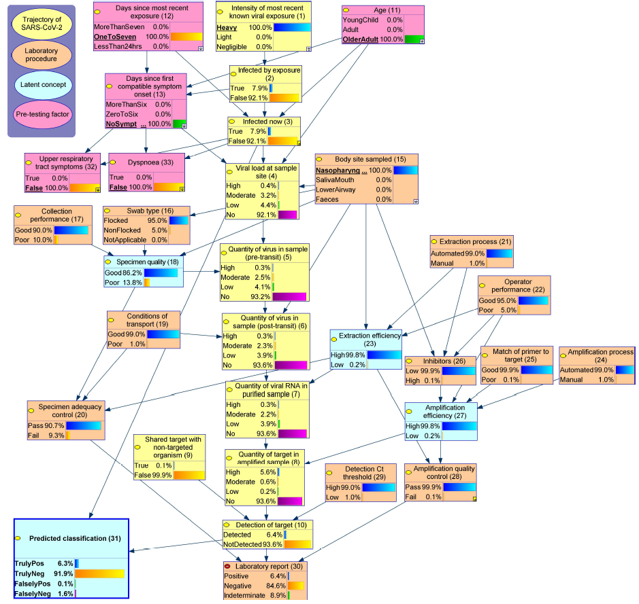
(a) Heavy exposure

Scenario 1

(b) Heavy exposure with symptoms
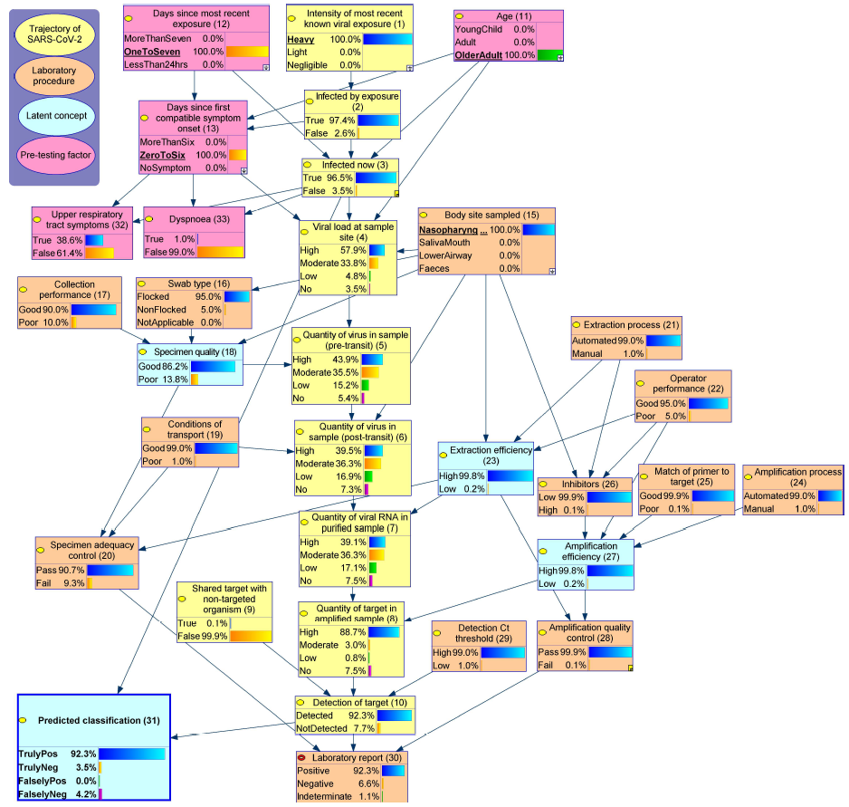

Scenario 1

(c) Light exposure
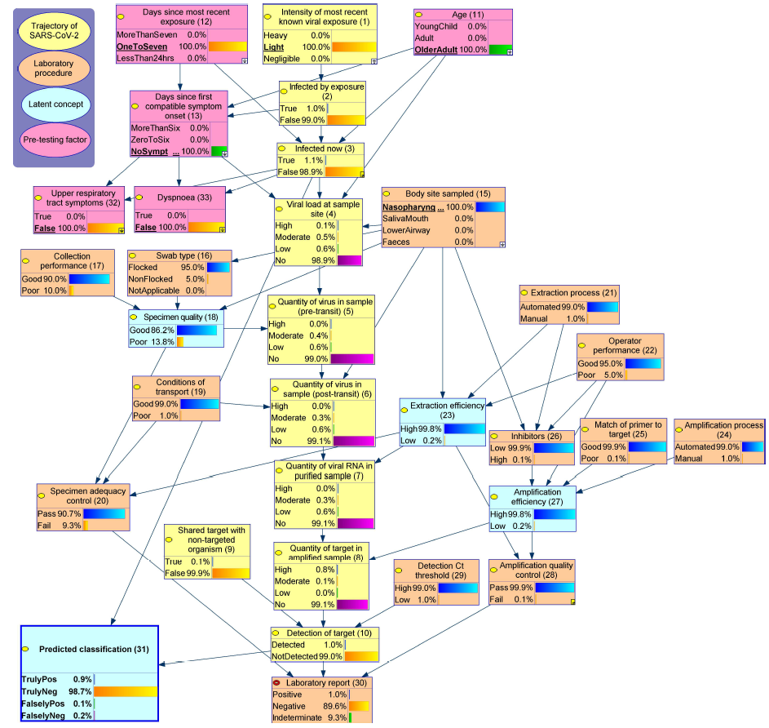

Scenario 2

(a) Good specimen quality
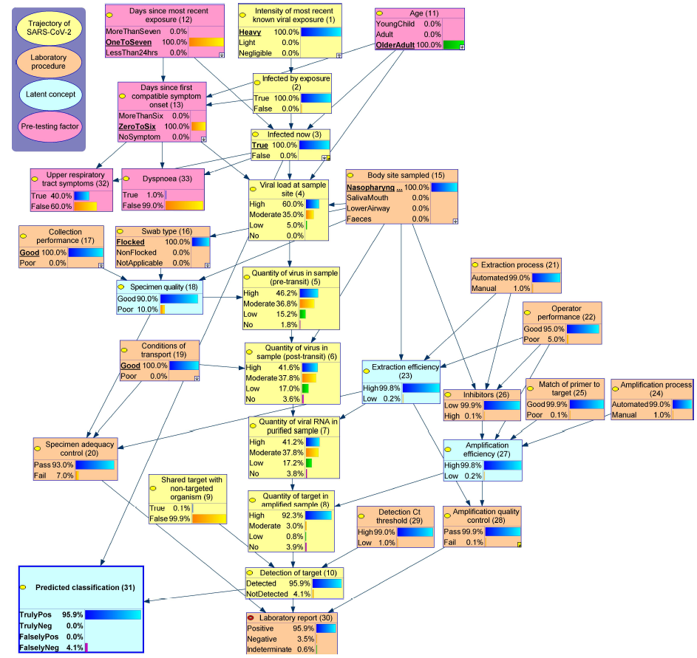

Scenario 2

(b) Poor specimen quality
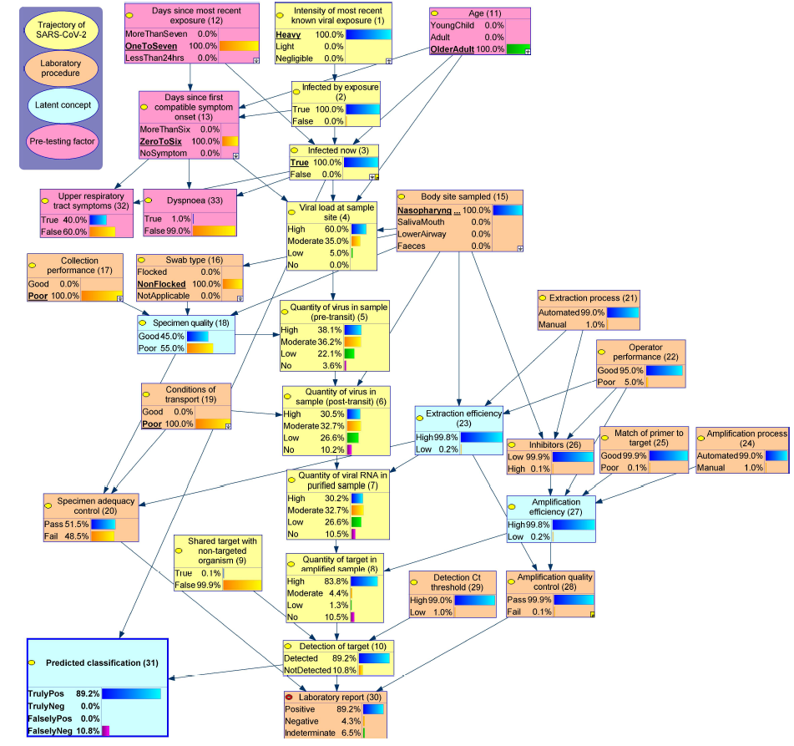

Scenario 3

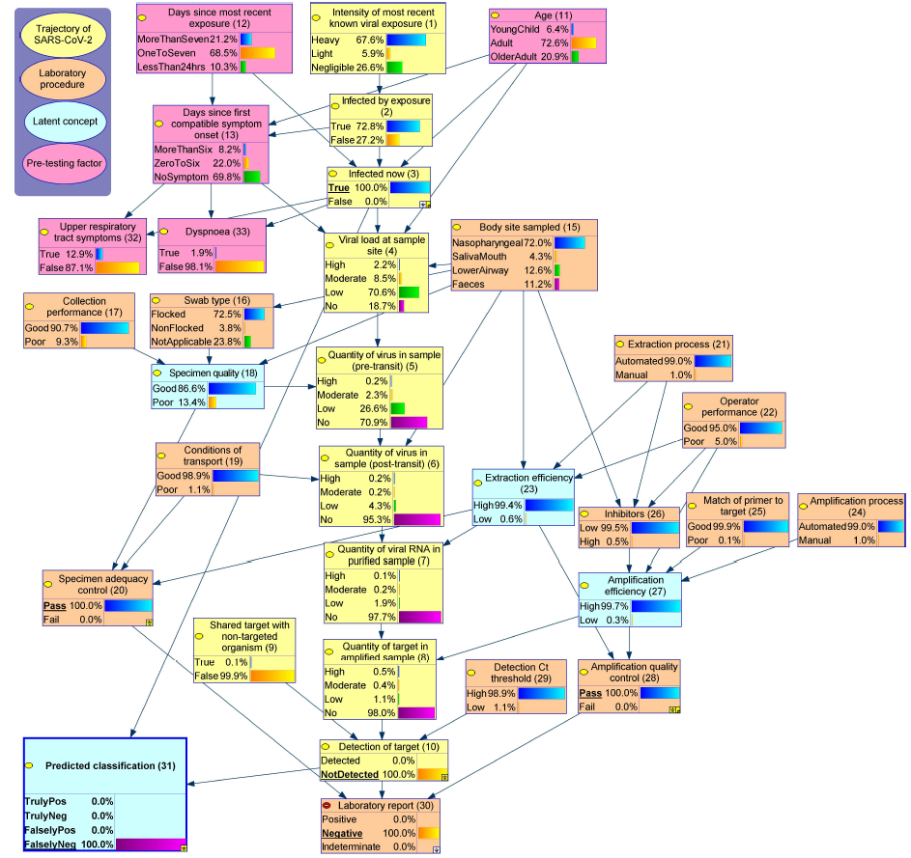
(a) Infected tested negative

Scenario 3

(b) Infected tested positive
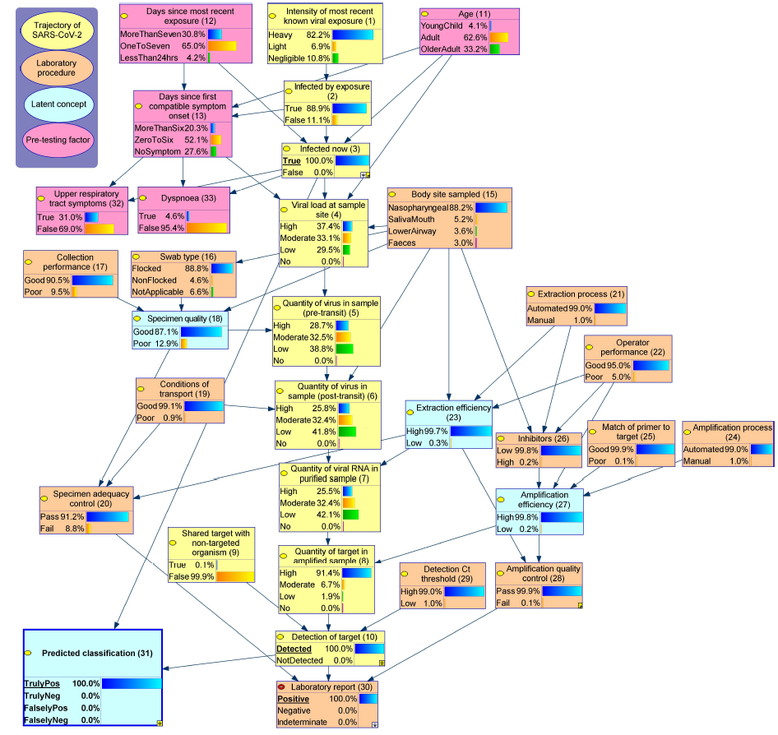

Scenario 4

(a) Low prevalence with upper respiratory tract symptoms
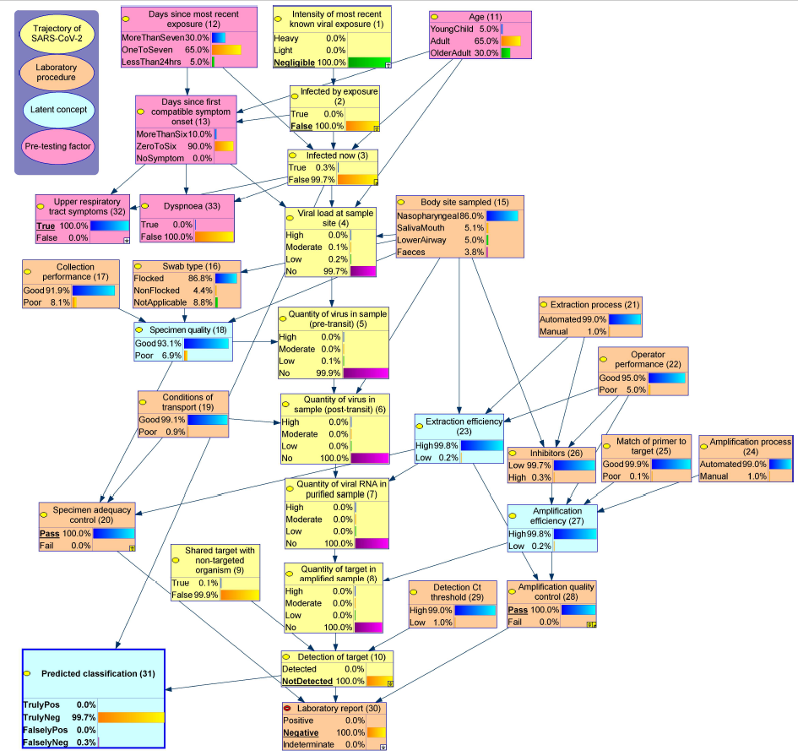

Scenario 4

(b) High prevalence with upper respiratory tract symptoms
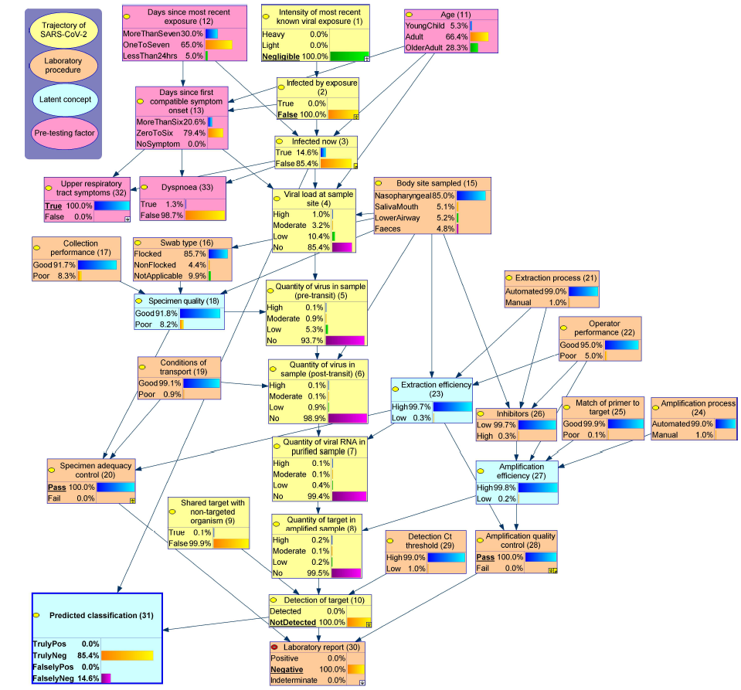

Scenario 4

(c) High prevalence with dyspnoea
