"This supplementary material is hosted by Epidemiology and Infection as supporting information alongside the article “Detection and viral load of SARS-CoV-2 in respiratory specimens relative to symptom onset among COVID-19 patients in Bavaria, German”.

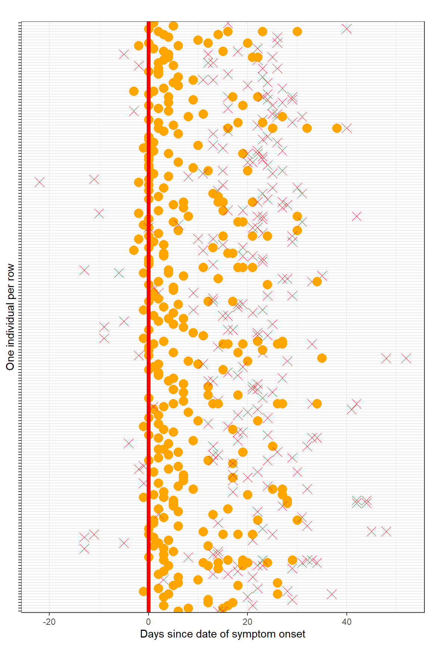
Figure S1. Date of onset and date of sampling are visualized for 210 COVID-19 patients sampled at least twice among one of the samples was tested positive, Bavaria, Germany.
Script to produce Figure 3 and 4, which includes the numbers of samples as well.
ggsurvplot(
fit = survfit(Surv(time = maxpos, time2 = negativ, type="interval2") ~ 1,
data = lab.grouped),
risk.table = TRUE,
surv.median.line = "hv",
xlab = "Days",
legend = "none",
font.x = c(10, "bold", "black"),
font.y = c(10, "bold","black"),
risk.table = TRUE,
ylab = "Persistence of positive testing (%)")

Figure 2. Time until the loss of SARS-CoV-2 RNA detection after symptom onset among 208 patients tested at least twice in Bavaria, Germany. The red line and red-shaded area depict the empirical distribution of persistence of positive tests and 95% confidence interval, respectively. The number of patients at selected points in time included to estimate the probability to test positive is shown in the table below the figure.

