Epidemiology and Infection
Immunogenicity and Safety of a Quadrivalent Meningococcal Tetanus Toxoid-Conjugate Vaccine (MenACYW-TT) Administered Concomitantly with Other Paediatric Vaccines in Toddlers: a Phase III randomized study
M. S. DHINGRA, L. NAMAZOVA-BARANOVA, J. L. ARREDONDO-GARCIA, K.-H. KIM, K. LIMKITTIKUL, W. JANTARABENJAKUL, O. PERMINOVA, I. A. R. KOBASHI, C.-W. BAE, J. OJEDA, J. PARK, D. CHANSINGHAKUL, S. B’CHIR, D. NEVEU, M. BONAPARTE, E. JORDANOV

Supplementary Methods
Methods for the determination of functional antibodies to the coadministered paediatric vaccine toxins
Diphtheria, tetanus and pertussis antibodies were measured by an electrochemiluminescent (ECL) assay. Briefly, a 96-well plate was pre-coated with six antigens (diphtheria toxoid, tetanus toxoid, pertussis toxin [PT], Filamentous hemagglutinin [FHA], fimbriae types 2 and 3 [FIM2,3 and pertactin [PRN]). The plates were incubated with serum samples and captured antibodies were detected with a SULFO-TAG-conjugated anti-human IgG. Electrical stimulation of the plates in the presence of a chemiluminescent substrate allowed quantification of the antibody against a reference standard curve. The lower limit of quantification (LLOQ) was 0.005 IU/mL for anti-diphtheria toxoid, 0.01 IU/mL for anti-tetanus toxoid, and 2 ELISA units (EU)/mL for anti-pertussis toxins.
Anti-Streptococcus pneumoniae antibodies were measured using a pneumococcal capsular polysaccharide (PnPS) IgG ECL assay for serotypes 1, 3, 4, 5, 6A, 6B, 7F, 8, 9N, 10A, 11A, 12F, 14, 15B, 18C, 19A, 19F, 22F, 23F, and 33F. 96-well plates were coated with purified antigens (MesoScale Discovery, Rockville, Maryland, USA) and diluted serum samples that had been pre-treated with pneumococcal cell wall absorbents were incubated in the wells. The plates were washed and SULFO-TAG-conjugated anti-human Ig was added to the wells, excess conjugate was removed and a read buffer added. The plate was read using ECL, and the amount of antibody was determined against a reference standard in µg/mL. The LLOQ of the assay was 0.15 µg/mL.

Seroprotective levels for coadministered paediatric vaccine antigens were defined as:
- Anti-measles antibody concentrations ≥255 mIU/mL
- Anti-mumps antibody concentrations ≥10 Mumps Ab units/mL
- Anti-rubella antibody concentrations ≥10 IU/mL
- Anti-varicella antibody concentrations ≥5 gpELISA Ab units/mL
- Anti-tetanus antibody concentrations ≥0.1 and 1.0 IU/mL
- Anti-pertussis (PT and FHA) vaccine response, defined as post-vaccination concentration ≥4x pre-vaccination concentration if pre-vaccination concentration<4xLLOQ or post-vaccination concentration ≥2x pre-vaccination concentration if pre-vaccination concentration ≥4x LLOQ
- Anti-diphtheria antibody concentrations ≥0.1 and 1.0 IU/mL
- Anti-PRP antibody concentrations ≥0.15 and 1.0 µg/mL
- Anti-poliovirus types 1, 2 and 3 antibody titres ≥1:8
- Anti-Hep B antigen antibody concentrations ≥10 and 100 mIU/mL
- Anti-pneumococcal antibody concentrations ≥0.35 and 1.0 µg/mL for serotypes 1, 3, 4, 5, 6A, 6B, 7F, 9V, 14, 18C, 19A, 19F, and 23F

Table S1. Geometric mean hSBA titres at baseline (Day 0) and Day 30 in participants randomized to MenACYW-TT+MMR+V and MenACYW-TT (PPAS)
 |  | MenACYW-TT+MMR+V (N=177) |  | MenACYW-TT  (N=87)
Serogroup | Timepoint | M | GMT (95% CI) | M | GMT (95% CI)
A | Day 0 | 177 | 5.2 (4.6, 5.9) | 87 | 6.1 (5.0, 7.4)
 | Day30 | 177 | 43.9 (37.4, 51.6) | 87 | 30.0 (23.1, 39.0)
C | Day 0 | 177 | 2.4 (2.1, 2.7) | 87 | 2.6 (2.2, 3.1)
 | Day 30 | 177 | 876 (725, 1057) | 87 | 600 (456, 790)
W | Day 0 | 177 | 2.2 (2.0, 2.3) | 87 | 2.3 (2.0, 2.6)
 | Day 30 | 177 | 46.8 (39.1, 56.0) | 87 | 35.5 (27.6, 45.7)
Y | Day 0 | 177 | 3.1 (2.8, 3.5) | 87 | 3.1 (2.6, 3.8)
 | Day 30 | 177 | 88.9 (75.1, 105) | 87 | 60.0 (47.3, 76.3)
CI, confidence interval; GMT, geometric mean titre; hSBA, serum bactericidal antibody assay using human complement; M, number of participants with valid serology results; MMR, measles, mumps and rubella vaccine; N, number of participants in PPAS; PPAS, per protocol analysis set; V, varicella vaccine.

Table S2. Proportion of participants with rSBA titres ≥1:8 and ≥1:128 at Day 30 in participants randomized to MenACYW-TT+MMR+V and MenACYW-TT (PPAS-rSBA subset)
 |  | MenACYW-TT+MMR+V (N=84) |  | MenACYW-TT  (N=42)
Serogroup | rSBA titre | n/M | % (95% CI) | n/M | % (95% CI)
A | ≥1:8 | 83/84 | 98.8 (93.5, 100.0) | 42/42 | 100.0 (91.6, 100.0)
 | ≥1:128 | 82/84 | 97.6 (91.7, 99.7) | 41/42 | 97.6 (87.4, 99.9)
C | ≥1:8 | 84/84 | 100.0 (95.7, 100.0) | 42/42 | 100.0 (91.6, 100.0)
 | ≥1:128 | 84/84 | 100.0 (95.7, 100.0) | 42/42 | 100.0 (91.6, 100.0)
W | ≥1:8 | 84/84 | 100.0 (95.7, 100.0) | 41/42 | 97.6 (87.4, 99.9)
 | ≥1:128 | 83/84 | 98.8 (93.5, 100.0) | 41/42 | 97.6 (87.4, 99.9)
Y | ≥1:8 | 83/84 | 98.8 (93.5, 100.0) | 42/42 | 100.0 (91.6, 100.0)
 | ≥1:128 | 82/84 | 97.6 (91.7, 99.7) | 42/42 | 100.0 (91.6, 100.0)
rSBA was only conducted in a subset of participants from South Korea only
CI, confidence interval; M, number of participants with valid serology results; N, number of participants in PPAS; MMR, measles, mumps and rubella vaccine; n, number of participants experiencing the endpoint listed; PPAS, per protocol analysis set; rSBA, serum bactericidal antibody assay using baby rabbit complement; TT, tetanus toxoid; V, varicella vaccine.

Table S3. Geometric mean titres for MMR and Varicella vaccine components at baseline (Day 0) and Day 30 in participants randomized to MenACYW-TT+MMR+V and MenACYW-TT (PPAS)
 |  | MenACYW-TT+MMR+V (N=177) |  | MMR+V  (N=92)
Antigens | Timepoint | M | GMT (95% CI) | M | GMT (95% CI)
Measles | Day 0 | 176 | 40.0 (37.2, 43.1) | 92 | 45.0 (40.1, 50.4)
 | Day30 | 177 | 2156 (1893, 2455) | 92 | 2840 (2389, 3378)
Mumps | Day 0 | 176 | 5.5 (5.2, 5.8) | 92 | 5.4 (5.1, 5.8)
 | Day 30 | 177 | 85.9 (74.7, 98.7) | 92 | 97.6 (83.1, 115)
Rubella | Day 0 | 176 | 5.9 (5.3, 6.6) | 92 | 7.1 (6.1, 8.3)
 | Day 30 | 177 | 87.6 (79.4, 96.7) | 92 | 104 (91.2, 118)
Varicella | Day 0 | 176 | 0.6 (0.5, 0.6) | 92 | 0.7 (0.5, 0.9)
 | Day 30 | 177 | 13.4 (11.6, 15.4) | 92 | 17.4 (15.2, 19.9)
CI, confidence interval; GMT, geometric mean titre; M, number of participants with valid serology results; MMR, measles, mumps and rubella vaccine; N, number of participants in PPAS; PPAS, per protocol analysis set; V, varicella vaccine.

Table S4. Geometric mean hSBA titres at baseline (Day 0) and Day 30 in participants randomized to MenACYW-TT+DTaP-IPV-HepB-Hib and MenACYW-TT (PPAS)
 |  | MenACYW-TT+DTaP-IPV-HepB-Hib (N=155) |  | MenACYW-TT  (N=79)
Serogroup | Timepoint | M | GMT (95% CI) | M | GMT (95% CI)
A | Day 0 | 155 | 5.4 (4.8, 5.9) | 79 | 5.5 (4.7, 6.5)
 | Day30 | 155 | 31.4 (25.9, 38.1) | 79 | 37.8 (28.5, 50.2)
C | Day 0 | 155 | 2.2 (2.1, 2.3) | 79 | 2.2 (2.0, 2.3)
 | Day 30 | 155 | 749 (633, 886) | 79 | 666 (538, 825)
W | Day 0 | 155 | 2.4 (2.2, 2.6) | 79 | 2.2 (2.0, 2.3)
 | Day 30 | 155 | 40.0 (32.5, 49.3) | 79 | 50.9 (37.2, 69.8)
Y | Day 0 | 155 | 2.6 (2.4, 2.9) | 79 | 2.9 (2.5, 3.5)
 | Day 30 | 155 | 79.7 (65.7, 96.6) | 79 | 90.9 (66.8, 124.0)
CI, confidence interval; DTaP-IPV-HepB-Hib, diphtheria, tetanus, pertussis, polio, hepatitis B and Haemophilus influenzae type b vaccine; GMT, geometric mean titre; hSBA, serum bactericidal antibody assay using human complement; M, number of participants with valid serology results; N, number of participants in PPAS; PPAS, per protocol analysis set

Table S5. Proportion of participants with rSBA titres ≥1:8 and ≥1:128 at Day 30 in participants randomized to MenACYW-TT+DTaP-IPV-HepB-Hib and MenACYW-TT (PPAS-rSBA subset)
 |  | MenACYW-TT+DTaP-IPV-HepB-Hib (N=65) |  | MenACYW-TT  (N=31)
Serogroup | rSBA titre | n/M | % (95% CI) | n/M | % (95% CI)
A | ≥1:8 | 65/65 | 100.0 (94.5, 100.0) | 31/31 | 100.0 (88.8, 100.0)
 | ≥1:128 | 65/65 | 100.0 (94.5, 100.0) | 31/31 | 100.0 (88.8, 100.0)
C | ≥1:8 | 65/65 | 100.0 (94.5, 100.0) | 31/31 | 100.0 (88.8, 100.0)
 | ≥1:128 | 65/65 | 100.0 (94.5, 100.0) | 31/31 | 100.0 (88.8, 100.0)
W | ≥1:8 | 65/65 | 100.0 (94.5, 100.0) | 31/31 | 100.0 (88.8, 100.0)
 | ≥1:128 | 65/65 | 100.0 (94.5, 100.0) | 31/31 | 100.0 (88.8, 100.0)
Y | ≥1:8 | 65/65 | 100.0 (94.5, 100.0) | 30/31 | 96.8 (83.3, 99.9)
 | ≥1:128 | 65/65 | 100.0 (94.5, 100.0) | 30/31 | 96.8 (83.3, 99.9)
rSBA was only conducted in a subset of participants.
CI, confidence interval; DTaP-IPV-HepB-Hib, diphtheria, tetanus, pertussis, polio, hepatitis B and Haemophilus influenzae type b vaccine; M, number of participants with valid serology results; N, number of participants in PPAS; n, number of participants experiencing the endpoint listed; PPAS, per protocol analysis set; rSBA, serum bactericidal antibody assay using baby rabbit complement

Table S6. Geometric mean titres for DTaP-IPV-HepB-Hib vaccine components at baseline (Day 0) and Day 30 in participants randomized toMenACYW-TT+DTaP-IPV-HepB-Hib and DTaP-IPV-HepB-Hib (PPAS)
 |  | MenACYW-TT+DTaP-IPV-HepB-Hib (N=155) |  | DTaP-IPV-HepB-Hib (N=68)
Antigens | Timepoint | M | GMT (95% CI) | M | GMT (95% CI)
Diphtheria | Day30 | 155 | 5.5 (4.9, 6.2) | 68 | 6.3 (5.5, 7.3)
Tetanus | Day 0 | 155 | 0.2 (0.2, 0.3) | 67 | 0.2 (0.2, 0.3)
 | Day 30 | 155 | 7.1 (6.0, 8.3) | 68 | 7.1 (5.8, 8.7)
Pertussis PT | Day 0 | 155 | 17.9 (15.1, 21.3) | 68 | 20.4 (15.3, 27.0)
 | Day 30 | 155 | 144 (130, 159) | 68 | 169 (144, 198)
Pertussis FHA | Day 0 | 155 | 45.5 (37.0, 55.9) | 68 | 57.4 (41.4, 79.5)
 | Day 30 | 155 | 299 (265, 337) | 68 | 391 (319, 480)
Polio 1 | Day30 | 155 | 4560 (3870, 5373) | 68 | 4034 (3052, 5332)
Polio 2 | Day 30 | 155 | 7244 (6208, 8453) | 68 | 5618 (4578, 6895)
Polio 3 | Day 30 | 155 | 5977 (4958, 7205) | 68 | 5100 (3840, 6772)
Hep B | Day 30 | 155 | 5171 (4104, 6515) | 68 | 7308 (5135, 10401)
PRP | Day 30 | 155 | 46.6 (39.6, 54.9) | 68 | 56.2 (41.5, 76.1)
CI, confidence interval; DTaP-IPV-HepB-Hib, diphtheria, tetanus, pertussis, polio, hepatitis B and Haemophilus influenzae type b vaccine; FHA, filamentous hemagglutinin; GMT, geometric mean titre; M, number of participants with valid serology results; N, number of participants in PPAS; PPAS, per protocol analysis set; PT, pertussis toxoid

Table S7. Geometric mean hSBA titres at baseline (Day 0) and Day 30 in participants randomized to MenACYW-TT+PCV13 or MenACYW-TT (PPAS)
 |  | MenACYW-TT+PCV13  (N=196) |  | MenACYW-TT  (N=96)
Serogroup | Timepoint | M | GMT (95% CI) | M | GMT (95% CI)
A | Day 0 | 196 | 6.0 (5.3, 6.8) | 96 | 8.5 (6.5, 11.3)
 | Day30 | 196 | 24.6 (20.2, 30.1) | 96 | 49.0 (36.8, 65.3)
C | Day 0 | 196 | 2.8 (2.4, 3.2) | 96 | 3.7 (2.8, 4.8)
 | Day 30 | 196 | 205 (156, 269) | 96 | 309 (218, 437)
W | Day 0 | 196 | 2.9 (2.5, 3.4) | 96 | 3.6 (2.7, 4.8)
 | Day 30 | 196 | 57.4 (47.9, 68.6) | 96 | 57.0 (44.3, 73.5)
Y | Day 0 | 196 | 2.9 (2.6, 3.3) | 96 | 3.5 (2.7, 4.5)
 | Day 30 | 196 | 139 (111, 173) | 96 | 172 (130, 229)
CI, confidence interval; GMT, geometric mean titre; hSBA, serum bactericidal antibody assay using human complement; M, number of participants with valid serology results; N, number of participants in PPAS; PCV13, pneumococcal conjugate vaccine; PPAS, per protocol analysis set

Table S8. Proportion of participants with rSBA titres ≥1:8 and ≥1:128 at Day 30 in participants randomized to MenACYW-TT+PCV13 or MenACYW-TT (PPAS-rSBA subset)
 |  | MenACYW-TT+PCV13  (N=100) |  | MenACYW-TT  (N=46)
Serogroup | rSBAtitre | n/M | % (95% CI) | n/M | % (95% CI)
A | ≥1:8 | 93/94 | 98.9 (94.2, 100.0) | 46/46 | 100.0 (92.3, 100.0)
 | ≥1:128 | 90/94 | 95.7 (89.5, 98.8) | 45/46 | 97.8 (88.5, 99.9)
C | ≥1:8 | 92/94 | 97.9 (92.5, 99.7) | 46/46 | 100.0 (92.3, 100.0)
 | ≥1:128 | 92/94 | 97.9 (92.5, 99.7) | 46/46 | 100.0 (92.3, 100.0)
W | ≥1:8 | 92/94 | 97.9 (92.5, 99.7) | 46/46 | 100.0 (92.3, 100.0)
 | ≥1:128 | 92/94 | 97.9 (92.5, 99.7) | 46/46 | 100.0 (92.3, 100.0)
Y | ≥1:8 | 93/94 | 98.9 (94.2, 100.0) | 46/46 | 100.0 (92.3, 100.0)
 | ≥1:128 | 93/94 | 98.9 (94.2, 100.0) | 46/46 | 100.0 (92.3, 100.0)
rSBA was only conducted in a subset of participants.
CI, confidence interval; M, number of participants with valid serology results; N, number of participants in PPAS; n, number of participants experiencing the endpoint listed; PCV13, pneumococcal conjugate vaccine; PPAS, per protocol analysis set; rSBA, serum bactericidal antibody assay using baby rabbit complement

Table S9. Geometric mean titres for PCV13 vaccine components at baseline (Day 0) and Day 30 in participants randomized toMenACYW-TT+PCV13 or PCV13 (PPAS)
 |  | MenACYW-TT+PCV13  (N=196) |  | PCV13  (N=92)
Antigens | Timepoint | M | GMT (95% CI) | M | GMT (95% CI)
1 | Day 0 | 193 | 0.87 (0.74, 1.01) | 92 | 0.92 (0.71, 1.18)
 | Day30 | 191 | 2.33 (1.98, 2.75) | 92 | 2.14 (1.63, 2.81)
3 | Day 0 | 193 | 0.41 (0.34, 0.49) | 92 | 0.41 (0.32, 0.53)
 | Day 30 | 191 | 0.80 (0.66, 0.97) | 92 | 0.77 (0.61, 0.98)
4 | Day 0 | 193 | 0.60 (0.51, 0.72) | 92 | 0.65 (0.51, 0.84)
 | Day 30 | 191 | 1.97 (1.68, 2.31) | 92 | 1.49 (1.15, 1.93)
5 | Day 0 | 193 | 0.83 (0.72, 0.95) | 92 | 0.78 (0.61, 1.00)
 | Day 30 | 191 | 1.99 (1.70, 2.31) | 92 | 1.73 (1.33, 2.24)
6A | Day 0 | 193 | 1.61 (1.33, 1.95) | 92 | 1.48 (1.09, 2.00)
 | Day30 | 191 | 5.96 (4.99, 7.13) | 92 | 6.13 (4.47, 8.41)
6B | Day 0 | 193 | 0.90 (0.72, 1.12) | 92 | 0.69 (0.51, 0.93)
 | Day 30 | 191 | 3.66 (2.99, 4.50) | 92 | 2.57 (1.83, 3.61)
7F | Day 0 | 193 | 1.32 (1.12, 1.55) | 92 | 1.39 (1.08, 1.77)
 | Day 30 | 191 | 3.05 (2.59, 3.58) | 92 | 2.67 (2.05, 3.47)
9V | Day 0 | 193 | 0.84 (0.71, 1.00) | 92 | 0.86 (0.66, 1.13)
 | Day 30 | 191 | 2.34 (1.95, 2.81) | 92 | 2.52 (1.92, 3.30)
14 | Day 0 | 192 | 3.25 (2.74, 3.86) | 92 | 3.00 (2.30, 3.91)
 | Day 30 | 191 | 7.62 (6.56, 8.83) | 92 | 6.30 (5.00, 7.93)
18C | Day 0 | 193 | 0.74 (0.62, 0.88) | 92 | 1.00 (0.77, 1.29)
 | Day 30 | 191 | 2.19 (1.87, 2.58) | 92 | 2.21 (1.73, 2.83)
19A | Day 0 | 193 | 1.65 (1.36, 2.01) | 92 | 1.96 (1.46, 2.64)
 | Day 30 | 191 | 5.75 (4.85, 6.80) | 92 | 5.91 (4.54, 7.69)
19F | Day 0 | 193 | 1.78 (1.43, 2.21) | 92 | 1.74 (1.28, 2.35)
 | Day 30 | 191 | 5.58 (4.57, 6.81) | 92 | 5.53 (3.98, 7.69)
23F | Day 0 | 192 | 0.63 (0.52, 0.77) | 92 | 0.73 (0.54, 1.00)
 | Day 30 | 191 | 2.42 (2.04, 1.86) | 92 | 2.58 (1.98, 3.37)
CI, confidence interval; GMT, geometric mean titre; M, number of participants with valid serology results; N, number of participants in PPAS; PCV13, pneumococcal conjugate vaccine; PPAS, per protocol analysis set

Figure S1. Participant flow. In total, 1183 participants were randomized in (A) South Korea, (B) Thailand, (C) Mexico and (D) The Russian Federation
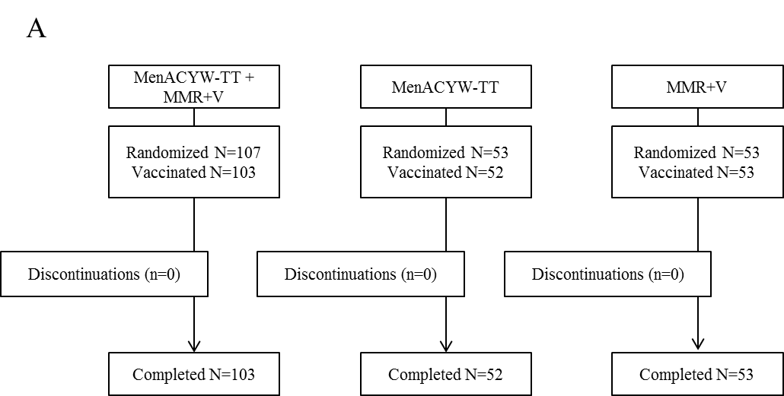
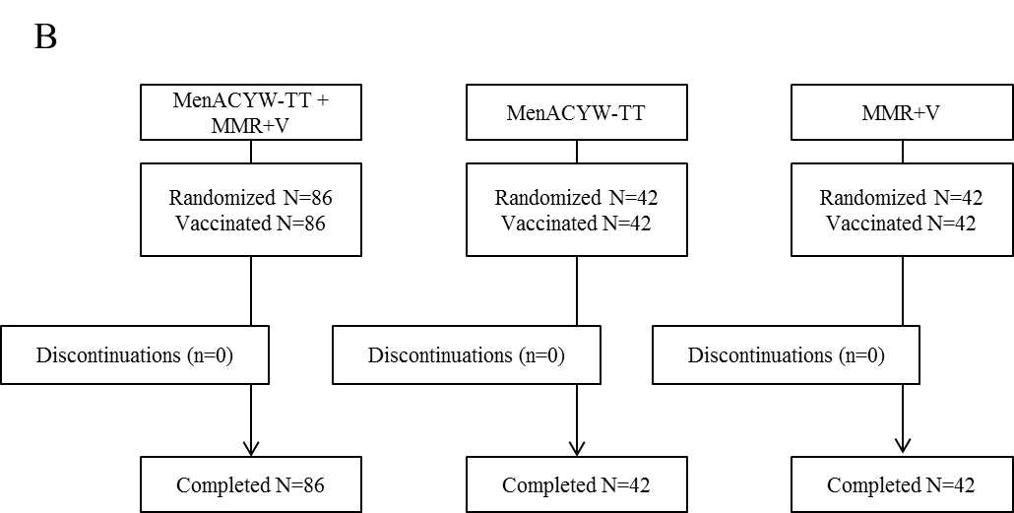

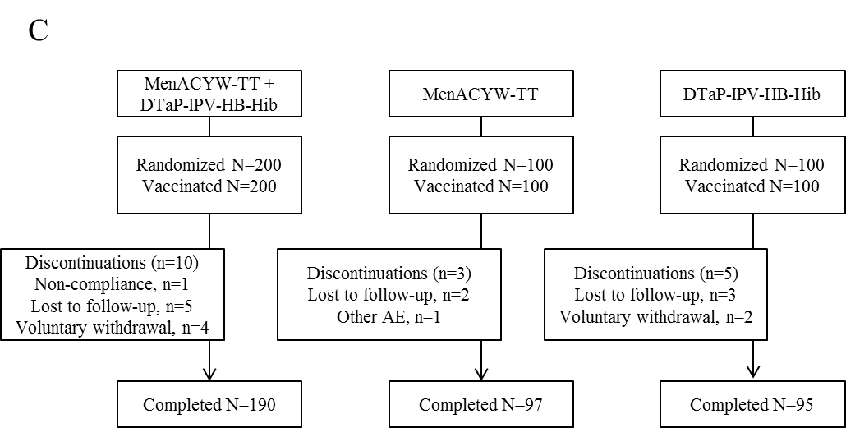

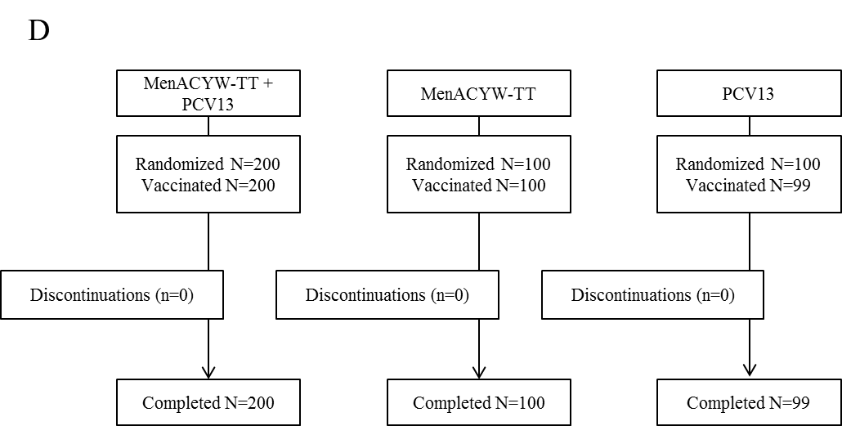

DTaP-IPV-HepB-Hib, diphtheria, tetanus, pertussis, polio, hepatitis B and Haemophilus influenzae type b vaccine; MMR, measles, mumps and rubella vaccine; PCV13, pneumococcal conjugate vaccine; V, varicella vaccine.
Figure S2. hSBA seroresponse* at Day 30 in participants randomized to MenACYW-TT+MMR+V and MenACYW-TT (PPAS)
*Seroresponse is defined as hSBApost-vaccination titres ≥1:16 in those with pre-vaccination titres <1:8, or post-vaccination titres ≥4-fold greater than the pre-vaccination titre
hSBA, serum bactericidal antibody assay using human complement; MMR, measles, mumps and rubella vaccine; PPAS, per protocol analysis set; V, varicella vaccine.

Figure S3. hSBA seroresponse* at Day 30 in participants randomized to MenACYW-TT+DTaP-IPV-HepB-Hib and MenACYW-TT (PPAS)
*Seroresponse is defined as hSBApost-vaccination titres ≥1:16 in those with pre-vaccination titres <1:8, or post-vaccination titres ≥4-fold greater than the pre-vaccination titre
DTaP-IPV-HepB-Hib, diphtheria, tetanus, pertussis, polio, hepatitis B and Haemophilus influenzae type b vaccine; hSBA, serum bactericidal antibody assay using human complement; PPAS, per protocol analysis set.

Figure S4. hSBA seroresponse* at Day 30 in participants randomized to MenACYW-TT+PCV13 and MenACYW-TT (PPAS)
*Seroresponse is defined as hSBApost-vaccination titres ≥1:16 in those with pre-vaccination titres <1:8, or post-vaccination titres ≥4-fold greater than the pre-vaccination titre
hSBA, serum bactericidal antibody assay using human complement; PCV13, pneumococcal conjugate vaccine; PPAS, per protocol analysis set.

