Appendix Word 1. Search strategy of PubMed.
#1 "COVID-19"[Supplementary Concept] OR "severe acute respiratory syndrome
coronavirus 2"[Supplementary Concept]
#2 COVID-19[Title/Abstract] OR COVID 19[Title/Abstract] OR 2019 novel coronavirus[Title/Abstract] OR 2019-nCov[Title/Abstract] OR coronavirus disease 2019[Title/Abstract] OR coronavirus disease-19[Title/Abstract] OR new coronavirus[Title/Abstract] OR novel corona virus[Title/Abstract] OR nCoV-2019[Title/Abstract] OR novel coronavirus pneumonia[Title/Abstract] OR "severe acute respiratory syndrome coronavirus 2"[Title/Abstract] OR SARS-CoV-2[Title/Abstract]
#3 #1 OR #2
#4 clinical characteristics[Title/Abstract] OR clinical characteristic[Title/Abstract] OR clinical feature[Title/Abstract] OR clinical features[Title/Abstract] OR risk factors[Title/Abstract] OR risk factor[Title/Abstract] OR prognosis[Title/Abstract] OR comorbidit*[Title/Abstract] OR cerebrovascular disease*[Title/Abstract] OR nervous system disease*[Title/Abstract] OR brain[Title/Abstract] OR neurologic* [Title/Abstract] OR stroke[Title/Abstract] OR cerebral infarction[Title/Abstract] OR epilepsy[Title/Abstract] OR dementia[Title/Abstract] OR severity[Title/Abstract] OR mortality[Title/Abstract]
#5 #3 AND #4

Appendix Figure 1. Sensitivity analysis by excluding Chinese studies for the association between nervous system diseases and COVID-19 severity

Appendix Figure 2. Sensitivity analysis by excluding Chinese studies for the association between cerebrovascular diseases and COVID-19 severity

Appendix Figure 3. Univariate meta-regression analysis on the sample size of each study for the association between nervous system diseases and COVID-19 severity
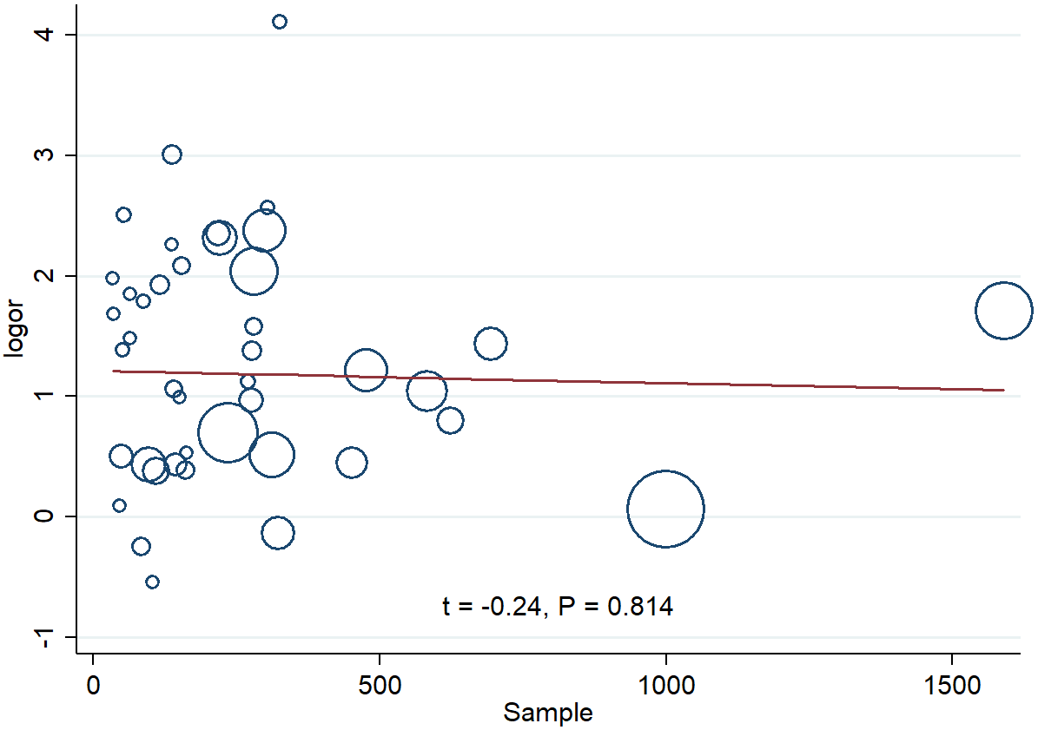

Appendix Figure 4. Univariate meta-regression analysis on the sample size of each study for the association between nervous system diseases and COVID-19 mortality
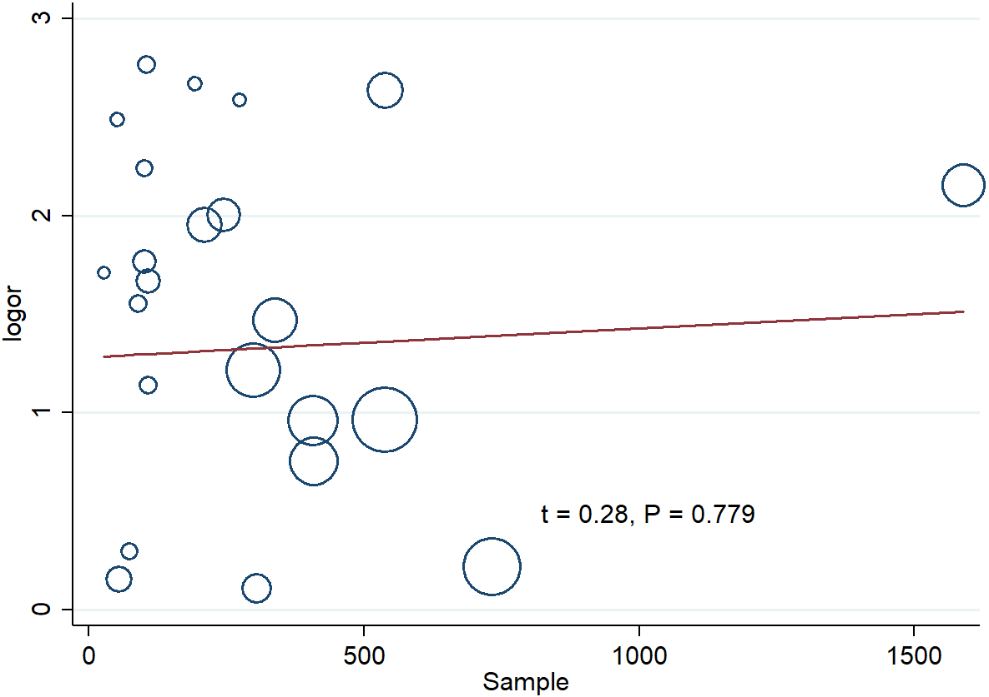
Appendix Figure 5. Univariate meta-regression analysis on the sample size of each study for the association between cerebrovascular diseases and COVID-19 severity
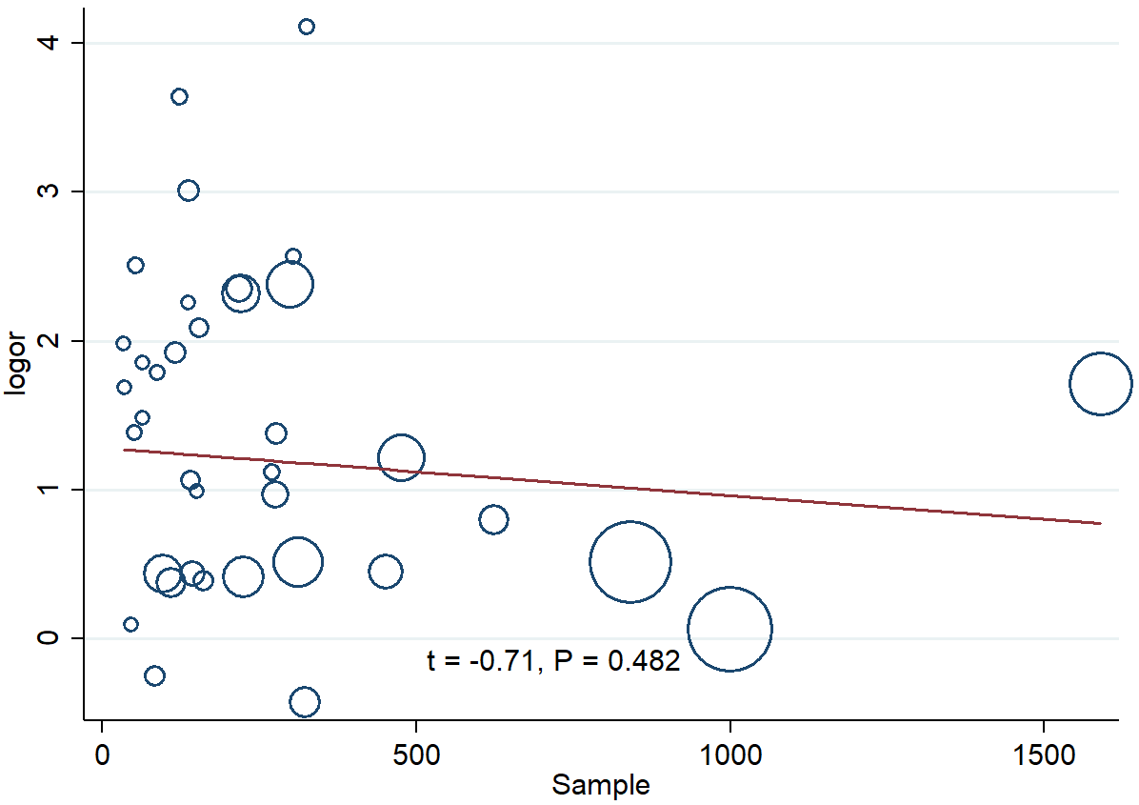

Appendix Figure 6. Univariate meta-regression analysis on the sample size of each study for the association between cerebrovascular diseases and COVID-19 mortality
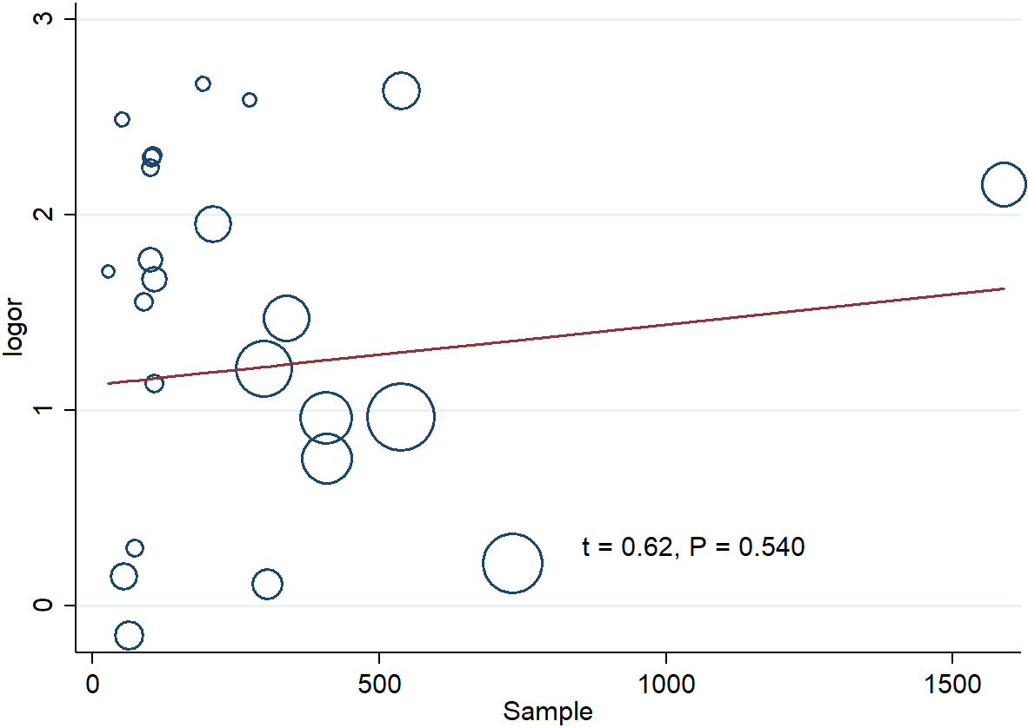

Appendix Figure 7. Funnel plot for the association between nervous system diseases and COVID-19 severity
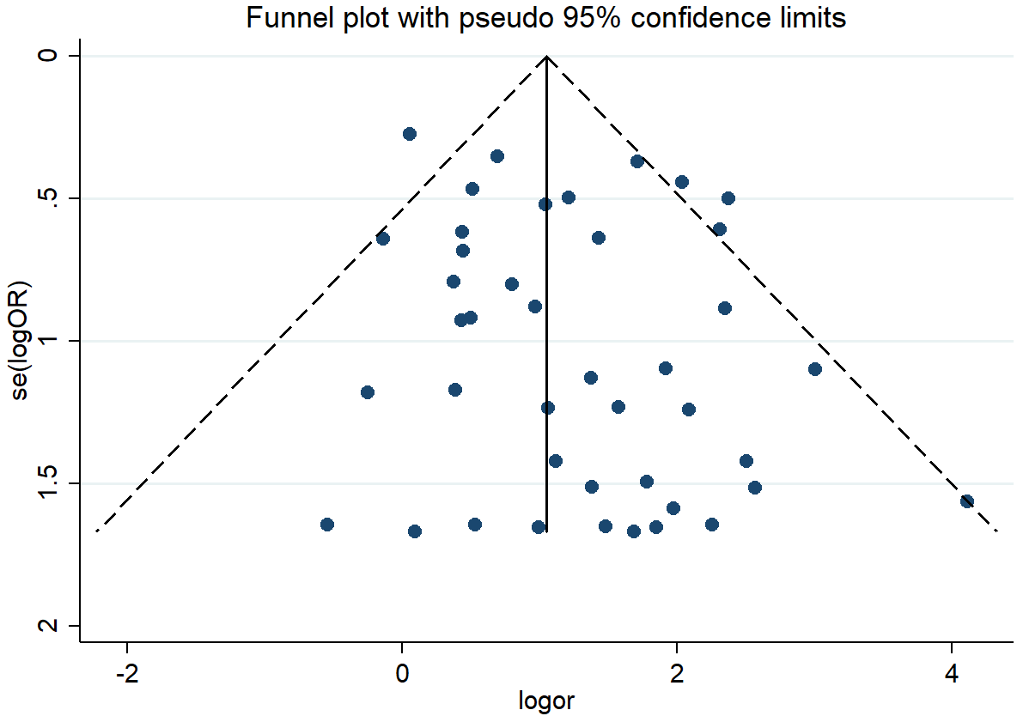

Appendix Figure 8. Funnel plot for the association between nervous system diseases and COVID-19 mortality
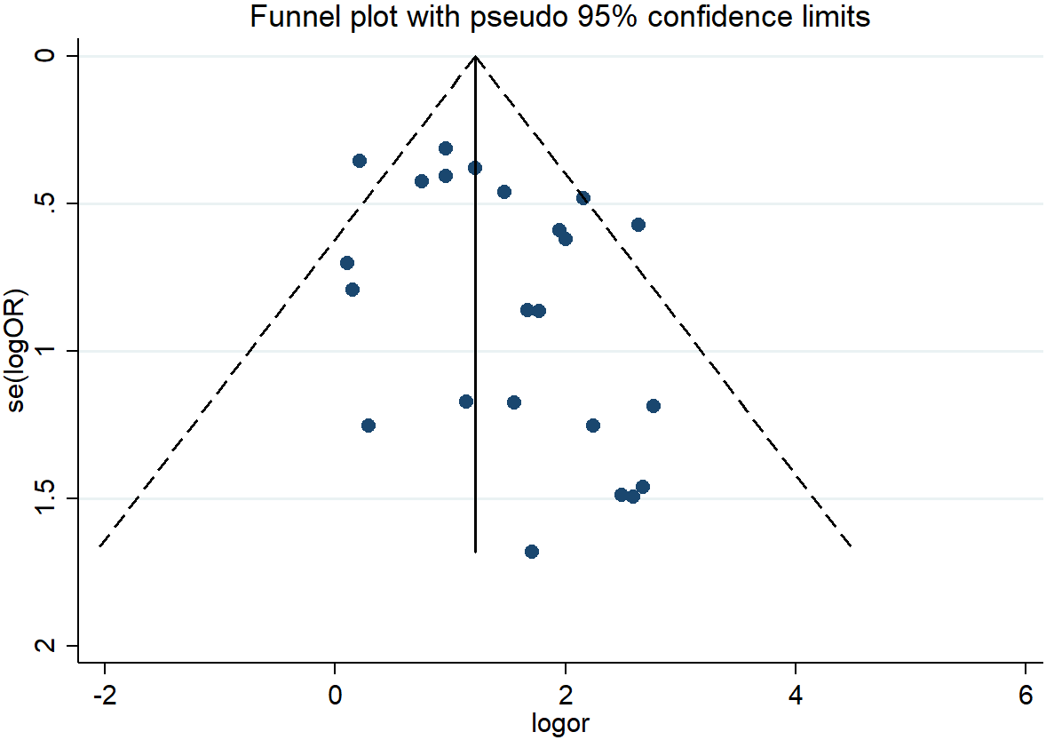

Appendix Figure 9. Funnel plot for the association between cerebrovascular disease and COVID-19 severity
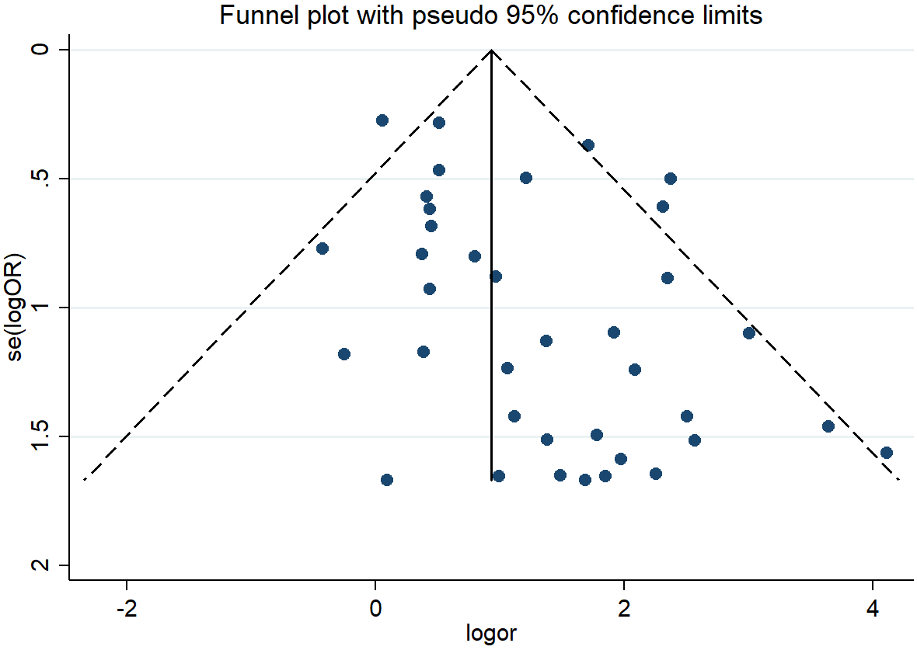

Appendix Figure 10. Funnel plot for the association between cerebrovascular diseases and COVID-19 mortality
