Supplementary Table 1
WHO influenza vaccine strain recommendations. Highlighted text indicates vaccines in which trivalent vaccine strain recommendation changed. B1 reflects strain recommended for trivalent vaccines. Both B1 and B2 are recommended for quadrivalent vaccines. NH: Northern Hemisphere; SH: Southern Hemisphere

 | AH1 | AH3 | Clade | B1 | Lineage | B2
SH2017 | A/Michigan/45/2015 (H1N1)pdm09 | A/Hong Kong/4801/2014 | 3C.2a | B/Brisbane/60/2008 | Victoria | B/Phuket/3073/2013
NH 2016-17 | A/California/7/2009 (H1N1)pdm09 | A/Hong Kong/4801/2014 | 3C.2a | B/Brisbane/60/2008 | Victoria | B/Phuket/3073/2013
SH2016 | A/California/7/2009 (H1N1)pdm09 | A/Hong Kong/4801/2014 | 3C.2a | B/Brisbane/60/2008 | Victoria | B/Phuket/3073/2013
NH 2015-16 | A/California/7/2009 (H1N1)pdm09 | A/Switzerland/9715293/2013 | 3C.3a | B/Phuket/3073/2013 | Yamagata | B/Brisbane/60/2008
SH2015 | A/California/7/2009 (H1N1)pdm09 | A/Switzerland/9715293/2013 | 3C.3a | B/Phuket/3073/2013 | Yamagata | B/Brisbane/60/2008
NH 2014-15 | A/California/7/2009 (H1N1)pdm09 | A/Texas/50/2012 | 3C.1 | B/Massachusetts/2/2012 | Yamagata | B/Brisbane/60/2008
SH2014 | A/California/7/2009 (H1N1)pdm09 | A/Texas/50/2012* | 3C.1 | B/Massachusetts/2/2012 | Yamagata | B/Brisbane/60/2008
NH 2013-14 | A/California/7/2009 (H1N1)pdm09 | A/Victoria/361/2011 | 3C.1 | B/Massachusetts/2/2012 | Yamagata | B/Brisbane/60/2008
SH2013 | A/California/7/2009 (H1N1)pdm09 | A/Victoria/361/2011 ** | 3C.1 | B/Wisconsin/1/2010 | Yamagata | B/Brisbane/60/2008
NH 2012-13 | A/California/7/2009 (H1N1)pdm09 | A/Victoria/361/2011 | 3C.1 | B/Wisconsin/1/2010 | Yamagata

* A/Texas/50/2012 is an A(H3N2) virus that following adaptation to growth in eggs has maintained antigenic properties similar to the majority of recently circulating cell-propagated A(H3N2) viruses including A/Victoria/361/2011.
** A/Ohio/2/2012, A/Maryland/2/2012, A/South Australia/30/2012, A/Brisbane/1/2012 and A/Brisbane/6/2012 are A/Victoria/361/2011-like viruses

Supplementary Figure 1: Weekly number of influenza vaccines administered (all locations combined) with linear trendline and correlation coefficient. Weeks numbered consecutively from Week 1 in Jan 2013 to Week 237 in July 2017

Supplementary Figure 2: Weekly number of negative influenza PCRs with linear trendline and correlation coefficient. Weeks numbered consecutively from Week 1 in Jan 2013 to Week 247 in Oct 2017

2013 2014 2015 2016 2017
Year

Supplementary Figure 3: Influenza data by type/subtype and week of the 4,571 influenza infections in the community reported by Singapore Ministry of Health to the WHO through FluNet (Influenza A 70.0% [AH3 74.9%, AH1 25.1%]; Influenza B 30.0%). AHx: Influenza A, subtype undetermined.

Supplementary Table 2: Summary data and odds ratio of predictors for influenza infection after vaccination from logistic regression analysis.
 | Flu | No flu | OR (95% CI) | p-value | Multivariable (95% CI) ¶ | p-value
N | 617 | 18676
Year vaccination  - 2013  - 2014  - 2015  - 2016  - 2017 | 19.0  18.8  23.0  28.0  11.3 | 15.6  17.0  26.8  24.8  15.8 | -  -  -  -  -
Demographics
Sex (% male) | 58.2 | 56.6 | 1.069 (0.910-1.257) | 0.42 | 1.054 (0.894-1.244) | 0.53
Age (Mean, SD) †  - Over 65 years (%) | 73.8 (12.87)  76.2 | 71.7 (14.77)  71.1 | 1.010 (1.004-1.016)  1.301 (1.083-1.573) | 0.00060  0.0057 | 1.011 (1.005-1.018)  - | 0.00053
Ethnicity (%)  - Chinese  - Indian  - Malay  - Other | 77.2  8.2  11.1  3.5 | 76.7  9.4  9.2  4.8 | Ref  0.868 (0.640-1.151)  1.227 (0.944-1.571)  0.738 (0.465-1.110) | Ref  0.34  0.12  0.17 | 0.924 (0.678 (1.232)  1.412 (1.075-1.830)  0.762 (0.479-1.149) | 0.60  0.01  0.22
Co-morbidities
Charlson score  (mean, SD) | 3.06 (2.508) | 2.93 (2.529) | 1.022 (0.990-1.053) | 0.17 | -
Co-morbidities (%)  - Pulmonary  - Cardiovascular  - Diabetes  - Renal  - Liver  - Malignancy | 58.7  39.1  34.9  7.6  22.7  8.4 | 44.1  36.3  36.0  6.3  22.8  7.4 | 1.791 (1.524-2.107)  1.131 (0.960-1.331)  0.944 (0.798-1.115)  0.994 (0.820-1.199)  1.211 (0.883-1.621)  1.133 (0.839-1.497) | <0.0001  0.14  0.50  0.95  0.22  0.40 | 1.588 (1.343-1.881)  -  -  -  -  - | <0.0001
Hospitalisation in year before vaccination (%) | 71.7 | 66.1 | 1.307 (1.097-1.564) | 0.0030 | 1.327 (1.104-1.602) | 0.0028
Influenza in year before vaccination (%) | 8.5 | 8.4 | 1.016 (0.755-1.340) | 0.911 | -
Vaccination details
Vaccine location (%)  - Hospital  - Specialist clinic  - Polyclinic | 41.3  47.9  10.8 | 42.7  45.4  11.9 | Ref  1.085 (0.916-1.285)  0.930 (0.703-1.214) | 0.347  0.602 | -  -
Time from prior influenza vaccination (%)  - <1 year  - <2 years  - <5 years | 25.4  56.6  64.0 | 18.9  45.2  53.8 | 1.454 (1.207-1.744)  1.556 (1.325-1.828)  1.504 (1.276-1.777) | <0.0001  <0.0001  <0.0001 | -  1.523 (1.283-1.810)  - | -  <0.0001  -

¶ Adjusted for age, sex, chronic pulmonary disease, hospitalisation in year before vaccination and receipt of two or more influenza vaccines in the previous two years
†Per year

Supplementary Figure 4: Influenza vaccine failure stratified by number of risk factors (age ≥ 65 years, chronic pulmonary disease, influenza vaccination in the previous two years), with linear trend line.

Number of risk factors | Influenza infections /n | Proportion of individuals with vaccine failure | Adjusted OR for influenza (95% CI) † | p-value
0 | 29/1700 | 1.71% | Ref | -
1 | 188/7875 | 2.39% | 1.51 (1.04-2.29) | 0.0400
2 | 207/5914 | 3.50% | 2.29 (1.57-3.46) | <0.0001
3 | 193/3809 | 5.07% | 3.47 (2.37-5.25) | <0.0001
†Adjusted for age, sex, ethnicity, chronic pulmonary disease, hospital admission in previous year, previous influenza vaccination in the 2 years before index date of vaccination, and influenza virus activity during that time period.

Supplementary Figure 5: Influenza vaccine failure stratified by number of influenza vaccines received in the two years before study entry, with linear trend line.
Number of vaccines | Influenza infections /n | Proportion of individuals with vaccine failure | Adjusted OR for influenza (95% CI) | p-value
1 (index vaccine) | 270/10517 | 2.57% | Ref | -
2 | 248/6584 | 3.77% | 1.51 (1.26-1.81) | <0.0001
3 | 92/2133 | 4.31% | 1.75 (1.36-2.25) | <0.0001
4 or more | 7/64 | 10.94% | 3.96 (1.67-7.92) | 0.0004

†Adjusted for age, sex, ethnicity, chronic pulmonary disease, hospital admission in previous year, previous influenza vaccination in the 2 years before index date of vaccination, and influenza virus activity during that time period.

Supplementary Figure 6: Phylogenetic tree of A/H3 haemagglutinin gene sequenced from a subset of cases.
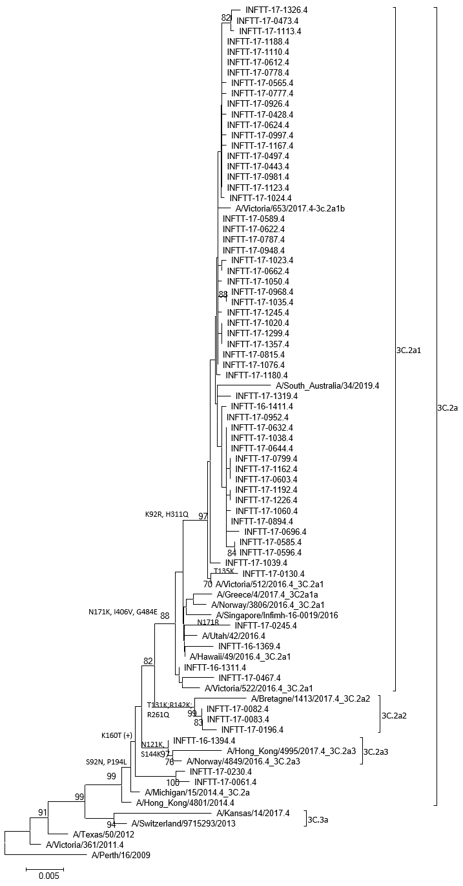
Supplementary Figure 7: Phylogenetic tree of A/H1 haemagglutinin gene sequenced from a subset of cases.
