Epidemiology and Infection

Title: Development and Validation of the Patient History COVID-19 (PH-Covid19) Scoring System: A Multivariable Prediction Model of Death in Mexican Patients with COVID-19
Authors: J. Mancilla-Galindo, J. M. Vera-Zertuche, A. R. Navarro-Cruz, O. Segura-Badilla, G. Reyes-Velázquez, F. J. Tepepa-López, P. Aguilar-Alonso, J. de J. Vidal-Mayo, A. Kammar-García.
Supplementary Material

Supplementary Figure S1. Risk for adverse events in Mexican patients with a positive test for SARS-CoV-2, according to individual scores in the PH-Covid19 scoring system.
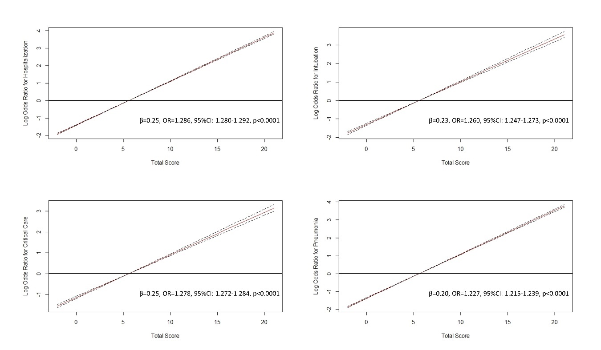
β: Regression coefficient, OR: Odds ratio, 95%CI: 95% coefficient interval. a) Risk of hospitalization, b) Risk of intubation, c) Risk of critical care, d) Risk of pneumonia.

