SUPPLEMENTARY MATERIAL

Supplementary Figure 1. Observed antibody levels against time post-vaccination, by season of vaccination per pathogen. Regression lines predicted by the final models per sex per pathogen, Pienter-2 Study.

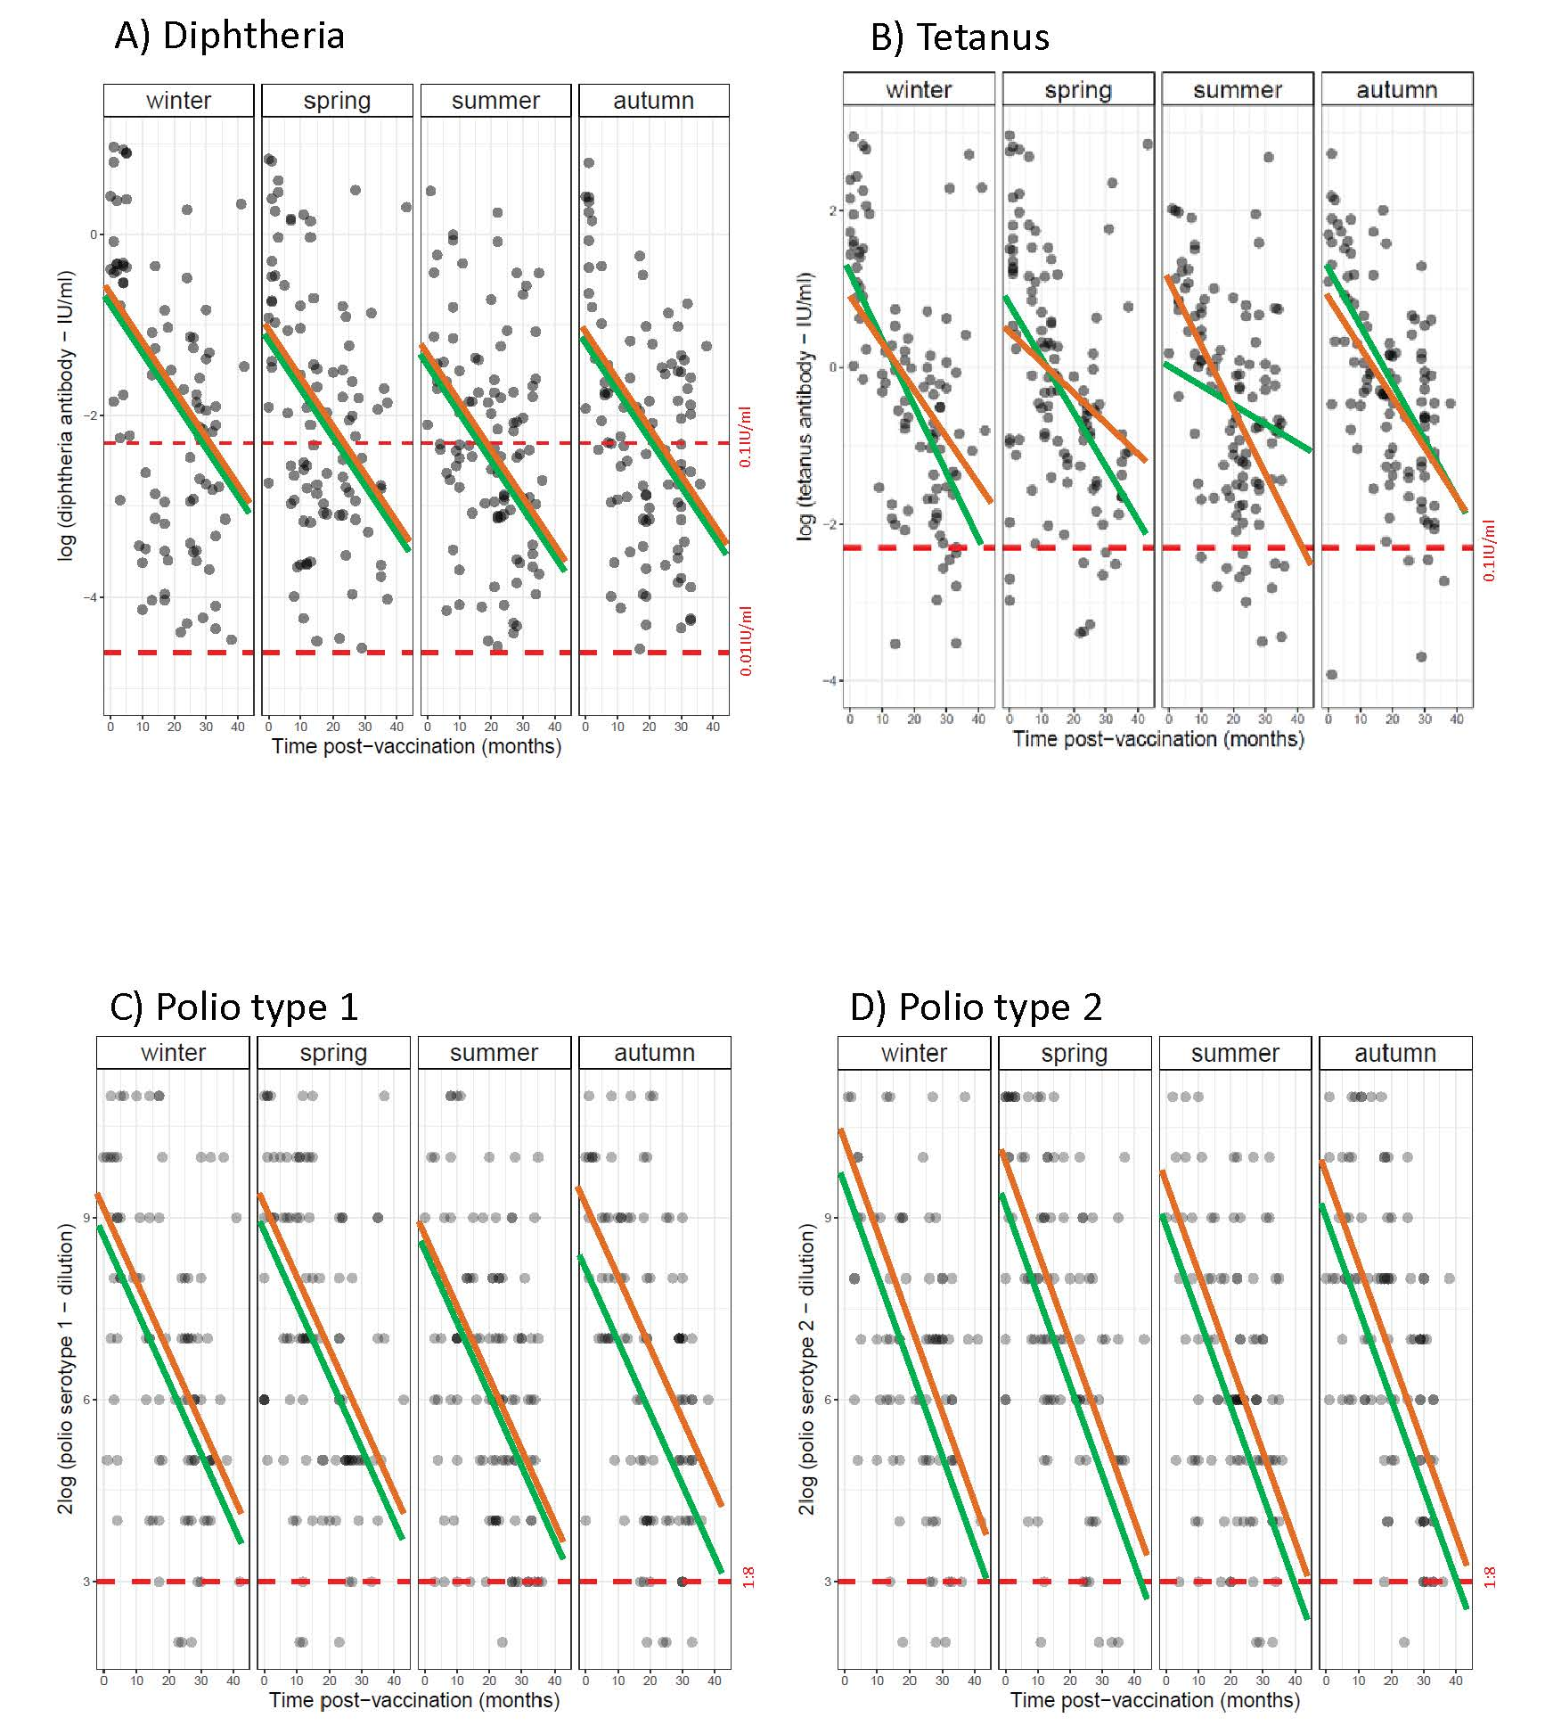

Sex : girl boy
Note: Darker points correspond to overlap of observations; Dashed horizontal red lines are thresholds of protection.
.

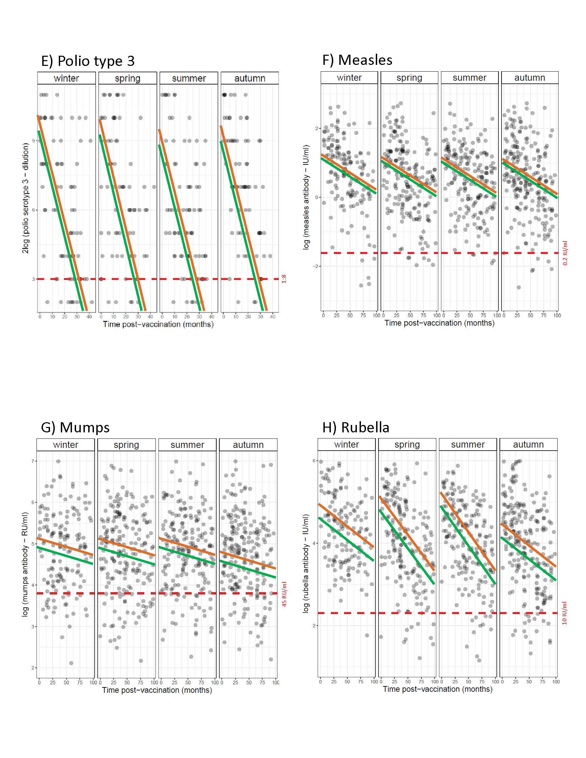
Sex: girl boy
Note: Darker points correspond to overlap of observations; Dashed horizontal red lines are thresholds of protection.

Sex: girl boy
Note: Darker points correspond to overlap of observations; Dashed horizontal red lines are thresholds of protection.

Supplementary Table 1. Seroconversion rate per season of vaccination, Pienter-2 Study.
 |  | Seroconversion threshold |  | Winter |  | Spring |  | Summer |  | Autumn |  | Overall |  | p-valueª
Diphtheria | 0.01 IU/ml |  | 93% |  | 91% |  | 92% |  | 97% |  | 93% |  | 0.249
Tetanus | 0.1 IU/ml |  | 93% |  | 91% |  | 92% |  | 97% |  | 93% |  | 0.424
Polio type 1 | 1:8 |  | 92% |  | 93% |  | 97% |  | 91% |  | 93% |  | 0.291
Polio type 2 | 1:8 |  | 93% |  | 91% |  | 92% |  | 91% |  | 92% |  | 0.936
Polio type 3 | 1:8 |  | 77% |  | 75% |  | 71% |  | 71% |  | 73% |  | 0.677
Measles | 0.2 IU/ml |  | 95% |  | 97% |  | 97% |  | 96% |  | 96% |  | 0.932
Mumps | 45 RU/ml |  | 85% |  | 81% |  | 85% |  | 80% |  | 82% |  | 0.372
Rubella | 10 IU/ml |  | 99% |  | 94% |  | 94% |  | 90% |  | 93% |  | 0.010
MenC | 0.2 µg/ml |  | 88% |  | 88% |  | 90% |  | 87% |  | 88% |  | 0.594
ªChi-square test

Supplementary Table 2. Pairwise Pearson correlation between individuals’ antibody levels, Pienter-2 Study.
Antibody | 1 | 2 | 3 | 4 |  | 5 |  | 6 |  | 7 |  | 8 |  | 9
1 Diphtheria | 1.00***
2 Tetanus | 0.69*** | 1.00***
3 Polio type 1 | 0.46*** | 0.50*** | 1.00***
4 Polio type 2 | 0.51*** | 0.57*** | 0.63*** | 1.00***
5 Polio type 3 | 0.41*** | 0.53*** | 0.62*** | 0.66*** |  | 1.00***
6 Measles | 0.06 | 0.01 | 0.03 | -0.01 |  | -0.08 |  | 1.00***
7 Mumps | 0.05 | -0.06 | -0.05 | -0.03 |  | -0.04 |  | 0.39*** |  | 1.00***
8 Rubella | 0.07 | -0.03 | -0.06 | 0.001 |  | -0.01 |  | 0.50*** |  | 0.52*** |  | 1.00***
9 MenC | 0.21*** | 0.28*** | 0.15** | 0.21*** |  | 0.25*** |  | 0.12* |  | 0.08 |  | 0.14* |  | 1.00***
Levels of significance: ***p< 0.001; **p< 0.01; *p< 0.05
Level of significance adjusted for multiple testing (Bonferroni correction): ***p< 0.001 (0.05/45 tests)

Supplementary Table 3. Sensitivity analysis excluding oversampled migrants: Linear Multivariate Regression Model estimates for antibody levels as a function of season of vaccination, time post-vaccination and sex for DT-IPV sub-sample, Pienter-2 Study.
 | Diphtheriaª |  |  | Tetanusª |  |  |  |  | Polio type 1^{b} |  |  |  |  |  | Polio type 2^{b} |  |  | Polio type 3^{b}
 |  |  |  | girls |  |  | boys |  |  | girls |  | boys
Intercept | -1.02** (-1.47, -0.58) |  | 0.90** (0.33, 1.47) |  |  | 1.49** (0.91, 2.07) |  | 8.63** (7.37, 9.90) |  |  | 8.92** (7.94, 9.89) |  |  | 9.69** (8.90, 10.47) |  |  | 9.38** (8.49, 10.27)
Winter vaccination | ref. |  | ref. |  |  | ref. |  | ref. |  |  | ref. |  |  | ref. |  |  | ref.
Spring vaccination | -0.44 (-0.91, 0.02) |  | -0.22 (-0.81, 0.37) |  |  | -0.01 (-0.85, 0.84) |  | 0.40 (-0.89, 1.69) |  |  | -0.20 (-1.31, 0.92) |  |  | -0.44 (-1.27, 0.39) |  |  | -0.53 (-1.47, 0.41)
Summer vaccination | -0.52* (-0.99, -0.06) |  | 0.10 (-0.48, 0.68) |  |  | -1.29* (-2.40, -0.18) |  | -0.05 (-1.32, 1.23) |  |  | -0.71 (-1.84, 0.42) |  |  | -0.72* (-1.55, 0.11) |  |  | -0.98* (-1.92, -0.05)
Autumn vaccination | -0.25 (-0.73, 0.22) |  | 0.28 (-0.34, 0.90) |  |  | -0.17 (-1.20, 0.85) |  | 0.23 (-1.15, 1.60) |  |  | -0.60 (-1.70, 0.49) |  |  | -0.13 (-0.97, 0.71) |  |  | -0.45 (-1.40, 0.51)
[1] Time post-vaccination^{c} | -0.06** (-0.08, -0.04) | -0.08** (-0.09, -0.06) |  |  | -0.09** (-0.12, -0.06) |  |  | -0.11** (-0.15, -0.07) |  |  | -0.12** (-0.16, -0.08) |  |  | -0.16** (-0.19, -0.14) |  |  | -0.21** (-0.24, -0.18)
Girl | 0.01 (-0.33, 0.35) |  | - |  |  | - |  | - |  |  | - |  |  | 0.70* (0.11, 1.30) |  |  | 0.46 (-0.21, 1.14)
Winter vaccination x [1] | - |  | - |  |  | ref. |  | - |  |  | - |  |  | - |  |  | -
Spring vaccination x [1] | - |  | - |  |  | -0.02 (-0.06, 0.03) |  | - |  |  | - |  |  | - |  |  | -
Summer vaccination x [1] | - |  | - |  |  | 0.05 (-0.01, 0.10) |  | - |  |  | - |  |  | - |  |  | -
Autumn vaccination x [1] | - |  | - |  |  | 0.01 (-0.03, 0.06) |  | - |  |  | - |  |  | - |  |  | -
Observations | 294 |  | 134 |  |  | 160 |  | 134 |  |  | 160 |  |  | 294 |  |  | 294
Adjusted R square | 0.17 |  | 0.33 |  |  | 0.36 |  | 0.17 |  |  | 0.2 |  |  | 0.33 |  |  | 0.38
Residual Standard Error | 1.45 (df = 288) |  | 1.18 (df = 129) |  |  | 1.18 (df = 152) |  | 2.61 (df = 129) |  |  | 2.59 (df = 155) |  |  | 2.57 (df = 288) |  |  | 2.91 (df = 288)
F Statistic | 12.80** (df = 5; 288) | 17.34** (df = 4; 129) |  |  | 13.76** (df = 7; 152) |  |  | 7.58** (df = 4; 129) |  |  | 11.08** (df = 4; 155) |  |  | 29.27** (df = 5; 288) |  |  | 37.41** (df = 5; 288)
ªlog-transformed; ^{b}log2-transformed; ^{c}in months. Notes: Confidence Intervals (95% CI) in parentheses; Reference levels are winter (season of vaccination) and boy (sex); Levels of significance: **p< 0.01; *p< 0.05.

Supplementary Table 4. Sensitivity analysis excluding oversampled migrants: Linear Multivariate Regression Model estimates for antibody levels as a function of season of vaccination, time post-vaccination and sex for MMR sub-sample, Pienter-2 Study.
 |  | Measlesª |  | Mumpsª | Rubellaª
Intercept |  | 1.17** (0.93, 1.42) |  | 4.82** (4.55, 5.08) | 4.48** (4.09, 4.87)
Winter vaccination |  | ref. |  | ref. | ref.
Spring vaccination |  | -0.16 (-0.41, 0.09) |  | -0.05 (-0.32, 0.23) | 0.22 (-0.28, 0.72)
Summer vaccination |  | -0.17 (-0.43, 0.09) |  | 0.01 (-0.27, 0.29) | 0.21 (-0.30, 0.72)
Autumn vaccination |  | -0.24* (-0.48, 0.01) |  | -0.22 (-0.48, 0.05) | -0.40 (-0.88, 0.08)
[1] Time post-vaccination^{b} |  | -0.01** (-0.01, -0.01) |  | -0.003 (-0.01, 0.0003) | -0.01* (-0.02, -0.001)
Girl |  | 0.13 (-0.03, 0.30) |  | 0.23* (0.05, 0.42) | 0.27** (0.09, 0.44)
Winter vaccination x [1] |  | - |  | - | ref.
Spring vaccination x [1] |  | - |  | - | -0.01 (-0.02, 0.0002)
Summer vaccination x [1] |  | - |  | - | -0.01 (-0.02, 0.001)
Autumn vaccination x [1] |  | - |  | - | -0.0002 (-0.01, 0.01)
Observations |  | 617 |  | 617 | 617
Adjusted R square |  | 0.07 |  | 0.01 | 0.13
Residual Standard Error |  | 1.06 (df = 611) |  | 1.15 (df = 611) | 1.10 (df = 608)
F Statistic |  | 9.81** (df = 5; 611) |  | 2.69* (df = 5; 611) | 12.33** (df = 8; 608)
ªlog-transformed; ^{b}in months. Notes: Confidence Intervals (95% CI) in parentheses; Reference levels are winter (season of vaccination) and boy (sex); Levels of significance: **p< 0.01; *p< 0.05
 | Supplementary Table 5. Sensitivity analysis excluding oversampled migrants: Linear Multivariate Regression Model estimates for antibody levels as a function of season of vaccination, time post-vaccination and sex for MenC sub-sample, Pienter-2 Study.
 |  |  | MenCª
 | Intercept |  | 0.57* (0.13, 1.02)
 | Winter vaccination |  | ref.
 | Spring vaccination |  | 0.42 (-0.03, 0.88)
 | Summer vaccination |  | 0.15 (-0.32, 0.63)
 | Autumn vaccination |  | 0.47* (0.03, 0.92)
 | Time post-vaccination^{b} |  | -0.07** (-0.09, -0.06)
 | Girl |  | 0.19 (-0.12, 0.49)
 | Observations |  | 266
 | Adjusted R square |  | 0.24
 | Residual Standard Error |  | 1.25 (df = 260)
 | F Statistic |  | 17.86** (df = 5; 260)
 | ªlog-transformed; ^{b}in months. Notes: Confidence Intervals (95% CI) in parentheses; Reference levels are winter (season of vaccination) and boy (sex); Levels of significance: **p< 0.01; *p< 0.05

Supplementary Table 6. Comparative results of model fit (adjusted R square): Time post-vaccination (original scale) versus Time post-vaccination (log-transformed), Pienter-2 Study.
 |  | Final model adjusted R square
 |  | Time post-vaccination (original scale) | Time post-vaccination (log-transformed)
Diphtheriaª |  | 0.14 | 0.21
Tetanusª | girls | 0.21 | 0.21
 | boys | 0.28 | 0.31
Polio type 1^{b} | girls | 0.20 | 0.20
 | boys | 0.22 | 0.19
Polio type 2^{b} |  | 0.29 | 0.27
Polio type 3^{b} |  | 0.35 | 0.33
Measlesª |  | 0.07 | 0.03
Mumpsª |  | 0.02 | 0.01
Rubellaª |  | 0.14 | 0.10
MenCª |  | 0.26 | 0.25
ªlog-transformed; blog2-transformed

Supplementary Table 7. Comparative results of estimates of waning MMR antibodies: Linear Mixed Model (longitudinal cohort) versus Linear Multivariate Regression Model, Pienter-2 Study
 |  | Measles^{a,d} |  |  | Mumps^{a,d} |  |  | Rubella^{a,d}
 |  | Longitudinal cohort | Pienter-2 Study |  | Longitudinal cohort | Pienter-2 Study |  | Longitudinal cohort | Pienter-2 Study
Intercept |  | 0.85** (0.34, 1.35) | 1.12* (0.91, 1.32) |  | 4.08** (3.69, 4.47) | 4.82* (4.59, 5.05) |  | 5.24* (4.91, 5.57) | 4.48* (4.27, 4.70)
Time post-vaccination^{b} |  | 0.0001 (-0.009, 0.009) | -0.01* (-0.02, -0.01) |  | 0.02** (0.01, 0.03) | -0.003 (-0.01, 0.001) |  | -0.01** (-0.02, -0.01) | -0.01* (-0.02, -0.01)
Girl |  | 0.16 (-0.52, 0.84) | 0.11 (-0.07, 0.29) |  | 0.86** (0.35, 1.38) | 0.19 (-0.01, 0.39) |  | 0.18 (-0.34, 0.55) | 0.24* (0.05, 0.43)
Observations |  | 106 | 483^{c} |  | 103 | 483^{c} |  | 106 | 483^{c}
ªlog-transformed; ^{b}in months; ^{c}Children aged between 15 to 50 months were included in the analysis for comparability purposes; ^{d}Models adjusted for sex only.
Notes: Confidence Intervals (95% CI) in parentheses; Reference levels are winter (season of vaccination) and boy (sex); Levels of significance: **p< 0.01; *p< 0.05

