Supplementary data
Supplementary Figure 1

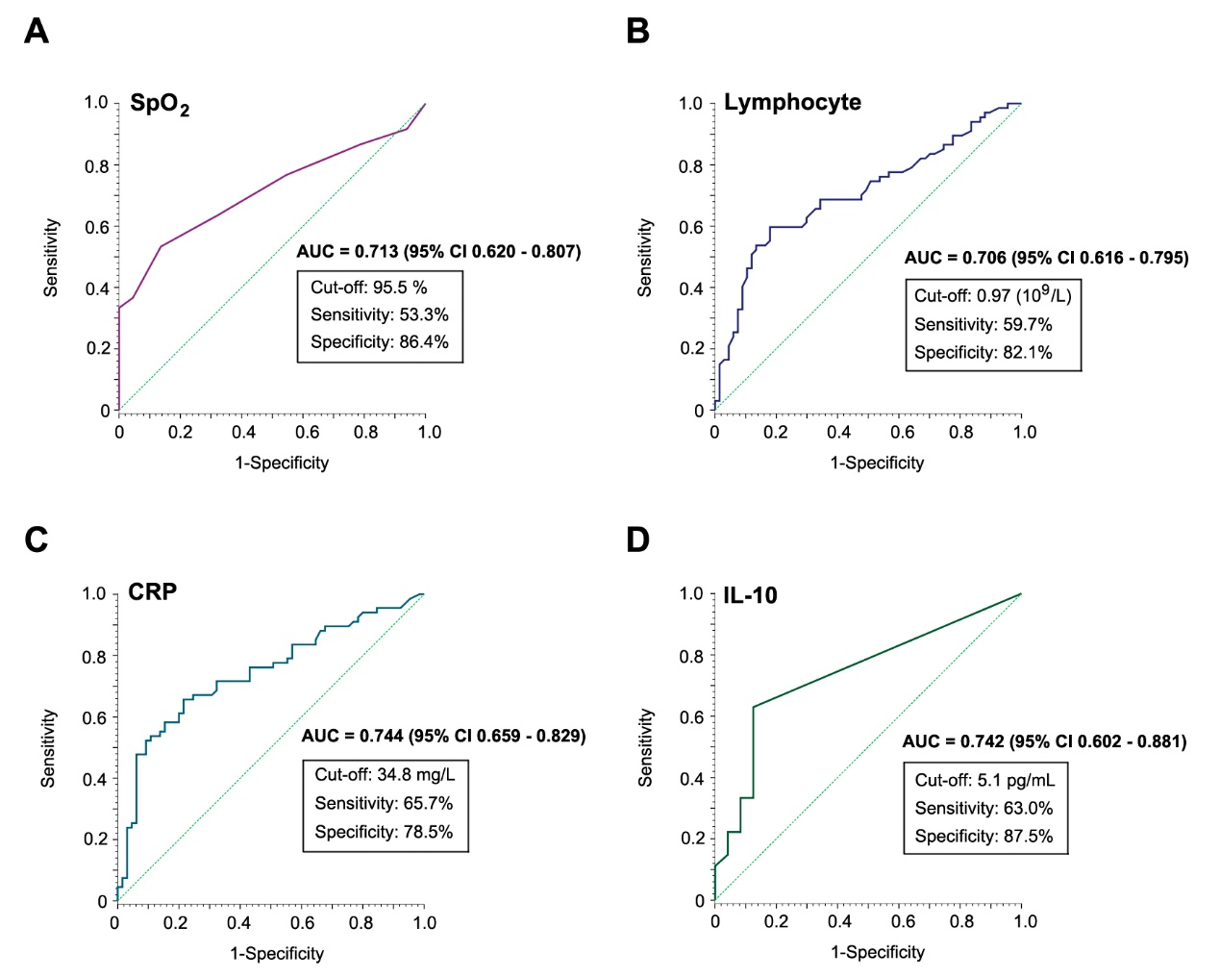
Supplementary Figure 1. Predictive values of certain clinical indicators in the blood of patients with severe COVID-19 analyzed by ROC curves. (only AUCs higher than 0.7 were listed). (A) ROC curve of SpO₂ (AUC =0.713, 95% CI: 0.620-0.807, sensitivity: 53.3%, specificity: 86.4%); (B) ROC curve of lymphocyte (AUC =0.706, 95% CI: 0.616-0.795, sensitivity: 59.7%, specificity: 82.1%); (C) ROC curve of CRP (AUC =0.744, 95% CI: 0.659-0.829, sensitivity: 65.7%, specificity: 78.5%); (D) ROC curve of IL-10 (AUC =0.742, 95% CI: 0.602-0.881, sensitivity: 63.0%, specificity: 87.5%). SpO₂, Peripheral oxygen saturation; CRP, C-reactive protein.

Supplementary Figure 2
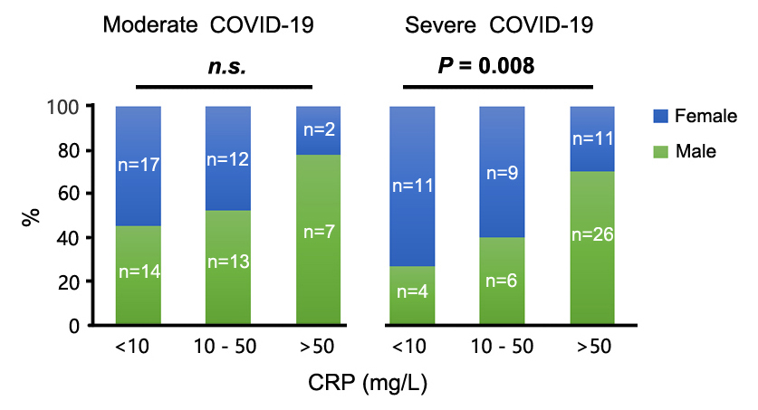
Supplementary Figure 2. Percentages of male and female patients with moderate cases and severe cases of COVID-19 at different concentrations of CRP. CRP was detected in approximately 98.51% (132/134) of patients with COVID-19. A high proportion of males among moderate and severe patients with COVID-19 exhibited high CRP concentrations. With reference to CRP, 10 mg/L is the 99th percentile upper reference limit (99th % URL); 50 mg/L indicates 5× 99th % URL of CRP; COVID-19, Corona virus disease 2019; CRP, C-reactive protein.

Supplementary Table 1. Demographic and clinical characteristics of male and female patients with moderate COVID-19 on admission
Variables | Male patients  (n=36) | Female patients  (n=31) | P value
Age, year (IQR) | 43 (38, 48) | 46 (39, 47) | 0.354
Time from the onset of illness to hospital admission, days (IQR) | 10 (5, 15) | 12 (8, 15) | 0.116
Length of hospital stay, days (IQR) | 15 (13, 20) | 14 (12, 20) | 0.527
Symptom, n (%)
Fever (temperature ≥ 37.3°C) | 32 (88.9) | 26 (83.9) | 0.548
Diarrhea | 6 (16.7) | 5 (16.1) | 0.953
Cough | 29 (80.6) | 23 (74.2) | 0.533
Fatigue | 10 (27.8) | 12 (38.7) | 0.342
Chest distress | 16 (44.4) | 12 (38.7) | 0.635
Treatment, n (%)
Antibiotics | 23 (63.9) | 19 (61.3) | 0.826
Antiviral treatment | 35 (97.2) | 31 (100.0) | 0.350
Corticosteroids | 8 (22.2) | 5 (16.1) | 0.529
IVIG | 8 (22.2) | 5 (16.1) | 0.529
IV | 1 (2.8) | 0 (0.0) | 0.350
Physiological parameter, (IQR)
Heart rate, per min | 84 (80, 97) | 82 (75, 101) | 0.580
Systolic pressure | 122 (117, 132) | 118 (109, 129) | 0.139
Diastolic pressure | 80 (73, 91) | 76 (71, 82) | 0.195
RR, breaths per min | 20 (20, 20) | 20 (19, 21) | 0.935
SpO₂, % | 97 (96, 98), n=35 | 97 (97, 99) | 0.188
Biological parameters, (IQR)
WBC, ×10⁹/L | 5.3 (4.3, 6.2) | 5.4 (3.8, 6.7) | 0.816
Neutrophil, ×10⁹/L | 3.2 (2.3, 4.1) | 3.6 (2.2, 4.3) | 0.637
Lymphocyte, ×10⁹/L | 1.3 (1.1, 1.5) | 1.3 (0.9, 1.6) | 0.758
Hemoglobin, g/L | 139 (132, 146) | 126 (120, 129) | <0.0001
Platelet, ×10⁹/L | 220.5 (168.8, 311.3) | 242.0 (188.0, 341.0) | 0.447
Albumin, g/L | 37.6 (33.5, 39.4) | 38.6 (34.4, 40.4) | 0.206
LDH, U/L | 267.0 (196.0, 318.8) | 235.0 (209.0, 287.0) | 0.414
NaHCO₃, mmol/L | 24.2 (22.8, 25.7) | 23.9 (22.6, 25.3) | 0.450
Urea, mmol/L | 3.5 (3.0, 4.0) | 3.6 (2.9, 4.4) | 0.619
Creatinine, μmol/L | 74.0 (64.0, 80.8) | 57.0 (52.0, 65.0) | <0.0001
Creatine kinase, U/L | 93.5 (52.8, 166.8), n=10 | 56.5 (38.8, 85.3), n=12 | 0.106
CRP, mg/L | 13.0 (3.8, 46.8), n=34 | 6.0 (1.1, 19.1) | 0.031
PCT, ng/mL | 0.06 (0.04, 0.09), n=17 | 0.03 (0.02, 0.04), n=17 | 0.001
SF, μg/L | 1104.3 (744.9, 1932.8), n=6 | 118.7 (90.2, 604.7), n=11 | 0.007
Fibrinogen, g/L | 5.3 (3.8, 6.3), n=31 | 4.0 (3.3, 4.8), n=28 | 0.010
hs-cTnI, pg/mL | 2.9 (1.9, 4.3), n=24 | 1.9 (1.9, 2.1), n=22 | 0.040
IL-2R, U/mL | 778.0 (444.8, 927.8), n=10 | 588.5 (464.5, 681.0), n=14 | 0.230
IL-6, pg/mL | 8.0 (1.5, 37.9), n=10 | 4.9 (1.9, 13.8), n=14 | 0.556
IL-8, pg/mL | 10.8 (7.4, 29.1), n=10 | 10.1 (6.2, 19.8), n=14 | 0.598
IL-10, pg/mL | 5.0 (5.0, 5.0), n=10 | 5.0 (5.0, 5.0), n=14 | 0.684
NT-proBNP, pg/mL | 22.5 (5.0, 62.5), n=22 | 67.5 (35.0, 178.5), n=20 | 0.025
D-Dimer, μg/mL | 0.47 (0.32, 1.37), n=34 | 0.42 (0.26, 0.91), n=30 | 0.346
Data are shown as the median (IQR), n (%), n, where n is the actual number with available data. IQR, Interquartile range; IVIG, Intravenous immunoglobin; IV, Invasive mechanical ventilation; RR, Respiratory rate; SpO₂, Peripheral oxygen saturation; WBC, White blood cell count; LDH, Lactate dehydrogenase; CRP, C-reactive protein; PCT, Procalcitonin; SF, Serum ferritin; hs-cTnI, Hypersensitive cardiac troponin I; NT-proBNP, N terminal pro B type natriuretic peptide.

Supplementary Table 2. Demographic and clinical characteristics of male and female patients with severe COVID-19 on admission
Variables | Male patients  (n=36) | Female patients  (n=31) | P value
Age, year (IQR) | 41 (36, 46) | 44 (37, 48) | 0.203
Time from the onset of illness to hospital admission, days (IQR) | 11 (7, 14) | 10 (7, 13) | 0.549
Length of hospital stay, days (IQR) | 20 (14, 26) | 20 (15, 25) | 0.821
Symptom, n (%)
Fever (temperature ≥ 37.3°C) | 33 (91.7) | 30 (96.8) | 0.379
Diarrhea | 5 (13.9) | 10 (32.3) | 0.072
Cough | 29 (80.6) | 28 (90.3) | 0.263
Fatigue | 9 (25.0) | 9 (29.0) | 0.710
Chest distress | 19 (52.8) | 13 (41.9) | 0.376
Treatment, n (%)
Antibiotics | 32 (88.9) | 23 (74.2) | 0.118
Antiviral treatment | 34 (94.4) | 30 (96.8) | 0.646
Corticosteroids | 22 (61.1) | 11 (35.5) | 0.036
IVIG | 12 (33.3) | 4 (12.9) | 0.051
HFNC | 2 (5.6) | 0 (0.0) | 0.183
NIV | 1 (2.8) | 4 (12.9) | 0.116
IV | 1 (2.8) | 0 (0.0) | 0.350
ECMO | 1 (2.8) | 0 (0.0) | 0.350
Physiological parameter, (IQR)
Heart rate, per min | 100 (88, 107) | 92 (80, 103) | 0.061
Systolic pressure | 126 (119, 135) | 121 (118, 129) | 0.252
Diastolic pressure | 82 (72, 90) | 77 (68, 88) | 0.204
RR, breaths per min | 20 (20, 22) | 21 (20, 23) | 0.368
SpO₂, % | 95 (93, 98), n=33 | 96 (91, 97), n=27 | 1.000
Biological parameters, (IQR)
WBC, ×10⁹/L | 5.6 (4.4, 7.4) | 5.4 (3.9, 7.3) | 0.642
Neutrophil, ×10⁹/L | 4.3 (3.0, 6.4) | 3.9 (2.4, 5.5) | 0.382
Lymphocyte, ×10⁹/L | 0.81 (0.67, 1.12) | 1.10 (0.78, 1.41) | 0.044
Hemoglobin, g/L | 138 (128, 148) | 123 (112, 132) | <0.0001
Platelet, ×10⁹/L | 199.0 (154.5, 265.3) | 263.0 (184.0, 297.0) | 0.159
Albumin, g/L | 35.2 (31.9, 37.6) | 33.0 (30.2, 38.1) | 0.542
LDH, U/L | 377.5 (275.8, 458.3) | 254.0 (227.0, 316.0) | 0.002
NaHCO₃, mmol/L | 23.0 (21.7, 24.8) | 24.6 (23.2, 26.9) | 0.014
Urea, mmol/L | 4.0 (2.7, 5.0) | 3.3 (2.3, 4.6) | 0.247
Creatinine, μmol/L | 76.5 (66.8, 89.0) | 52.0 (46.0, 61.0) | <0.0001
Creatine kinase, U/L | 171.0 (75.0, 430.0), n=11 | 38.0 (35.5, 106.0), n=9 | 0.053
CRP, mg/L | 73.1 (43.7, 132.3) | 24.0 (6.8, 67.4) | 0.002
PCT, ng/mL | 0.13 (0.06, 0.17), n=28 | 0.04 (0.03, 0.06), n=26 | 0.001
SF, μg/L | 957.0 (524.8, 1672.3), n=11 | 299.1 (215.2, 593.1), n=12 | 0.010
Fibrinogen, g/L | 5.8 (5.4, 6.9), n=28 | 5.1 (4.2, 6.0), n=22 | 0.035
hs-cTnI, pg/mL | 4.8 (2.7, 8.4), n=23 | 2.6 (1.9, 4.8), n=25 | 0.046
IL-2R, U/mL | 825.0 (534.3, 1052.8), n=14 | 714.0 (600.0, 1116.5), n=13 | 0.698
IL-6, pg/mL | 20.5 (11.4, 64.0), n=14 | 7.9 (2.3, 38.4), n=13 | 0.159
IL-8, pg/mL | 18.9 (9.7, 20.9), n=14 | 18.5 (9.4, 36.1), n=13 | 0.884
IL-10, pg/mL | 9.0 (5.2, 12.8), n=14 | 5.0 (5.0, 10.5), n=13 | 0.111
NT-proBNP, pg/mL | 114.5 (50.5, 259.5), n=22 | 52.5 (18.3, 349.3), n=22 | 0.260
D-Dimer, μg/mL | 0.68 (0.39, 1.15), n=34 | 0.68 (0.46, 1.21), n=29 | 0.793
Data are shown as the median (IQR), n (%), n, where n is the actual number with available data. IQR, Interquartile range; IVIG, Intravenous immunoglobin; HFNC, High-flow nasal cannula oxygen therapy; NIV, Non-invasive mechanical ventilation; IV, Invasive mechanical ventilation; ECMO, Extracorporeal membrane oxygenation; RR, Respiratory rate; SpO₂, Peripheral oxygen saturation; WBC, White blood cell count; LDH, Lactate dehydrogenase; CRP, C-reactive protein; PCT, Procalcitonin; SF, Serum ferritin; hs-cTnI, Hypersensitive cardiac troponin I; NT-proBNP, N terminal pro B type natriuretic peptide.

Supplementary Table 3. The correlations between variables and severe COVID-19 cases
Variables | Correlation coefficient (r) | P value
Age, year | -0.107 | 0.221
Heart rate, times per min | 0.297 | 0.001
Systolic pressure | 0.120 | 0.166
Diastolic pressure | 0.019 | 0.825
RR, breaths per min | 0.284 | 0.001
SpO₂, % | -0.372 | <0.0001
WBC, ×10⁹/L | 0.119 | 0.171
Neutrophil, ×10⁹/L | 0.256 | 0.003
Lymphocyte, ×10⁹/L | -0.356 | <0.0001
Hemoglobin, g/L | -0.057 | 0.516
Platelet, ×10⁹/L | -0.117 | 0.179
Albumin, g/L | -0.293 | 0.001
LDH, U/L | 0.296 | 0.001
NaHCO₃, mmol/L | -0.085 | 0.328
Urea, mmol/L | 0.029 | 0.740
Creatinine, μmol/L | -0.018 | 0.835
Creatine kinase, U/L | 0.104 | 0.511
CRP, mg/L | 0.423 | <0.0001
PCT, ng/mL | 0.279 | 0.008
SF, μg/L | 0.116 | 0.476
Fibrinogen, g/L | 0.317 | 0.001
hs-cTnI, pg/mL | 0.274 | 0.007
IL-2R, U/mL | 0.232 | 0.101
IL-6, pg/mL | 0.326 | 0.020
IL-8, pg/mL | 0.246 | 0.082
IL-10, pg/mL | 0.474 | <0.0001
NT-proBNP, pg/mL | 0.265 | 0.014
D-Dimer, μg/mL | 0.169 | 0.057
RR, Respiratory rate; SpO₂, Peripheral oxygen saturation; WBC, White blood cell count; LDH, Lactate dehydrogenase; CRP, C-reactive protein; PCT, Procalcitonin; SF, Serum ferritin; hs-cTnI, Hypersensitive cardiac troponin I; NT-proBNP, N terminal pro B type natriuretic peptide.

Supplementary Table 4. ROC curve analyses with AUC values between 0.6 and 0.7
Variable | AUC | 95% CI | Cut-off | Sensitivity (%) | Specificity (%)
HR, times per min | 0.671 | 0.580-0.762 | 89.5 | 64.2 | 62.7
RR, breaths per min | 0.656 | 0.563-0.749 | 20.5 | 48.5 | 77.6
Neutrophil, ×10⁹/L | 0.648 | 0.554-0.741 | 3.89 | 59.7 | 78.7
Albumin, g/L | 0.669 | 0.577-0.762 | 36.7 | 70.1 | 65.7
LDH, U/L | 0.671 | 0.579-0.762 | 290.0 | 56.7 | 73.1
PCT, ng/mL | 0.664 | 0.552-0.777 | 0.11 | 35.2 | 94.1
Fibrinogen, g/L | 0.684 | 0.583-0.785 | 4.97 | 74.0 | 64.4
hs-cTnI, pg/mL | 0.654 | 0.542-0.766 | 2.25 | 70.8 | 60.9
IL-6, pg/mL | 0.688 | 0.543-0.834 | 11.94 | 63.0 | 70.8
NT-proBNP, pg/mL | 0.653 | 0.536-0.769 | 189.5 | 38.6 | 90.5
HR, Heart rate; RR, Respiratory rate; LDH, Lactate dehydrogenase; PCT, Procalcitonin; hs-cTnI, Hypersensitive cardiac troponin I; NT-proBNP, N terminal pro B type natriuretic peptide.

Supplementary Table 5. Single variable conditional logistic regression model for risk factors associated with male and female patients with severe COVID-19 on admission
 | Male |  | Female
Variables | Odds ratio  (95% CI) | P value | Odds ratio  (95%CI) | P value
HR, times per min (>89.5 vs <89.5) | 2.200 (1.061-4.562) | 0.034 | 1.382 (0.681-2.803) | 0.370
RR, breaths per min (>20.5 vs <20.5) | 1.757 (0.904-3.417) | 0.097 | 1.689 (0.825-3.416) | 0.145
SpO₂, % (<95.5 vs >95.5) | 2.488 (1.248-4.962) | 0.010 | 2.239 (1.053-4.764) | 0.036
Neutrophil, ×10⁹/L (>3.89 vs <3.89) | 2.235 (1.118-4.470) | 0.023 | 1.383 (0.684-2.797) | 0.367
Lymphocyte × 10⁹/L (<0.97 vs >0.97) | 4.200 (1.975-8.931) | <0.0001 | 1.313 (0.643-2.680) | 0.454
Albumin, g/L (<36.7 vs >36.7) | 1.923 (0.946-3.908) | 0.071 | 2.444 (1.126-5.309) | 0.024
LDH, U/L (>290.0 vs <290.0) | 2.538 (1.194-5.398) | 0.016 | 1.456 (0.698-3.038) | 0.317
CRP, mg/L (>34.8 vs <34.8) | 2.930 (1.284-6.689) | 0.011 | 2.482 (1.227-5.019) | 0.011
PCT, ng/mL (>0.11 vs <0.11) | 2.115 (0.991-4.515) | 0.053 | 1.708 (0.404-7.228) | 0.467
Fibrinogen, g/L (>4.97 vs <4.97) | 2.634 (0.914-7.592) | 0.073 | 2.804 (1.199-6.560) | 0.017
hs-cTnI, pg/mL (>2.25 vs <2.25) | 2.549 (0.757-8.578) | 0.131 | 2.051 (0.931-4.517) | 0.075
IL-6, pg/mL (>11.94 vs <11.94) | 2.200 (0.614-7.886) | 0.226 | 1.714 (0.576-5.101) | 0.333
IL-10, pg/mL (>5.1 vs <5.1) | 3.667 (1.023-13.143) | 0.046 | 2.036 (0.684-6.057) | 0.201
NT-proBNP, pg/mL (>189.5 vs <189.5) | 2.222 (0.932-5.297) | 0.072 | 1.731 (0.740-4.049) | 0.206
All variables were classified into sub-groups with a cutoff value in the ROC curve analysis. HR, Heart rate; RR, Respiratory rate; SpO₂, Peripheral oxygen saturation; LDH, Lactate dehydrogenase; CRP, C-reactive protein; PCT, Procalcitonin; hs-cTnI, Hypersensitive cardiac troponin I; NT-proBNP, N terminal pro B type natriuretic peptide.

Supplementary Table 6. Multivariable conditional logistic regression model for risk factors associated with male and female patients with severe COVID-19 on admission
 | Male |  | Female
Variables | Odds ratio  (95% CI) | P value | Odds ratio  (95%CI) | P value
Lymphocyte × 10⁹/L (<0.97 vs >0.97) | 4.241 (1.913-9.402) | <0.0001 | - | -
SpO₂, % (<95.5 vs >95.5) | - | - | 1.828 (0.829-4.027) | 0.135
CRP, mg/L (>34.8 vs <34.8) | - | - | 2.113 (0.955-4.676) | 0.065
All variables were classified into sub-groups with a cutoff value in the ROC curve analysis. SpO₂, Peripheral oxygen saturation; CRP, C-reactive protein; A total of 93.54% (58/62) female and 91.67% (66/72) male cases with available data were included in the analysis.

