Supplementary Appendix to Manuscript Entitled
Epidemiological Profile and Transmission Dynamics of COVID-19 in the Philippines

Table of Contents
Table S1. Evolution of case definitions - persons under investigation (PUI), persons under monitoring (PUM), suspect, probable, confirmed cases - of COVID-19 in the Philippines 1
Imputing Dates of Symptom Onset for COVID-19 in the Philippines 1
Table S2. Distribution Parameters of time-to-event distributions 7

Table S1. Evolution of case definitions - persons under investigation (PUI), persons under monitoring (PUM), suspect, probable, confirmed cases - of COVID-19 in the Philippines
 | Symptoms |  |  |  | Epidemiological links |  |  |  | Testing |  | Case definitions version
 | Fever | Cough/cold | Other symptoms |  | Travel history within past 14 days | Exposure history* | Others |  | Result |  | Jan 21 | Jan 30 | Mar 10 | Mar 11 | Mar 16 | Apr 9
1 | None of these |  | Not considered |  | Any part of China | Yes/No |  |  | No result |  | PUM | PUM | PUM | PUM | PUM
2 | None of these |  | Not considered |  | No travel history to China | Yes |  |  | No result |  |  | PUM | PUM | PUM | PUM
3 | None of these |  | Not considered |  | Any country with local transmission and risk of importation† | Yes/No |  |  |  |  |  |  | PUM | PUM | PUM
4 | None of these |  | Not considered |  | None in a country with local transmission and risk of importation† | Yes |  |  | No result |  |  |  | PUM | PUM | PUM
5 | None of these |  | No diarrhea, no shortness of breath or other respiratory symptoms |  | Any country with local transmission and risk of importation† | Yes/No |  |  | No result |  |  |  | PUM‡ | PUM
6 | None of these |  | No diarrhea, no shortness of breath or other respiratory symptoms |  | None in a country with local transmission and risk of importation† | Yes |  |  | No result |  |  |  | PUM‡ | PUM
7 | None of these |  | Not considered |  | Any local area in the Philippines with enhanced community quarantine (ECQ) | Yes/No |  |  | No result |  |  |  |  |  | PUM
8 | None of these |  | Not considered |  | None in any local area in the Philippines with ECQ | Yes |  |  | No result |  |  |  |  |  | PUM
9 | Either of these |  | Not considered |  | Non-Hubei parts of China | No |  |  | No result |  | PUM | PUI | PUI | PUI | PUI | Suspect
10 | Either of these |  | Not considered |  | Non-Hubei parts of China | Yes |  |  | No result |  | PUI | PUI | PUI | PUI | PUI | Suspect
11 | Either of these |  | Not considered |  | Hubei | Yes/No |  |  | No result |  | PUI | PUI | PUI | PUI | PUI | Suspect
12 | Either of these |  | Not considered |  | Any international travel aside from China to countries with confirmed cases | No |  |  | No result |  |  | PUM | PUI | PUI | PUI | Suspect
13 | Either of these |  | OR diarrhea, shortness of breath, or other respiratory symptoms |  | Any country with local transmission and risk of importation† | Yes/No |  |  | No result |  |  |  | PUI‡ | PUI |  | Suspect
14 | Either of these |  | OR diarrhea, shortness of breath, or other respiratory symptoms |  | None in a country with local transmission and risk of importation† | Yes |  |  | No result |  |  |  | PUI‡ | PUI |  | Suspect
15 | Either or these |  | OR diarrhea, shortness of breath, or other respiratory symptoms AND presents as severe acute respiratory infection (SARI) AND requiring hospitalization AND with no other etiology to fully explain clinical presentation |  | None in a country with local transmission and risk of importation† | No | Part of a known cluster of influenza- like illness (ILI) cases in household or workplace |  | No result |  |  |  | PUI‡ | PUI |  | Suspect
16 | Either of these |  | OR shortness of breath, or other respiratory symptoms |  | Any country with local transmission and risk of importation† OR local area in the Philippines with ECQ | Yes/No |  |  | No result |  |  |  |  |  | PUI‡ | Suspect
17 | Either of these |  | OR shortness of breath, or other respiratory symptoms |  | None in a country with local transmission and risk of importation† OR local area in the Philippines with ECQ | Yes |  |  | No result |  |  |  |  |  | PUI‡ | Suspect
18 | Either of these |  | OR shortness of breath, or other respiratory symptoms AND presents as SARI AND requiring hospitalization AND with no other etiology to fully explain clinical presentation |  | None in a country with local transmission and risk of importation† OR local area in the Philippines with ECQ | No | Part of a known cluster of ILI cases in household or workplace |  | No result |  |  |  |  |  | PUI‡ | Suspect
19 | --------------- PUI / PUM / Suspect case referred for reverse-transcription polymerase chain reaction (RT-PCR) laboratory testing but with inconclusive result --------------  ------------------------------------------------ OR positive RT-PCR result but not conducted in Department of Health (DOH)-accredited lab ------------------------------------------------ |  |  |  |  |  |  |  |  |  | --- Retain PUM/PUI classification --- |  |  |  |  | Probable
20 | ----------------------------------------- PUI / PUM / Suspect case referred for RT-PCR laboratory testing in a DOH-accredited lab ---------------------------------------- |  |  |  |  |  |  |  | Positive |  | ----------------------- Confirmed ----------------------
* Prior to Jan 30, history of exposure defined as any of the following: (1) close contact with a confirmed COVID-19 case; (2) health care facility in a country where COVID-19 cases have been reported; visiting/working in a live animal market in Hubei; (4) direct contact with animals in countries with circulating SARS-CoV-2 infection in humans and animals. Jan 30 onwards: history of exposure defined any of the following occurring within the past 14 days: (1) providing direct care for COVID-19 patient without proper personal protective equipment (PPE) - well-fitting N95 mask, eye protection, impermeable gown, and surgical gloves; (2) working together or staying in the same close environment of a COVID-19 patient; (3) traveling together with COVID-19 patient in any kind of conveyance; (4) living in the same household as a COVID-19 patient
† As evaluated by the ASEAN Biodiversity Diaspora Center for travellers arriving at ports of entry; WHO Situation Reports for patients visiting health facilities
‡ Only fever and cough/colds considered for travellers arriving at ports of entry

Imputing Dates of Symptom Onset for COVID-19 in the Philippines

INTRODUCTION
In any infectious disease outbreak, the ideal measurement of the epidemic curve is based on the date of symptom onset. However, there are significant delays between symptom onset and reporting by an official government authority in any health system context. This is driven by multiple factors.
- There is a health-seeking behavior component where there is a lag between symptom onset and health facility visit, which may be long in the Philippine context given physical and financial barriers to health care utilization.
- There is also a testing capacity component where the time between health facility visit and release of laboratory results, which may be high if accredited laboratories are operating at maximum capacity.
- Finally, there is a reporting component, where cases are first processed through the surveillance notification system before they are publicly reported by the Department of Health (DOH).

It is also likely that specimen collection precedes symptom onset for cases asymptomatic at the time of public announcement, and their date of symptom onset is followed-up during a later day. This results in negative values of time between symptom onset and public announcement.

On any given day, there are three types of missing data.
- First, there are cases that have already been reported but have unknown dates of symptom onset. This may be caused by: incomplete entries in the case investigation form (CIF), failure to follow-up patients if they were asymptomatic at the time of CIF interview, or remained asymptomatic all throughout their condition. If all reported confirmed cases so far present with symptoms at some point during their condition, then the epidemic curve will comprise all known cases up until that day.

- The second type of missingness involves cases who have already presented symptoms but are yet to be reported. This missingness is what drives the epidemic curve downward in the days leading up to the present. All known cases will be reported at some future point after the outbreak has ended.

- The third type missingness is arguably the largest, as these comprise cases who will never be reported throughout the course of the outbreak. This is a function of compliance to epidemiologic surveillance and laboratory testing. This is also largely unknowable, given that the only way to completely address this missingness is if 100% of the population are tested.

With the imputation of symptom onset, we aimed to address the first type of missing data.

METHODS
Our methods are based on a similar effort made in the German state of Bavaria for COVID-19 by Günther et al (2020) who using a flexible generalized additive model for location, age, and shape assuming a Weibull distribution for time between symptom onset and reporting date, henceforth referred to as “reporting delay.” This analysis used the official line list of DOH-EB as of April 29, 2020, and all analysis was done on R 4.0, using the gamlss function (R documentation here).

Our imputation model considered: (1) region of residence, with missing values imputed using the region where the disease reporting unit of the case was located; (2) laboratory where the positive result was processed; (3) sex; (4) weekday when the case was reported; and two smoothed favtors: (5) calendar week of reporting and (6) age. The same predictors were added to this model, together with additional additive factors. Other variables were not added due to concerns of data completeness.

The distribution of the reporting delay was checked first to determine the appropriate distribution for the model. Then, outliers were excluded, defined as values beyond the median ± 1.5 * interquartile range (IQR). No stepwise elimination was done during model selection, as all of the variables considered so far are likely to be predictors given the health system context of the Philippines. Diagnostic plots were generated to check for model goodness-of-fit. Then, dates of symptom onset were imputed by deducting the predicted reporting delay from the reporting date. Those with reported symptom onset dates were not imputed.

IMPUTATION RESULTS AND DISCUSSION
As of April 29, 2020, 8,212 cases have been officially reported. Of those, only 5,169 (63.0%) had actual dates of symptom onset. Among these, the median reporting delay was 12 days (IQR: 8 to 16 days. A total of 179 outliers were detected, considered as those with reporting delays less than -4 days and greater than 28 days. Additionally, one case did not have age information. All of them were excluded in the model, resulting in a final sample size of 4,989. Based on the distribution of reporting delay data, the appropriate fit was a Weibull distribution, offset such that the lowest value was 1.

Figure 1 presents the diagnostic plots, suggesting good model fit. Residuals show that the average error in predictions was 0.0095 days with a variance of 0.923 days. All of the predictors had p-values less than 0.05. For the region variable, notable regions included National Capital Region (p = 0.024), and Region IV-A (p = 0.034), and Region III (p = 0.067), all with shorter reporting delays than other regions. With regards to reporting day of the week, Tuesdays had longer reporting delays (p < 0.0005) while Saturdays had the least (p = 0.002). Among confirming laboratories, those with shorter reporting delays included Bicol Regional Diagnostic and Reference Laboratory (p = 0.042), Lung Center of the Philippines (p = 0.015), and Makati Medical Center (p = 0.027). Full model results generated from R are on the last page of this document.

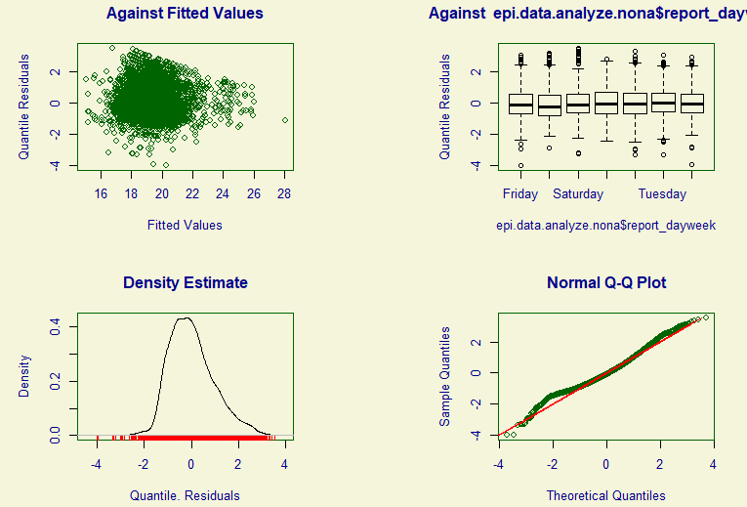
Figure 1. Diagnostic plots of onset imputation model. Top left: Residual plots against fitted values; Top right; box plots against one of the predictors (day of week of reported date); Bottom left: Histogram of residuals; Bottom right: quantile-quantile plots of residuals.

Figure 2 presents the epidemic curves, distinguishing between imputed date of onset of symptoms and observations with complete onset dates. Note that there remained six cases with no imputed values as they had missing ages, therefore the model could not generate predicted values. As expected, the later the date, the higher the proportion of imputed dates of symptom onset that day.

The dispersion of reporting delays is apparent in the imputed epidemic curves. The surge of more than 100 cases daily in Region 7 due to Barangay Luz, Barangay Labangon, and Cebu City Jail was spread out over a six day period, instead of being imputed at the date of sample collection, which was only within a span of two days. Given the wide variations in the incubation period of COVID-19, the imputed dates of symptom onset may provide a more realistic projection of what happened in these hotspots.

The impact of testing capacity is also more apparent with the imputed epidemic curves, especially in NCR and Luzon in general. Before the imposition of strict community-level quarantines, cases seemed to be peaking as testing capacity remained stagnant with the sole lab being the Research Institute for Tropical Medicine (RITM). During the quarantine, cases were rising, but this also corresponded with expansion of testing capacity, with more than a dozen labs serving mainly Luzon being accredited over the past few weeks. It is expected that cases will continue to rise as testing capacity is expanded.
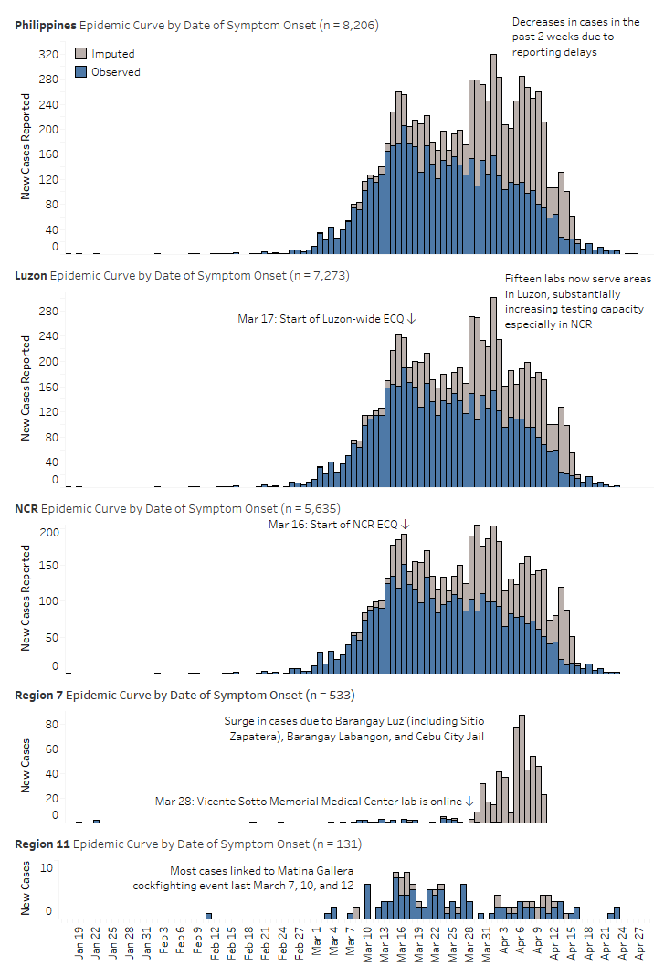
Figure 2. Epidemic curves with imputed dates of symptom onset.

Model results (Copied output from R)

Family: c("WEI", "Weibull")

Call: gamlss(formula = delay_offset ~ report_dayweek + proxyregion + confirminglab + sex + s(age) + s(report_week),
family = WEI, data = epi.data.analyze.nona)

Fitting method: RS()

------------------------------------------------------------------
Mu link function: log
Mu Coefficients:
Estimate Std. Error t value Pr(>|t|)
(Intercept) 2.5295799 0.0819203 30.879 < 2e-16 ***
report_dayweekMonday -0.0081163 0.0161153 -0.504 0.614538
report_dayweekSaturday -0.0512025 0.0164294 -3.117 0.001840 **
report_dayweekSunday 0.0274089 0.0159030 1.724 0.084860 .
report_dayweekThursday -0.0270382 0.0167456 -1.615 0.106451
report_dayweekTuesday 0.0585021 0.0160707 3.640 0.000275 ***
report_dayweekWednesday -0.0269015 0.0172785 -1.557 0.119551
proxyregion10 0.0809897 0.1084135 0.747 0.455072
proxyregion11 -0.0748357 0.0855882 -0.874 0.381960
proxyregion12 0.1608676 0.1101038 1.461 0.144064
proxyregion2 -0.0851062 0.0696338 -1.222 0.221692
proxyregion3 -0.0869080 0.0475593 -1.827 0.067706 .
proxyregion4A -0.0963329 0.0454184 -2.121 0.033970 *
proxyregion4B -0.1240215 0.0869429 -1.426 0.153795
proxyregion5 0.0766944 0.0889051 0.863 0.388369
proxyregion6 -0.0065672 0.0769935 -0.085 0.932030
proxyregion7 0.0149999 0.1229808 0.122 0.902928
proxyregion8 0.0431203 0.1440274 0.299 0.764655
proxyregion9 -0.0646531 0.0960828 -0.673 0.501049
proxyregionBARMM 0.0399264 0.1404366 0.284 0.776191
proxyregionCAR 0.0214819 0.0712238 0.302 0.762961
proxyregionCARAGA -0.1138840 0.2217890 -0.513 0.607639
proxyregionNCR -0.1003647 0.0444015 -2.260 0.023840 *
proxyregionUnknown 0.0780436 0.0730361 1.069 0.285319
confirminglabBicol Regional Diagnostic and Reference Laboratory -0.2890573 0.1423670 -2.030 0.042373 *
confirminglabChinese General Hospital -0.0181168 0.0896579 -0.202 0.839874
confirminglabDetoxicare Molecular Diagnostics Laboratory -0.0807895 0.2956674 -0.273 0.784677
confirminglabLung Center of the Philippines 0.2540701 0.1039375 2.444 0.014542 *
confirminglabMakati Medical Center -0.2097126 0.0950558 -2.206 0.027415 *
confirminglabPhilippines Red Cross -0.0669893 0.1067720 -0.627 0.530423
confirminglabResearch Institute for Tropical Medicine 0.0601249 0.0615739 0.976 0.328880
confirminglabSan Lazaro Hospital 0.0768502 0.0880325 0.873 0.382719
confirminglabSouthern Philippines Medical Center 0.0150643 0.0961766 0.157 0.875542
confirminglabSt. Luke's Medical Center - BGC -0.0412830 0.0842790 -0.490 0.624271
confirminglabSt. Luke's Medical Center - Quezon City 0.3575919 0.2136355 1.674 0.094225 .
confirminglabThe Medical City - Ortigas -0.0904606 0.1334410 -0.678 0.497862
confirminglabUP National Institutes Of Health 0.1129850 0.0753574 1.499 0.133854
confirminglabVicente Sotto Memorial Medical Center 0.0405870 0.1353390 0.300 0.764273
confirminglabWestern Visayas Medical Center 0.1006150 0.1043148 0.965 0.334826
sexMale 0.0206459 0.0083533 2.472 0.013485 *
s(age) 0.0015234 0.0002383 6.393 1.78e-10 ***
s(report_week) 0.0269289 0.0032069 8.397 < 2e-16 ***
---
Signif. codes: 0 ‘***’ 0.001 ‘**’ 0.01 ‘*’ 0.05 ‘.’ 0.1 ‘ ’ 1

------------------------------------------------------------------
Sigma link function: log
Sigma Coefficients:
Estimate Std. Error t value Pr(>|t|)
(Intercept) 1.24234 0.01059 117.3 <2e-16 ***
---
Signif. codes: 0 ‘***’ 0.001 ‘**’ 0.01 ‘*’ 0.05 ‘.’ 0.1 ‘ ’ 1

------------------------------------------------------------------
No. of observations in the fit: 4989
Degrees of Freedom for the fit: 43
Residual Deg. of Freedom: 4946
at cycle: 5

Global Deviance: 30912.2
AIC: 30998.2
SBC: 31278.35
******************************************************************

References
Günther F, Bender A, Katz K, Küchenhoff H, Höhle M. Nowcasting the COVID-19 Pandemic in Bavaria [Internet]. Munich, Germany: Statistical Consulting Unit StaBLab; 2020. Available from: https://www.stablab.stat.uni-muenchen.de/_assets/docs/nowcasting_covid19_bavaria.pdf

Table S2. Distribution Parameters of time-to-event distributions
Time to event (fitted distribution) | n | Parameter | Estimate | Standard Error
Serial interval (Weibull) | 55 | shape | 1.106 | 0.126
 |  | scale | 7.293 | 0.925
Health-seeking behavioral delay or time between illness onset and first medical consultation (gamma) | 5,611 | shape | 0.805 | 0.013
 |  | scale | 0.119 | 0.003
Diagnostic delay or time between specimen collection to laboratory confirmation (lognormal) | 4,055 | meanlog | 1.593 | 0.010
 |  | sdlog | 0.656 | 0.007
Length of stay for recoveries (Weibull) | 1,241 | shape | 1.572 | 0.036
 |  | scale | 17.819 | 0.335
Length of stay for deaths (gamma) | 421 | shape | 0.966 | 0.058
 |  | scale | 0.133 | 0.010
Duration of illness for recoveries (Weibull) | 1,319 | shape | 2.629 | 0.056
 |  | scale | 29.988 | 0.330
Duration of illness for deaths (gamma) | 606 | shape | 2.086 | 0.112
 |  | scale | 0.165 | 0.010
Reporting delay or time between laboratory confirmation and public announcement (gamma) | 6,833 | shape | 1.257 | 0.019
 |  | scale | 0.508 | 0.010

