Supplementary Table 1: Reference range of laboratory indicators
Indicator | Unit | Reference range
C-reactive protein | mg/L | <5.00
White blood cell count | ×10⁹/L | 4.00~10.00
Neutrophil count | ×10⁹/L | 1.80~6.30
Lymphocyte count | ×10⁹/L | 1.10~3.20
Haemoglobin | g/L | 130.00~175.00
Platelet count | ×10⁹/L | 125~350
ALT | u/L | 9.0~50.0
AST | u/L | 15.0~40.0
Total bilirubin | umol/L | 3.40~20.50
Direct bilirubin | umol/L | 0~8.60
Albumin | g/L | 40.00~55.00
Blood urea nitrogen | mmol/L | 3.60~9.50
Creatinine | umol/L | 57.00~111.00
Sodium | mmol/L | 137.00~147.00
Potassium | mmol/L | 3.50~5.30
Calcium | mmol/L | 2.10~2.55
LDH | u/L | 109.00~245.00
Creatine Kinase | u/L | 30.00~200.00
CK-MB | u/L | <24
Myohemoglobin | ng/ml | <48.80
cTnI | ng/ml | <0.04
PCT | ug/L | <0.05
ESR | mm/h | <15
BNP | pg/ml | <250
Fibrinogen | g/L | 2.00~4.00
D-dimer | ug/L | <0.50

Supplementary Table 2: Cox regression analysis of factors associated with overall survival of COVID-19 patients
Variable | Level | Unadjusted HR | 95%CI | P value
Age (years) | <40 | Ref
 | 40-69 | 3.361 | 1.193-9.468 | 0.0218
 | ≥70 | 9.823 | 3.402-28.365 | <0.0001
Hypertension | Yes | 3.161 | 1.998-4.999 | <0.0001
 | No | Ref
ALT - u/L | >40 | 1.657 | 1.051-2.614 | 0.0298
 | ≤40 | Ref
Troponin I- ng/ml | ≤0.04 | Ref
 | >0.04 | 2.513 | 1.397-4.518 | 0.0021
Myohemoglobin - ng/ml | ≤48.8 | Ref
 | >48.8 | 2.671 | 1.638-4.355 | <0.0001

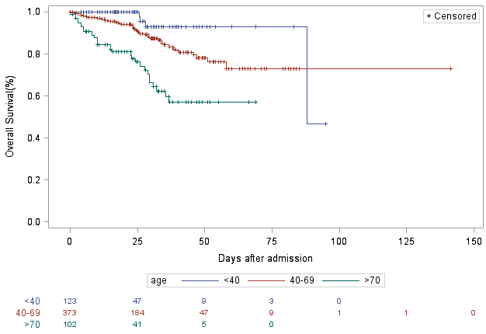

Supplementary Figure 1: Kaplan-Meier estimate of overall survival of COVID-19 patients according to age group

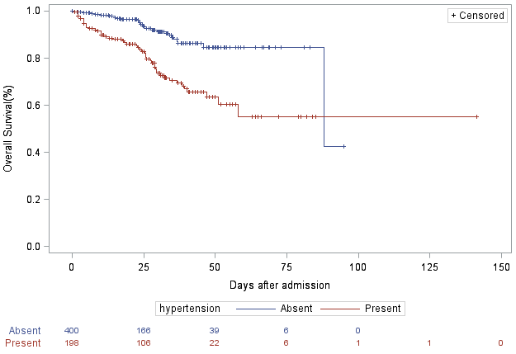
Supplementary Figure 2: Kaplan-Meier estimate of overall survival of COVID-19 patients according to comorbidity of hypertension

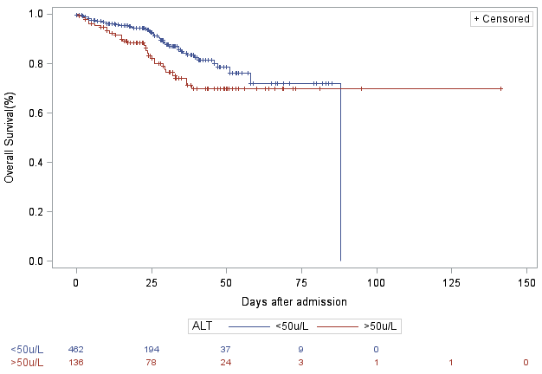
Supplementary Figure 3: Kaplan-Meier estimate of overall survival of COVID-19 patients according to level of ALT

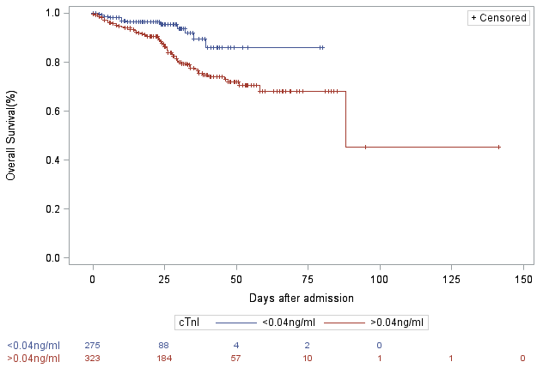

Supplementary Figure 4: Kaplan-Meier estimate of overall survival of COVID-19 patients according to level of cTnI

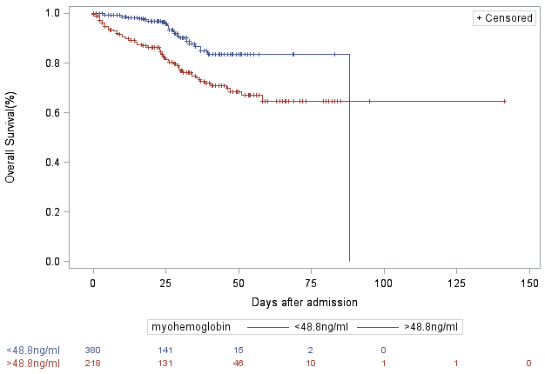

Supplementary Figure 5: Kaplan-Meier estimate of overall survival of COVID-19 patients according to level of myohemoglobin

