Epidemiology and Infection
Epidemiological and genetic characteristics of influenza virus and the effects of air pollution on laboratory-confirmed influenza cases in Hulunbuir, China, from 2010 to 2019
B. Lu, Y. C. Wang, Z. S. Zhu, Z. Zhang, T. Dong, F. L. Li, Y. Gao, Z.Y. Qu, X. Q. Du
Supplementary Material
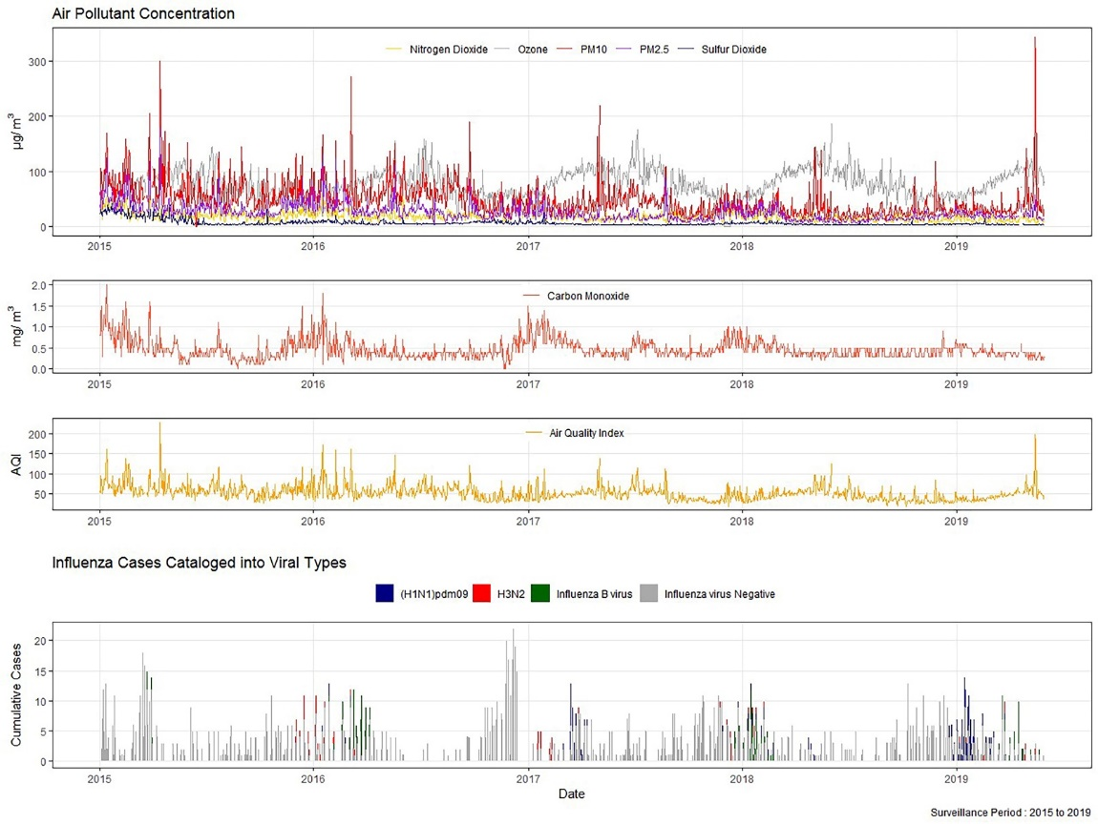
Fig.S1. Air pollutant concentrations and number of influenza cases in Hulunbuir, during January 2015-May 2019.
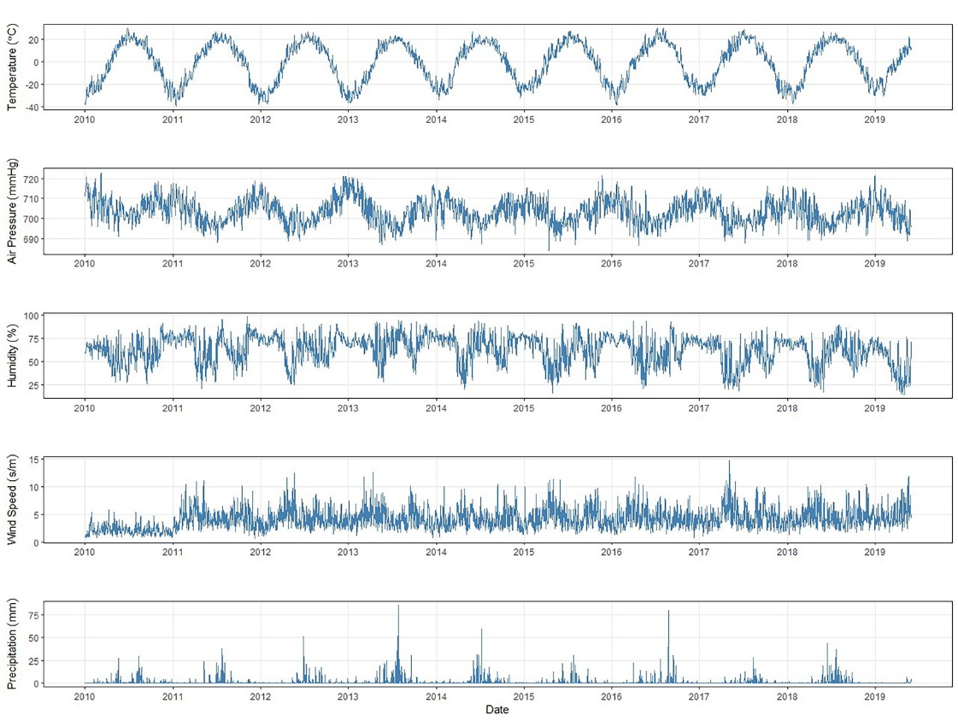
Fig.S2. Meteorological measurements in Hulunbuir, during January 2010-May 2019.

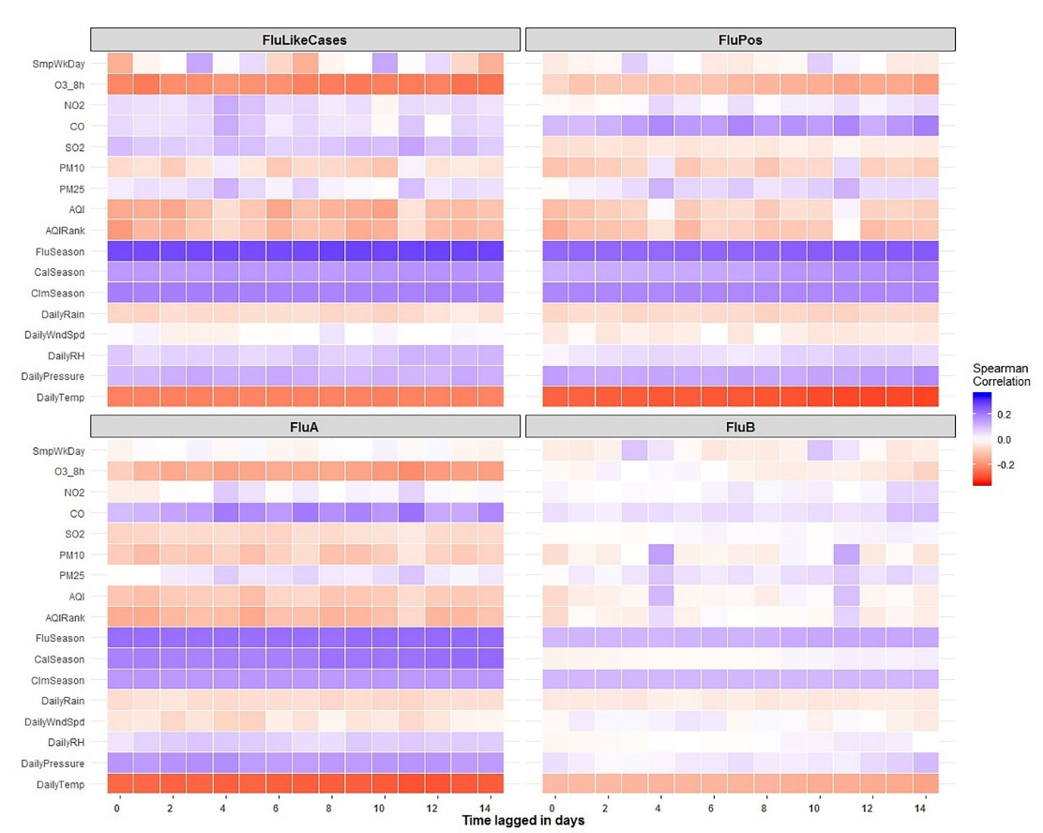
Fig.S3. Association of influenza-positivity rate and environmental factors in Hulunbuir with time lagged in days.
Notes : FluLikeCase(Influenza like cases in total), FluPos (Influenza positive cases), FluA (Influenza A virus cases), FluB (Influenza B virus cases); SmpWkDay (Weekday), O₃_8h(Ozone), NO₂ (Nitrogen dioxide), CO (Carbon monoxide), SO₂ (Sulfur dioxide), PM₁₀ (particulate matter 10 micrometers or less in diameter), PM_{2.5} (particulate matter 2.5 micrometers or less in diameter), AQI (Air quality index), AQIRank (Air quality index levels of health concern), FluSeason (Influenza seasons), CalSeason (Calendar seasons), ClmSeason(Climate Seasons), DailyRain (Daily precipitation), DailyWndSpd (Daily Wind Speed), DailyRH (Daily relative humidity), DailyPressure(Daily air pressure), DailyTemp (Daily air temperature).

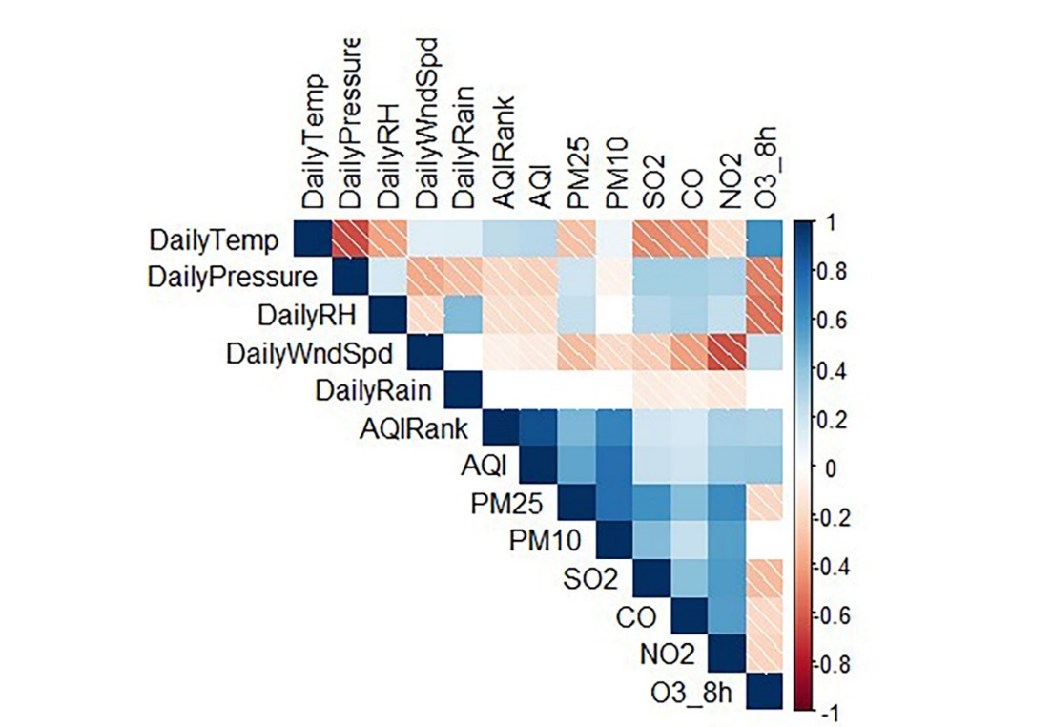
Fig.S4. Correlation Matrix of ambient factors in Hulunbuir
Notes: DailyTemp (Daily air temperature), DailyPressure(Daily air pressure), DailyRH (Daily relative humidity), DailyWndSpd (Daily Wind Speed), DailyRain (Daily precipitation), AQIRank (Air quality index levels of health concern), AQI (Air quality index), PM_{2.5} (particulate matter 2.5 micrometers or less in diameter), PM₁₀ (particulate matter 10 micrometers or less in diameter), SO₂ (Sulfur dioxide), CO (Carbon monoxide), NO₂ (Nitrogen dioxide), O₃_8h(Ozone).

Fig.S5. Residual autocorrelation (ACF) and partial autocorrelation (PACF) of environmental factors in Hulunbuir.
Notes: DailyTemp (Daily air temperature), DailyPressure(Daily air pressure), DailyRH (Daily relative humidity), DailyWndSpd (Daily Wind Speed), DailyRain (Daily precipitation), AQIRank (Air quality index levels of health concern), AQI (Air quality index), PM_{2.5} (particulate matter 2.5 micrometers or less in diameter), PM₁₀ (particulate matter 10 micrometers or less in diameter), SO₂ (Sulfur dioxide), CO (Carbon monoxide), NO₂ (Nitrogen dioxide), O₃_8h(Ozone).

Table.S1. The summary of model fit measurement from GAM
Lagged | Influenza like cases |  |  | Influenza positive cases |  |  | Influenza A virus |  |  | Influenza B virus
Days | R2adj | VarExp |  | R2adj | VarExp |  | R2adj | VarExp |  | R2adj | VarExp
0 | 0.184 | 0.239 |  | 0.026 | 0.058 |  | 0.099 | 0.151 |  | 0.078 | 0.121
1 | 0.124 | 0.181 |  | 0.005 | 0.015 |  | 0.126 | 0.184 |  | 0.025 | 0.072
2 | 0.146 | 0.205 |  | 0.014 | 0.042 |  | 0.136 | 0.205 |  | 0.091 | 0.153
3 | 0.074 | 0.099 |  | 0.041 | 0.062 |  | 0.142 | 0.201 |  | 0.096 | 0.151
4 | 0.181 | 0.258 |  | 0.083 | 0.071 |  | 0.112 | 0.181 |  | 0.325 | 0.332
5 | 0.112 | 0.173 |  | 0.082 | 0.079 |  | 0.114 | 0.177 |  | 0.177 | 0.169
6 | 0.119 | 0.165 |  | 0.012 | 0.022 |  | 0.113 | 0.172 |  | 0.101 | 0.167
7 | 0.103 | 0.141 |  | 0.005 | 0.012 |  | 0.045 | 0.086 |  | 0.004 | 0.002
8 | 0.130 | 0.186 |  | 0.006 | 0.014 |  | 0.077 | 0.119 |  | 0.029 | 0.053
9 | 0.145 | 0.203 |  | 0.004 | 0.012 |  | 0.056 | 0.122 |  | 0.096 | 0.184
10 | 0.102 | 0.120 |  | 0.033 | 0.054 |  | 0.058 | 0.122 |  | 0.062 | 0.108
11 | 0.165 | 0.236 |  | 0.102 | 0.103 |  | 0.051 | 0.086 |  | 0.347 | 0.333
12 | 0.152 | 0.212 |  | 0.152 | 0.152 |  | 0.086 | 0.114 |  | 0.124 | 0.099
13 | 0.103 | 0.143 |  | 0.002 | 0.005 |  | 0.111 | 0.182 |  | 0.004 | 0.003
14 | 0.110 | 0.151 |  | 0.001 | 0.006 |  | 0.094 | 0.123 |  | 0.031 | 0.053
Notes: R2adj represents the adjusted R square; VarExp represents the portion of variations of dependent variable explained by the model.

