Figure 5: Population of Italian regions in all the age groups considered for the analysis (<1, 1-4, 5-9. 10-14, 15-24, 25-64 and >64 years)

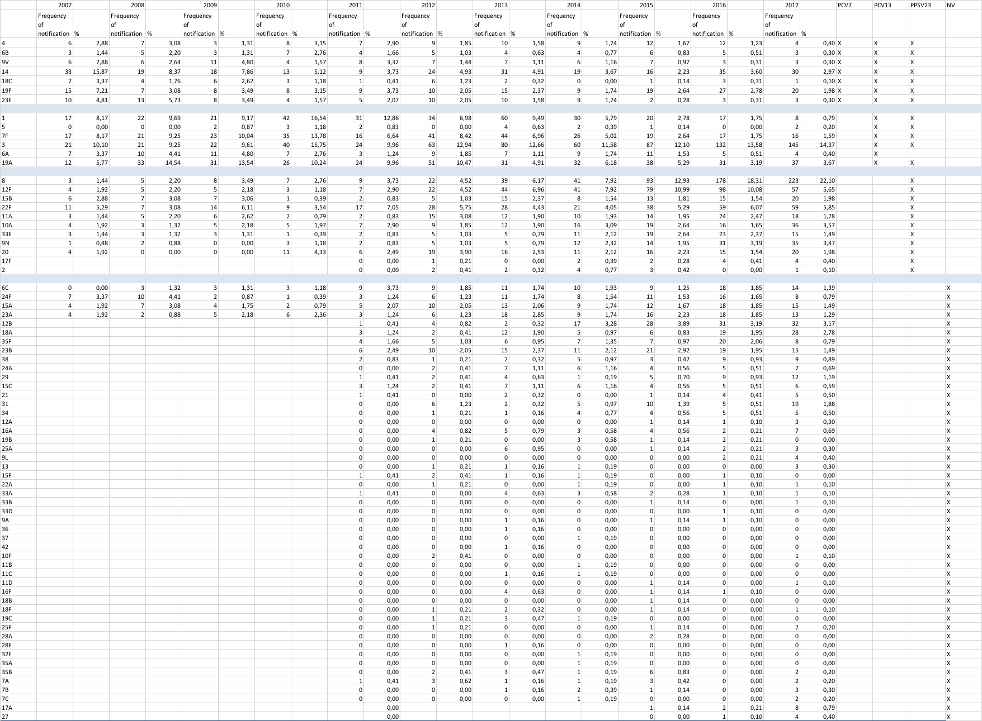

Table 2: Frequency of notification and % of total cases notified/year per single serotype in general population, Italy, 2007-2017

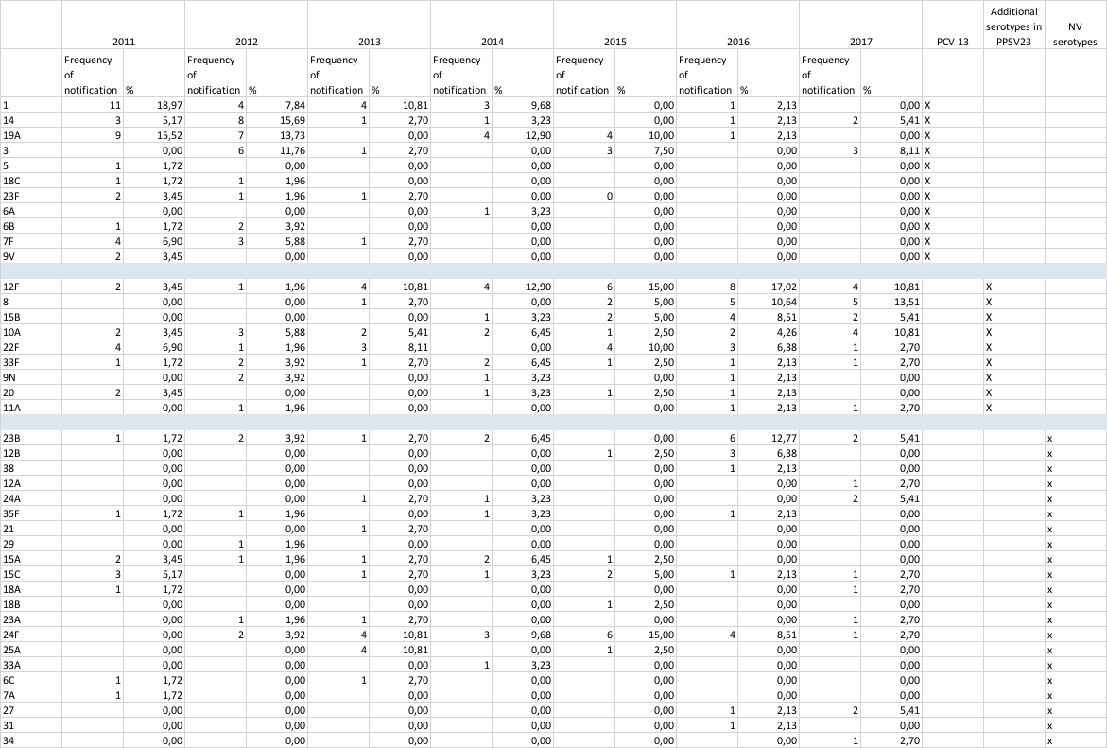

Table 3: Frequency of notification and % of total cases notified/year per single serotype in infants and children aged 4 years or less, Italy, 2011-2017

Figure 6: Frequency of identification of pneumococcal serotypes by vaccine formulation in infants and children aged 4 years or less, Italy, 2011-2017.

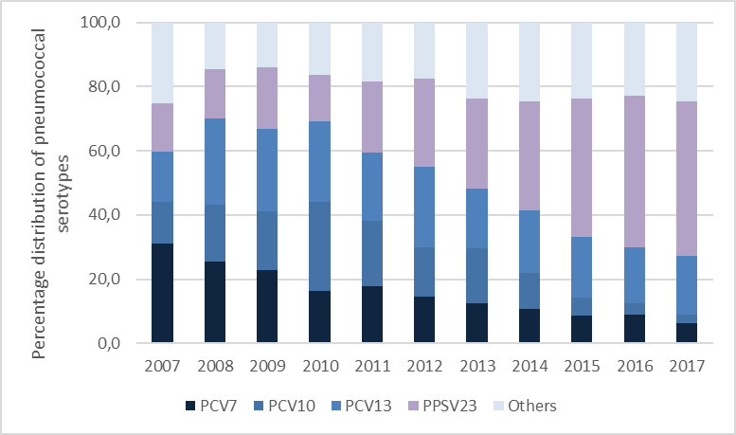

Figure 7: Distribution of pneumococcal serotypes by vaccine formulation, Italy, 2007-2017

