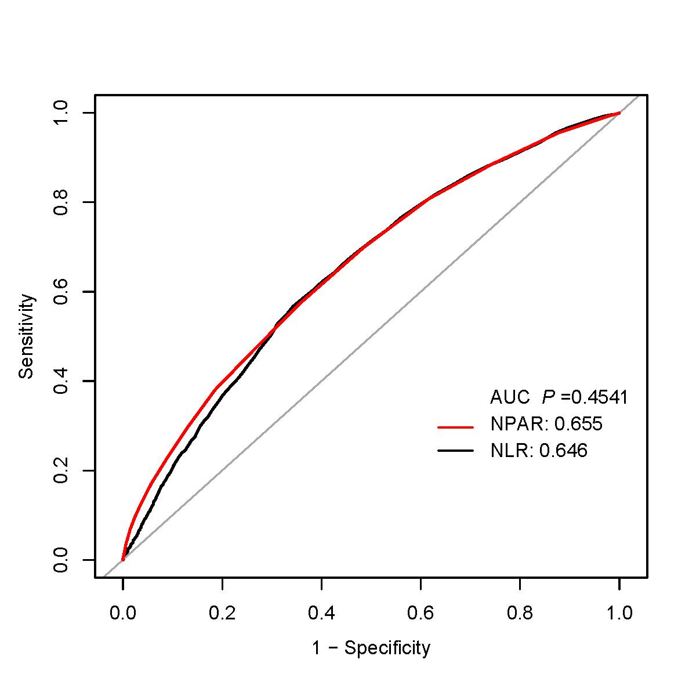
Fig. 1 ROC curves for the prediction of mortality in critically ill patients with severe sepsis or septic shock, the ability of NPAR and NLR to predict 365-day mortality. The AUCs for NPAR and NLR were 0.655 and 0.646, respectively.
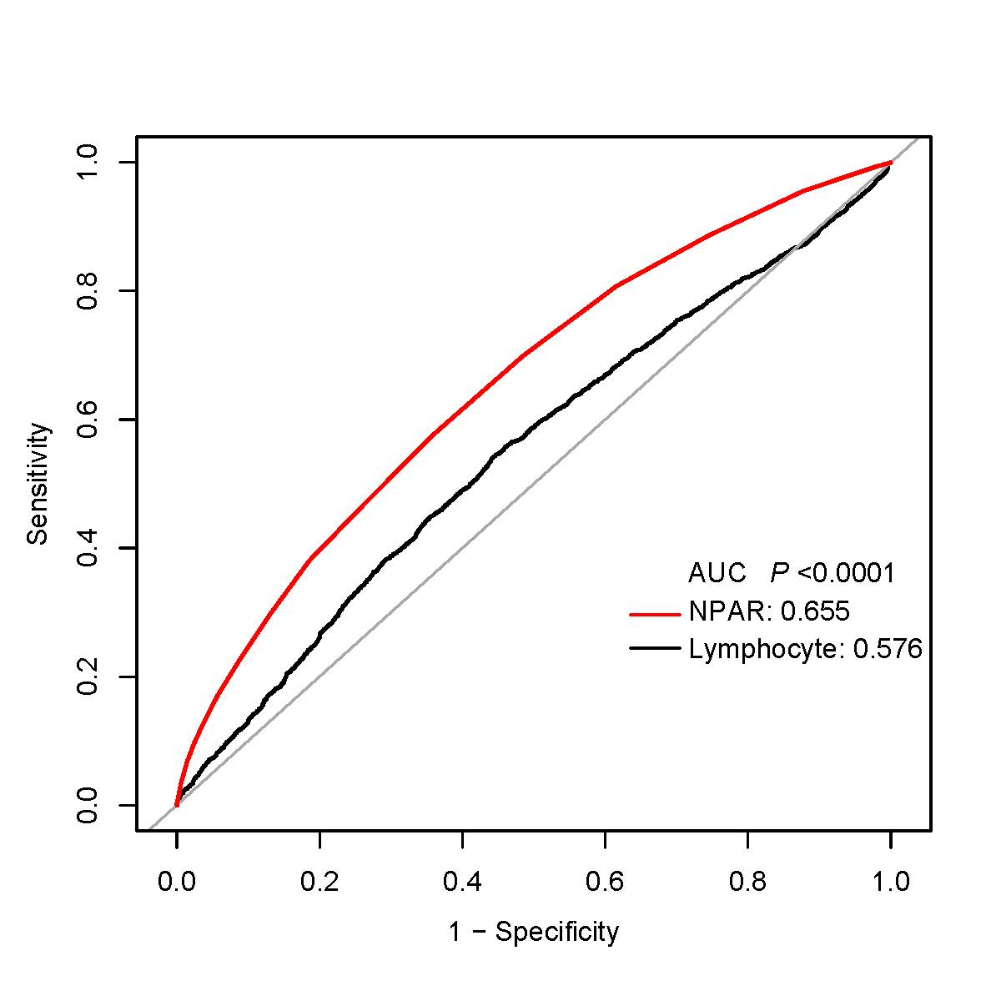
Fig. 2 ROC curves for the prediction of mortality in critically ill patients with severe sepsis or septic shock, the ability of NPAR and lymphocyte to predict 365-day mortality. The AUCs for NPAR and lymphocyte were 0.655 and 0.576, respectively.

