Supplementary materials
Supplement 1 Definitions of Exposure, Contact and Immunity
Significant exposure was defined as:
- Contacts in the same room (e.g. in a house or a 2-4 bed dormitory) for a significant period of time (15 minutes or more).
- Face to face contact, for example while having a conversation.
- Immunosuppressed contacts on large open wards, where air-borne transmission at a distance has occasionally been reported.
High risk contacts (in this adult male only setting) were defined as immunocompromised people. Pregnant women among IRC staff were also considered high risk contacts.
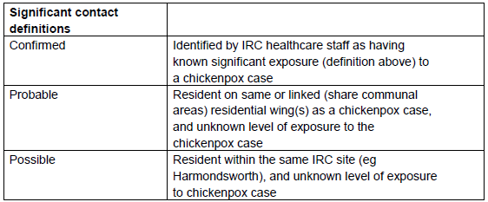

Definition of non-immune people was based on interpretation of VZV IgG level from serology (blood test):
- Immunocompromised patient:
- <165 mIU/mL – No evidence of VZV immunity
- ≥165 mIU/mL – Evidence of VZV immunity
- Immunocompetent / pregnant patient:
- <100 mIU/mL – No evidence of VZV immunity
- ≥100 mIU/mL – Evidence of VZV immunity
Non-immune people were categorised as follows, for the purposes of isolation/cohorting arrangements:
- Non-immune new arrival: New arrivals, non-immune; No exposure
- Non-immune confirmed contact: Contacts of chickenpox cases identified as having significant exposure and non-immune; Significant exposure and at high risk of developing disease
- Non-immune probable contact: Detainees resident on same or linked residential wing(s) as chickenpox cases and non-immune; Possibility of significant exposure, but less certainty than confirmed contacts
- Non-immune possible contact: Detainees resident within same IRC site as chickenpox cases and non-immune: Possibility of significant exposure, but less certainty than confirmed or probable contacts

Supplement 2: Mathematical modelling analysis

To test how different control measures affect the development of the outbreak and further to provide critical information to guide the management and control of the infection, a SEIR transmission dynamics model was proposed. The model considers the following control measures having been applied from 9th January 2018 when Case 2 was notified and OCT was convened (see Figure 1 in main text):
1. No new admissions to Centre B
2. No movement between Centre B and Centre A
3. Isolation of cases
4. Significant contacts identified and tested for immunity, at present cohorted but ultimately quarantined for 21 days from exposure.
5. Mass testing of all detainees in residential units in Centre B where Case 3 &
Case 4 were accommodated, to identify further non-immune potential contacts. Those immune will be moved offsite to allow additional capacity to quarantine non-immune contacts.
6. No transferring to other IRCs of non-immune contacts.

Because mass testing to identify non-immune detainees has been very resource intensive and operationally challenging to sustain, mathematical modelling was used to analyse the necessity and effectiveness of full testing. Three conditions were considered.

Condition 1 (no testing): No immunity testing of wider detainee population, and no quarantining and cohorting for non-immune detainees amongst the wider IRC population
Condition 2 (full testing): Full immunity testing of detainees in Centre B with quarantining or cohorting of non-immune detainees for 21 days (the length of incubation period).
Condition 3 (partial testing): Interruption of mass immunity testing of detainees in Centre B from 29th January 2018. Up to this date, 300 detainees in Centre B (out of 706) were tested for immunity, with quarantining and cohorting for all non-immune detainees.

A patch SEIR model was developed to represent the flow of detainees within and between the two detention centres, as outlined in Figure S1 below. Because the cases were only among detainees during the outbreak we model the transmission process that involved with only detainees. In the SEIR compartmental model, each case was assumed to pass through four stages: Susceptible, Exposure (infected but not yet infectious), Infectious and Recovered. The transmission dynamics can be approximated by the following differential equations
Centre A:

$\frac{d}{dt}S_{A}=-\frac{βI_{A}}{N_{A}}S_{A}+α_{A}ρN_{A}-\left(α_{A}+m\right)S_{A}+mS_{B}$
$\frac{d}{dt}E_{A}=\frac{βI_{A}}{N_{A}}S_{A}-\left({σ+α}_{A}+m\right)E_{A}+mE_{B}$ (1a)
$\frac{d}{dt}I_{A}=σE_{A}-\left({γ+α}_{A}+m\right)I_{A}+mI_{B}$
Centre B:
$\frac{d}{dt}S_{B}=-\frac{βI_{B}}{N_{B}}S_{B}+α_{B}ρN_{B}-\left(α_{B}+m\right)S_{B}+mS_{A}$
$\frac{d}{dt}E_{B}=\frac{βI_{B}}{N_{B}}S_{B}-\left({σ+α}_{B}+m\right)E_{B}+mE_{A}$ (1b)
$\frac{d}{dt}I_{B}=σE_{B}-\left({γ+α}_{B}+m\right)I_{B}+mI_{A}$

Here S_{k}, E_{k} and I_{k} represent the numbers of susceptible, exposed and infectious individuals on site k ={A(Centre A), B(Centre B)}. N_{k} represent the capacity of site k, α_{k} the daily replacement rate on site k and m the daily movement rate between two sites. β is the transmission coefficient of VZV, σ the average rate at which the infected become infectious and γ the recovery rate. ρ denotes the rate of non-immune detainees.

Parameterization:
Following Brisson et al (2000), we assume that the latent period of infection L =14 days. In general situation, the infectious period lasts from 48 hours before the rash appears until all the vesicles have crusted over (approximately 5 days, although this may be prolonged in immunosuppressed individuals). In view of the fact that during the outbreak in the IRC the four cases that have been reported up to 24th January 2018 were isolated 1,1,2,4 days post symptom onset (average =2 days) and the infective are contagious 2 days before the rash appears, we assume an infectious period of D =4 days. In the above equation, $σ=1/L$,$=1/D$. The current control measures are assumed to reduce the contact rates between detainees. Before 9th January 2018, the transmission coefficient is set to β; with control measures taking effect, the transmission coefficient is supposed to reduces to wβ. Here w describes the effects of control measures in reducing the contact rates between detainees (c.f., Zhang et al 2017). We assume that: 0<w<1.

To maintain the constant size of each site, we assume the daily replacement rate as $α_{A}=13/312$ and $α_{B}=13/706$ for Centre A and Centre B respectively. The daily rate of movement between sites is approximated as $m=42/[(312+706)31]$. The rate of non-immune detainees (ρ) is set to 7%, the result from 150 samples from Centre B site up to 24th January 2018. Within each site, the reproductive number, which is usually used to characterise the transmissibility of infectious agent (Anderson and May 1991), is determined by the growth rate ψ_{r},
(2)
For the patch model with movement between sites, the reproductive number R can also be derived by the method of van den Driessche and Watmough (2002) as
$R=\sqrt{\frac{B+\sqrt{B^{2}-4C}}{2}}$ (3)
with
$B=\frac{m}{γ+α_{B}+m}×\frac{m}{γ+α_{A}+m}+\frac{m}{σ+α_{B}+m}×\frac{m}{σ+α_{A}+m}+\frac{σ}{σ+α_{B}+m}×\frac{ρβ}{γ+α_{B}+m}+\frac{σ}{σ+α_{A}+m}×\frac{ρβ}{γ+α_{A}+m}$
$C=\frac{σ}{σ+α_{A}+m}×\frac{ρβ}{γ+α_{A}+m}×\frac{σ}{σ+α_{B}+m}×\frac{ρβ}{γ+α_{B}+m}-\frac{σ}{σ+α_{B}+m}×\frac{ρβ}{γ+α_{A}+m}×\frac{m}{γ+α_{B}+m}×\frac{m}{σ+α_{A}+m}-\frac{σ}{σ+α_{A}+m}×\frac{ρβ}{γ+α_{B}+m}×\frac{m}{γ+α_{A}+m}×\frac{m}{σ+α_{B}+m}+\frac{m}{γ+α_{B}+m}×\frac{m}{γ+α_{A}+m}×\frac{m}{σ+α_{B}+m}×\frac{m}{σ+α_{A}+m}$
It is worth pointing out that the values of these parameters used in actual mathematical modelling assessments were obtained up to 24th January 2018; hence they slightly differed from the values obtained when the outbreak was declared over. However, these slight differences do not noticeably affect our conclusion from mathematical modelling. Therefore we reported the actual results.

Initial seeding: We set 22nd December 2017 (date of rash onset of Case 1) as the first day of the transmission dynamics and the initial condition is set as follows. At the early stage the number of infected people was assumed to increase exponentially: infection starts from Centre A and the process has no chance and time to move the virus into Centre B. Hence we have
$$I_{A}\left(t=Δt\right)=I_{A}\left(t=0\right)+[σ{E_{A}\left(t=0\right)-\left(γ+α_{A}\right)I}_{A}\left(t=0\right)]{Δt≈I}_{A}\left(t=0\right)exp⁡(Ψ_{r}Δt)$$

Given the value of reproductive number (R) from equation (3), the growth rate in equation (2) can be expressed as
$$ψ_{r}=\frac{\sqrt{{(L+D)}^{2}+4\left(R-1\right)LD}-(L+D)}{2LD}$$

From these we obtain the initial condition
$I_{A}\left(t=0\right)=1$ $I_{B}\left(t=0\right)=0$
$E_{A}(t=0)≈\frac{\left(γ+α_{A}\right)∆t+\exp\left(Ψ_{r∆t}\right)-1}{σ∆t}I_{A}(t=0)$ $E_{B}\left(t=0\right)=0$ (4)
$S_{A}\left(t=0\right)=ρN_{A}-I_{A}\left(t=0\right)-E_{A}\left(t=0\right)$ $S_{B}\left(t=0\right)=ρN_{B}-I_{B}\left(t=0\right)-E_{B}\left(t=0\right)$

Control measures: Since 9th January 2018 (day 19 from the symptom onset of case 1), no new admissions to Centre B and no movement between two sites so that α_{H} =0, m =0 when t ≥19. In Condition 1 (no testing), the transmission process continues from the initial condition given in equation (4). Condition 2 that from 19/01/2018 (day 29) testing all detainees in Centre B and isolating the non-immune detainees for 21 days imposes
S_{B}(t) =S_{B}(t-1)*(1-daily_test_rate), E_{B}(t) =E_{B}(t-1)*(1-daily_test_rate), t≥29. (5)

Here daily_test_rate represents the immunity test rate per detainee per day and is assumed to remain unchanged and approximated as 300/(706×10) over ten days from 19 to 28 January 2018 (see below). After the incubation period of 21 days, these quarantined will be released but we assume they will not further be involved within the transmission process due to cohorting arrangements.

In Condition 3: Immunity testing was stopped on 29th January 2018 (day 39) up to which 300 detainees in Centre B (out of 706) have been tested and all the non-immune detainees (7% of 300) have been isolated. Therefore Condition 3 imposes the following,
S_{B}(t) =S_{B}(t-1)×(1-daily_test_rate), E_{B}(t) =E_{B}(t-1)*(1-daily_test_rate), 39>t≥29. (6)

Inference: To reflect the variation in the daily number of cases, the negative binomial likelihood function will be used. The number x(t) of cases on day t is distributed as
where
Here is the dispersion parameter and are the predictions of the cases on day t from the transmission dynamics model. Assuming that the observed incidence x(1),x(2),…,x(T) are conditionally independent, the total likelihood given parameters β and w is
We used the observed data up to 24th January 2018 (day 34 since 22nd December 2017) for parameter estimation. As the outbreak had been thoroughly investigated, the chance that a case was missed was extremely low. In the modelling, we assumed the actual observed size of the outbreak up to 24th January 2018 was four cases.

We propose the Bayesian inference for the model calibration and use Markov Chain Monte-Carlo (MCMC) (Zhang et al 2017) to sample posterior distributions of model parameters and to project the possible development of the outbreak into 4 weeks ahead under different control measure conditions. 5000 MCMC samples were generated to assess the probabilities of various extreme situations.

Results
The reproductive number (R) is estimated to have a median 4.76 with 95% confident interval ranging from 2.80 to 6.98, which is in agreement with the previous survey (Nardone et al 2007). The dispersion parameter of the negative binomial likelihood function is estimated as η =100 [25,238], indicating a huge dispersion in the number of infections.

Model fitting and projections into future 4 weeks under three control conditions are shown in Figures S2-S4 below. Under condition 1 (no testing & no quarantine): transmission of chickenpox on Centre A should have died out by 24th January 2018 by the chance of 95%; but it has a small probability of 2.5% that there will be additional 3 cases within 4 weeks. Transmission in Centre B should also have died out by 24th January by the chance of 95% and will die out by day 47 (6 February 2018) by the chance of 97.5%. There is a small probability of 2.5% that there will be 18 additional cases up to 4 weeks late.

Under Condition 2, full testing and quarantining of the non-immune in Centre B was performed. Compared with condition 1, the full testing and quarantining can reduce the number of additional cases and stop transmission early. By the chance of 95%, transmission on both sites has died out by 24th January 2018. However, it may remain in Centre A in a very small probability: up to 4 weeks late since 24th January 2018, there is a 2.5% probability that there are sporadic cases which will accumulate additional two new cases. The reason for this should be: with control measures taken effect from 09/01/2018, Centre A is still open to accept new admissions and detainees can leave the site. As there is a two day gap between infectiousness and symptom onset, a detainee who becomes infectious but not yet symptomatic may stay on the site for one or two days after getting infected and therefore transmits the virus to others. Without testing in Centre A, these detainees will not be detected and can silently pass the virus on. Transmission in Centre B will die out by day 36 (26 January 2018) by the chance of 97.5% and there is a probability of 2.5% for two new cases. We can see a large effect in Centre B.

Under condition 3 (partial testing and quarantining), the number of additional cases in Centre B can also be significantly reduced comparing to condition 1. Nevertheless, there is a probability of 2.5% that there will be three additional cases in Centre B within the 4 weeks late. Comparing to full testing (condition 2), partial testing (condition 3) will only allow one more additional case. However, the effect on Centre A is small, which is understandable.

Limitations of the model: For mathematical simplicity, a deterministic model was assumed. In view of the small size of the detainee population (312+734=1045), however, a stochastic model may appear more appropriate. In the modelling, we assume the mass action principle for detainee mixing patterns in each centre which may deviate from the actual mixing patterns. If time allowed, some sensitivity analysis should be done to explore how robust the modelling prediction is relative to different model parametrization.
Figure S1 The patch model illustrating flow of detainees within two detention centres 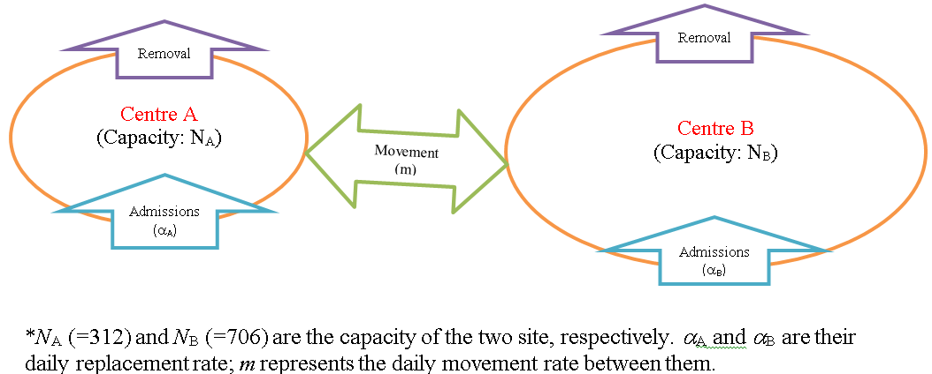

Figure S2: Time series* of chickenpox outbreak under condition 1 (no immunity testing)
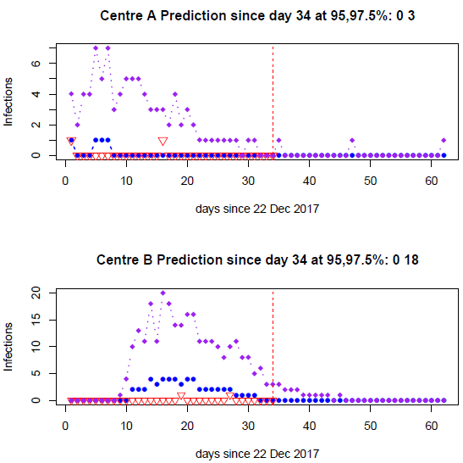
* Red triangles represent observed data up to 24 January 2018 (day 34). Red dashed vertical lines show the date to which data are available. The 50% and 90% levels of model prediction are identical with the horizon line at 0 and not plotted for clarity. The blue and purple dotted lines represent respectively the upper 95% and 97.5% levels of the prediction.

Figure S3: Time series* of chickenpox outbreak under condition 2 (full immunity testing of all detainees in Centre B)
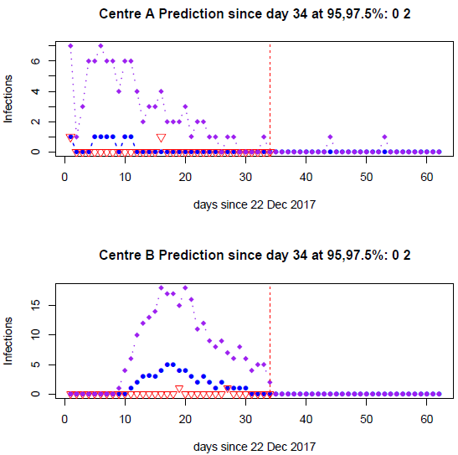
*: same as in Figure S2

Figure S4: Time series* of chickenpox outbreak under condition 3 (interruption of immunity testing of detainees in Centre B; partial testing)
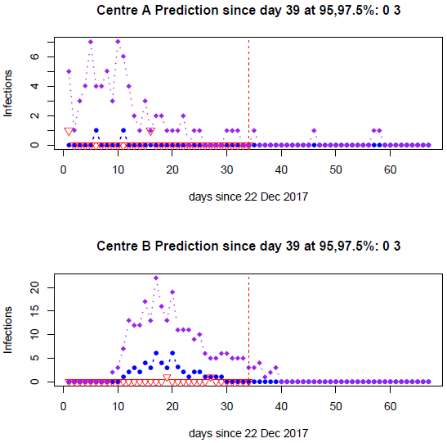

*: same as in Figure S2
References for Supplement 2: Mathematical modelling analysis
Anderson RM, May RM. Infectious diseases of humans: dynamics and control. Oxford, UK: Oxford University Press. 1991.

Brisson M, Edmunds WJ, Gay NJ, Law B, de Serres G. Modelling the impact of immunization on the epidemiology of varicella zoster virus. Epidemiol Infect. 2000125:651–669.

Nardone A, de Ory F, Carton M, Cohen D, van Damme P, et al. The comparative sero-epidemiology of varicella zoster virus in 11 countries in the European region. Vaccine 2007; 25:7866–7872.

van den Driessche P, Watmough J. Reproduction numbers and sub-threshold endemic equilibria for compartmental models of disease transmission. Math Biosci. 2002180:29–48.

Zhang X-S, Pebody R, Charlett A, de Angelis D, Birrell P, Kang H, Baguelin M, Choi YH. Estimating and modelling the transmissibility of Middle East Respiratory Syndrome CoronaVirus during the 2015 outbreak in the Republic of Korea. Influenza Other Respir Viruses. 2019 ;11(5):434-444.

