Supplementary Figure 1. Funnel plots of investigated polymorphisms

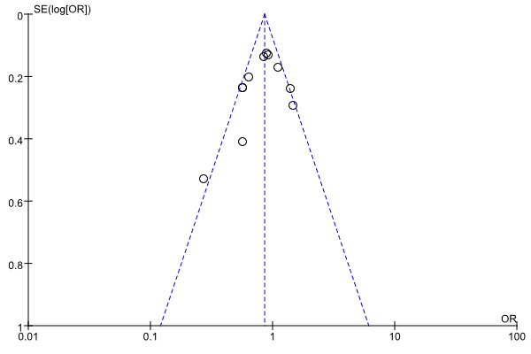
Funnel plot of CTLA-4 rs231775 polymorphism and viral hepatitis under dominant comparison

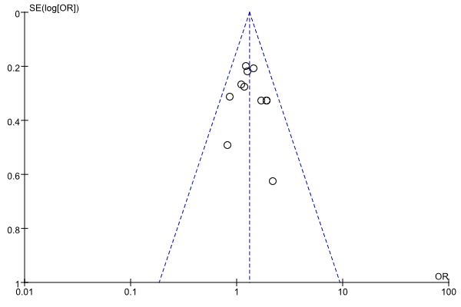
Funnel plot of CTLA-4 rs231775 polymorphism and viral hepatitis under recessive comparison

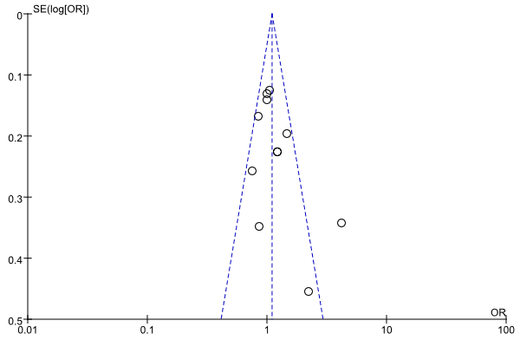
Funnel plot of CTLA-4 rs231775 polymorphism and viral hepatitis under over-dominant comparison

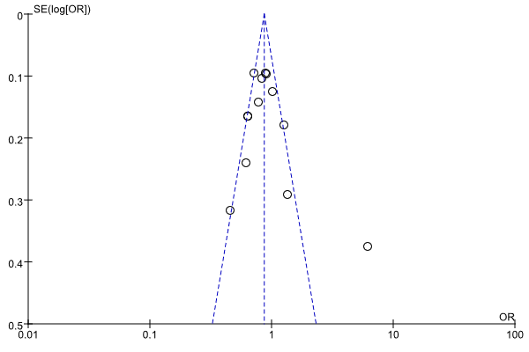
Funnel plot of CTLA-4 rs231775 polymorphism and viral hepatitis under allele comparison

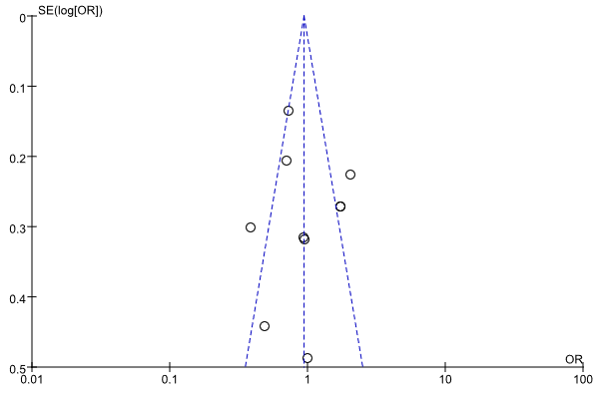
Funnel plot of CTLA-4 rs5742909 polymorphism and viral hepatitis under dominant comparison

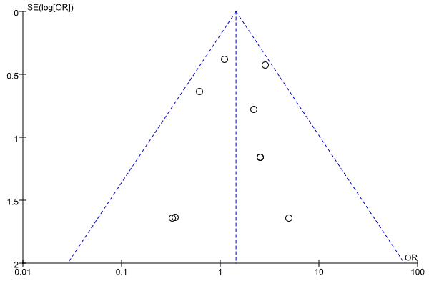
Funnel plot of CTLA-4 rs5742909 polymorphism and viral hepatitis under recessive comparison

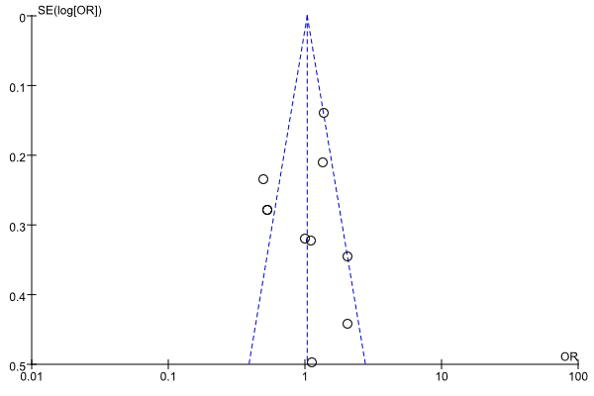
Funnel plot of CTLA-4 rs5742909 polymorphism and viral hepatitis under over-dominant comparison

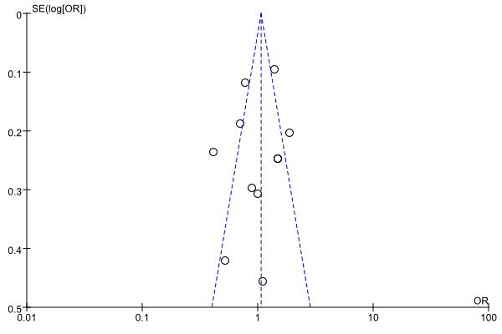
Funnel plot of CTLA-4 rs5742909 polymorphism and viral hepatitis under allele comparison

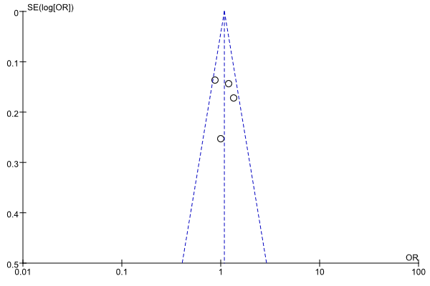
Funnel plot of CTLA-4 rs3087243 polymorphism and viral hepatitis under dominant comparison

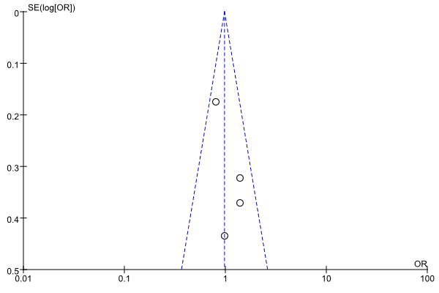
Funnel plot of CTLA-4 rs3087243 polymorphism and viral hepatitis under recessive comparison

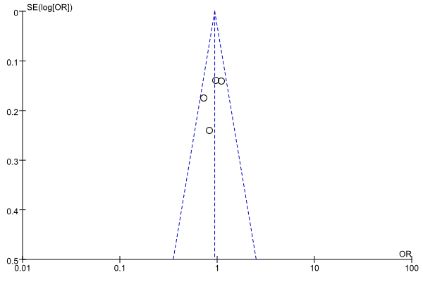
Funnel plot of CTLA-4 rs3087243 polymorphism and viral hepatitis under over-dominant comparison

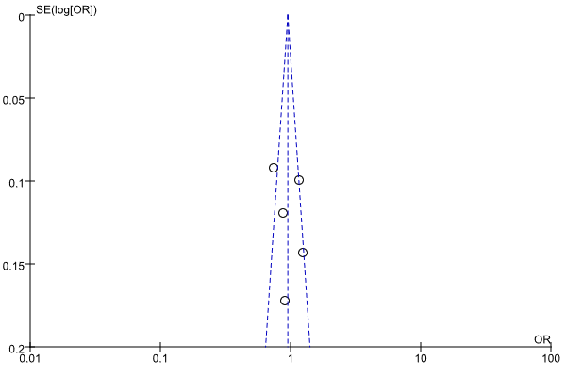
Funnel plot of CTLA-4 rs3087243 polymorphism and viral hepatitis under allele comparison

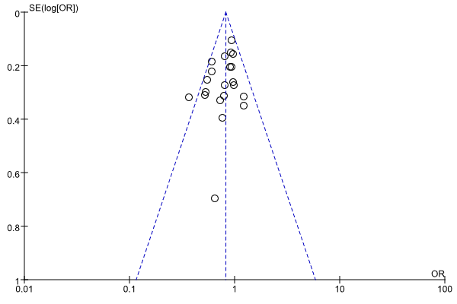
Funnel plot of IL-18 rs1946518 polymorphism and viral hepatitis under dominant comparison

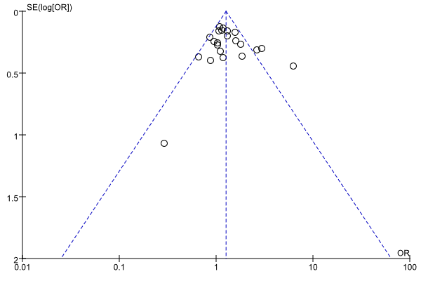
Funnel plot of IL-18 rs1946518 polymorphism and viral hepatitis under recessive comparison

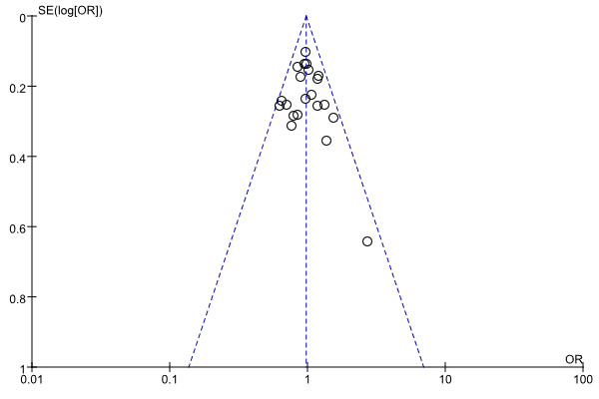
Funnel plot of IL-18 rs1946518 polymorphism and viral hepatitis under over-dominant comparison

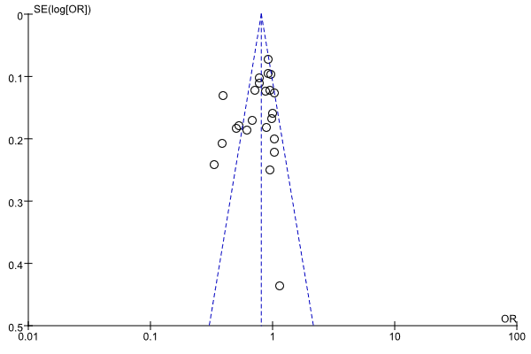
Funnel plot of IL-18 rs1946518 polymorphism and viral hepatitis under allele comparison

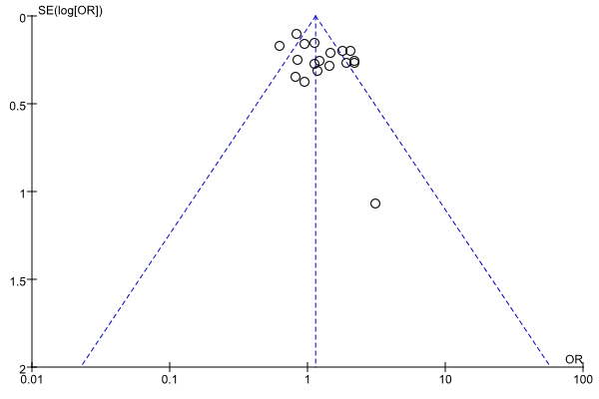
Funnel plot of IL-18 rs187238 polymorphism and viral hepatitis under dominant comparison

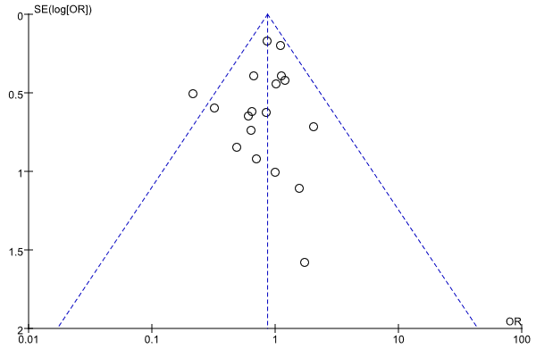
Funnel plot of IL-18 rs187238 polymorphism and viral hepatitis under recessive comparison

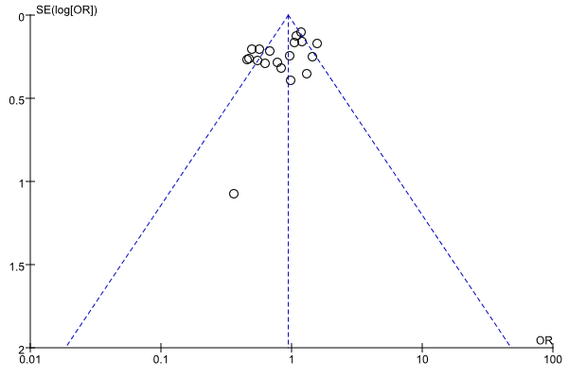
Funnel plot of IL-18 rs187238 polymorphism and viral hepatitis under over-dominant comparison

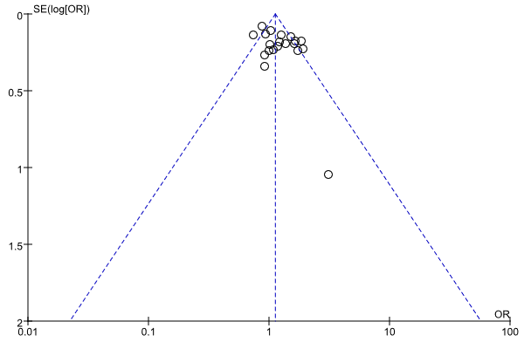
Funnel plot of IL-18 rs187238 polymorphism and viral hepatitis under allele comparison

